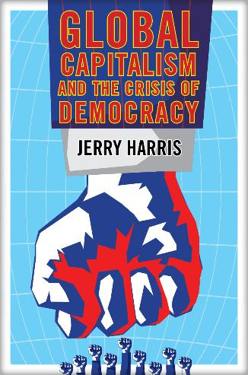  ISBN: 978-0-9860853-2-1 $23.95 2016 285 pp.  EBOOK: $19.00 | DEMOCRACY:  Still possible in the Transnational Era  GLOBAL CAPITALISM  AND THE CRISIS OF DEMOCRACY  by  Jerry Harris  REVIEWS:  Jerry Harris is a preeminent scholar on global  studies, particularly on global capitalism and  transnational class theory.  Marek Hrubec, Director, Center of Global Studies, Academy of Sciences, Prague  This is an excellent book, packed with meticulously-documented facts, indicating the disastrous direction that global capitalism, dominated by a new transnational capitalist class, is taking us... Highly recommended!  —David Schweickart, Loyola University,  author of Beyond Capitalism  There is a vast literature on the contradictions and evils of global capitalism, but relatively little on progressive non-capitalist alternatives. In this stimulating book, Harris, who is one of the originators of transnational capitalist class analysis, poses the all-important question: Can the power of democracy overcome the power of global capitalism?... This book will spark productive controversy among theorists and activists, precisely what is required if we are to find progressive non-capitalist alternatives.  Leslie Sklair, London School of Economics, author of The Transnational Capitalist Class  Harris critiques with great perspicacity the ideology and destructive practices of hegemonic neoliberalism as well as the failure of 20th century socialism to provide a viable alternative and the limitations of anarchism. All three ideologies are found wanting in the quest for human liberation. In this new globalized information age our emancipatory potential, he suggests, lies in freeing democracy from the constraints of capitalism through a more balanced relationship between the state, market and civil society. Harris’ ideas should be widely studied and debated.  William I. Robinson, University of California at Santa Barbara, author of Global Capitalism and the Crisis of Humanity
Global Capitalism and the Crisis of Democracy is a seminal work which addresses the major questions raised by neoliberal globalization. This volume should be read and used in classrooms and study groups to stimulate a conversation about the new era of globalization, and the prospects for building twenty-first century socialism.
Harry Targ, Purdue University, Portside

Global Capitalism and the Crisis of Democracy is an exceptionally thorough and thought-provoking work. Very rarely, these days, do I use a highlighter when reading a book in order to remind myself of facts, points of interest or points of difference. In this case, the highlighter was with me till the end, with my knowing that I will return to this book as a resource for better understanding, as well as explaining, the development of global capitalism and its implications for the billions of people on this planet ravaged by it.
Bill Fletcher, Jr. author of "They're Bankrupting Us!": And 20 Other Myths about Unions

Available from Clarity Press, amazon.com

