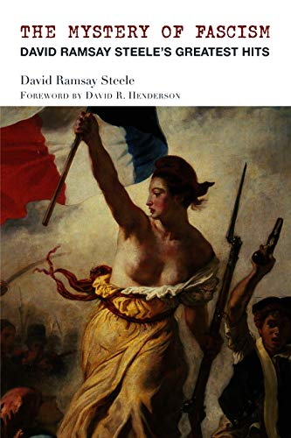
Program on Saturday, January 18th
at the College of Complexes
The Mystery of Fascism
Meeting # 3,564 –
author David Ramsay Steele discusses his new book
​Article:
www.la-articles.org.uk/fascism.htm

David Ramsay Steele’s latest book is The Mystery of Fascism: David Ramsay Steele’s Greatest Hits, a collection of twenty-three of his articles spanning the years 1987–2018. The most famous piece, still constantly read and re-read with astonishment, is “The Mystery of Fascism” (2001). Other chapters cover Ayn Rand, Thomas Szasz, Friedrich Hayek, the TV show Dexter, why gambling is productive, how we know we’re not living in the Matrix, how Hillary Clinton could have won the 2016 election, and why it’s moral to eat meat.

In his talk Dr. Steele will focus on fascism: what it means and what we can do about it. Copies of The Mystery of Fascism will be on sale, and if you want your grandchildren to be multimillionaires, the author may be persuaded to autograph them (the books, not the grandchildren). Dr. Steele’s other books include Orwell Your Orwell (2017), Therapy Breakthrough (2013), Atheism Explained (2008), Three Minute Therapy (1997), and From Marx to Mises (1992).

