Weekly Free Speech Forum established Jan. 6, 1951

College of Complexes
The Playground for People Who Think
sustaining the academic tradition of “One Fool at a Time”

Every Saturday Main Page
at 6:00 PM www.collegeofcomplexes.org
Facebook
https://www.facebook.com/collegeofcomplexes/

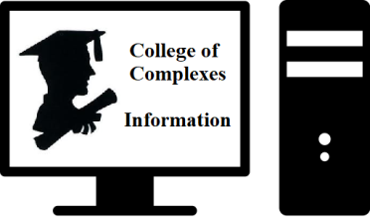
To Join the Zoom Meeting
https://us02web.zoom.us/j/81216467150

Mobile phone
1 312 626 6799, 8 121 646 7150# US (Chicago)
Landline
1 312 626 6799 US (Chicago)
Meeting ID: 812 1646 7150

To Join CoC Google Group for Updates
Send a Blank Email to:
collegeofcomplexes+subscribe@googlegroups.com

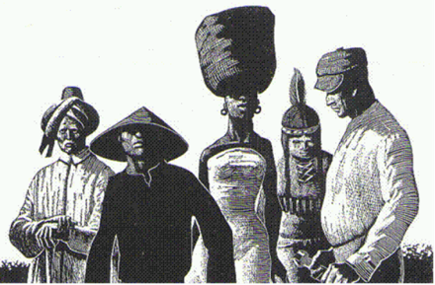
Nov 27th Race, Racial Ideas, and Racism
Meeting # 3,644
Jian Li, PhD in anthropology and a Mandarin teacher, will discuss the understandings and misunderstandings of the concepts of “race, racial ideas, and racism”. Based on the theories of anthropology, genetics and her own personal experiences and reflections, she argues that the concept of race that many people still hold true is outdated. We need to re-examine the concepts of race and racism so we can move towards more open-minded and socially responsible citizens.

December 4th The Illinois Environmental Council (IEC)
Environmental Scorecard for the Illinois General Assembly
Meeting #3,645 - Jen Walling, Executive Director.
"Our mission at IEC is not just passing environmental policies that benefit Illinoisans and our state’s environment, but building power for people and legislators’ recent decisions on the environment accessible to you, so you can see just how they’re leveraging their influence in the general assembly to either advocate for their constituents’ right to a healthy environment OR for the interests of big polluters." http://ilenviro.org/2021-scorecard/

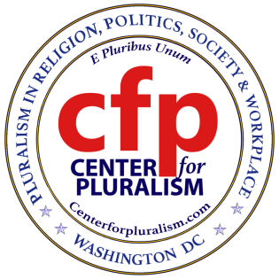
Dec 11th Center for Pluralism
"Talking with difficult people" or
"Cleaning your slate and living in peace"
Meeting # 3,646 - Mike Ghouse, President https://centerforpluralism.com/
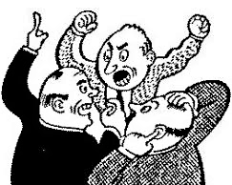
Dr. Mike Ghouse is a speaker, thinker, author, community consultant, pluralist, activist, newsmaker, and interfaith wedding officiant. Mike is deeply committed to Pluralism in Religion, Politics, Societies, and the workplace. He is an activist for Human Rights and freedom. He has
dedicated his life to building a cohesive America and offers pluralistic solutions to the media and the policymakers on issues of the day. Everything about him is at www.TheGhousediary.com

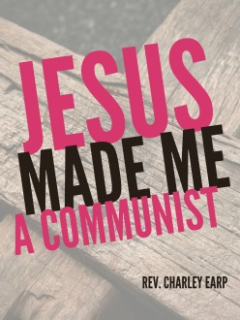
Dec 18th The Church of The Revolution
intersectional ecosocialist religious communism
Meeting #3,647 - Rev. Charley Earp https://www.facebook.com/charley63
This emerging online and in-person congregation is committed to advancing a new vision of an intersectional ecosocialist Religious Communism that integrates the radicalism of Jesus of Nazareth, Karl Marx, and Universalism.

Dec 25, Jan 1 Happy Holidays! Closed

1st meeting of the CoC was on January 6, 1951

January 8th America Walks / Pedestrian Advocacy
Meetings # 3,648 - Ian Thomas, PhD, State and Local Program Director
America Walks is leading the way in advancing walkable, equitable, the national voice for public spaces that allow people to safely walk and move. At the regional, state, and neighborhood levels, America walks provides critical strategic support, training, and technical assistance to partner organizations and individuals to effectively advocate for change.

January 15th Dank Libertarian Meme Stash
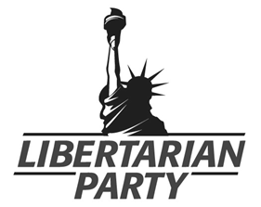
Meetings # 3,649 - Justin Tucker, Executive Director of the Libertarian Party of Illinois,
rings in the New Year with a slideshow of the dankest libertarian-themed memes shared on social media. He will demonstrate how humor is a fun way to spread the message of liberty and show appreciation for dank memes as an art form. From thoughtful quotes to Leonardo DiCaprio, these dank memes will provoke thoughts and laughs. There will also be an update on the Libertarian Party of Illinois as we enter the 2022 election cycle. Trigger Warning: excessive dank. Rated PG-13.

About the Libertarian Party:
We, the members of the Libertarian Party, challenge the cult of the omnipotent state and defend the rights of the individual.

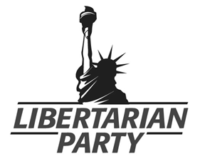
We hold that all individuals have the right to exercise sole dominion over their own lives, and have the right to live in whatever manner they choose, so long as they do not forcibly interfere with the equal right of others to live in whatever manner they choose.

Governments throughout history have regularly operated on the opposite principle, that the State has the right to dispose of the lives of individuals and the fruits of their labor. Even within the United States, all political parties other than our own grant to government the right to regulate the lives of individuals and seize the fruits of their labor without their consent.

https://lpillinois.org/ LP of Illinois
https://www.facebook.com/groups/ChicagoLP/posts/3008396199400699/ LP of Chicago
\\

January 22nd Just Strategy / Alliance for a Just Society
National Campaign for Transit Justice
Meeting # 3,650 - Libero Della Piana, Senior Strategist and LeeAnn Hall
Founded by LeeAnn Hall in 1993, AJS began as the Northwest Federation of Community Organizations (NWFCO). They advanced racial justice and multiracial organizing in rural and conservative communities. In 2003, this network expanded nationally and changed its name to Alliance for a Just Society. Our network played a pivotal role in the national campaign to win the Affordable Care Act. https://www.allianceforajustsociety.org/

Transformational change requires strategic organizing
The Alliance for a Just Society builds powerful issue campaigns that win.
We educate organizers and movement leaders.
We help develop effective strategies for racial and economic justice movements.
We create innovative organizing projects.
We partner with organizations to build people’s power.
The Alliance for a Just Society launched the National Campaign for Transit Justice in response to the emergency faced by public transit systems around the country. The pandemic and the resulting economic crisis pushed public transit around the country to the edge of disaster.
We and the broad coalition of over 60 transit rider organizations, national advocates, and transit unions have helped win $69 billion in federal support from Congress to avoid fare hikes, service cuts, and shutdowns.
Now the campaign is working to transform transportation priorities and ensure public transit drives the future of the economy. Our transit work is guided by concern for equity, the climate and our transit justice principles.
https://www.allianceforajustsociety.org/campaigns/transit-justice/

January 29th Coalition of Immokalee Workers (CIW)
The Fair Food Program, Anti-Slavery Campaign, Boycott Wendy’s
Meetings # 3,651
​The Coalition of Immokalee Workers (CIW) is a worker-based human rights organization internationally recognized for its achievements in fighting human trafficking and gender-based violence at work. The CIW is also recognized for pioneering the design and development of the Worker-driven Social Responsibility paradigm, a worker-led, market-enforced approach to the protection of human rights in corporate supply chains.
​
Built on a foundation of farmworker community organizing starting in 1993, and reinforced with the creation of a national consumer network since 2000, CIW’s work has steadily grown over more than twenty years to encompass broad and overlapping spheres. https://ciw-online.org/
​

February 5th The Surrender of Democracy
Meeting # 3,652
The Surrender of Democracy
Kenneth Williams, President, Dallas, Texas Alliance for Retired Americans, and Democratic Activist, will discuss the Question: "Should Democrats be doing more to save democracy from the anti-democratic movement that has taken over the Republican party?" He concludes that they should, and offers directions as to what we can do to combat this situation.

February 12 Open
19, 26 Meetings # 3,653+
If you would like to speak contact the Program Coordinator Charles Paidock at (312) 842-5036, (312) 714-7790 cell, or by email to cpaidock@hotmail.com

Saturdays Presentation at 6:00 PM
To Join the Zoom Meeting
https://us02web.zoom.us/j/81216467150

Mobile phone
1 312 626 6799, 8 121 646 7150# US (Chicago)
Landline
1 312 626 6799 US (Chicago)
Meeting ID: 812 1646 7150

www.collegeofcomplexes.org

facebook: College of Complexes

https://www.facebook.com/collegeofcomplexes

Watch Videos of Previous Presentations (150+)
CoC Lecture Library
http://www.collegeofcomplexes.org/LectureLibrary.html
or go to main page for link

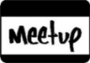
Join our Meetup Group
in order to receive weekly speaker / topic information
https://www.meetup.com/FreeSpeechForum/

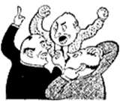
Continue Your Education All Week Long
on our electronic discussion group - to join send a blank e-mail to:
collegeofcomplexes+subscribe@googlegroups.com

