

Weekly Free Speech Forum established Jan. 6, 1951

College of Complexes
The Playground for People Who Think
sustaining the academic tradition of “One Fool at a Time”

Every Saturday Main Page
at 6:00 PM www.collegeofcomplexes.org
Facebook

https://www.facebook.com/collegeofcomplexes/

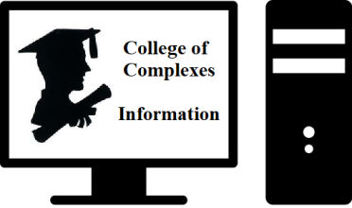
To Join the Zoom Meeting
https://us02web.zoom.us/j/81216467150

Mobile phone
1 312 626 6799, 8 121 646 7150# US (Chicago)
Landline
1 312 626 6799 US (Chicago)


Meeting ID: 812 1646 7150

To Join CoC Google Group for Updates
Send a Blank Email to: collegeofcomplexes+subscribe@googlegroups.com


October 23rd The Covid Conspiracy
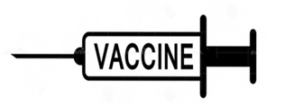
Meeting # 3,639 –, Jim Fetzer, Ph.D.
The pandemic is fake but the vax is real. Sherri Tenpenny has described the mRNA vaccines as "perfectly designed killing machines". See "The Coronavirus Phenomenon: Medical Emergency or Political Pandemic?" (24 May 2020),
https://www.bitchute.com/video/AlJz3cI3AhHk/


Oct 30th Illinois Green Party Candidate for Congress
Adam Broad for CD-10
Meeting # 3,640

10 Key Values: These are 10 principles that guide and unite Greens from around the world.
Grassroots Democracy

Social Justice
Ecological Wisdom
Nonviolence
Decentralization
Community-Based Economics
Feminism and Gender Equity
Respect for Diversity
Personal and Global Responsibility
Future Focus and Sustainability

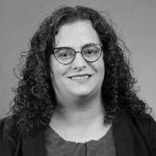

Nov 6th Marsha Williams for Congress IL-16
Stands For Universal Healthcare, Green New Deal, and Criminal Justice Reform
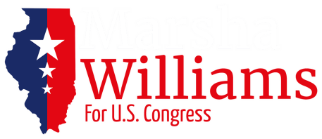
Meetings #3,641 - with Nicolle DiMaria, Campaign Manager
Candidate states: "As members of Congress, it is our job to create laws and policies that will uplift our communities and make America a better place – a safer place - for future generations. It is time to move forward as a country by finding real solutions to the issues we face every day."


November 13th Pace e Bene Nonviolence Service

Promotes a “Campaign Nonviolence”
Meetings #3,642 - Veronica Pelicaric, Director of Educational Programs.
Promotes a “Campaign Nonviolence - a long-term movement is to build a culture of peace and nonviolence free from war, poverty, racism, climate crisis, and the epidemic of violence.”


November 20th Coalition for the National Infrastructure Bank (NIB) $5 Trillion, 25 Million Jobs
Meeting #3,643 -
NIB IS an organization of individuals and groups dedicated to a common purpose: To get legislation enacted by the US Congress that creates a $5 Trillion National Infrastructure Bank.

Our proposed $5 trillion Bank would provide funding for a nationwide network of high-speed rail, rebuilding thousands of bridges and tunnels, repairing and upgrading tens of thousands of miles of roads, constructing large-scale water projects to provide clean, fresh water for drinking and irrigation, upgrading our electricity generating capacity as well as the transmission network, building broadband internet access, and schools and hospitals. In addition, it will provide sufficient funding to finally realize new technologies.

These projects would create more than 25 million new, good-paying industrial American jobs.
In short, the NIB would change the life of every single person in America, and impact people and events worldwide.

It means giving the people of the United States back their sense of identity as producers, not merely "consumers." The NIB will be crucial for our recovery from the COVID crisis; we can not only regain what we lost during the crisis, but achieve a level of capability that will mean we are never caught unprepared again.
We need you help to get Congress to adopt legislation for a $5 trillion National Infrastructure Bank.
Please like our Facebook page and share the videos with your friends, family and colleagues. http://www.nibcoalition.com/
http://www.nibcoalition.com/

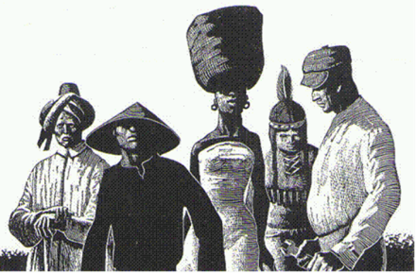
Nov 27th Race, Racial Ideas, and Racism
Meeting # 3,644
Jian Li, PhD in anthropology and a Mandarin teacher, will discuss the understandings and misunderstandings of the concepts of “race, racial ideas, and racism”. Based on the theories of anthropology, genetics and her own personal experiences and reflections, she argues that the concept of race that many people still hold true is outdated. We need to re-examine the concepts of race and racism so we can move towards more open-minded and socially responsible citizens.


December 4th The Illinois Environmental Council (IEC)
Environmental Scorecard for the Illinois General Assembly
Meeting #3,645 - Jen Walling, Executive Director.

"Our mission at IEC is not just passing environmental policies that benefit Illinoisans and our state’s environment, but building power for people and legislators’ recent decisions on the environment accessible to you, so you can see just how they’re leveraging their influence in the general assembly to either advocate for their constituents’ right to a healthy environment OR for the interests of big polluters." http://ilenviro.org/2021-scorecard/

Dec 11th Center for Pluralism
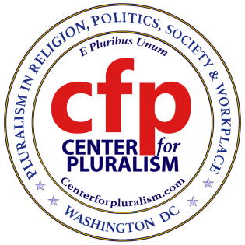
"Talking with difficult people" or
"Cleaning your slate and living in peace"
Meeting # 3,646 - Mike Ghouse, President https://centerforpluralism.com/
Dr. Mike Ghouse is a speaker, thinker, author, community consultant, pluralist, activist, newsmaker, and interfaith wedding officiant. Mike is deeply committed to Pluralism in Religion, Politics, Societies, and the workplace. He is an activist for Human Rights and freedom. He has dedicated his life to building a cohesive America and offers pluralistic solutions to the media and the policymakers on issues of the day. Everything about him is at www.TheGhousediary.com


Dec 18th Open
Meeting # 3,647 - contact the Program Coordinator Charles Paidock if
you would like to speak at (312) 842-5036, (312) 714-7790 cell, or by email to cpaidock@hotmail.com


Saturdays Presentation at 6:00 PM
To Join the Zoom Meeting
https://us02web.zoom.us/j/81216467150

Mobile phone
1 312 626 6799, 8 121 646 7150# US (Chicago)
Landline
1 312 626 6799 US (Chicago)
Meeting ID: 812 1646 7150

www.collegeofcomplexes.org


facebook: College of Complexes

https://www.facebook.com/collegeofcomplexes



Watch Videos of Previous Presentations (150+)
CofC Lecture Library
http://www.collegeofcomplexes.org/LectureLibrary.html
or go to main page for link


Join our Meetup Group
in order to receive weekly speaker / topic information
https://www.meetup.com/FreeSpeechForum/


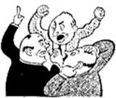
Continue Your Education All Week Long
on our electronic discussion group - to join send a blank e-mail to:
collegeofcomplexes+subscribe@googlegroups.com

