Weekly Free Speech Forum established Jan. 6, 1951

College of Complexes
The Playground for People Who Think
sustaining the academic tradition of “One Fool at a Time”

Every Saturday Main Page
at 6:00 PM www.collegeofcomplexes.org
Facebook
https://www.facebook.com/collegeofcomplexes/
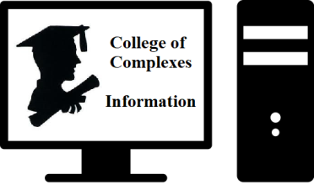
To Join the Zoom Meeting
https://us02web.zoom.us/j/81216467150

Mobile phone
1 312 626 6799, 8 121 646 7150# US (Chicago)
Landline
1 312 626 6799 US (Chicago)
Meeting ID: 812 1646 7150

To Join CoC Google Group for Updates
Send a Blank Email to:
collegeofcomplexes+subscribe@googlegroups.com

Earth Day Series of Speakers
https://www.facebook.com/groups/ChicagoLP/posts/3008396199400699/

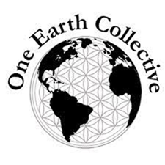
April 9th One Earth Collective
https://oneearthcollective.org/ or https://www.facebook.com/OneEarthCollective
Upcoming Earth Week Mini Film Festival in partnership with the City of Chicago (Apr 18-24, 2022)
Meeting # 3,661
One Earth Collective harnesses the power of people through vibrant environmental programming that inspires action, facilitates learning, and fosters inclusion to create safer communities and a healthier planet.

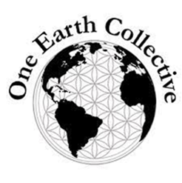
Through our three program areas: One Earth Film Festival, One Earth Local and One Earth Youth Voices, we engage more than 7,000 people annually in activities that spur creativity. After encounters with One Earth, people of all ages are encouraged to see the possibilities and adopt solution-oriented mindsets, and share their learnings and ideas with others.

Since 2010, One Earth Collective has built environmental awareness and inspired action in the Chicago area as well as nationally, with an emphasis on developing youth leadership.

Our grass-roots, community-based work is centered at the intersection of the environment and social justice. We invite people into our work through the power of art, nature, activism and community.
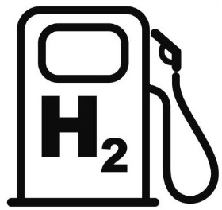
April 16th "Green Hydrogen" - What Is It and What Role Might it Play in Helping the World Get to a Net-Zero Carbon Economy
Meeting # 3,662 - Allan Lindrup
Presenter is an activist with the Unitarian Universalists for Social Justice Environmental Task Force, and a member of numerous environmental organizations.

April 23rd Green Party Candidates for the Metropolitan Water Reclamation District (MWRD)
Meeting # 3,663 - Toneal M. Jackson and Mark Buettner
Created in 1889 as the Sanitary District of Chicago, the Metropolitan Water Reclamation District of Greater Chicago (MWRD) today is an award-winning, special-purpose district responsible for treating wastewater and providing stormwater management for residents and businesses in its service area, which encompasses 882.1 square miles and includes Chicago and 128
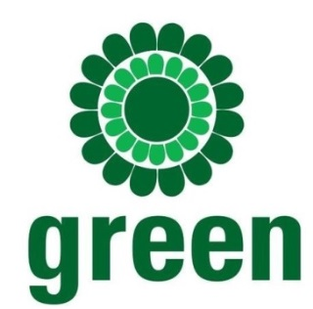
suburban communities throughout Cook County. The MWRD serves approximately 12.72 million people each day, including 5.16 million residents.
\Toneal M. Jackson
International Award-Winning Author, publisher, podcaster and organizer. Founder of Artists Promoting Success and I’m Glad to be a Woman, Jackson uses her platforms to educate and empower. Her podcast, Toneal Talks Politics has helped bring awareness to the Green Party, their core values as well as other environmental issues.
Mark Buettner
Mark received a degree in Water Technology from New Mexico State University in 2008. He worked as an Illinois wastewater treatment works operator class 1 for 14 years in the water reclamation industry; nine of those years as an MWRD treatment plant operator.

Information https://www.mwrdgreens.org/

Get Involved https://www.ilgp.org/get-involved /

Main website ILGP https://www.ilgp.org/

April 30th Proof there is a Primitive Species Living in the Forests of the US, and The Need to Preserve / Restore Their Habitat
National Arbor Day is April 29, 2022 https://www.arborday.org/celebrate/
Meeting # 3,664 – Charles Paidock, Secretary, Chicago Greens, will speak on “cryptozoology” and the why the lumber industry, land conversion, and urban sprawl should be stopped.
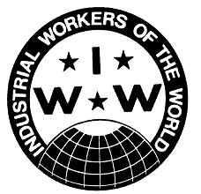
May 7th Special May Day Speaker
The Industrial Workers of the World (IWW) the "Wobblies"
Meeting # 3,665 - Kelsey Tanabe Walker, General Secretary-Treasurer
North American Regional Administration
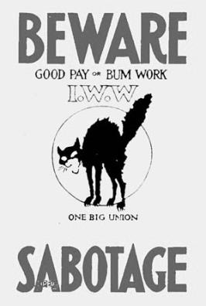
The IWW is an international labor union that was founded in Chicago in 1905. The philosophy and tactics of the IWW are described as "revolutionary industrial unionism," with ties to socialist, syndicalist, and
anarchist labor movements. The IWW promotes the concept of "One Big Union," and contends that all workers should be united as a social class to supplant capitalism and wage labor. It is known for the shop model of workplace democracy, in which workers elect their own managers.

IWW
https://www.iww.org /

Greater Chicago IWW
https://l.facebook.com/l.php

Greater Chicago IWW (Facebook)
https://www.facebook.com/ChicagoIWW/?ref=page_internal
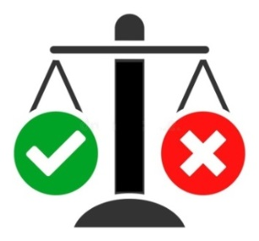
May 14th Truth Brigade Illinois / Indivisible Illinois
Meeting # 3,666 - Co-coordinators Etta Worthington and Candace Davis
“The Truth Brigade is people (us!) fighting disinformation by sharing the truth. We have learned that arguing with people on Facebook or twitter or Instagram or anywhere else doesn’t work. When we comment or answer postings that contain misinformation we unfortunately just boost the

original post so more people see the lies. Instead, we are creating our own truthful posts to counter the hurtful lies that are out there. We do that by creating “truth sandwiches” – a statement that is true, followed by a response to a lie questioning the author’s motives – followed by another true statement. We have found that people respond best to positive statements so a truth sandwich can be a great way to get the truth out there and discredit lies.”

Website
https://www.indivisibleillinois.org/truthbrigade/
Facebook
https://www.indivisibleillinois.org/truthbrigade/

Indivisible Illinois is part of the locally-led, people-powered Indivisible Project network, a grassroots American movement founded in 2016, with thousands of chapters across the U.S. in urban, suburban and rural communities. Indivisible Illinois reflects the Heart of the Midwest by promoting an equity agenda in pursuit of liberty and justice for all.

Our grassroots power comes from working in solidarity and in coalition with others. We do this through advocacy and direct action organizing for progressive issues and by electing progressive leaders.

May 21st Health Disparities through the Lens of Long Covid
Meeting # 3,3667 – Martha Pack of Wail of a Tail
“COVID 19 has changed lives around the world. This project was conceptualized by Marty while working as a COVID Investigator for Grand County Public Health. Based on direct experience by Marty and
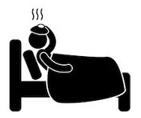
collogues, we expose inequalities. Our goal is to educate others on the conditions our society is facing, and to effect change.

The purpose of the project is to educates students, teachers, and the public on Long Covid. This is done by looking at the disparities in our health system like those caused by health deserts in both rural and urban communities. We interview individuals from different economic and

social backgrounds to understand the vast physical, financial, and emotional differences faced by undocumented, middle class, and wealthy individuals struggling with Long Covid.”

May 28th How to Combat and Deal with Disruptive Audiences & Disinformation at School Board Meetings
(concerning anti-vaccination, anti-masking and critical race theory (CRT)
Meeting # 3,668 - Joyce Slavik and Jim McGrath of NWSOFA
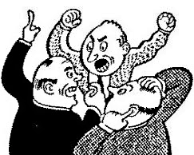
“All are invited to attend and learn / contribute what is happening locally / across Illinois and nationally.

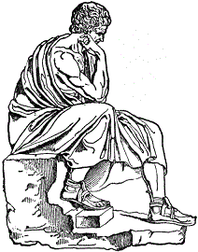
There is an organized effort to spread disinformation, we need to understand who is sponsoring the disinformation, and how to stop it. This is hand-to-hand combat as these conservative activists are trying to create local unsafe school anti-masking, anti-vaccination, racist policies, unseat duly elected representatives and disrupt our local school board meetings, Learn what we can do to level the playing field!”

June 4 How to Make Meaning
Meeting # 3,669 – Philosophy Prof. Bob Lichtenbert, published author of eight books on the topic, will discuss what meaning is, and ways to get more of it in its major sources such as relationships, building community, God, and interpreting art. He will argue and conclude on what made him search for meaning so intensely.

Tips for Making Meaning
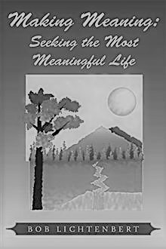
The book supplies suggestions or "tips" for a person making the most meaning in her or his life. There are also aphorisms and uplifting tidbits for living a more meaningful life. The short and pithy tone is conducive to easy reading and comprehension. It is also educational in that it brings in insights into many famous philosophers, writers, artists, and scientists. As in Robert Lichtenbert's other books, "meaning" is defined as the "positive impact of a person," or in other words, referring to one's good effects or relations to other people or things. This makes it an objective, not merely subjective, concept. The tips and aphorisms also are intended to make clear to the reader why making meaning is important to his or her life.

June 11 Open
18, 25 Meetings # 3,670+
If you would like to speak contact the Program Coordinator Charles Paidock at (312) 842-5036, (312) 714-7790 cell, or by email to cpaidock@hotmail.com

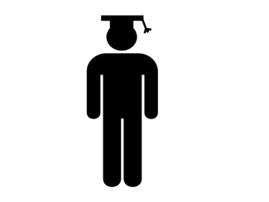
Saturdays Presentation at 6:00 PM
To Join the Zoom Meeting
https://us02web.zoom.us/j/81216467150

By phone
1 312 626 6799, 8 121 646 7150# US (Chicago)
Meeting ID: 812 1646 7150

www.collegeofcomplexes.org

facebook: College of Complexes

https://www.facebook.com/collegeofcomplexes

Watch Videos of Previous Presentations (150+)
CoC Lecture Library
http://www.collegeofcomplexes.org/LectureLibrary.html
or go to main page for link

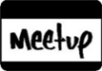
Join our Meetup Group
in order to receive weekly speaker / topic information
https://www.meetup.com/FreeSpeechForum/

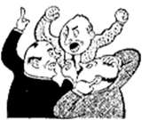
Continue Your Education All Week Long
on our electronic discussion group - to join send a blank e-mail to:
collegeofcomplexes+subscribe@googlegroups.com

