Weekly Free Speech Forum established Jan. 6, 1951

College of Complexes
The Playground for People Who Think
sustaining the academic tradition of “One Fool at a Time”

Every Saturday Main Page
at 6:00 PM www.collegeofcomplexes.org
Facebook
https://www.facebook.com/collegeofcomplexes/
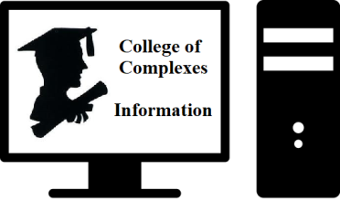
To Join the Zoom Meeting
https://us02web.zoom.us/j/81216467150

Mobile phone
1 312 626 6799, 8 121 646 7150# US (Chicago)
Landline
1 312 626 6799 US (Chicago)
Meeting ID: 812 1646 7150

To Join CoC Google Group for Updates
Send a Blank Email to:
collegeofcomplexes+subscribe@googlegroups.com

May 14th Truth Brigade Illinois / Indivisible Illinois
Meeting # 3,666 - Co-coordinators Etta Worthington and Candace Davis
“The Truth Brigade is people (us!) fighting disinformation by sharing the truth. We have learned that arguing with people on Facebook or twitter or Instagram or anywhere else doesn’t work. When we comment or answer postings that contain misinformation we unfortunately just boost the original post so more people see the lies. Instead, we are creating our own truthful posts to counter the hurtful lies that are out there. We do that by creating “truth sandwiches” – a statement that is true, followed by a response to a lie questioning the author’s motives – followed by another true statement. We have found that people respond best to positive statements so a truth sandwich can be a great way to get the truth out there and discredit lies.”

Website
https://www.indivisibleillinois.org/truthbrigade/
Facebook
https://www.indivisibleillinois.org/truthbrigade/

Indivisible Illinois is part of the locally-led, people-powered Indivisible Project network, a grassroots American movement founded in 2016, with thousands of chapters across the U.S. in urban, suburban and rural communities. Indivisible Illinois reflects the Heart of the Midwest by promoting an equity agenda in pursuit of liberty and justice for all.

Our grassroots power comes from working in solidarity and in coalition with others. We do this through advocacy and direct action organizing for progressive issues and by electing progressive leaders.

May 21st Health Disparities through the Lens of Long Covid
Meeting # 3,3667 – Martha Pack of Wail of a Tail
“COVID 19 has changed lives around the world. This project was conceptualized by Marty while working as a COVID Investigator for Grand County Public Health. Based on direct experience by Marty and
collogues, we expose inequalities. Our goal is to educate others on the conditions our society is facing, and to effect change.

The purpose of the project is to educates students, teachers, and the public on Long Covid. This is done by looking at the disparities in our health system like those caused by health deserts in both rural and urban communities. We interview individuals from different economic and
social backgrounds to understand the vast physical, financial, and emotional differences faced by undocumented, middle class, and wealthy individuals struggling with Long Covid.”
…………………………………………………………

May 28th How to Combat and Deal with Disruptive Audiences & Disinformation at School Board Meetings
(concerning anti-vaccination, anti-masking and critical race theory (CRT)
Meeting # 3,668 - Joyce Slavik and Jim McGrath of NWSOFA
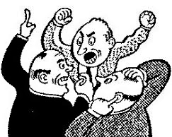
“All are invited to attend and learn / contribute what is happening locally / across Illinois and nationally.

There is an organized effort to spread disinformation, we need to understand who is sponsoring the disinformation, and how to stop it. This is hand-to-hand combat as these conservative activists are trying to create local unsafe school anti-masking, anti-vaccination, racist policies, unseat duly elected representatives and disrupt our local school board meetings, Learn what we can do to level the playing field!”

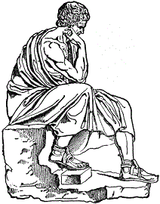
June 4th How to Make Meaning
Meeting # 3,669 – Philosophy Prof. Bob Lichtenbert, published author of eight books on the topic, will discuss what meaning is, and ways to get more of it in its major sources such as relationships, building community, God, and interpreting art. He will argue and conclude on what made him search for meaning so intensely.

Tips for Making Meaning
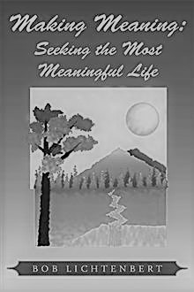
The book supplies suggestions or "tips" for a person making the most meaning in her or his life. There are also aphorisms and uplifting tidbits for living a more meaningful life. The short and pithy tone is conducive to easy reading and comprehension. It is also educational in that it brings in insights into many famous philosophers, writers, artists, and scientists. As

in Robert Lichtenbert's other books, "meaning" is defined as the "positive impact of a person," or in other words, referring to one's good effects or relations to other people or things. This makes it an objective, not merely subjective, concept. The tips and aphorisms also are intended to make clear to the reader why making meaning is important to his or her life.

June 11th Debate: "Was Jesus a Communist?"
Meeting # 3,670
Justin Tucker, Executive Director of the Libertarian Party of Illinois
Justin states that "Jesus was not a communist. I will make the case by comparing and contrasting communist political philosophy with the teachings of Jesus Christ, pointing to the obvious conclusion that the rabbi from Nazareth was not a communist."

Libertarian Party of Illinois https://lpillinois.org/
Libertarian Party of Chicago https://www.facebook.com/groups/ChicagoLP/posts/3008396199400699/

vs.
Rev. Charley Earp of the The Church of The Revolution, an intersectional ecosocialist religious communism
“This emerging online and in-person congregation is committed to advancing a new vision of an intersectional ecosocialist Religious Communism that integrates the radicalism of Jesus of Nazareth, Karl Marx, and Universalism.” https://www.facebook.com/charley63

"Each person who gathered to see Him was fed. The bread and fish were multiplied until everyone ate their fill, and there was even food left over (John 6:11–13). This is astounding because the Bible notes 5,000 men in attendance, plus women and children (Matthew 14:21). Some scholars believe that the crowd could have been between 15,000 and 20,000 people."

June 18th Hoarding
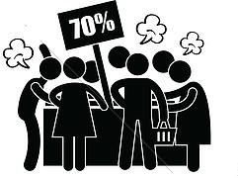
Meeting # 3,671 - Dan Bader, LCPC, LMFT,
was a community psychotherapist for 23 years. He retired
from the Chicago Department of Public Health in 2016
Speaker states that "The presentation will address how unmet needs and mismanaged emotions can lead to the adoption of a hoarding lifestyle. It will discuss how the formation of emotionally-driven decisions and beliefs maintains maladaptive hoarding behavior. Practical interventions and where to obtain assistance will also be covered."

June 25th American Electoral Reform, Open Primaries, Independent Voter’s Rights
Meetings # 3,672 – Jarell Corley
Jarell Corley has been an advocate of Independent Voter’s rights for the past 10 years. He became involved with IndependentVoting.org in 2013. Since his involvement with this organization, he has acted as an advocate spokesperson for American electoral reform. Jarell canvassed his Olympia Field’s neighborhood for signatures in support of Representative John Delaney’s Open our Democracy Act in 2015. Other activities in his efforts include, fundraising, social media management, and grassroots organizing.

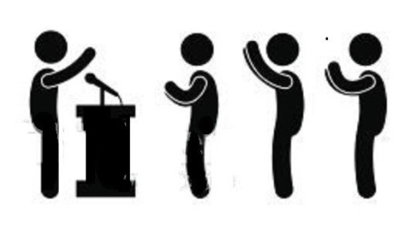
Presently, Jarell serves as a National Spokesperson for Open Primaries, an electoral reform organization headquartered in New York City. Open Primaries is currently building the foundation for a grassroots campaign for electoral reform here in Illinois.

Elections in our country empower a toxic political culture that is superficial and ineffective. Fortunately, the evolution of American Democracy is quietly taking shape. Independents of all beliefs and backgrounds are working for electoral reform, pushing for different initiatives all around the country. Today’s program will revolve around a few organizations playing a pivotal role in reshaping how we vote in this country.

The organization’s covered in today’s presentation include IndependentVoting.org, Open Primaries, and Veteran’s for Political Innovation. Jarell will also briefly touch on other movements fighting to shed light on the idea of electoral reform being an effective solution to solve the issue of America’s deteriorating democracy.

Open Primaries Website
https://www.openprimaries.org

Independent Voting Website
https://independentvoting.org

Jarell’s YouTube Channel on The Independent Voter’s Movement
https://www.youtube.com/channel/UCTIwhRqM3HnD38p1NkjyWwA

July 2nd World UFO Day
75th Anniversary of the Incident at Roswell
Meeting # 3,673 – Charles Paidock et al in progress
World UFO Day is an awareness day for people to gather together and watch the skies for unidentified flying objects (UFO).

The Roswell incident is the 1947 recovery of balloon debris from a ranch in New Mexico by US Army Air Forces officers, and the conspiracy theories, decades later, claiming that the debris was a flying saucer and that the truth had been covered up by the government.

July 9th Open
16, 23, 30 Meetings # 3,674+
If you would like to speak contact the Program Coordinator Charles Paidock at (312) 842-5036, (312) 714-7790 cell, or by email to cpaidock@hotmail.com

Saturdays Presentation at 6:00 PM
To Join the Zoom Meeting
https://us02web.zoom.us/j/81216467150

By phone
1 312 626 6799, 8 121 646 7150# US (Chicago)
Meeting ID: 812 1646 7150

www.collegeofcomplexes.org

facebook: College of Complexes

https://www.facebook.com/collegeofcomplexes

Watch Videos of Previous Presentations (150+)
CoC Lecture Library
http://www.collegeofcomplexes.org/LectureLibrary.html
or go to main page for link

Join our Meetup Group
in order to receive weekly speaker / topic information
https://www.meetup.com/FreeSpeechForum/

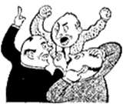
Continue Your Education All Week Long
on our electronic discussion group - to join send a blank e-mail to:
collegeofcomplexes+subscribe@googlegroups.com

