Weekly Free Speech Forum established Jan. 6, 1951

College of Complexes
The Playground for People Who Think
sustaining the academic tradition of “One Fool at a Time”

Every Saturday Main Page
at 6:00 PM www.collegeofcomplexes.org
Facebook
https://www.facebook.com/collegeofcomplexes/
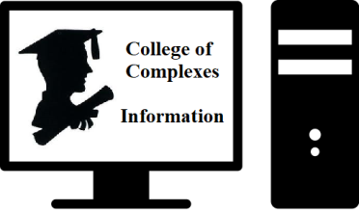

To Join the Zoom Meeting
https://us02web.zoom.us/j/81216467150

Mobile phone
1 312 626 6799, 8 121 646 7150# US (Chicago)
Landline
1 312 626 6799 US (Chicago)
Meeting ID: 812 1646 7150

To Join CoC Google Group for Updates
Send a Blank Email to:
collegeofcomplexes+subscribe@googlegroups.com

Please Note Program Change

August 6th Stop the Steal...of your lives, security, and safety / Candidate for Sheriff of Cook County
Meeting # 3,678 - Brad Sandefur
Endorsed Libertarian candidate for Sheriff of Cook County

Speaker states that “I will discuss the drastic increase in crime in cities that have eliminated drug charges and bail for suspected offenders. I will also discuss the lowering of living standards, the impact on local businesses, how businesses are moving away from liberal Democratic cities due to crime increases, the lowered living standards based on open, public drug use and other crimes, and how the lack of enforcement and abandonment by businesses are removing jobs and resource availability.
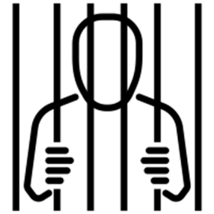
I will also throw in true statistics to disprove the false notions that police are "hunting black people or that Blacks are disproportionally incarcerated. I may also discuss the harm of the new Illinois Safe-T Act, which is anything but safe. I will end by discussing why voters should vote for me than the incumbent or the Republican candidate.”

Website
https://sandefurforsheriff.org/sandefur-for-sheriff
Facebook Page
https://www.facebook.com/SandefurforSheriff

August 13th Unalienable Rights? The Consent of the Governed? Yeah, I don’t know about all that…
Meeting # 3,679 - Brian Dennehy , JD, LL.M
Speaker states that: “It’s been a rough couple of years for the American Constitutional Republic. Lockdowns, vaccine mandates, federal red-flag laws, and other expansive assertions of political authority leave many questioning the direction of the country. Moreover, recent Supreme Court decisions addressing the right of the people to keep and bear arms, the right to legally obtain an abortion, and the scope of federal bureaucratic power have created legal issues and questions that will remain uncertain for the near future.

All the while, politicians drape more problems in the cloak of solutions and decry the need for more money and power to address the same problems that have turned into a crisis since they’ve been regulating them e.g., environment, healthcare, education, poverty, drug addiction, etc.
What are “we the people” supposed to accept with all this mess? Aren’t we supposed to have certain “unalienable” rights or something? What are these guys doing with their “limited and enumerated” powers and our money that they continue to need more power and money? Is choosing between the lesser of two evils supposed to represent “consent” to every stupid policy they come up with? Join political philosopher Brian Dennehy as we discuss these questions and more.”

August 20th A Look at the Green View of Politics in the Platform of the Illinois Green Party
A Guide for All Voters
Meetings # 3,680 - Anna Schiefelbein, Charles Paidock, and other members of the ILGP, GP US
These actions are considered “positive recommendations for progressive change.” The principles and objectives of the party also embraces other forms of political activism, including support for various non-electoral movements.

Platform 10 Key Values
https://www.ilgp.org/platform /

Website
https://www.ilgp.org/
Facebook

https://www.facebook.com/ILGreenParty
Become a Member

https://www.ilgp.org/membership/
Run for Office

https://www.ilgp.org/get-involved/run-green/

August 27th Community Solar
Citizens Utility Board – CUB
Meeting # 3,681 - Kate Shonk, Outreach Coordinator
Help the transition of alternative energy to reduce the use of fossil fuels.
You do not need to have solar panels on your roof with community solar.

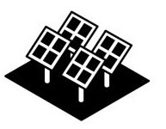
Illinois’ new community solar program allows electricity customers to enjoy the benefits of solar energy without installing panels on their own homes. Solar in the Community is a free resource—brought to you by the nonprofit consumer group Citizens Utility Board (CUB)—to educate consumers about the program and help them assess community solar offers on the market. Note: This resource is about Illinois’ Community Solar program.

For information about rooftop solar, go here.
https://www.citizensutilityboard.org/solar-in-the-community/

Website https://www.citizensutilityboard.org/

Facebook https://www.facebook.com/cubillinois

September 3rd Special Labor Day Speaker
The History of the Factory - how we came to live in a factory made world
Meeting # 3,682 – Charles Paidock, IAMAW, AFL-CIO
Speaker is a graduate of the DePaul University Labor Education Center and the Univ of IL School of Labor and Employment Relations, and a member of UALE, United Assn of Labor Educators.

Speaker states that: “The factory system was a new way of organizing labor made necessary by the development of machines, which were too large to house in a worker’s cottage and much too expensive to be owned by the worker.

Between the 1760s and 1850, the nature of work transitioned from a craft production model to a factory-centric model. Changes continue today with the introduction of robots, and now work-at-home arrangements.
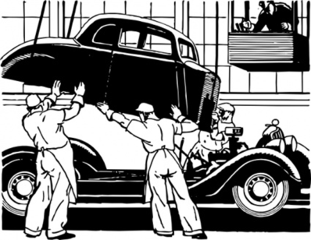
Individuals once worked at their own pace, with their own tools, within their own cottages. Factories set hours of work and the machinery within them shaped the pace of work. The factory system was partly responsible for the rise of urban living, as large numbers of workers migrated into the towns in search of employment in the factories.

The first factory established in the US dates back to 1790 when Samuel Slater came from England and constructed a factory to produce yarn. There were many such textile mills opened. An average factory floor had 200-250 looms, each making 55 yards of cloth per day. The noise was tremendous, with workers communicating by holding up colored signal flags because they couldn’t be heard even if screaming.”

September 10 Open
17, 24 Meetings # 3,683+ contact the program coordinator Charles Paidock if
you would like to speak at (312) 842-5036, (312) 714-7790 cell,
cpaidock@hotmail.com

Saturdays Presentation at 6:00 PM
To Join the Zoom Meeting
https://us02web.zoom.us/j/81216467150

By phone
1 312 626 6799, 8 121 646 7150# US (Chicago)
Meeting ID: 812 1646 7150

www.collegeofcomplexes.org

facebook: College of Complexes

https://www.facebook.com/collegeofcomplexes

Watch Videos of Previous Presentations (150+)
CoC Lecture Library
http://www.collegeofcomplexes.org/LectureLibrary.html
or go to main page for link

Join our Meetup Group
in order to receive weekly speaker / topic information
https://www.meetup.com/FreeSpeechForum/

Continue Your Education All Week Long
on our electronic discussion group - to join send a blank e-mail to:
collegeofcomplexes+subscribe@googlegroups.com

