Weekly Free Speech Forum established Jan. 6, 1951

College of Complexes
The Playground for People Who Think
sustaining the academic tradition of “One Fool at a Time”

Every Saturday Main Page
at 6:00 PM www.collegeofcomplexes.org
Facebook
https://www.facebook.com/collegeofcomplexes/
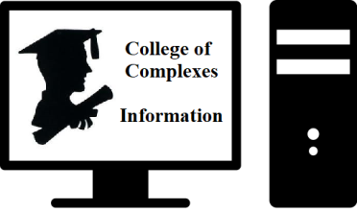

To Join the Zoom Meeting
https://us02web.zoom.us/j/81216467150

Mobile phone
1 312 626 6799, 8 121 646 7150# US (Chicago)
Landline
1 312 626 6799 US (Chicago)
Meeting ID: 812 1646 7150

To Join CoC Google Group for Updates
Send a Blank Email to:
collegeofcomplexes+subscribe@googlegroups.com

October 1st Joe Miller, Campaign Announcement
Independent Candidate for Mayor of Chicago
Meeting # 3,686 -
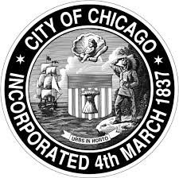
Speaker states that: “I'm a born and raised Southsider from the Gage Park neighborhood. Public school educated (Nightingale Elementary & Hubbard High School) and joined a union carpenter's apprenticeship program after high school. My career as a carpenter was short-lived due to the tragic events of Sept. 11, 2001, the next month I enlisted with the USAF, and left for basic training in January of 2002. Roughly eight years on active duty, deploying twice and volunteering locally (e.g. Hurricane Katrina). But my last tour of duty is where my passion for politics grew.

My last tour was in Chicago Heights, IL as a USAF recruiter, and witnessed the impact of unequal school funding within the state. After my recruiting tour, I began my academic journey by studying at Prairie State College and then moving to UIC. While at UIC I met former council member and instructor Dick Simpson. It was then that I learned about Chicago's true political history, Daley vs. Despres,etc. During the teacher's strike of 2012, I marched with CTU and CORE while interning with former Alderman Bob Fioretti. After the teachers won, I took a short break and began organizing locally.
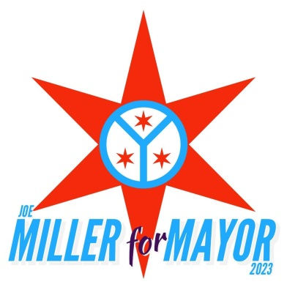
While living in Pilsen, I organized with Friends of the Chicago River and the 25th Ward IPO (Independent Political Organizations). During the 2016 presidential elections, while volunteering with the Bernie campaign, I witnessed the impact independents had on elections and was inspired. We then began organizing other IPO's and created the 14th Ward IPO. Roughly around that time, Standing Rock began to boil, and a few Veterans along with myself mobilized the "Veterans for Standing Rock" protests.

When I returned home from Standing Rock, I reflected and wanted to finish out my degrees. Currently, I'm five courses from completing a Bachelor of Arts in Public Policy (with a focus on housing and economic redevelopment) and a Master of Public Administration from UIC's CUPPA. But when Mayor Lightfoot raised the bridges during the George Floyd protests is when I decided it was time to run for mayor.

Despite the contrary and unfortunately popular belief, Chicago is not lost but it's on the wrong path. The power struggle we see in the city council today is partly due to the structure that former mayor Richard J. Daley created and that impedes our city's greatness. Climate change, along with climate migration will impact Chicago in unprecedented ways. The fight over who's going to be the next Daley has to come to an end and reform can only come from an independent mayor.”

October 8th Voting on the Workers’ Rights Amendment
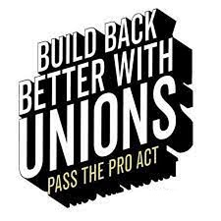
to update the Illinois constitution
Meetings # 3,687 - Frances Orenic, Coalition Director, Vote Yes for Workers' Rights
“This November, workers are on the ballot to guarantee every Illinoisan has the right to join together with other workers to negotiate for better pay, improved benefits, and safe working conditions.”

The proposed amendment would add a new section to the Bill of Rights Article of the Illinois Constitution that would guarantee workers the fundamental right to organize and to bargain collectively and to negotiate wages, hours, and working conditions, and to promote their economic welfare and safety at work. It would also prohibit from being passed any law that interferes with, negates, or diminishes the right of employees to organize and bargain collectively over their wages, hours, and other terms and conditions of employment and workplace safety. At the general election to be held on November 8, 2022, you will be called upon to decide whether the proposed amendment should become part of the Illinois Constitution.
Get involved: https://workersrights.com/

October 15th Representative Theresa Mah (D)
2nd District, Chicago
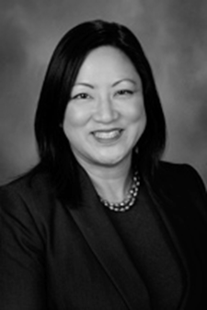
Illinois General Assembly
Meeting # 3,688 -
Committee assignments: Health Care Licenses (Chairperson); Approp-Elementary & Secondary Educ; Immigration & Human Rights Committe; Housing Committee; International Trade & Commerce; Museums, Arts, & Cultural Enhanceme; Tourism Committee; Redistricting Committee; Financial Impact Subcommittee

Biography: Former college professor; Ph.D, University of Chicago; community organizer and policy advocate; local school council member; policy advisor to Governor Pat Quinn; served on the Illinois Advisory Council on Bilingual Education and board of directors for Common Cause Illinois; worked closely with the Asian American Employment Plan Advisory Council and the Language Access Task Force for the State of Illinois; a daughter of immigrant parents, Mah is the first Asian American to serve in the Illinois House of Representatives.

Oct 22nd How to Be an Informed Voter
presentation by the
Independent Voters of Illinois, IVI
Meeting # 3,689 – Jim Garfield, State Chair et al
A look at the organization and operations of the Independent Voters of Illinois, IVI, “Your Source for Good Government since 1945,” and then a review of who will be on the ballot you will be given at the polling place on election day

Oct 29th Open
Meetings # 3,690 - contact the program coordinator Charles Paidock if
you would like to speak at (312) 842-5036, (312) 714-7790 cell,
cpaidock@hotmail.com

Saturdays Presentation at 6:00 PM
To Join the Zoom Meeting
https://us02web.zoom.us/j/81216467150

By phone
1 312 626 6799, 8 121 646 7150# US (Chicago)
Meeting ID: 812 1646 7150

www.collegeofcomplexes.org

facebook: College of Complexes

https://www.facebook.com/collegeofcomplexes

Watch Videos of Previous Presentations (150+)
CoC Lecture Library
http://www.collegeofcomplexes.org/LectureLibrary.html
or go to main page for link

Join our Meetup Group
in order to receive weekly speaker / topic information
https://www.meetup.com/FreeSpeechForum/

Continue Your Education All Week Long
on our electronic discussion group - to join send a blank e-mail to:
collegeofcomplexes+subscribe@googlegroups.com

