Program Open to All Who Wish to Speak on the topic of:
Three Things This Country Needs to Do
Saturday July 11th 6:00 PM
Meeting # 3,333
The College of Complexes was established as a weekly free speech forum on January 6, 1951, to solve all the world’s problems, and has been meeting continuously since then. All programs are numbered, for absolutely no practical purpose that anyone can remember.

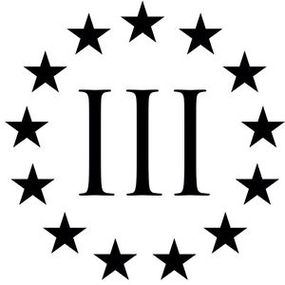

According to Pythagoras the number 3, which they called triad, is the noblest of all digits, as it is the only number to equal the sum of all the terms below it.

College of Complexes
The Playground for People Who Think
Saturday Presentation at 6:00 PM
Please Note: New Location + Starting Time
$3 Tuition, dinner optional
Hilltop Restaurant 6-9:00 PM
2800 West Foster Ave / at California
Free Parking, #92 Foster CTA bus from Jeff Park Blue Line, Berwyn Red Line L Stations
www.collegeofcomplexes.org

