Weekly Free Speech Forum established Jan. 6, 1951

College of Complexes
The Playground for People Who Think
sustaining the academic tradition of “One Fool at a Time”

Every Saturday Main Page
at 6:00 PM www.collegeofcomplexes.org
Facebook
https://www.facebook.com/collegeofcomplexes/

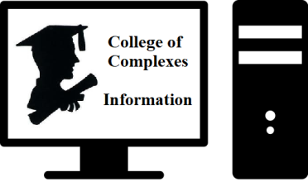
To Join the Zoom Meeting
https://us02web.zoom.us/j/81216467150

Mobile phone
1 312 626 6799, 8 121 646 7150# US (Chicago)
Landline
1 312 626 6799 US (Chicago)
Meeting ID: 812 1646 7150

To Join CoC Google Group for Updates
Send a Blank Email to:
collegeofcomplexes+subscribe@googlegroups.com

1st meeting of the CoC was on January 6, 1951

January 15th Dank Libertarian Meme Stash
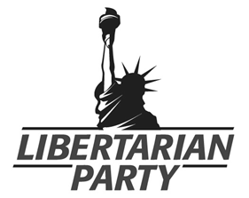
Meetings # 3,649 - Justin Tucker, Executive Director of the Libertarian Party of Illinois,
rings in the New Year with a slideshow of the dankest libertarian-themed memes shared on social media. He will demonstrate how humor is a fun way to spread the message of liberty and show appreciation for dank memes as an art form. From thoughtful quotes to Leonardo DiCaprio, these dank memes will provoke thoughts and laughs. There will also be an update on the Libertarian Party of Illinois as we enter the 2022 election cycle. Trigger Warning: excessive dank. Rated PG-13.

https://lpillinois.org/ LP of Illinois
https://www.facebook.com/groups/ChicagoLP/posts/3008396199400699/
LP of Chicago

About the Libertarian Party:
We, the members of the Libertarian Party, challenge the cult of the omnipotent state and defend the rights of the individual.

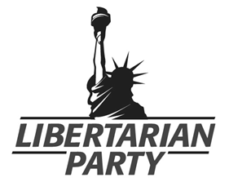
We hold that all individuals have the right to exercise sole dominion over their own lives, and have the right to live in whatever manner they choose, so long as they do not forcibly interfere with the equal right of others to live in whatever manner they choose.

Governments throughout history have regularly operated on the opposite principle, that the State has the right to dispose of the lives of individuals and the fruits of their labor. Even within the United States, all political parties other than our own grant to government the right to regulate the lives of individuals and seize the fruits of their labor without their consent.

January 22nd The Fleecing of America
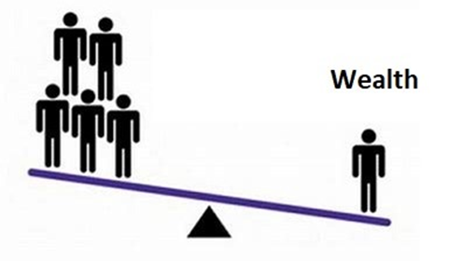
Meeting # 3,650 - Dr, John Beesley
Dr, John Beesley, English born Author, retired after a long career with Xerox, (Educated at London's Imperial College and the University of Dallas, BSc, DIC, MBA, Ph.D.), will discuss how over the past four decades the quality of life for most Americans has slowly, but surely, been degraded. The severity of current social ills has been blamed on character defects, with which the poorest are said to be uniquely endowed. He argues that the reality is that American institutions, along with their attendant myths, have been constructed to bring this about. The US Congress, under the ownership of the money class, has been willingly complicit. John will make a vigorous attempt to bring together the various socio-economic factors that have caused the "Fleecing of America".

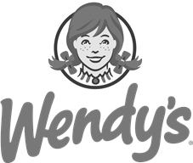
Jan 29th Coalition of Immokalee Workers (CIW)
The Fair Food Program, Anti-Slavery Campaign, Boycott Wendy’s
Meetings # 3,651
​The Coalition of Immokalee Workers (CIW) is a worker-based human rights organization internationally recognized for its achievements in fighting human trafficking and gender-based violence at work. The CIW is also

recognized for pioneering the design and development of the Worker-driven Social Responsibility paradigm, a worker-led, market-enforced approach to the protection of human rights in corporate supply chains.
​
Built on a foundation of farmworker community organizing starting in 1993, and reinforced with the creation of a national consumer network since 2000, CIW’s work has steadily grown over more than twenty years to encompass broad and overlapping spheres. https://ciw-online.org/

February 5th The Surrender of Democracy
Meeting # 3,652
The Surrender of Democracy
Kenneth Williams, President, Dallas, Texas Alliance for Retired Americans, and Democratic Activist, will discuss the Question: "Should Democrats be doing more to save democracy from the anti-democratic movement that has taken over the Republican party?" He concludes that they should, and offers directions as to what we can do to combat this situation.

Feb 12th Illinois Green Party
Township Citizens Initiatives on the Ballot
Chicago Petition for Climate Action
Meeting # 3,653 - Anna Schiefelbein https://www.ilgp.org/april2022 /
Illinois law requires that townships hold at least one public meeting per year, on the second Tuesday in April. (April 12 in 2022.) At these meetings, members of the public have the same voting power as the township committee members. At this meeting, a majority vote of those in attendance can put a question on the ballot for the next election. The exception to this is Chicago, which will meet the following day, April 13, 2022 at 10am to bring City Council a climate action petition to set a zero-emissions date of 1/1/30.
​
The bar for getting a ballot initiative put on a Regular or Special Township Meeting agenda is very low, at 15 signatures from residents of the township/ward.

Feb 19th The US War on Venezuela
Meeting # 3,654 - Stansfield Smith returns with another detailed analysis of foreign affairs
(program description in progress)

February 26th Autonorama: The Illusory Promise of High-Tech Driving and Technofuturistic Driving Utopias
Meetings # 3,655 - Peter Norton, Assoc Prof, University of Virginia, technology historian
“The foundation has been laid for fully autonomous,” Elon Musk announced in 2016, when he assured the world that Tesla would have a driverless fleet on the road in 2017. “It’s twice as safe as a human, maybe better.” Promises of technofuturistic driving utopias have been ubiquitous wherever tech companies and carmakers meet.

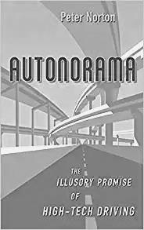
In Autonorama: The Illusory Promise of High-Tech Driving, technology historian Peter Norton argues that driverless cars cannot be the safe, sustainable, and inclusive “mobility solutions” that tech companies and automakers are promising us. The salesmanship behind the driverless future is distracting us from investing in better ways to get around that we can implement now. Unlike autonomous vehicles, these alternatives are inexpensive, safe, sustainable, and inclusive.

Norton takes the reader on an engaging ride —from the GM Futurama exhibit to “smart” highways and vehicles—to show how we are once again being sold car dependency in the guise of mobility. He argues that we cannot see what tech companies are selling us except in the light of history. With driverless cars, we’re promised that new technology will solve the problems that car dependency gave us—zero crashes! zero emissions! zero congestion! But these are the same promises that have kept us on a treadmill of car dependency for 80 years.

Autonorama is hopeful, advocating for wise, proven, humane mobility that we can invest in now, without waiting for technology that is forever just out of reach. Before intelligent systems, data, and technology can serve us, Norton suggests, we need wisdom. Rachel Carson warned us that when we seek technological solutions instead of ecological balance, we can make our problems worse. With this wisdom, Norton contends, we can meet our mobility needs with what we have right now.

March 5th Food and Water:
Will Laws Save Food and Water
or Will Local Farmers and Citizens?
Meeting # 3,656 - Dan Weinberg, seasoned college regular, gardener, and librarian, asks:
“Why pay $2.59/lb for apples when you can pay $.99/lb? Are co-ops and farmer's markets worth the extra price you pay? Yes. Is Organic worth more to the Earth and to the eater? Yes. Is Organic really helpful to the climate? Yes. Can I afford $2.59/lb for apples? Yes. Can the Earth afford Organic? Yes.
"It's not all about the money. What is carbon sequestration? What do food and war have in common? How can keeping the soil healthy allow people to grow real food? How much corn is used by humans? Where are the food markets-NYC, CME, ADM, Cargill, Buge, Nestle, Coke, Pepsi, or farms? Is high fructose corn syrup (HFCS) nutritious? How did great civilizations end in the past? Can the soil absorb all the carbon dioxide in the air? Are GMOs good for nutrition? I will answer these and other questions in the talk."

https://www.youtube.com/watch?v=zC0jw4zefnQ
Detroit Dirt will be great for your garden.

https://www.youtube.com/watch?v=qRJ0y9LMhI4
No-till farming is becoming more popular in the
USA all the time.

https://www.youtube.com/watch?v=nvAoZ14cP7Q&t=73s
The story of carbon around the Earth is the theme of this video.

https://www.youtube.com/watch?v=K3-V1j-zMZw
This is a good movie about soils and carbon.

https://tomatomountain.csaware.com/tomato-mountain-farm-share-C16666
Tomato Mountain farm boxes are full of good
organic foods for a good price.

March 12th The US War on Nicaragua
Meeting # 3,657 - Stansfield Smith returns with another detailed analysis of foreign affairs
(program description in progress)

March 19th My Whirlwind Lives
Navigating Decades of Storms
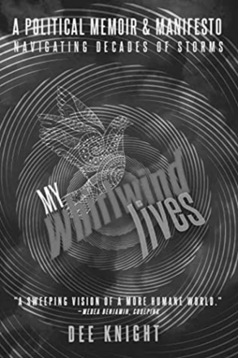
A Political Memoir & Manifesto by Dee Knight
Meeting # 3,658 - https://www.goodreads.com/book/show/59205031-my-whirlwind-lives
Author states: "My Whirlwind Lives" is a response to current stormy events and trends that are changing history. But it’s a special response, looking not just at recent experiences, but viewing them through a prism of five decades of resistance and real protest. The book “takes us through decades of turmoil in the U.S. and overseas, and decades of movement building against war, injustice and destruction of the planet,” says Medea Benjamin of CodePink. It tells a story of witnessing and supporting revolutions in Portugal and Nicaragua, and building a socialist movement at home. As Gerry Condon of Veterans For Peace said, the story “shares much with that of thousands of young people whose lives and world views changed when they were pushed to participate in unjust U.S. wars.
Some people have experienced a whirlwind in their lives. My life has been a series of whirlwinds.” Website: https://deeknight.blog/my-whirlwind-lives/

March 26th Beyond a Black and White Worldview:
Entering a World of Yin-Yang Dynamism
Meeting # 3,659 - Jian Li, PhD in anthropology and a Mandarin teacher, will explore the limitations of a “Black and White” worldview and introduce different ways of thinking based on the Chinese philosophy and insights from “superforecasting” developed by Philip E. Tetlock . In a world where many people feel a sense of righteous anger against those who think differently, she suggests that we should seek “understanding before making judgements, collaboration over confrontation, and compassion over self righteousness”.

April 2, 23 Open (seeking Special Earth Day Speakers)
Meeting # 3,660, 63
If you would like to speak contact the Program Coordinator Charles Paidock at (312) 842-5036, (312) 714-7790 cell, or by email to cpaidock@hotmail.com

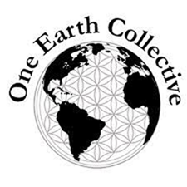
April 9th One Earth Collective
https://oneearthcollective.org/ or https://www.facebook.com/OneEarthCollective
Upcoming Earth Week Mini Film Festival in partnership with the City of Chicago (Apr 18-24, 2022)
Meeting # 3,661
One Earth Collective harnesses the power of people through vibrant environmental programming that inspires action, facilitates learning, and fosters inclusion to create safer communities and a healthier planet.

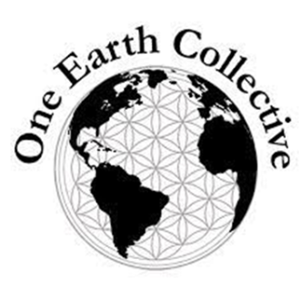
Through our three program areas: One Earth Film Festival, One Earth Local and One Earth Youth Voices, we engage more than 7,000 people annually in activities that spur creativity. After encounters with One Earth, people of all ages are encouraged to see the possibilities and adopt solution-oriented mindsets, and share their learnings and ideas with others.

Since 2010, One Earth Collective has built environmental awareness and inspired action in the Chicago area as well as nationally, with an emphasis on developing youth leadership.

Our grass-roots, community-based work is centered at the intersection of the environment and social justice. We invite people into our work through the power of art, nature, activism and community.

April 16th "Green Hydrogen" - What Is It and What Role Might it Play in Helping the World Get to a Net-Zero Carbon Economy
Meeting # 3,662 - Allan Lindrup
Presenter is an activist with the Unitarian Universalists for Social Justice Environmental Task Force, and a member of numerous environmental organizations.

April 30th Proof there is a Primitive Species Living in the Forests of the US, and The Need to Preserve / Restore Their Habitat
National Arbor Day is April 29, 2022 https://www.arborday.org/celebrate/
Meeting # 3,664 – Charles Paidock, Secretary, Chicago Greens, will speak on “cryptozoology” and the why the lumber industry, land conversion, and urban sprawl should be stopped.

Saturdays Presentation at 6:00 PM
To Join the Zoom Meeting
https://us02web.zoom.us/j/81216467150

By phone
1 312 626 6799, 8 121 646 7150# US (Chicago)
Meeting ID: 812 1646 7150

www.collegeofcomplexes.org

facebook: College of Complexes

https://www.facebook.com/collegeofcomplexes

Watch Videos of Previous Presentations (150+)
CoC Lecture Library
http://www.collegeofcomplexes.org/LectureLibrary.html
or go to main page for link

Join our Meetup Group
in order to receive weekly speaker / topic information
https://www.meetup.com/FreeSpeechForum/

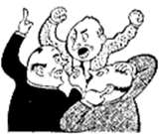
Continue Your Education All Week Long
on our electronic discussion group - to join send a blank e-mail to:
collegeofcomplexes+subscribe@googlegroups.com

