Weekly Free Speech Forum established Jan. 6, 1951

College of Complexes
The Playground for People Who Think
sustaining the academic tradition of “One Fool at a Time”

​

Every Saturday Main Page
at 6:00 PM www.collegeofcomplexes.org
Facebook
https://www.facebook.com/collegeofcomplexes/

To Join the Zoom Meeting
https://us02web.zoom.us/j/81216467150
Passcode: 094136

Mobile phone
1 312 626 6799, 8 121 646 7150# US (Chicago)
Landline
1 312 626 6799 US (Chicago)
Meeting ID: 812 1646 7150

October 17th IVI Independent Voters of Illinois
Meetings #3,586 - Josef Michael Carr, State Chair
an overview of the candidate endorsement process tp produce a voter's guide
The IVI–IPO is a not-for-profit, multi-partisan, independent political organization. Our endorsements reach hundreds of thousands of voters throughout the greater Chicagoland area. Our work on campaign finance and ethics reform in the past and in the present has gotten high marks from all quarters and our commitment to good government is as strong now as it has ever been.

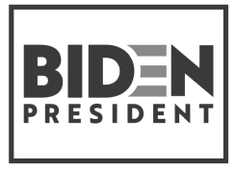
October 24th Why Abolishing the Electoral College Would Not Help the Democrats
Meetings #3,587 - author David Ramsay Steele returns with another political essay / analysis
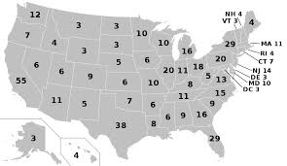
David Ramsay Steele, Ph.D., is the author of The Mystery of Fascism: David Ramsay Steele’s Greatest Hits (2019), Orwell Your Orwell (2017), Atheism Explained (2008), and From Marx to Mises (1992). He is co-author (with Michael R. Edelstein, Ph.D.) of Therapy Breakthrough (2013) and Three Minute Therapy (1997). Dr. Steele has written numerous articles and given many talks on diverse topics.
Program description:
The outcome of the 2016 election led many Democrats to believe that Hillary Clinton lost because of the Electoral College system. But is it true that abolishing the Electoral College would help the Democrats?
Clinton got more popular votes than Trump, but neither won a majority. Any national popular vote system that might replace the Electoral College would provide for a run-off, and in 2016 Trump might easily have won a run-off.
More fundamentally, the total popular vote, in a situation where the total popular vote counts for absolutely nothing, is not a good measure of how people feel about the candidates. People would not vote the same way in a popular vote system as they vote under the present system. Under the Electoral College system, Republicans in high-population states viewed as safely Democratic (California, New York, Illinois) face a reduced incentive to turn out and vote.
Dr. Steele argues that whoever wins the Electoral College would have won the popular vote under a popular vote system.

Oct 31st Debate: For and Against the Illinois Fair Tax Amendment
Meetings #3,588 - ​ Ernest Norrman for / Brian Dennehy against

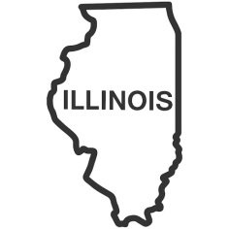
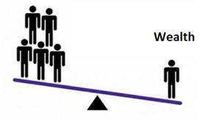
Ernie Norman says: “I am very interested, and reasonably well informed on this issue. I have been attending lectures and reading, and phone banking and participating in other supportive activities for various organizations, including Jane Addams Seniors in Action. Having practiced as a tax accountant for several years, I have first hand knowledge of how tax laws actually effect different types of returns.”

Brian Dennehy is an attorney and accountant, and a candidate for Cook County State's Attorney by the Libertarian Party.
He states that: “As an attorney and accountant working in the tax field, I’ve read hundreds if not thousands of statutes, cases, regulations, and commentaries on complex issues impacting my clients."

November 7th Sugar: Good for What?
Meetings #3,589 - ​college regular Dan Weinberg returns with another well-researched presentation
Speaker states that: ​​All these questions and more I will try to answer in my talk...
Will Trump or Biden do anything about sugar?
Do fruits and vegetables cure diabetes?
Why do 26.8% of people aged 65+ in the USA have diabetes?
Why does Dr. Robert Lustig call sugar a "toxic substance"?
Does sugar do the same thing to the brain that
heroin and alcohol do?

Nov 14th Election Re-Cap / Summary and Analysis Open Microphone
Meeting #3,590 - Charles Paidock presents a summary of election results nationwide, followed by an open microphone for anyone to comment

Nov 21st Slaughter Free Cities, Slaughter Free
Chicago Campaign
Meeting #3,591 - Robert Grillo, Founder
“The Chicago Union Stockyards has been memorialized in the historical record of our city as the hallmark of the industrial revolution. This resulted in a few families like Armour and Swift making immense fortunes on the backs of countless workers and animals subjected to horrific conditions, as depicted in Upton Sinclair’s famous novel The Jungle. We envision our campaign as the evolution of Sinclair’s legacy and its logical conclusion.
Our 12-point case shows how closing slaughterhouses will present solutions to many of our city’s most urgent problems.”

November 28th November is National American Indian Heritage Month
An Intro to the History and Heritage of the North American Indian
An eclectic collection of fascinating facts, everyone should know, for understanding the culture and lifestyle of the indigenous people of the United States
Meeting #3,592 – powerpoint by Charles Paidock
Dec 5, 12, 19,26 Open
Meeting # 3,593+ contact the Program Coordinator Charles Paidock if you would like to speak at (312) 842-5036, (312) 714-7790 cell, or by email to cpaidock@hotmail.com

Saturdays Presentation at 6:00 PM
To Join the Zoom Meeting Passcode: 094136
https://us02web.zoom.us/j/81216467150

Mobile phone
1 312 626 6799, 8 121 646 7150# US (Chicago)
Landline
1 312 626 6799 US (Chicago)
Meeting ID: 812 1646 7150

www.collegeofcomplexes.org

facebook: College of Complexes

https://www.facebook.com/collegeofcomplexes/

Watch Videos of Previous Presentations (150+)
CofC Lecture Library
http://www.collegeofcomplexes.org/LectureLibrary.html
or go to main page for link

Join our Meetup Group
in order to receive weekly speaker / topic information
https://www.meetup.com/FreeSpeechForum/

Continue Your Education All Week Long
on our electronic discussion group - to join send a blank e-mail to:
collegeofcomplexes-subscribe@yahoogroups.com

