SAFE HAVEN
-- BREAKING THE CYCLES

Towards a Gang-Free, Drug-Free, Full-Employment Economy in America by 2020.

Kimball Ladien, MD

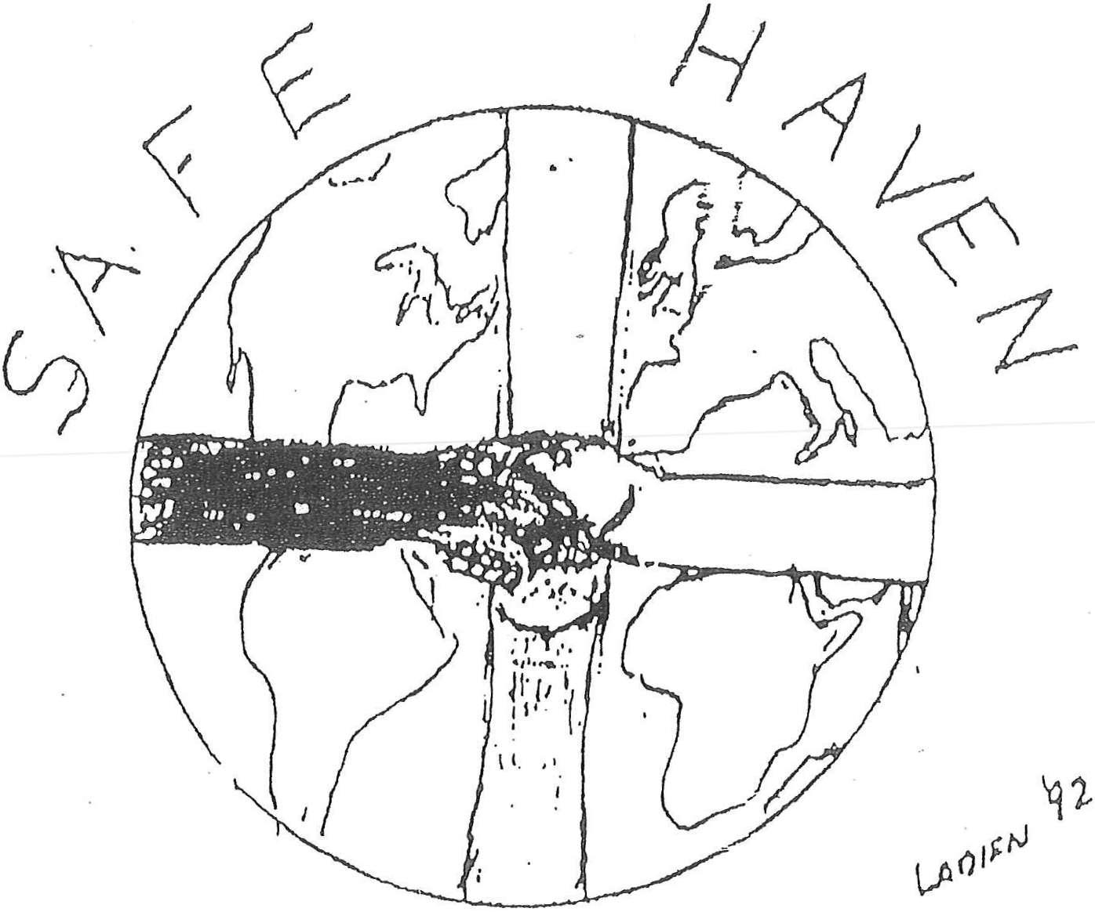

Dedication

To my parents, Julia and Edward--for values lived
To the American People--for values rediscovered

"If within the next decade we can again walk down any street anywhere in America at any time of the day or night and both feel and actually be safe, then we are starting to do our job. If we can go into any home and find love and caring; if we can go into any school and see learning and growing; if we can go into any workplace: and find productive and drug-free employees, if we can reach out into any neighborhood and find a sense of pride and co moment to the Community, then indeed a new millennium will have been reached. This is our goal. This is our dream. It is one I hope to share: with you all. Working alone we can accomplish little. But working together we can change the World. As we read history and set the agenda, we have only three years to go and not a second to lose."

--Kimball Ladien, MD

Table of Contents
Preface: Safe Haven— 25 Years Later-- A Penny of Prevention is STILL Worth a Dollar of Cure.
Preface-The Original Goals—‘Thinking About Tomorrow”
- Introduction

- The Welfare Cycle—Its Evolution and Perpetuation
2.1 Learned Helplessness: Origins and Treatment
2.1.1—Case 1. Tammy B.
2.1.2—Dr. Seligman’s Dogs
2.1.3—Cycles of Risk
2.1.4—Cycles of Addiction
2.1.5—Case 2. James T.

2.2 The Welfare Trap
2.2.1—Case 3. Luella T.

2.3 Social Dogmas and Conceptual Revolutions

2.4 The Value of EMPOWERMENT—On Freedom’s Road
2.4.1—Values
2.4.2—Freedom Quotient
2.4.3—Case Analysis—Cycles of Despair

2.4.3.1—Case 1. Tammy B.
2.4.3.2—Case 2. James T.
2.4.3.3—Case 4. Mary T.
2.4.3.4—Case 3. Luella T.
2.4.3.5—Case 5. Betty B.

3. Safe Haven—Breaking the Cycles
3.1 Multi-Systems Analysis (MSA)—Taking the Overview

3.1.1 Introduction
3.1.2 Multi-Systems Analysis (MSA)—The Win-Win Option

3.1.2.1—MSA—Background
3.1.2.2—Case 6. Peter B.
3.1.2.3—MSA—Steps in the Process

3.1.3 Safe Haven: One-Stop Case Management

3.2—Work—The Full Employment Option

3.2.1 Background
3.2.2 Community Service Corps (CSC)
3.2.3 Public Jobs
3.2.4 Private Jobs

3.2.4.1 Tax Credits
3.2.4.2 Free-Enterprise Zones
3.2.4.3 Adopt-a-Community
3.2.4.4 Work Apprenticeships
3.2.4.5 Continuing Education
3.2.4.6 Full-Employment Economy

3.2.5 Global Competition and World Economies
3.2.6 Towards a Global Safe Haven

3.3 Education
3.3.1 Background
3.3.2 High-Quality Day Care

3.3.2.1 Pre-Head Start/Advance
3.3.2.2 Pre-Head Start/Head Start
3.3.2.3—Schools of the Twenty-first Century Program
3.3.2.4—Safe Haven-Day Care

3.3.3 Expanded School Programs
3.3.3.1—Interdisciplinary Teams and Parental Involvement
3.3.3.2—Safe, Positive Before- and After-School Programs
3.3.3.3—At Risk Support Groups

3.3.4 Post-Secondary Educational Options
3.3.4.1—Apprenticeships/On-the-Job Training
3.3.4.2—Formal Continuing Education and the NCSC
3.3.4.3—Business-Academic Partnerships
3.3.4.4—Life Skills: Personal Development and Empowerment
3.3.4.5—The Democratization of Problem Solving

3.4 Social Services

3.4.1 Community-Based Self-Help Programs
3.4.1.1 Background: One-Stop Case Management
3.4.1.2 After-School Programs
3.4.1.3 Community Service Corps Support Groups

3.4.2 Child Protective Services—A Penny of Prevention
3.4.2.1 Levels of Intervention
3.4.2.2 CSC Support Groups/Home Visits

3.4.3 Community Mental Health

3.4.3.1 Levels of Intervention
3.4.3.2 Dry Shelters and Representative Payees
3.4.3.3 Mandatory Drug Testing
3.4.3.4 CSC Special Needs Programs

3.4.4 Family Support Systems
3.4.4.1 Effective Family Problem Solving: The Win-Win Contract
3.4.4.2 CSC and Family Empowerment
3.4.4.3 From Enablement to Empowerment—Breaking the Cycles

3.4.5 Civil Liberties Vs Civil Anarchy
3.4.5.1 Developmental Model of Values
3.4.5.2 Social Contracts

3.5 Criminal Justice
3.5.1 Background
3.5.2 Probation/Parole/Work Release/Community Service Corps
3.5.3 Creative Sentencing
3.5.4 Windows of Change

3.6 Health Policy—The Wellness of a Nation
3.6.1 Overview
3.6.2 Managed Care—Making Choices
3.6.3 AIDS: Rights vs. Responsibilities—A Cautionary Tale
3.6.4 Empowerment: From Disability to Capability
3.6.5 CSC-Home Health Care (HHC)
3.6.6 EEAP: Enhanced Employee Assistance = Productivity

3.7 Case Analysis—Profiles of Success

3.7.1 MSA: Profiles of Success
3.7.2 Case 1. Tammy B.
3.7.3 Case 2. James T.
3.7.4 Case 3. Luella T.
    - Case 4. Mary T.
3.7.6 Case 5. Betty B.
3.7.7 Case 6. Peter B.
3.7.8 Summary Review

4. The Politics of Change: Designing the Future

4.1 MSA—Levels of Change
4.1.1 Case 9. Rolling Over Beethoven: Broken Dreams
4.1.2 Feedback and Accountability
4.1.2.1 Case 10. Tunnel Vision: The Chicago Flood
4.1.2.2 Bureaucracies and Democracies: Series and Parallel Systems
4.1.2.3 Vex Popular—The Dynamics of Dialog
4.1.2.4 Of Ensembles and Assemblies, Catalysts and Revolutions

4.1.3 Win-Win Systems
4.1.3.1 Individuals and Families
4.1.3.2 Safe Haven Resident Management Corporations
4.1.3.3 Prevention-Oriented Incentive-Plans (Preps)
4.1.3.4 Science—Universal. Win-Win Problem Solving
4.1.3.5 Medical Models and Clinical Trials

4.2 Safe Haven—Trials and Tribulations
4.2.1 Case 11. Safe Haven-Chicago Futures (Cycle 1)
4.2.2 Case 12. Safe Haven-Illinois: Circuit Testing the System
4.2.3 Case 13. SH-CF: Something Ventured. Something Lost.
4.2.4 Safe Haven-Illinois: Post-Mortem Blues
4.2.5 Earnfare- I: Glimmers of Vision
4.2.6 Earnfare- II: Promises Made, Promises (As Yet) Unkempt

4.3 National Agendas
4.3.1 United We Stand
4.3.2 Setting Goals. Planning Strategies
4.3.3 Tracking and Accountability: Writing the Wrongs
4.4.4 To the Mountaintop and Beyond

4.5 Global Imperatives—To the Mountaintop and Beyond
4.5.1 Safe Haven- II: Global Goals and Strategies
4.5.2 Waging Peace
4.5.3 Thinking About Tomorrow

5. Conclusions
Footnotes

Appendix A: Safe Haven-Illinois Letters of Support
Appendix B: Tokens of Esteem
--“La Plant” Award (Suitable for Hanging)
--Safe Haven Good Citizenship Award

Table of Contents—Figures
2.1.1 Learned Helplessness—Seligman’s Dogs
2.2.1 Welfare Cycle—Points of Intervention
2.2.2 The Welfare Trap: Barriers to Work
2.4.1 Freedom Quotients (FQ)
2.4.2 Freedom Quotient Graph and Profiles
2.4.3 Freedom Quotient—Tammy B.
2.4.4 Freedom Quotient Profile—Tammy B.
2.4.5 Freedom Quotient—James T.
2.4.6 Freedom Quotient Profile—James T.
2.4.7 Freedom Quotient—Mary T.
2.4.8 Freedom Quotient Profile—Mary T.
2.4.9 Freedom Quotient—Luella T.
2.4.10 Freedom Quotient Profile—Luella T.
2.4.11 Freedom Quotient—Betty B.
2.4.12 Freedom Quotient Profile—Betty B.
2.4.13 Family Tree: Tammy, Betty, and Peter Barnes
2.4.14 Family Tree: James, Mary, and Luella Tucker

3.1.1 Multi-Systems Analysis (MSA)—Individualized Goals Profile
3.1.2 Multi-Systems Analysis (MSA)—Decision Flow Chart
3.1.3 One-Stop Case Management
3.1.4 Individualized Goals Profile (IGP)
3.2.1 Community Service Corps (CSC)—Work Continuum
3.2.2 CSC Community Policing/Resident Patrols Organization Chart
3.4.1 Cycles of Poverty—Points of Intervention
3.4.2 Developmental Internalization of Positive Values
3.4.3 Mental Health—Levels of Intervention
3.5.1 Criminal Justice—Levels of Intervention
3.7.1 Case 1. Tammy B. IGP Graph
3.7.2 Case 1. Tammy B. Partial IGP Work-Up Sheet
3.7.3 Case 2. James T. IGP Graph
3.7.4 Case 2. James T. Partial IGP Work-Up Sheet
3.7.5 Case 3. Luella T. IGP Graph
3.7.6 Case 3. Luella T. Partial IGP Work-Up Sheet
3.7.7 Case 4. Mary T. IGP Graph
3.7.8 Case 4. Mary T. Partial IGP Work-Up Sheet
3.7.9 Case 5. Betty B. IGP Graph
3.7.10 Case 5. Betty B. Partial IGP Work-Up Sheet
3.7.11 Case 6. Peter B. IGP Graph
3.7.12 Case 6. Peter B. Partial IGP Work-Up Sheet
3.8.1 Levels of Change
3.8.2 Safe Haven-Illinois Organizational Chart
3.8.3 Safe Haven-America Organizational Chart
3.8.4 National Goals Profile (NGP)
3.8.5 Global Federations for Change
3.8.6 Global Goals Profile (GGP)

4.1.1 Levels of Change
4.1.2 Series-Parallel Systems Design
4.1.3 Series-Parallel Multi-Systems Design
4.1.4 State Changes and Hysteresis
4.1.5 Goals/Strategies List—Tammy B.
4.1.6 Problems/Solution List—Baker Family
4.1.7 Baker Family Contract
4.1.8 Truth: “Connecting the Dots”
4.2.1 Safe Haven Organizational Chart
4.2.2 “La Plant” Award
4.2.4 Tunnel Vision
4.2.5 Staying the Course
4.2.6 Preparing for the Crunch: Staying the Course- II
4.2.7 Safe Haven Organizational Analysis: Blocks Arid Bypasses
4.2.8 Accountability: Keeping Score for ‘94
4.3.1 National Freedom Quotient (NFQ)

Table of Contents—Tables
2.1.1 Welfare to Work “Breakeven” Points
3.2.1 Partial Summary of Early Safe Haven Programs
3.2.2 Safe Haven—Earnfare Demonstrations Job Summary
3.2.3 Sample Savings and Services with Safe Haven in Chicago
3.2.4 Comparison of Welfare and esc—Illinois
3.2.5 Levels of Private-Sector Work Interventions
3.2.6 Sample Tax Credits for At-Risk Entry-Level Workers
3.3.1 Perry Pre-School Project: 1965-1984
3.4.1 Child Abuse—Levels of Intervention
3.4.2 Levels of Mental Health Intervention
3.6.1 Medical Disabilities/Work Capabilities Level System
3.6.2 Individual Goals Profile—Performance Evaluations
3.7.1 Case 2. James T. Excess Costs: Entitlement vs. Empowerment
3.8.1 Comparison of Welfare and esc—Illinois
3.8.2 Comparison of Welfare and CSC—National.
4.1.1 MSA: Steps in the Process
4.1.2 National Comparison: Welfare vs. Safe Haven
4.2.1 Safe Haven Short-Term Goals: 1989-1993

Preface: Safe Haven— 25 years Later-- A Penny of Prevention is STILL Worth a Dollar of Cure.
"Towards a Gang-Free, Drug-Free, Full-Employment Economy in America by 2020--Better late than never."
This is the 25th Anniversary version of my book, Safe Haven, originally written in 1993. While the original goal was to achieve a Gang-Free, Drug-Free, Full-Employment Economy by 2000,” and the “powers that be” at the time, Liberal and Conservative, Republican and Democrats all signed letters of support for these programs (cf Appendix), in the end, one very small-minded, bigoted individual literally destroyed some 20 years of work (cf Epilogue). Nonetheless, as noted above, better late than never.
While the current goal of Safe Haven, to achieve a Gang-Free, Drug-Free, Full-Employment Economy by 2020, is certainly ambitious, it is also absolutely Doable.
If the ONLY thing we do in 2018-2019 is to implement the Afterschool programs for our children and Work Programs for ALL individuals on Probation and Parole, we can easily reach the initial goal of Reducing Gang Crime and MURDERS >40% and help make Chicago a Model for the Country on the way towards achieving a gang free, drug-free, full-employment economy in America by the year 2020 that SAVES LIVES and BILLIONS of tax dollars--significantly IMPROVING Education and Business OUTCOMES while Dramatically Reducing Crime in the process. This would be a true win-win for ALL Americans.
Simply put, not only can Safe Haven finally break the cycles of gangs, drugs, dropouts, abuse and Joblessness while SAVING LIVES and Billions of tax dollars in the process, when combined with my Global Energy Independence Program (GEIP), we can finally give the PEOPLE truly BIPARTISAN Universal Healthcare and Education and much more based on optimizing OUTCOMES instead of Ideologies.
Given that both 2018 and 2020 are Election Years, the PEOPLE of America can do a great deal to hold Politicians of ALL Parties ACCOUNTABLE for moving beyond “Politics as Usual” to genuine GOOD GOVERNMENT for the GOOD of ALL. As noted below, and as described in detail in my forthcoming book The Chicago Project, much as with landing a man on the moon by the end of the decade was a noble goal for a previous generation, replicating and expanding these and related programs around the World literally could give us genuine PEACE on Earth by 2030. Let these be goals truly worthy of us all.

In many ways Safe Haven was born in the Great Depression with Franklin Delano Roosevelt’s Civilian Conservation Corps (CCC) and Work Projects of America (WPA). The CCC and WPA were two of FDR’s most popular programs and helped him to win landslide elections in the process.
The purpose of the CCC and WPA was to put people back to work in positive win-win ways that helped to plant our forests, build our dams and undertake many other projects to help strengthen the Country at a time of great need.
So, too, a Community Service Corps (CSC) would give people JOBS in the public and private sector. By having people from local communities work as day care assistants, teacher’s aides, afterschool tutors and monitors and neighborhood patrols, we could go very far towards breaking the cycles of gangs, drugs, dropouts, abuse and joblessness while SAVING LIVES and Billions of tax dollars in the process.
Similarly, by having individuals released on probation or parole working in anything from picking up garbage and in recycling centers to contract-based jobs in the private sector, as well as living in dry shelters and participating in AA/NA programs as needed, we could significantly reduce recidivism and crime rates while benefiting all— most certainly including these individuals and their families.
Simply put, true EMPOWERMENT comes from combining Rights AND Responsibilities. And A PENNY OF PREVENTION truly is worth A DOLLAR OF CURE. These are core themes of Safe Haven.
Please tell me if these principles are “liberal” or “Conservative,” “Republican” or “Democrat.” Hopefully, GOOD PREVENTIVE MEDICINE can simply be GOOD GOVERNMENT versus “Politics as Usual.” This will be a major theme of Safe Haven as will be discussed further below
While the needs were great during the Depression, in many ways the values were strong. Both my parents and grandparents would comment frequently how on a hot summer’s night, long before air-conditioning was available and affordable, many people would sleep in the parks and on the beaches of Chicago just to stay a little cooler in the stifling heat. Back then, people could do this without fearing for their safety.
Similarly, even in the poorest areas of town, people often left their doors unlocked. Children could play on the streets until the late night hours without fear of being shot.
So too, because money was so tight, there would be often up to 60 children in a classroom but you could still literally hear a pin drop. Discipline may have been strict, but children learned. The Right to a good education was Balanced by the Responsibility to behave and DO YOUR HOMEWORK.
These were not matters of money. People were far poorer then by any financial measurement. But it was most certainly a matter of VALUES.
In the 1960s, the World-renowned African-American Child Psychiatrist, Dr. James Comer, took the two worst performing high schools in New Camden, New Jersey and made them the second and third Highest performing schools simply by getting the parents consistently involved in the education of their own children--just as would be done with the Community Service Corps today but on steroids.
Study after study has shown that it is NOT the amount of money spent per pupil or class size, but Parental Involvement, that is the Number One Predictor of a child’s academic performance. And yet unions will inevitably ask for more money and smaller classes while few emphasize what truly can transform our schools and our communities into literal Safe Havens and centers of Learning for children and adults alike. Simply put, these are matters of VALUES lost and Values “rediscovered.”
A major theme of Safe Haven is that true EMPOWERMENT inherently comes from a balancing of Rights AND Responsibilities. ENTITLEMENT, however, is the inevitable and self-destructive outcome of Rights WITHOUT Responsibilities.
Back in the 19th century, before the urbanization of America, if you lived on a farm, from the time that you could walk, everybody was doing something to help. As far back as Thessalonians it was written that “Those who do not work, do not eat.” (Thessalonians 2:12).
Clearly there were many problems still during those times that needed correction. But the pendulum of history often swings too far one way or the other as we strive to build “a more perfect union.”
Clearly we were born as a Nation saying “All men are created equal,” but enslaved great portions of our population and disenfranchised many others—most certainly including women. It literally took a Civil War and the blood of over 600,000 of our Countrymen before the issue of slavery was even partially resolved. And it took even another over 50 years before women finally even got the votes. But the struggles for Justice and Equality in America, let alone around the World, are far from over.
Throughout the segregationist Jim Crow years preceding Brown v Board of Education in 1954, “Separate but Equal” was quite literally “the law of the land.” Indeed, Plessy v Ferguson in 1896 was decided on a vote of 7-1 and was seen by most (especially those with power) as perfectly acceptable.
But just as laws can change, so too can the fundamental values of a society. And this is not always for the good.
When FDR first Enacted Aid to Families with Dependent Children (AFDC) in 1933, fewer than 5% of children lived in “single-parent families.” And the vast majority of these families were composed of widows of soldiers who had fought and died during WWI.
Now, sadly, there are communities where “single parent families” can be as high as 80% and minorities, far from being “helped,” suffer the most from such policies. Simply put, the growth of Entitlement and the decline of the two-parent family may be traced to what might have been “good intentions,” but with terrible long-term Outcomes.
Both knowing and understanding the difference between “intentions” and OUTCOMES is a critically important Lesson to be Learned. This is also the distinction between “Politics as Usual” and GOOD GOVERNMENT based on GOOD SCIENCE versus simple “opinions” as will be discussed below.
Clearly, if we as a Society and even as a Planet wish to reach true EMPOWERMENT for ALL of God’s children, then we must strive to always achieve a proper BALANCE between Rights AND Responsibilities. This is precisely what Safe Haven is designed to achieve.
In many ways, Safe Haven can rightly be seen as the first “chapter” in what I have described as the Chicago Project with its ultimate goal to achieve PEACE on Earth by 2030. Just as a previous generation made landing a man on the moon a noble goal, so too PEACE on Earth by 2030 is not only Doable, it is ESSENTIAL if we as a Society are to truly LEARN from History to Build a Better World for ALL of God’s children. Simply put, if the Manhattan Project helped to build the Bomb now, with the Chicago Project, we can all help to build the Peace.
The four interrelated goals of the Chicago Project are as follows:
1. A Gang-Free, Drug-Free, Full-Employment Economy in America by 2020 (Safe Haven);
2. Building the “Cyber-City of the Future” (IF-PREVENT and Super-EPIC);
3. Building and implementing GEIP; and
4. PEACE on Earth by 2030.
The original subtitle of Safe Haven was "Towards a Gang-Free, Drug-Free, Full-Employment Economy in America by 2000." As can be seen at the back of this book, with broad Bipartisan support ranging from then-Governor Jim Edgar through then-Senator Carol Mosely Braun, this goal could have actually been achieved. In 1994, with broad Bipartisan support, President Clinton and Newt Gingrich worked TOGETHER to help “End Welfare as we know it.”
But while the Welfare Reform Act of 1994 could have been the key element for accomplishing the goals of Safe Haven by the year 2000, first Clinton had his “Monica problem,” then Newt left and one racist CEO in a “southern” town in Illinois literally killed Safe Haven with the explanation “We don’t want to be known as the Black Hospital.”
Sadly, the Sister-Owners of this Hospital and even the local Bishop of Kankakee failed to come to my assistance-- even when these programs would have greatly helped not just the Hospital but the Church to fulfill their mission to all of the people of the County.
Just as “The Birth of a Nation” seriously set back the cause of Civil Rights, so too “The Silence of the Sisters” led to the demise of Safe Haven for many years to come.
It was as one very well-meaning and kind high official in Kankakee County explained, “Safe Haven is dead.” And, indeed, it was for at least two decades.
Many things, both good and bad, have occurred over the past 20 years. In late 1993, the girl that I had first met when my mother was our second-grade Sunday School teacher, Sylvia, heard me speaking on a national radio broadcast about Safe Haven. We married and happily lived together until Sylvia’s WRONGFUL DEATH on 2/4/12 at a Catholic hospital where I had been on staff for over 15 years. Sadly, again, the Sisters, Cardinal George and even his successor, Archbishop Cupich, who could have helped to Investigate, Fix and, above all, PREVENT such tragedies moving forward have, as yet, failed to do so.
Sylvia was an artist, writer and super-genius with an IQ of 185. Sylvia always believed in “making something very GOOD out of something very Bad.” Because of her values, Sylvia would never have wanted the Taj Mahal as a “legacy.”
But Sylvia would very much like to share PEACE on Earth with ALL of God’s children. In no small part, because of Sylvia’s and my parents, Julia and Edward’s, VALUES, this book is re-dedicated to them and their firm belief to always try and Build a Better World and make something very GOOD out of something very Bad.
As I ended my Safe Haven book some 23 years ago and believe now, more and more each day, “Alone, we can accomplish little. Working TOGETHER we can change the World.”
As I also wrote at the end of Safe Haven, only slightly paraphrased, “We have now only three years to go and not a second to lose.” Let these be goals truly worthy of us all.

--Kimball Ladien, November 22, 2017

Preface-The Origin Goals—“Thinking About Tomorrow”
“This must be America’s New Direction. Let us summon the Courage to seize it.” --Bill Clinton
February 17, 1993

Back in the 1960s with Lyndon Johnson’s Great Society and War on Poverty, there was a great deal of idealism that a new era was being born in America. With the Civil Rights Movement gaining strength and the Apollo Program gearing up for the race to the Moon, there was a sense of pride and optimism in the Country that, whatever our problems, working together as Communities, they could be overcome. Indeed, as Bob Dylan sang, the times they were a changin’.

Perhaps much more than the assassination of President Kennedy or the growing protests over the war in Vietnam, it was the Watts Riots of 1967 and the assassination of Martin Luther King Jr that signaled a fundamental change in the character of both the debate over reform and the values underlying it. While most could agree even them that the current Welfare system wasn’t working, debate was polarized between even further expanding the Liberal Entitlement programs or “cracking down” with more Law and Order.

The values and sense of “Entitlement” among those rioting in the 60s and since has been qualitatively different from the quest for simple Justice that moved their parents only a decade before with the boycotts in Birmingham or the Marches in Selma. There was a growing rift between the Intelligentsia with their noble “causes” and the brutal realities of life in the ghettos. Policies weren’t working, but attitudes became fixed. If people were poor, we would give them more money. If people broke the law, we would build more prisons. Rather than dealing with problems, we focused ever more on the symptoms.

Even while the Country became increasingly disenchanted with higher taxes and worsening social problems, rather than finding solutions, we ended up with gridlock. While voters began to elect with regularity Republican Presidents, the Congress has remained by and large a bastion of liberal Democratic ideology. With the landslide elections of Ronald Reagan in 1980 and 1984 some minor progress was made in areas such as welfare reform. But the basic ideological divide between “liberals” and “conservatives” remained. President Bush’s fundamental inability to end this legislative gridlock, along with the rise of Ross Perot as the populist alternative voice for change, were both significant factors leading to his defeat in 1992. Thus the stage was set for the challenges that lie before us.

In President Clinton’s first major economics speech to the Nation on February 17, 1993, he addressed a broad range of legislative initiatives from creating high-skilled jobs and health care reform to a National Service Corps and “ending welfare as we know it.” Even well-respected Republicans were willing to call this Vision for America’s future the most white-ranging and ambitious, albeit potentially the most expensive, since LBJ’s original formulation of the Great Society and War on Poverty during the early 60s.
So the question becomes “Is there a way that we can actually achieve rather than just talking about these goals while strengthening, rather than bankrupting the Country in the process?” Is there a way that we can reach and maintain a broad bipartisan unity to achieve America’s “New Direction?”

This book comes out of my own frustrations at seeing a System and a Society go from bad to worse over the past four decades with no clear addressing of the underlying issues yet taking place. It is as if Society as a whole were a dysfunctional family where we kept making excuse after excuse for impaired family members, but never fundamentally broke the cycles and insisted upon change. Instead, both the “identified patients” (the poor) and the rest of the family of America have steadily gotten worse instead of better. Even traditional Families Systems Theory as well as common sense would tell us that such an outcome was as predictable as it was unnecessary. Safe Haven describes both the theoretical and practical underpinnings of a set of programs aimed at breaking the cycles of gangs, drugs, and welfare in America ONCE AND FOR ALL.

Integrating many of the proposals already endorsed by President Clinton, Safe Haven endeavors to design programs that go beyond ideology to finding practical solutions capable of both working and achieving broad bipartisan support. Going back to the Civilian Conservation Corps (CCC) and Work Projects of America (WPA) of FDR’s New Deal, Safe Haven’s Community Service Corps (CSC) puts people back to work in their own communities dealing with precisely the sort of problems that started these all-too-vicious cycles in the first place.

In finally solving these long-standing problems, it is important to note that the individual details of the analyses and proposals made here are by no means meant to be considered sacrosanct. Rather, overall the intent of this book is to serve as a stimulus for dialog and a catalyst for change in the liberal and conservative mindsets going back at least as far as the New Deal that have served to keep us apart rather than bring us together. If you wish to break the cycles of a dysfunctional “family,” large or small, you must first gain leverage and change perceptions as well as behaviors. The time has come not simply for new dialog, but a new vision of America and our potential that can break the past gridlock and prepare us as a Nation for the challenges of tomorrow.

The stated goal and subtitle of Safe Haven is to move “Towards a Gang-Free, Drug-Free, Full-Employment Economy in America by the year 2000.” While certainly “ambitious,” such a goal is not only possible, but essential if we are to remain World Leaders and models for the World of the Twenty-First Century. From the Middle East to Africa to the still unstable fragments of the Soviet Empire, there are many challenges facing America and the World. But before we can truly help others, we must show by deeds, not words, that we can first set our own house in order and achieve a Society with true Liberty and Justice for ALL.

A major theme of this book is that true Empowerment Combines Rights AND Responsibilities and moves people from words to actions. By setting explicit, quantifiable goals for Safe Haven within a specific historical timeframe (1993-2000), we can all clearly determine whether periodic benchmark goals are being met or not. It is also well worth noting that there are local State and National elections to be held at least every two years between now and the year 2000. If these goals aren’t accomplished, in the long-run we have no one to blame but ourselves. As Ross Perot has correctly observed, “If we stand united, our voices will be heard.”

Consider this book, therefore, as a challenge to us all. Consider these goals as the moral and political equivalent to what putting a man on the moon was just a generation ago. As I write in the conclusion to this book, if within the next decade we can again walk down any street anywhere in America at any time of the day or night and both feel and actually be safe, then we are starting to do our job. If we can go into any home and find love and caring; if we can go into any school and find learning and growing; if we can go into any workplace and find productive and drug-free employees; if we can reach out into any neighborhood and find a sense of pride and commitment to the Community, then indeed a new millennium will have been reached. This is our goal. Working alone we can accomplish little. But working together we can change the World. As we read history and set the agenda, we have only seven years to go and not a second to lose.

--Kimball Ladien, MD
February 19, 1993

I. Introduction
Imagine if your local fire department responded to calls by pouring gasoline onto burning buildings. Because the evidence of harm, fires getting worse, would be obvious to everyone we would quickly move to rectify this bizarre, counterproductive policy. Yet when evidence of harm is not as clear and alternative policies perhaps not as obvious, then it is not so surprising that we as a society can feel stuck in a quagmire from which escape may seem hopeless. Such are the feelings often cited in such areas as our growing crises in drugs, gang, violence, school dropouts, teen pregnancy, child abuse, and chronic unemployment. Clearly despite the spending of billions of dollars on numerous social welfare initiatives over the past 60 years we have seen these problems go from minor brushfires to major conflagrations. The more we have spent, the worse the problems seem to have become.

In this book it will be argued that the present design of welfare in America has done much to foster chronic, often multi-generational, dependency among the very people it was designed to help. It’s as if we had been giving heroin to a large group of Americans for the past sixty years and then somehow been surprised when things got worse instead of better. From a Preventive Community Mental Health perspective, it will be argued that major reforms in the basic design of social support services will be essential if we are to make truly significant progress in these areas of raging epidemics and plagues upon the land.

To illustrate the principles here discussed, I will be describing a program called Safe Haven which was begun as a demonstration project at Lathrop Homes, a public housing site in Chicago. Despite several early successes and written support of officials from the Governor of Illinois to local community organizations and residents, however, Safe Haven is yet to be fully implemented even at Lathrop Homes. A discussion later in this book into some of the reasons for these problems of dealing with bureaucracies in the implementation of fundamental System reforms of any kind. Indeed, a final conclusion of this book will be that if we wish to break the cycles of gangs, drugs, and welfare in America ONCE AND FOR ALL, it will take all of us working together and insisting upon such reform from our elected officials. In the long-run, it is only such accountability that will ensure the accomplishment of these much-needed reforms.

In order to humanize the description of the problems that Safe Haven is designed to address, I have also included in this book the Case Studies of members of the two families over several generations dealing with the issue of poverty and other hardships. As will be seen, the reasons for their being on welfare are far from simple or easy to resolve. Nonetheless, by learning from these Cases, we may also help to prevent such tragedies in the future. In order to protect the confidentiality of the individuals involved, these histories will actually represent composites of many cases seen over the past several years. They are not meant to represent any current or former residents of Lathrop Homes. The details may be changed, but the stories, as you will see, are all too real.

The subtitle for this book is “Towards a Gang-Free, Drug Free, Full-Employment economy in America by the Year 2000.” It will be argued that, by understanding the underlying factors perpetuating the welfare cycle in the context of a Multi-Systems Analysis (MSA) approach to Preventive Community Mental Health, we can design cost-effective, win-win intervention and treatment strategies for their containment and ultimate eradication. The focus of this book will therefore be moving from the old Entitlement Ethic of Rights without Responsibilities to one of true Empowerment that combines Rights AND Responsibilities for the betterment of all—individuals, their families, their communities, and taxpayers alike.

As one specific example of this theme of true Empowerment, I will discuss the development of a Community Service Corps (CSC). Much as with the original Civilian Conservation Corps (CCC) and Work Projects of America (WPA), CSC would guarantee people JOBS NOT SUBSIDIES and would offer people A HAND NOT A HANDOUT. Examples of such CSC jobs would include Community Policing, Resident Patrols, Day Care, After-School and Tutoring programs, Teacher’s- and Home-Health Aids, Community Clean-Up and Meals-on-Wheels to name but a few.

While the focus of this book will be on Chicago and Illinois, everything we discuss here is fundamentally generalizable to all Public Aid recipients and other “at-risk populations (eg, teen parents, school dropouts, gang members, convicts, addicts and many others) whether in public housing or not, anywhere in the Country. In addition, far from costing additional money, the Safe Haven Program has the potential for actually saving substantial amounts of tax dollars while simultaneously empowering individuals and providing much needed support services to at-risk communities.

If, for instance, Safe Haven were able to reduce teen pregnancy, gang crime, and drug usage in Illinois by even 10%, we would be saving over $400 Million annually. By reinvesting at least some of these savings into prevention-oriented programs including affordable, high-quality day care and afterschool programs, we could achieve a multiplier effect with even greater savings (both financial and human) in future years. On a National level, such savings would be potentially in the billions even while greatly expanding the availability of self-help social services.

There have been several excellent books in recent years that have outlined in detail the problems with the current welfare system (eg, Murray, 88; Ellwood, 88; Wilson, 87; Shirr, 88). Therefore, the focus of this book will be more on proposed solutions to these problems rather than simply on the problems themselves. In order to set a context for this discussion this book will be divided into 3 Sections.

1. The Welfare Cycle- Its Evolution and Perpetuation – describes the phenomenon of Learned Helplessness and its relevance to breaking the cycles of gangs, drugs, and welfare ONCE AND FOR ALL.

2. Safe Haven- Breaking the Cycles – a Multi-Systems Analysis of changes in the areas of Education, Jobs, Social Services and Criminal Justice necessary to achieve the Safe Haven goal of a “Gang free, Drug Free, Full-Employment Economy in America by 2000”

3. Conclusions- Summary of Issues and a Call to Arms.

In describing the factors that have helped to maintain the Welfare cycle of America’s Underclass, I am going to make an argument as to how over the past sixty years spending more money on welfare and expecting less of its recipients has, in fact, been more of a problem than the solution. In fact, as I will argue (discussing Learned Helplessness and addictions), welfare has been much like giving heroin to heroin addicts and then wondering why they got worse instead of improving.

Although some of these concepts may be controversial and not in keeping with conventional wisdom, for a while I would ask you to temporarily suspend your judgement and consider these proposals not as Republicans or Democrats, Liberals or Conservatives, Communists or Capitalists, but as a Scientist and Physician trying to understand and combat a truly tragic but treatable disease and plague upon the land. It is only thus that we can move beyond ideologies to consciously designing practical solutions that break these cycles ONCE AND FOR ALL. Before discussing specific interventions, however, it will be useful to elaborate upon some of the economic, psychological and social policy factors leading to the establishment and perpetuation of these all too vicious cycles.

II. The Welfare Cycle—Its Evolution and Perpetuation
2. The Welfare Cycle—Its Evolution and Perpetuation
2.1 Learned Helplessness: Origins and Evolution

Three key elements necessary in order for people to be gainfully employed include opportunities, skills and motivation. While the first two issues, job opportunities and skills training, have been the focus of many past intervention efforts, it will be argued here that major economic disincentives and psychological barriers block the successful transition from welfare to work. Therefore, a fundamental part of the Safe Haven program focuses on the motivational pitfalls of the present system and moves to correct them. The following case of Tammy B. will help to illustrate some of these issues.

    - Case 1. Tammy B. 16 yo SWF)
Tammy is a 16-year-old single, white female with a 4-month old baby daughter, Charity. Although she claims not to remember the details, Tammy’s parents were divorced when she was 7. At eight years old, Tammy’s mother married a second time to a man, Frank, who, it rapidly became apparent, was a severe alcoholic. Frank would often come home drunk and physically abuse both Tammy’s mother, Tammy and her younger sister, Sissy. On further history, Tammy had revealed that she had been sexually abused by Frank from the age of 9 until she was 14. At 14 Tammy told a teacher about the abuse when she realized that her stepfather was also now abusing Sissy as well.

After a Department of Children and Family Services (DCFS) investigation, Frank was arrested and Tammy’s mother divorced him. Frank is presently in prison and not paying any child support. Because of the many court appearances and crises involving Tammy and Sissy at school, Mrs. B lost her job as a waitress and had to apply for Public Aid. Tammy’s grades, which had been poor (C’s and D’s) had progressively got worse as she began to spend more and more time isolated in her room.

Because of Mrs. B’s financial situation, they had to move into a low-rise public housing project, Talbot Park, when Tammy was 15. Because the apartment was smaller than where they had been before, Tammy now had to share her bedroom with her sister, Sissy. In such close quarters, the tension and the fighting between Tammy and her mother increased. With nowhere to isolate herself anymore, Tammy began to spend more and more time away from home. It was shortly thereafter that Tammy met James.

James was a 24-year-old African American neighbor from one of the nearby buildings in Talbot Park. Because Tammy’s was one of the few Caucasian families at Talbot, Tammy quickly found herself being harassed by local gang members. James had rescued Tammy from one such encounter shortly after she arrived at Talbot. At the time, all Tammy knew was that the gang members “respected” James and she felt safe in his presence. Tammy began to spend more and more time at James’ apartment.

When Tammy started “skipping” school and failing most of her classes, Mrs. B began to fight with her about James whom she called a “no-good, drug-dealing gang leader.” The more Mrs. B complained, the less Tammy came home. Within 4 months of moving into Talbot Park, Tammy announced that she was pregnant.

When Tammy started getting Welfare benefits, James invited her to move in with him. Quickly, however, Tammy realized that James was selling her Food Stamps in order to buy drugs and alcohol. When she complained to him about this, James, who was drunk at the time, beat her with his fists and a belt before literally throwing her out of the apartment at two in the morning. With nowhere else to go, she went back to her mother who took her back in. At the time, Tammy was seven months pregnant.

Two months after the birth of her daughter, Charity, Tammy moved to an apartment of her own. She had by then also dropped out of school to take care of Charity, but says she intends to go back “once my baby is older." For a while James would occasionally stop by to see Charity, but then stopped when he moved in with a new girlfriend. He has never paid any child support. Out of loneliness, Tammy began to spend time with some of the other single mothers in her building. Many of the mothers used drugs and sold them to supplement their Public Aid checks. Tammy found her new "friends" increasingly urging her to try different drugs, including injecting heroin which, to her surprise, she enjoyed. For at least a while, Tammy would forgive her troubles.

At first Tammy was afraid of her responses and withdrew again into her apartment to spend more time with Charity alone. More recently, however, partially out of boredom, partially out of loneliness, partially because of the brief periods of escape offered by the drugs, she found herself using them more and more. When police were summoned by neighbors who had heard Charity crying for hours; they found Tammy stuporous on the floor with a syringe of heroin still beside her. She was brought to the hospital where this history was obtained the following day.

As Tammy finished her story, she admitted that James had called saying that he was in trouble and wanted to spend the night. Reluctantly she agreed but insisted that he sleep on the couch. Before going to bed, they both shot up heroin using the same needle in the process. Awakening during the night still hung over from the drugs she had used, Tammy found James going through her purse looking for money. When confronted, James beat and raped Tammy before he left taking the little money she had. Tammy said she took the overdose of heroin, not so much because of the beating or rape as such. Rather, when James raped her, Tammy could only see her stepfather sexually abusing her. "It was like everything was starting all over again," Tammy stated and she "just wanted it all to end"--literally.

What the case of Tammy B. should illustrate more than anything else, perhaps is the complex interaction of factors that can help to lead individuals into negative-type behaviors. Rather than assigning "blame" for these events, just as with any other disease process, it is far more productive to look at the causes and potential remedies. For this reason, the story of Dr. Seligman’s and other's experiments from the 1940's through the 1970's have important relevance to this discussion.

    - Dr. Seligman’s Dogs
To understand the case of Tammy as well as the problems of the inner cities (including gangs and drugs) in general, it 1s useful to consider a developmental model of the welfare cycle in its various stages throughout life. But before discussing humans, however, it would be useful to tell you a short and rather sad story about Dr. Seligman and his famous dogs. Unfortunately, as you hear the story, again you may realize that you already know it all too well. Fortunately, in this case at least, the story has a happy ending.

In his experiments, Dr. Seligman put dogs into a room with an electric grid on one side separated from an ungridded side by a low fence (Figure 2.la). Dr. Seligman would ring a bell and then a few seconds later administer a shock to the animals. Soon the dogs learned at the sound of the bell or even before to jump to the safe side of the room and life for them went along just fine. Undoubtedly, if the dogs could talk, they would even report a certain sense of pride and satisfaction at having figured out "the system” (Figure 2.lb). But then Dr. Seligman changed the rules., Now, he harnessed the dogs so that, try as they might, they could no longer escape the shocks. As you can well imagine, the dogs would hear the bell and struggle and howl, obviously in distress? (Figure 2.lc). Sadly, however, over time the dogs learned· that struggling was of no use and, ultimately, they came to just lie on the floor, accepting the shocks without even blinking and looking and acting fully clinically depressed (Figure 2.1d).

Next comes the undoubtedly saddest part of all in the story. Dr. Seligman unharnessed the dogs and, as you might have guessed, the dogs did nothing. Now, although the dogs were physically free, as some might say "they wore their chains in their head (Figure 2. le). Dr. Seligman called this phenomenon "Learned Helplessness" and it can be seen all too often in people as well as the result of prolonged inescapable abuse, neglect and trauma.

Now imagine that we carry out Dr. Seligman's experiment just one tragic step further. Suppose that Dr. Seligman’s dog is female, pregnant and, in fact, is now delivering her litter. At this stage, even though the fence between the two sides of the room is low, the young pups are unable to get across' by themselves. Before being harnessed, the mother could have easily picked her pups up and moved them and herself to safety. But now she is no longer able to care for herself let alone her brood. Instead, now all of the family is getting shocked and the pups are learning not only from their own experience, but from the role model of their mother as well, that escape is impossible and that, in fact, this is simply the way of the World. Human and other species' behavior being what it is, however, if escape one way becomes "impossible," escape another will be 'sought.
If we now allowed the dogs unlimited access to drugs or even ··electrode stimulation of the brain's "pleasure centers" every time they pressed a bar, we would rapidly get increasingly frequent bar­ pressing behavior with even less interest in or focus on other types of escape behavior. In short, the dogs, both old and young, are now "addicted" to their condition and will be very unlikely, other things being equal, to spontaneously “remit" (Figure 2.lf). I mentioned that there is was indeed a happy ending to the story and it is one very important to our present discussion because it involves treatment. Many things have been tried over that; years with Seligman's dogs. Some things have worked, many haven' t.
First, again, simply removing the harness doesn't work. Nor does providing extra rations or just petting the dog or otherwise simply helping it to "feel good." In fact, the only things that as a group seem to overcome Learned Helplessness are active, structured processes involving in one way or another repeatedly and consistently physically getting the dog to the other side of the room. Generally, it is best to lower or completely remove the barriers in the room during the early stages of treatment and only gradually return them latter after a consistent, successful response has been achieved. One of the most elegant ways of reestablishing the positive escape behavior is to gradually move the dogs' food to the other side of the room with the barrier down (Figure lg) and only gradually replace the barrier later as positive escape behavior is reestablished (Figure 1.1h).

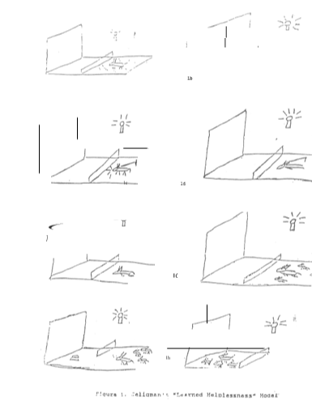

2.1.3 Cycles of Risk

Figure 2.2 depicts a highly simplified developmental model of the welfare cycle identifying various risk factors at different life stages leading to the establishment and perpetuation of a Learned Helplessness state. The main purpose of this figure is simply to note that there are many environmental and even biological factors that work to erode self-confidence and self-esteem creating higher and higher barriers in life and fostering feelings of hopelessness and helplessness, anger and frustration. When people feel trapped, unloved and unwanted and think they can no longer " escape" one way, again, it can hardly be surprising when they turn to other, more dysfunctional paths, be it drugs, violence or simply chronic welfare and despair. Thus, it should hardly be surprising that Figure 2.2 also identifies the basic risk factors for drug usage, gang crime, teen pregnancy, declining school performance and dropouts and the myriad of other related problems arising from a sense of hopelessness, low self-esteem and Learned Helplessness. The major point to be noted from this discussion, however, is that, just as with Seligman’s dogs, once these patterns have been established, they are not readily amenable to simple change as "circumstances" improve.

2.1.4 Cycles of Addiction

Before finishing this section, it is worth exploring somewhat more the concept of addictive processes as a subset of Learned Helplessness behaviors. By their very nature, addictions tend to have a gradual onset and begin with a period during which the individual very well may still be partially "in control" and able to back out, thus breaking the downward spiral. In all addictive processes, however, sooner or later the point is reached where, by definition, the Individual is clearly no longer "in control" of their own behavior. From this point on, the individual is becoming increasingly less free, less automatous and more at the mercy of their addiction of choice. An addict in withdrawal will protest vehemently and will escalate negative behaviors to astounding degrees to obtain the very thing which enslaves them. I will use the case of James T. to illustrate some of these and related issues.

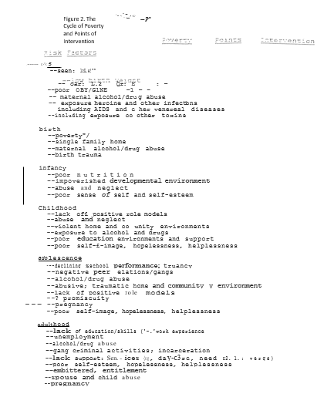

2.1.5 Case 2. James T. (24 yo SBM)

James has been a fighter all of his 24 years of life. Born in the inner-city to an unwed mother, life has never been easy. His mother, Mary, had been an alcoholic and heavy drug abuser during her pregnancy. To support her drug habit, she would solicit men then take them to a place where others would rob them. During such a robbery, a man was killed. When Ms. T was arrested with the others, she boasted to a cellmate that she would get a suspended sentence by having a baby. Because, however, of multiple previous arrests, she was convicted and sentenced to ten years in jail as an accomplice to murder. At the time she was four months pregnant.

While incarcerated, Mary went into labor one month prematurely. James was born a " blue-baby” and spent the first three months of his life in a neonatal Intensive Care Unit. Mary returned to prison three days after James' birth. By her own choice, she did not see James again for five years. At three months of age, James underwent surgical correction of a heart defect during which he suffered a period of decreased oxygen reaching his brain. After surgery, James was in a coma for three days. It was not certain whether he would live or not. James did, however, slowly recover. He was finally released from the hospital some 9 months after his birth. The cost of his stay, surgery and medicine were in excess of $500,000.

James spent the next several years of his life with his grandmother until his mother was released from jail when he was 5 years old. (She was released early in part because of James.) James’ grandmother had cared for him well. He had been making progress with his speech through a Developmental Disabilities Clinic that his grandmother took him to weekly. This stopped, however, within a month of his mother's return. Secondary to frequent fights with her mother over her returning to drugs and prostitution, Mary moved in with a boyfriend taking James with her. For weeks thereafter, James would cry incessantly for his "Momma" but this gradually subsided as James became more withdrawn and depressed.

From the age of 5 on, James had memories of a series of his mother's "boyfriends" routinely assaulting her and himself. At seven, he tried to stop the violent beating of his mother by a "drugged-up John" she had brought home to spend the night. In a rage, with one hand, the huge half-naked man picked James up over his head and literally threw him across the room into a wall. "It was nothin'" James mutters looking downward. But the next week he set fire to a building across the street in which two small children were caught inside and died. James was sent to a mental institution where he quickly fell in with a "tough" group of adolescents.

There were several fights and one more fire-setting incident during his extended hospitalization. Despite his age, several of the older girls complained of James’ attempts to touch their breasts and private parts. It appeared that these exploits gave him "status" among his male peers. Along with numerous learning disabilities, James was diagnosed as having Attention Deficit Hyperactivity Disorder (ADHD) for which he was started on the first of many medicines with which he was ultimately "treated." Through a strong behavioral modification levels system and his growing attachment to several of the mental health workers on the staff, James' behavior gradually improved.

Although Mary was sporadic in her visits, after 8 months of hospitalization James was discharged to his mother's care. Despite Mary T's agreement to bring James to outpatient counseling, he never showed up. Later Mary claimed that the reason was that she did not have carfare and could not find a sitter for James' new baby sister, Melissa. James' grandmother, whom he continued to call "Momma" had suffered a stroke secondary to her chronic diabetes and hypertension while he was in the hospital.

As James grew up, he did very poorly in school, preferring to hang out with his gang friends drinking, planning "turf raids" (spray-painting gang signs in nearby neighborhoods) and smoking marijuana. Arrested many times for petty crimes, he was always released to his mother after, at most, a few weeks of detention. He was expelled from his sophomore year of High School for pulling a knife on a teacher who had tried to reprimand him for fighting. James never returned to school. At the time of his dropping out, James was reading at the 5th-grade level. By 15, James was rarely coming home, living with friends and selling drugs to support his own growing habit. Besides his daughter, Charity, from his brief relation with Tammy B., James claims to be the father of three other children but has not seen them or their mothers in many years.

At 17, while high on PCP, James severely beat a rival gang member who later died. Because of his complaints of "strange voices" telling his to "kill, kill, kill" James was taken back to a psychiatric hospital. While there, James was diagnosed as "schizophrenic" and placed on a high dose of an antipsychotic medication. After walking around "zombie-like" for several months, he was declared mentally fit to stand trial. Although convicted of homicide in the death of the rival gang member, because of his mental history James was placed on the forensic unit of a nearby psychiatric hospital.

James was released last year after five years in the hospital. Although still prescribed antipsychotic medications, he seldom takes them, complaining that it makes him "feel funny" and keeps him from getting erections. He lives in public housing at Talbot Park on Social Security (SSI). Recently James has been a suspect in several armed robberies and rapes, but there are no local witnesses who are able, or perhaps willing, to identify him to the police. He is frequently late in paying his rent, having spent his SSI check on alcohol and drugs. He frequently has loud Wild parties in his apartment at all hours of the night, but his neighbors never complain. James has been a fighter all of his life.

While there are many evolving "internal" factors that perpetuate addictions, a Multi-Systems Analysis (MSA) approach to the study and correction of these problems as described in Section 3.1 below would also explore various external factors that also tend to reinforce negative behaviors. When we examine the families of alcoholics or drug addicts, for instance we often find elaborate interactive patterns of dysfunctional behaviors that tend to "enable" the alcoholic or addict to maintain their behavior even when superficially everyone can "agree" that they would prefer the behavior to stop.

Just as families can enable dysfunctional behaviors, societies, by their actions and inactions can also be intimately involved in the "System." One need only to look cross-culturally (both to other countries and to different times here in America) to quickly realize that there is nothing at all inevitable about our present problems. In fact, I will argue in the next section that it is precisely many of the changes in social policy that have arisen over the past sixty years that have literally "enabled" the present crises to have evolved.

Many professionals and intellectuals in our society have despaired at ever curing addictions and talk instead of legalizing drugs and/or maintaining but containing addicts' dysfunctional behaviors (eg, Social Security subsidies with participation in Methadone clinics). In many ways, this may be our society’s own version of Learned Helplessness and enablement that some would simply give up the fight or even defend addiction. as a justifiable "alternative life style" rather than believe that we could successfully treat and even cure the underlying pathology. When the Learned Helplessness model is understood, however, it becomes clear that, the ACLU notwithstanding, you are not doing an addict a favor to maintain their dependency, regardless of the extent of their increasing protests as they face the consequences of withdrawal. Instead, such excuses only enable the behavior and thus worsen the pathology.

Much as with other forms of mind-control and addictive cults, it is only after escaping the addiction that the individual can acknowledge how controlled they were. Before the addict can again "jump the fence" spontaneously, he or she must first practice the behavior and thus come to believe that escape is actually both possible and desirable. Thus the primary active ingredients in the successful treatment of any addictive/Learned Helplessness behavior include (as noted above):

l. Removing the addictive substance/process (taking off the chains).
2. Structuring the environment so as to require practicing the positive behaviors (eg, moving the food) and
3. Setting the "payoffs" (incentives/disincentives) so as to reinforce positive behaviors including a sense of mastery and positive self-esteem.

It needs to be emphasized that while external controls and "reinforcement schedules" may allow an individual the opportunity to practice the new behaviors, it is not until she or he "takes control of” (and responsibility for) her or his own life that they can truly be said to be free. It is precisely the " on a weapons ban on AR 15 anything on acting really on the phone regularly got regulation With “internalization" of this renewed sense of autonomy and possibilities, of Rights AND Responsibilities, that we will discuss when we return to this issue in Section 2.4 on Empowerment.

2. 2 The Welfare Trap

If Learned Helplessness is an outcome stemming from prolonged inescapable trauma, then in many ways the present welfare system has been the trap into which its victims have fallen. Many may already be familiar with the highly important historical analysis of the American welfare system by Charles Murray (1984) in his landmark book Losing Ground. This book explores in great detail both the origins of the present welfare systems and the avenues available for potential improvement in the future.
In Losing Ground, Murray reviews the remarkable increases in spending on social programs over the past forty years and the even more remarkable increased during this same period in Black male unemployment, unwed single teen mothers, and crime and decreases in educational standards along with increases in arrest and conviction rates. Just some of the statistics Murray cites include

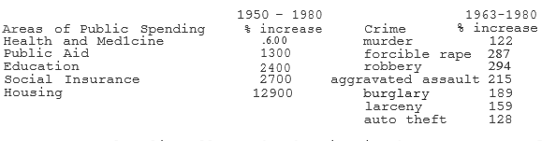

Murray also literally graphs the rise in the percentage of families receiving AFDC as it correlates with various regulations and legislative changes from 1950 - 1980. For as well-intentioned as these social policies may have been, clearly something wasn't working as expected. The Case of James T's Grandmother, Luella T., illustrates this point well.

2.2.1 Case 3. Luella T. (61 yo WBF)

Luella T. had been born into a share-cropper's family in rural Georgia in 1931. Being the oldest of seven children, Luella had many Responsibilities for her younger brothers and sisters as well as for chores around the farm. Although their’s was a deeply religious family, Luella’s father did not believe much in formal education, particularly for "women-folk.” The County officials also made no effort to insist upon formal schooling. Therefore, Luella, like many other of her friends, simply did not attend school after 8th grade. Throughout her life, however, Luella always read from her Father's Bible every night before going to bed. She saw much sadness and pain throughout her life but always accepted it as "The Lord's Will.”

In 1947 when Luella was 16, she fell in love with and married a local WWII hero, John T. From his small farm near-by to where Luella’s family lived. John and Luella were one of the few Black families in their County to actually own their own land. They worked hard and the farm prospered. In 1949, the first of their three daughters, Mary, was born followed in two-year intervals by Rebecca and Rachael.

As time went on, John and Luella became important pillars in their local Black Community and Church. During the late 50's and early 60s- neighbors looked to John as a local leader in the Civil Rights Movement. While outwardly supportive of her husband, Luella knew how local Whites had for decades dealt with “uppity niggers." She worried. Each night, Luella said a special prayer for John and her family.
Late one night in October of 1960 following a local voter registration drive, the family was awakened to the sound of breaking glass. Someone had thrown a firebomb through the kitchen window of their small wood frame farmhouse. Shots rang out. Within what seemed to be seconds passing like hours, the entire house was engulfed in flames.

Although badly burned, Luella was able to escape the house with Mary and Rachael. They could see John still inside the house looking for Rebecca when the roof caved in. Many years later, Mary remembered hearing men laughing in the distance, shooting their rifles in the air and yelling "Die, nigger, Die." This image has always stayed with her. It is an image less of fear than of rage that burns within her still.

Luella, Mary and Rachael all required extensive medical attention which could only partially be done in the local hospital. Particularly Rachael had suffered damage to her lungs and disfiguring scars leaving her permanently disabled and in need of further surgery. Thus, although Luella's family had lived in Georgia for many generations, she knew for the health as well as safety of her children she would now have to move.

By the time Luella, Mary and Rachael were all released from the hospital around Christmas 1960, all of their savings and possessions were gone. Because John and Luella had neither health nor life insurance, what was left of their farm had to be sold to pay off their debts. The little money that was left was just enough for Luella to buy tickets to Chicago for herself, Mary and Rachael where a cousin had promised them a place to stay and try to rebuild their lives.

When Luella arrived in Chicago with her children she quickly discovered that her cousin was little better off then them. Luella's cousin, Sara, lived on welfare with her 15-year-old son, Jeff, and 13-year-old daughter, Irene, in one of the poorest areas of Chicago's South Side. Luella's family had always been "too proud to accept 'charity' from others." Because of Rebecca's medical needs, however, Luella accepted Irene's assistance in applying for Welfare. Thus began the cycle that continued to the present day.

As Luella’s, Tammy B's and James T's stories would suggest, as many researchers have noted before (Murray, 1984; Bane & Ellwood, 1989), a system that " gives people a handout instead of a hand" can be expected to increase dependency behavior among a population already at risk because of few skills, low expectations, poor role models and self-images, early pregnancies and often a fundamental sense of hopelessness and helplessness. If these may be some of the inducements on to welfare, the economic barriers ' of lack of day care and medical benefits and poor hopes of finding a job much above minimum wage at least at the beginning are enough to set in motion a style of life often perpetuated over generations.

Clearly, as Murray shows, we have set the economic payoffs in such way as to often make welfare a "rational" decision for individuals who otherwise perceive little opportunity for advancing in life. Table 2.2.1 based on an article by Bane & Ellwood (1989) shows basically the same set of institutionalized disincentives to work for exactly those females most likely to maintain the cycle, ie, those with the fewest skills and the least hope for economic advancement. Figure 2.2.2 summarizes these barriers for a single parent with one, two or three children, respectively, and potential responses in three different scenarios. Depending upon the option adopted by Society, different outcomes can be expected.

In Option A, a cap is placed on the amount given to a mother no matter how many children she may have. Under these conditions, the “costs" to Society increase moderately with each additional child. These "additional risk costs" would include, for instance, a greater likelihood for children of single parents on welfare themselves, in time, cost society more from increased crime, teen pregnancy rates and the like. By capping welfare subsidies, the economic “benefits" to the parent go down with each additional child. Under such circumstances there is at least some disincentive to having additional children but still an incentive to having a child in the first place.

In Option B, Society "rewards" a single parent by giving her an additional $1,000/child. Under these circumstances, pregnancy and welfare become even more "attractive" alternatives for an "at-risk" youth with "little to lose." While the "benefits" to the welfare recipient are substantial, the costs to Society of Option B are also significantly greater. In return for a short­ term "benefit,” therefore. ultimately the individual, their family and Society can lose significantly. As a Learned Helplessness model suggests, if welfare is seen as a potentially addictive process, then once on it there is very little likelihood that simply, for example, raising subsidies will do anything but dig the hole even deeper and induce even more people to fall in.

In Option C, a single parent is offered a guaranteed job in a Community Service Corps (CSC) as an alternative to a traditional subsidy. In this situation the welfare barrier is directly broken by removing the disincentive to work and substituting strong incentives for pursuing further education and potentially marriage as well. Here, both parents would bear the full costs of having children either through child support payments and/or work in the public or private sector. Both potential parents, however, would be eligible for continuing education or apprenticeship programs through a National Community Service Corps (NCSC) with or without having children first. Under such circumstances, the welfare cycle is broken in a way that everyone benefits. We will return to an expanded version of Figure 2.2.2 when we discuss Freedom Quotients in Section 2.4.

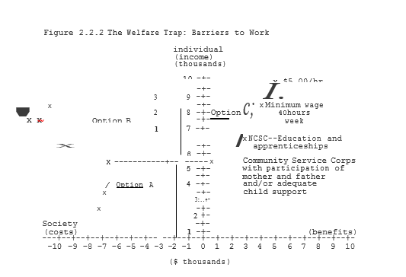

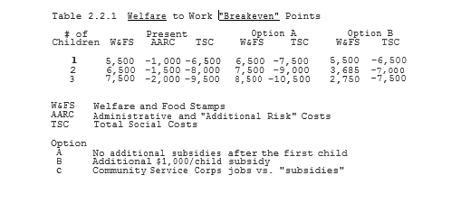

2.3 Social Dogmas and Conceptual Revolutions

Thomas Kuhn in his book The Structure of Scientific Revolutions (1962) describes how Science adopts a theoretical Paradigm to account for the data in a particular area. In Good Science, paradigms generate testable hypotheses which can help to evaluate the strengths and weaknesses of a particular theory. As data accumulates, old dogmas come into question and conf1icts arise as to whether theories can be readjusted or if new paradigms are necessary for progress to continue. While the same phenomenon of social dogmas occurs in popular culture as well, they are rarely held to the same standards of scientific rigor for testing out their underlying assumptions. Change ultimately comes, but in the process much suffering can occur.

In an age where walls are literally being torn down and people around the World are calling out for Freedom, it ls perhaps appropriate that we also examine those factors that continue to keep significant numbers of Americans in the bondage of poverty, drugs, crime, illiteracy, abuse and hopelessness. While some may argue that such a discussion goes beyond the purview of traditional psychiatry, these environmental pathogens are clearly major epidemiological risk factors for the development of significant individual and social pathology. For Mental Health professionals to ignore these broader social issues can, in fact, become a form of professional enablement that contributes significantly to the perpetuation of these problems.

From a review of American history over the past 60 years, it can be seen that the Great Depression of the 1930s brought about a prof und reorientation in both social and economic thought and political voting patterns as people struggled to adapt to the individual and social tragedies of the time. As economic disparities between the "have's" and the "have-not's'' of society became more apparent, political pressure mounted to right these inequities.

Even at the inception of the New Deal in the 1930s, Roosevelt, who called welfare "a narcotic" in his 1932 Inaugural Address, recognized its potentially addictive nature. But during the Great Depression, except for AFDC which back then served a relatively small number of genuine widows and orphans, most programs such as Work Projects of America (WPA) and the Civilian Conservation Corps (CCC) concentrated on providing job opportunities and skills rather than subsidies. In addition, these programs were clearly seen as temporary until the economy and individual circumstances improved.

Over time the focus of these Liberal Movements moved from Economic Rights to more broadly defined Human Rights building up to the Civil Rights movement which continues to the present day. As important and necessary as many of these changes were, however, the singular focus on individual Rights had the unfortunate side-effect of neglecting the concept of equal and reciprocal individual Responsibilities. Initially this was not much of a problem as there was a predominant cultural ethic of individual Responsibilities with often strong connections between individuals and their families, churches and communities (Wilson,1987). Over the years, however, as a "culture of poverty" took root, this connection between individual Rights and Responsibilities become increasingly tenuous, and the increasingly worsening welfare situation became its predictable and inevitable outcome.

As the Learned Helplessness model illustrates, and common sense would suggest, simply providing subsidies to individuals not only doesn't change dependency, it reinforces it. Further, however, what such a system sets up is a transition in individuals and societies from a Work Ethic to an Entitlement Ethic. When society requires of its citizens some form of contribution to the common good, we are saying that individuals have Responsibilities to help themselves if they are to improve. The equivalent in a family are the parents who realizes that they are actually helping their children to succeed in life when they assign them chores to help with around the house and insist on their doing their homework and classwork to the best of their ability. In fact, on a continuum, as children mature into adults, what they are doing is assuming greater and greater Responsibilities for their own and society's well-being. When we short circuit this process, whether in children or adults, far from freeing individuals, we ensure their continuing dependency on others and frequent exploitation by those who find something to gain from their condition be it drug pushers seeking dollars or politicians seeking votes.

There have certainly been many instances in history where designs were made for people with very few benefits being given in return. Lord knows, the World has seen too much of Fascism whether it comes from the Right or the Left. The Holocaust, the Gulag, the Killing Fields and Tiananmen Square should all serve to remind us of how fragile freedom can be and how easily it is lost when not defended. Responsibilities without Rights is slavery, but Rights without Responsibilities leads to Entitlement and the expectation of unconditional privileges. It is hopefully clear that neither Rights nor Responsibilities when applied alone leads to freedom. Instead, it is only the combining of Rights with equal and reciprocal Responsibilities that leads individuals to true Empowerment. On the road to freedom, society can help people along by insisting on their participation (moving people to the other side of the room), but true Empowerment doesn't come until individuals take the next step along the road where they clearly can say "I want this, I believe in this, I will work to see this happen."

When John Kennedy said in 1960 "Ask not what your Country can do for you--Ask what you can do for your Country," he was in many ways stating the ideal of good citizenship for us all. For too many years though, there were numerous attitudinal and institutional barriers to a truly free and equal participatory society for all citizens. The Civil Rights Movement of the 50s and 60s was clearly necessary to shake society from its complacency and acceptance of discrimination and bigotry. Yet many of the social changes that have occurred since then, as well-intentioned as they may have been, have only helped to enslave rather than liberate many of those they were specifically designed to help.

Many people of diverse races and viewpoints are coming to believe that issues such as drugs, crime, dropouts and chronic welfare have reached such proportions as to be the major barriers to a truly unified and healthy society. When Jack Kemp and many others call for a Second Civil Rights Movement much of the impetus comes from these profoundly troubling trends. When Martin Luther King, Jr. and others of his generation spoke of Civil Rights, they could take for granted that responsible behavior was also a prerequisite to freedom. Individual responsibility was the norm with a strong sense of family of community and even of church that united individuals and gave them the strength and conviction to fight for what they believed in, to arm in arm march down Freedom's Road.

Throughout the years the notion of Responsibilities has always been there at least implicitly but it has never yet been seen as the major missing factor for Empowerment to occur. A Second Civil Rights Movement would by necessity reaffirm the fundamental principles of human dignity and self-worth so nobly preached by the Reverend King. But also, a new movement would have to focus as much on the self as it does on society. A new movement would insist that each of us expect the best from ourselves and each other and constantly strive towards achieving these goals. A new movement would not only have students staying in school, it would have them alive with intellectual curiosity, artistic creativity, and noble ideals. It would have us as a society not only off of drugs but demanding mandatory testing and treatment so that we can go from a society of enablement to one of Empowerment. It would have young adults see having families as a lifetime commitment to growing, understanding, loving and supporting spouses and children alike. It would structure society so as to move people forward, not leave them behind.

If these are the goals of Empowerment that we seek for ourselves and each other, then every day into the future becomes a march towards greater and greater freedoms for us all. By expecting as a society that everybody participates, we free up the greatest source of potential strength in society--ourselves. As we look upon each other as resources to be developed then no one is unimportant, no one is expendable. As all contribute, so too, ultimately, all benefit. Setting up society so, voicing our Declaration of Interdependence, we all have a vested interest in each other’s successes--for they become our own as well.

2.4 The Value of EMPOWERMENT--On Freedom's Road
2.4.1 Values
"A cynic is a person who knows the cost of everything and the value of nothing" --Oscar Wilde

In a time when the subject of values is beginning to permeate even the political dialog of both Parties, it is right to reflect on their effect on Social Dogmas and their ability to lead to Conceptual Revolutions whether in individuals or society at large. Values more than anything else, whether consciously or unconsciously, are the motivators of behavior. As I tried to illustrate in the preceding Sections, how we think and feel about a particular situation will, by and large, determine how we will act in it. How we view the World and our roles in it will determine whether we feel Empowered by the challenges of life or entrapped by them. Such is the Power of Values.
In this Section, we will be defining terms and exploring their applications to the problems before us. The first and perhaps most important term to define is "Values” itself. Given our above discussion, it is clear that our values depend upon our perceptions as to whether a particular act, event or behavior is "good" or "bad." Therefore, we can offer the following definition of values:

Values = Perceived benefits - Perceived cost

As is suggested by this definition of Values, rarely is such an assessment a matter of absolutes. Instead, we must generally compare the relative costs and benefits of a behavior in order to determine our overall assessment of it. For instance, in general the perceived “costs" of taking another person's life would far exceed the "benefits." In the case of responding to a brutal tyrant, a mass murderer for even a Soldier in Work, however, the choice may not at all be so clear. But when considering the values of an entire subculture such as inner-city gangs where the perceived costs of "whacking," "icing," "popping" or otherwise killing others is drastically discounted, we should not be surprised that murder becomes an accepted everyday occurrence.

By applying this "Values equation" to the study of an individual’s behaviors, we also can gain further insight into their own personal value system. It also follows that, if an individual's perceptions of relative costs and benefits changes, it is likely that they will modify their behavior accordingly. Thus, for instance, by increasing the costs of crime by longer jail sentences, we would hope to have a deterrent effect on anti-social behaviors. Conversely, giving criminals the message that they won't be arrested, convicted and/or sentenced would obviously seriously undermine the credibility of such deterrence. It is not so much what we Say as a Society, but what we actually Do that sets the moral tone for acceptable and unacceptable behaviors.

While increasing the rapidity, certainty and amount of actual rewards and punishments can be vital factors in changing behaviors, it is equally important (and cost-effective) to change the perceptions of costs and benefits in the first place. For instance, a gang-banger who sees going to jail as a "rite of passage" may actually consider his number of arrests as badges of honor that give him status within his group. For a gang member, it may be much more of a deterrent to have to put on orange overalls after school and clean graffiti off walls in the neighborhood for a few hours a day for several weeks with all of his friends looking on. Particularly if coupled with mandated, long-term after-school study halls and sports activities as rewards, significant changes could occur in a relatively positive ""win-win manner.

As the above quote from Oscar Wilde and the above equation would suggest, costs alone are much different than actual Value. The "value" of an object or the "values" of an individual or society are generally the cumulative results of many experiences.

As the Cases I have presented suggest, particularly early experiences can have a vital role in shaping the perceived costs and benefits of particular behaviors or situations (See Section 2.4.3). Thus the earlier and more consistently we can surround individuals with positive environments, the more likely it will be for them to adopt a long-term positive value system. It is specifically to design and continuously expand upon such Safe Havens that this present effort is addressed.

2.4.2 Freedom Quotient

If we are to use Values as a liberating force for good in the World, then we must understand how they can help or hinder us from achieving positive objectives, values and behaviors that either draw people closer together (win-win) or set them further apart and against one another (win-lose, lose-lose). In short, to be able to make such choices, to know where we are and where we want to go, it is useful to have a map of Freedom's Road.
While complicated computer models can and, ultimately, will be developed to more completely assess progress towards particular objectives, for our purposes it will be much more useful to adopt an intuitive COMMON-SENSE approach to measuring such progress. Previously, I have made a common-sense distinction between the concepts of Entitlement and true Empowerment as follows:

Entitlement = Rights without Responsibilities

Empowerment = Rights AND Responsibilities
From the data, whether it is a child growing up or an adult or nation stuck within a destructive rut ("loop," cycle, etc}, I have argued that an Entitlement Ethic only perpetuates and deepens such a rut. It is only by combining Rights AND Responsibilities that individuals can learn and practice the behaviors that can truly set them free. It is precisely in order to operationalize this definition of Empowerment that I will now describe the notion of a Freedom Quotient (FQ) as defined below.

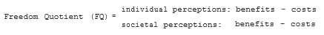

The Freedom Quotient is a simple common-sense approach to illustrating both where an individual or group might be at a particular time and where they would like to go. Equally important, the FQ can help us to visually appreciate the distinction between "win-win," "win-lose," and "lose-lose" strategies. It is in the context of the Freedom Quotient that the distinction between an Entitlement Ethic and an ethic of true Empowerment can become readily apparent.
Because at this point the FQ is being used in a simple intuitive manner, we can subjectively estimate the relative costs and benefits of a particular action or policy upon both individuals and society at large. I will argue that the Entitlement Ethic of the past 60 years, by focusing on, in essence, a one-dimensional model was bound to fail. By combining the notions of both Rights AND Responsibilities in an Empowerment Ethic we can start to have a better understanding of the overall impact of particular actions or programs.

Before discussing specific means of designing programs and systems to lead to Empowering win-win solutions to long-standing problems, however, it will be useful to briefly discuss some of the typical situations we are likely to encounter. Figure 2.4.l presents some examples of FQs for continuing with an education, going on to welfare for someone who had dropped out of school vs. a recently divorced college graduate with two small children, for both of these individuals participating in CSC, for a drug user early and; late in their addiction, and for citizens in a totalitarian regime early and later in its course. The resulting FQs. are plotted in Figure 2.4.2. For the sake of. simplicity, I have assigned perceived relative costs and benefits of such situations on a scale of l (minimum value) to 10 (maximum value).

In the cases described in the next section, I discuss some factors in determining such subjective values.
For a student with loans the long-term benefits of continuing education (9) is often tempered by the perceived short-term costs (4) of loans and other deferred gratifications (jobs, marriage, etc). Similarly, Society ultimately benefits from individuals their education (9). While the costs to Society (3) are generally less than to the individual, often taxpayers to one extent or another underwrite at least part of the costs of continuing education. Entering these subjective estimates of costs and benefits into the Freedom Quotient suggests that education overall tends to be a net positive objective (5/6) for individuals and Society alike.

If there are expenses involved in continuing education, the costs to individuals and Society of the present welfare system are significantly greater. But even in identical financial and geographical situations, two individuals can differ significantly in their responses to being on welfare. A recently divorced middle-class mother of two may find welfare both terrifying and highly aversive (-3/-6). Conversely, a teen mother high school dropout who has grown up in the inner-city on welfare may not only see it as the norm, but as a "step up" from living in a crowded chaotic apartment with brothers and sisters (2/-6). Thus, perceptions are as important as material "realities” in determ1n1ng an individual’s motivation to change. For both individuals, however, going to work in a Community Service Corps (CSC--Section 3.2.2) may ultimately be an empowering experience that helps them to break the welfare cycle once and for all (5/5).

Just as the Learned Helplessness of welfare may be slow in developing, so too the bondage of other addictions may begin enticingly as well. With early, infrequent use of drugs, for instance, a youth may experience all of the "benefits" (7) while minimizing the not-as-yet major costs (3) involved. It is only with repeated usage, once both physical and mental addiction is in place that the true costs (-5/-7 vs 4/-4) may become clear.
Although addictions are difficult to treat, they are by no means impossible. After the Communist victory on Mainland China in 1949, “rice patty therapy" was extremely effective in breaking addictions quickly and permanently. By their excessively and needlessly brutal techniques, however, the Chinese went from a starting point that produced Societal if not individual benefits (-9/2) to one where everybody lost as China fell further and further behind economically (-9/-4). Techniques such as boot camps (-3/2) as transition points to esc, further education and Jobs can help to map our "win-win" strategies for motivating positive change.

While the concept and usage of Freedom Quotients is discussed in much greater detail elsewhere (Ladien, l992) it would be useful to make a few observations on these two figures as they relate to our present discussion. As shown, Figure 2.4.2 is divided into four quadrants defining conditions which are at least perceived as benefiting the individual but not society (win-lose), society but not the individual (lose-win), neither (lose-lose) or both (win-win). As both perceptions and realities can change over time, arrows showing such movement can suggest certain “profiles" of evolving behaviors. Because of the relatively subjective nature of the actual values, the direction of change is more important than the numbers per se. It is also important to note that, while change can occur in both directions (improving and worsening), such a quotient and graph allow us to describe at least in theory how positive change can occur and what some of the costs of lack of change can be for both the individual and society.

Most importantly, however, Figure 2.4.2 allows us the ability to illustrate the distinction between a "right" (anything that is perceived by the individual as "benefiting" them) and freedom" (win-win scenarios where everybody benefits). While win-lose situations may also be perceived as freedom, in the long-run they are inherently unstable because whoever is "winning” today can just as easily be "losing" tomorrow. While addictive processes tend to degenerate into lose-lose scenarios, win-win scenarios are inherently stable and tend to progress in a positive direction (people and societies moving towards the maximum of their potential).

By such a conceptual reformulation, progressing from a unidimensional model of Rights to a multidimensional model of Freedoms, we can resolve many of the apparent conflicts posed between traditional liberal and conservative approaches to social reform. Before going into details of these solutions, however, it will be useful to see where the Cases I have already presented fit upon these continuums. In particular, it will be useful to graphically see the cycles of negative lose-lose behaviors that so often block positive progress. If we wish to see where we can go, it is also helpful to see where we have been. Thus, in plotting our course towards a society that works for everyone, we may now have a map of Freedom's Road.

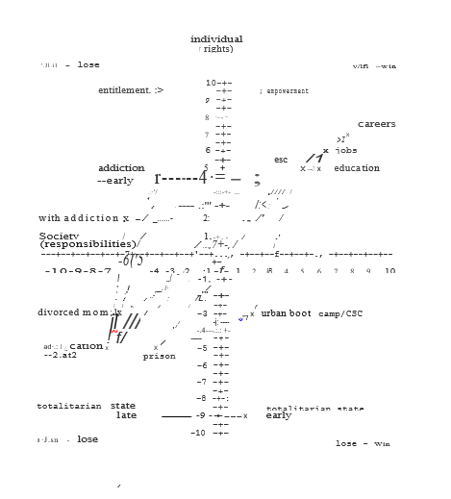

2.4.3 Case Analyses— Cycles of Despair
2.4.3.1 Case l: Tammy B. (18 yo SWF)

In the case of Tammy, the physical and sexual abuse by her stepfather had early on lead to a very low self-esteem where the perceived "costs" of the abuse (8) far outweighed any perceived Benefits, for instance, of having a place to live and food to eat (2). Thus from early on Tammy had < I relatively strong negative subjective perception of her own satisfaction with live (2-8=-6). While she might wish the situation were different, at age 8 she already felt relatively powerless and afraid to change things. Although Tammy's grades in school were relatively poor (C's and D's), initially she was in general perceived by others to be " behaved" if somewhat withdrawn. Thus, the "costs" of mediocre grades (5) were balanced out by no major negative problems (4) that might have brought her to earlier attention. In retrospect, the lack of any major warning signs helped to perpetuate the abusive conditions that would later take their toll on both Tammy and society at large.
By the time that Tammy was·15, her perceived quality of life had improved insofar as the abuse by her stepfather had stopped (6). But her family's move to the relatively stressful conditions at Talbot Park still kept her from being more positive in her self-image. The further decline in Tammy's grades, however, was starting to place her at increasing risk for developing a negative lifestyle which would be increasingly difficult to change while relatively simple interventions at this stage (eg, after-school programs, including study halls, tutoring, support groups, sports, etc) would have conceivably made a significant difference. Unfortunately, in Tammy's case, they were not available.
By the time that Tammy dropped out of school and had her baby at 16, the direction of her choices was clearly being directly influenced by present governmental policies. Without at this point placing a "value judgment" upon them, it is important to note that present welfare policies allowed Tammy several "benefits” (7) including among others: a guaranteed income; assured health benefits; the ability to live on her own; and a " socially acceptable" reason for dropping out of school. Because our present Welfare system offered her these options, it should come as a surprise to no one that she would take advantage of. them. Simply put, we have no one to blame but ourselves for such a dysfunctional System. If the System is to be FIXED, it is WE must FIX IT.

Conversely, the perceived costs (2) of Tammy's actions at least initially were relatively low. In fact, a major difference bet weens Tammy at 14 and 16 is that, by “acclimating” to her surroundings their relative "cost" to her had gone down significantly. Thus, by lowering her long-term expectations, the perceived costs of her actions also went down considerably. The price, however, for this accommodation was the adoption of a set of negative values of long-term harm to herself, her child and Society.

As Tammy began experimenting with drugs, in the short-term her overall satisfaction with life went up (8). Not only did she now have “friends” with whom she could share “pleasurable" experiences, the effects of the drugs themselves helped her to “forget". her problems (reduce costs) if only for brief periods of time. While Tammy was temporarily "feeling better" about herself, the costs to Society in general and to her daughter, Charity, in particular were increasing (8) while the benefits of her behavior was not improved (2). Simply put, problems left unresolved and to get worse over time.

When Tammy was physically assaulted and raped by James, the facade of perceived benefits of her present lifestyle was shattered (2). In addition, the original costs of pain that she had suffered being sexually abused as a child returned in full force (8). The costs (8) and benefits (2) of her lifestyle to society remained the same. It was the suddenness of this "decompensation” from a relative "high" (6/-6) to a severe "low” (-6/6) along with her impaired judgement on heroin that contributed to her suicide attempt. Feeling "trapped" and "hopeless," Tammy saw death as a route of escape.

Again, as the Learned Helplessness model suggests, if "escape” one way is not possible, escape another way will be sought. What Tammy's case sadly illustrates is the etiology and evolution of such negative values embodied in the Entitlement Ethic. The natural corollary of this mindset is that "If Society won't let me "win" one way (win-win), then I'll find satisfaction another way (win-lose)." Thus, as much for self-preservation as out of anger or antisocial tendencies, a win-lose Entitlement strategy can evolve. The longer such an Entitlement Ethic persists, however, as illustrated below, the more destructive the process becomes for all involved.

While Tammy's "story" is not yet complete, for the purposes of understanding the "cycles" of destructive behaviors into which people can fall, it is useful to "complete the loop" as to the possible negative outcomes of these behaviors.

As noted above, early on in an addictive process the individual may perceive increased benefits ("thrills," "escape," etc) even if society and other family members (eg, Charity) are hurt by these behaviors. Over time, however, even the short-term "benefits" of drugs wear off as more and more of the negative consequences of a chronic addiction are experienced. Thus, addictions that start off as a "win-lose" scenario over time devolve into increasingly negative situations in which everyone loses. As the subjective "positive" benefits of antisocial behaviors wear off (3), there is an increasing likelihood of even more serious negative behaviors in the future (costs = 8). Just as with the use of drugs themselves, over time it takes an increasingly greater expenditure (drugs, violence, etc) to achieve the same "high." Simultaneously, the more negative the perceived reality a person is in, the less are the relative perceived costs of apprehension or incarceration (eg, -5/-7 versus -6/-5). For a homeless person, for instance, one can see being in jail as a "step up" or a gang-banger can feel they have "nothing to lose" when they shoot a witness to a crime, all of Society is at tremendous risk. The case of James T. illustrates these issues well.

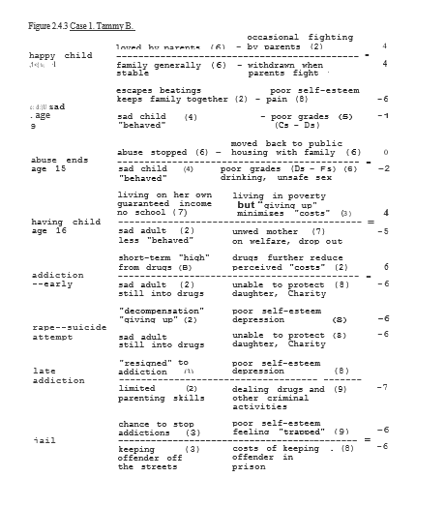
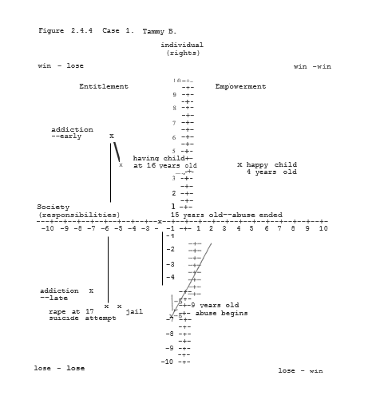

2.4.3.2 Case 2. James T. (24 yo SBM)

Before James was ever born, he had many “strikes” against him. Not only did he not have his mother available to help in developing a secure base and positive self-image, his multiple serious medical problems were significant net costs to both himself (-5) and society (-4). The fact that James' Grandmother, Luella T., was able to care for him in his mother's absence, however, helped to make his early years. overall relatively positive (3/2). The positive influence of Luella is, in fact, a good example of how consistent love and nurturing are much more important than simple material possessions in determining an individual’s overall satisfaction with life. Tammy B., for instance, had a much poorer environment living with a sexually abusive alcoholic step-father in a middle-class suburb than did James living with his Grandmother in poverty. It was the ending of this relation with his Grandmother that was probably the most significant loss in James' life. It was this loss and his later chronic abuse that significantly contributed to his rage and negative lifestyle that has been with him ever since.
By the time that James set the fire at age 7 that resulted in the deaths of the two children (cost= 9), his overall quality of life was very poor (-5/-6). Already by 15 years old, just as with Tammy, once James "gave up" he was able to significantly increase his perceived personal "benefits" (8) by the adoption of a highly negative win-lose lifestyle (5/-5). The "crash" in his World (-5/-7) with the murder of a rival gang member while James was high on Angel Dust was as predictable as it was avoidable. Given James' negative, angry attitude towards the World at large and authority figures in particular as well as his past violent behavior, this death was a tragedy just waiting to happen.
While the diagnosis of "schizophrenia" that James was given while high on PCP was at best highly questionable, it had two additional major negative effects. The first major negative effect of this diagnosis was to make the District Attorney's office unwilling to pursue homicide charges against James. By being found "Not Guilty by Reason of Insanity," James ended up spending less than 5 years in a State Forensic Psychiatric Unit where he received heavy doses of major antipsychotic medications, but. very little real therapy. James was released with the full knowledge that were he to be arrested again in the future the worst that would happen would probably be that he might be sent back to the same State Psychiatric Hospital. To James this meant that in returning to crime he had much to gain and little to lose. James was back to using and dealing drugs within a week of his release.

The second major “benefit” (6) of James’ diagnosis was that he was actually assisted in applying for and receiving a permanent income from Social Security (SSI) which actually started while he was still in the hospital. Since there were no mandatory requirements in his benefits that he continue in outpatient therapy, he simply did not go. Since there were no mandatory work requirements associated with his benefits, James’s “work” became his drug dealing, robberies and “leadership” role in his gang. Thus, in essence, while Society had no net benefit from the 5 years James spent in the Forensic Unit, James was "rewarded” with a grant of $660/month with no strings attached. Police, court and hospital expenses related to investigating, prosecuting and "treating" James in this case had cost taxpayers over $350,000 even before his SSI benefits ever began. These costs do not even start to include the costs of his four children to three different mothers, including his baby, Charity, by Tammy B.

While James thus in theory had a "steady income," within months of being released from the hospital his drug habit was costing more than the total amount he was receiving from SSI. At the time he first met Tammy B., James was making enough money selling drugs and participating in robberies and break-ins to cover his costs. As noted earlier, however, even before Charity was born James had gotten to the point that he was stealing Tammy’s Food Stamps to buy more alcohol and drugs. While James admitted that at first, he genuinely cared about Tammy ("Like I do with all of my Ladies"), he said that his reason for wanting Tammy to have a baby was so that he would be able to spend his check on drugs and be able to live with Tammy on her AFDC income and Food Stamps.

As with most addicts, at the time James thought he would be able to limit his habit and that it would not get worse. As we have seen, it got worse anyway. By the time that James called Tammy asking to stay the night he was homeless, spending his SSI checks on alcohol and drugs instead of rent. Whatever remaining status he had with his gang had been lost when James became involved in a drug deal that “went bad.” He now owed the Mafia over $50,000. The word on the street was that there was a contract out on James' life.

Tammy had let James stay overnight on the couch out of pity but wanted him to leave by the next day and told him so. James had beaten and raped Tammy out of "rage" when she refused to sleep with him. By this point, James had developed such a sense of Entitlement (Rights without Responsibilities) that he genuinely “believed” that Tammy "owed it" to him to have sex and hand over her money to him. After beating and raping Tammy, James used her money to flee to another State. He robbed two gas stations along the way. One clerk was shot and spend several weeks in the hospital recovering from a gunshot wound to her abdomen. The attendant had almost died.

At this point James was in an extreme lose-lose position (-7/-8) both in his own life and regarding Society at large. Ironically, both James and Society would be better off if he were apprehended and returned to the Forensic Unit or even jail. Unfortunately, however, with no other fundamental changes in his treatment and in the social systems that helped to perpetuate his dysfunctional behaviors, the cycles would simply be repeated yet one more time.

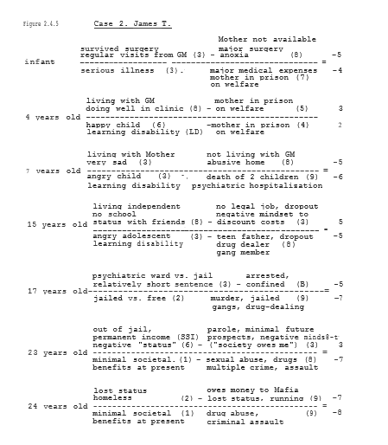
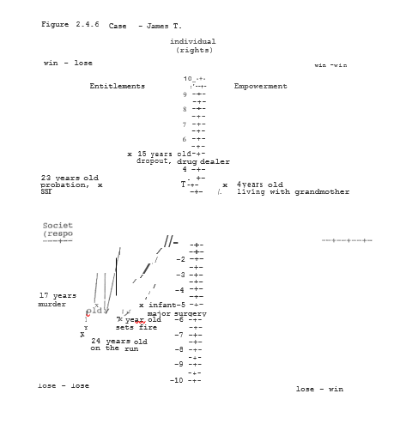

Although Mary T. has been alluded to in the discussion of both her son, James, and mother, Luella, it will be useful to summarize her history in mapping out the cycles of her own and her family’s behavior. This history is particularly relevant as it helps to illustrates the continuity of stories and the deepening tragedies as the cycle of welfare passes from one generation to the next. In this context, Mary’s story also helps to illustrate why with the present system the downward spiral of economics and values, once set in motion, is so difficult to break. Just as with her mother, Luella, Mary was born into a very loving a supportive family. Her early years, therefore, were highly positive for both herself and her family (6/7). Again, the fact that her family was, early on, of very modest means was not a significant factor in Mary's overall early happiness.
In her early years, Mary was relatively shielded from the bitter racism of the times both by her age and the deliberate efforts of her parents. While Mary knew her father went to "meetings,” she just felt proud about how so many of her neighbors looked up to him as a leader in their community. It wasn't until very close to the firebombing itself that Mary began to be afraid for her father and the family. It was her mother's crying at night and constant praying that let Mary know how serious the situation really was.

When the firebombing actually came it was a time of absolute horror for Mary. The bedrooms in their small wood frame farmhouse were on the second floor. Were it not for the bravery of both of her parents, no one would have survived. Mary could just remember images from the fire. The pitch darkness of the thick, scorching smoke. Her terror as she crawled along the floor to where her mother literally threw her and her sister from the second story window before jumping herself. And the utter anguish as she saw the roof collapsing on the house as her father and younger sister, Rebecca, were still inside. And all the time in the background there were men laughing, shooting their guns and yelling "Die, nigger, die." It was in those few minutes that her own innocence turned to fear, then rage. But rather than outwards, for years this rage was turned against herself, her family and her community.

While in the hospital recovering from their burns and scarred lungs, Mary, Rachael and Luella were so ill that they were not even able to attend the funerals of John and Rebecca. At first, Mary cried incessantly and had vivid nightmares where she thought the laughing men were coming back for her and her family. Later, she became more and more sullen and withdrawn. She stopped crying and spoke very little. As her rage built within, the nightmares subsided. The rage protected Mary from her feelings of hurt and despair, but ensured that her tragedies were only beginning.
When Mary arrived in Chicago with her sister and mother at Christmas-time 1960, she was leaving her entire World behind. Not only was Mary leaving all of her many friends, but the South Side of Chicago to which her family moved was itself a very dangerous place. It would be hard for the values of cultures to be more difference than 63rd St. and Lomax Mary felt afraid and hopeless. These feelings came out as anger and rebellion towards her mother.

As noted previously, Luella's cousin, Sara, and her two children, Jeff (15) and Irene (13) were themselves also poor. But their poverty went far beyond simple finances. Sara had raised her children alone on Public Aid since divorcing her husband, LeRoy, some six years earlier. Before she finally threw him out, LeRoy would routinely come home drunk and beat both Sara and the children. These beatings had left their mark in more ways than one.

Since early in grade school, teachers had always complained to Sara about Jeff "picking on" the other children. LeRoy actually encouraged Jeff in this behavior and more than once had beaten him for running away from a fight. By eleven, Jeff was routinely stealing lunch money from younger children. By 13, he was a drug runner for the Stone Tigers, a local gang. By 15, he had status among the Stones by already having been arrested five times. The longest he had ever spent in jail was three days. The longest he had stayed in court-ordered counseling was two weeks.

When Luella and the children moved in with Sara, Mary and Jeff became close friends. Quickly Mary was accepted as a member of the Stones. They were her friends, her family. As opposed to her mother’s "Trust in God," she learned "Trust in yourself and the Stones." Where her mother preached the Golden Rule, the Stones preached the Rule of Gold. Instead of decency and love, cruelty and fear became the values Marry associated with status and security. The more she adopted these values, the further both physically and emotionally she became from her mother. Using and dealing drugs only speeded this process up. By 15, Mary was running away. By 16, she was pregnant.

Luella reluctantly agreed to Mary's plans to move out on her own. Her apartment was used by the Stones as a "Safe House" and place to transact drug deals. Some gang members and their friends paid Mary money to "spend the night." Mary was using heroin heavily by now and cared about little except how she would make enough money to buy drugs and use prostitution to escape from 63rd St. with her baby forever. Because of her drug use, however, her baby, Anita, was born two months early with very poorly developed lungs. After two weeks in the Pediatric Intensive Care Unit, Anita died. If Mary had any hope for the future and a better life, it died with Anita.

Following Anita’s death, Mary's bitterness and rage only grew. She had convinced herself that nothing mattered and she would take whatever she could get from others. After the loss of her AFDC checks Mary turned with her Stones friends to a scheme where she would proposition men and lure them to a place where her friends would rob them. Mary had multiple arrests for prostitution but the Stones would always bail her out. It was while on bail that Mary enticed a drunken White Southern businessman into an alley where her friends robbed him.

Perhaps it was because he was drunk, but just when Mary and her friends were ready to leave, the man looked straight at her and called her a “Goddamn nigger bitch." Without thinking, Mary pulled out a gun and shot him five times. The police found the man the following day with his pants still pulled down and his penis shot off. Three weeks later Mary and two others were arrested for murder. No one had actually seen the shooting, but the three were seen by witnesses riffling the dead man's pockets. One of Mary's friends was arrested trying to use the man's credit cards.

It was while in jail awaiting trial before bond was set that Mary had boasted of having a child to reduce her sentence. It was the following year that James was born. As noted previously, numbers, graphs and figures alone could never in any way convey anything of the pain, hurt and rage underlying so much of Mary's, James' and so many other's behaviors. We all too easily see the symptoms, the results of these feelings and the sense of Entitlement that generally accompanies them. Rarely do we see in clear detail, not just the physical circumstances, but •the emotional and “subcultural" factors that help to develop and maintain these behaviors.
In Mary’s case her childhood, like Luella's, was highly positive for both her and her community (6/7). With the murder of her father and sister, however, her World shattered and became almost polar opposites of what it had been previously (-7/-5). In this process, Mary "snapped." Just as with the sudden personality shifts seen in some religious conversions or in people entering into a cult, Mary was thrust suddenly and unwillingly into the gang World of the Stone Tigers.

In Mary’s 11-year-old mind, her father had been killed because he was "weak." If his and her mother's insistence on nonviolence had caused her tremendous pain and fear, the Stones offered her a way of never having to feel afraid or weak again. There was thus something relatively beneficial and “empowering about this message that initially attracted Mary. What Jeff and the Stones offered Mary more than anything else was a sense of relative “safety" in a very dangerous place.
Over the next few yea.rs, however, the price of this safety to Mary, her family and Community became increasingly clear. For over a year when Mary first arrived in Chicago, she simply "tagged along" with Jeff wherever he went. His friends became, her friends. When Jeff would have a "party," Mary would feel very much part of the group if they offered her something to drink or smoke.

At first it was just fun. Fun and "safe." After a while Jeff would offer Mary money to run drugs for them for some of their "regular" customers. They would always give Mary a little of the drugs, usually cocaine as a reward. The drugs, at first, just made Mary feel "powerful" and "invulnerable.” Soon, however, Mary realized that she was making more dealing drugs than her mother made on welfare. Thus, by 15, Mary had significantly increased his personal perceived benefits (6) and discounted the overall costs of her behaviors (4) such that she felt relatively good about her situation even if Society as a whole did not (2/-3).

The death of Mary's first baby, Anita, did much to both harden her even while reawakening her to the bleak realities of her present World. The more chat Mary gave up hope, the less was the difference between the perceived negativity of her gang- and drug-related life (-3/-6) and that of jail (-5/-7). Under these circumstances, again, the murder of the businessman became a predictable if avoidable tragedy.

Mary's early release from prison some five years later only left her more bitter and negative in her values than she went in (-1/-4). When Mary took James and returned to drugs and prostitution, she had fought bitterly with her mother. For years following that, she and Luella spoke very little even though living within a few blocks of each other. In "retaliation," James rarely got to see his grandmother after that.

In many ways, James' violence even in his youth was a reflection of Mary's own anger at the World about her. She could see the destructive effect of her behaviors on James, but felt powerless to change. "It was like," she said “watching cars skidding on ice, about to crash. Everything went by like ln slow motion, but there was nothin’ I could do to stop it."

When James was 15 years and in trouble at school and with the law, Mary got pregnant again. The father of her child soon left but, for many reasons, this time Mary decided to keep the baby. By the time Thomas was born, James had already dropped out of school and was living on his own. Mary vowed to herself that "things would be different with Thomas. She stopped completely prostitution and substantially cut back her drug dealing as well--dealing only enough to support her own habit and occasional binge drinking. Because of the birth of Thomas, Mary continued to receive her AFDC subsidies from Public Aid as well (4/-6). Without a job, however, Mary remained and felt "trapped" at Talbot Park. Thus, for all of her determination, the more "things change," the more they remained the same.
From the point of Mary's arrest and imprisonment to the present, she has "cycled" between the "highs" of the economic benefits of selling drugs and prostitution and the "lows" of occasional arrests and the problems with James and her Community. Since her rejection by her mother, Luella, Mary's "family" has been the very gangs that have perpetuated the violence and terror surrounding her.

The murder of her father may have started this cycle of despair for Mary and her family, but it is the violence of her own Community and its addiction to welfare as much as drugs and alcohol that has in many ways kept her trapped within it. Thus the tragedy of Mary's life up to the age of 23 only helped to set the stage for the next cycle of tragedies as we have already seen involving her son, James. Without effective intervention now, Mary can see Thomas ready to follow in his older brother’s footsteps. As the next two cases will illustrate, however, such lose-lose scenarios are by no means inevitable.

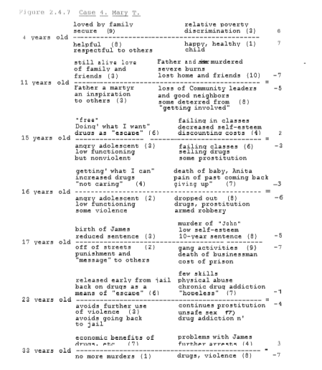
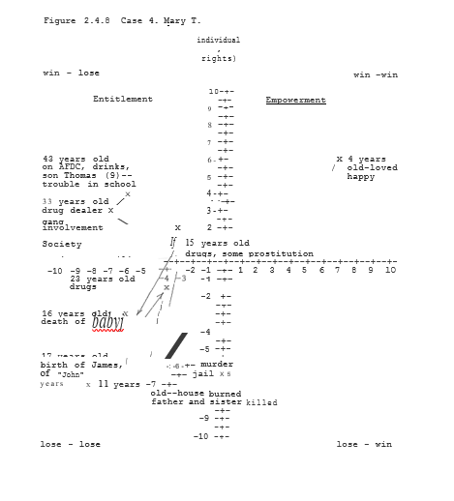

2.4.3.4 Case 3. Luella T. (59 yo WBF)

Throughout her life, Luella T. saw greater poverty and endured greater bigotry and racism than either her daughter, Mary, or grandson, James, ever did. Yet through it all Luella has remained constant in her faith and positive in her outlook on life. Thus, rather than economic or even emotional hardships in the end, it was a set of values that helped to most clearly define Luella's life and actions. Throughout her early years, Luella grew up knowing that she was loved and cared for not only by her family, but by the entire rural Black Community in which she lived. Although her family and neighbors were all extremely poor, they had a richness to their lives that money could never buy. In many ways, the Church was the center of their lives. It gave them both meaning and strength in times of need. Some of Luella's earliest and most cherished memories ' were of her family and other church members living and working together. Thus, from the beginning, a win-win condition of love and communion existed between Luella and her Community (6/7).

By the age of 14 when Luella left school to work full-time on the farm she was already known as someone who went out of her way to help others. Luella felt badly about not being able to continue her formal education, but she knew that both her mother and. father needed her help. As noted before, she read and ultimately memorized long sections out of her father's Bible. For every trial she ever had, Mary had a passage of Scripture to comfort her. Her overall satisfaction in life as a teenager thus actually went up (7/7) even though the material circumstances of her life were as difficult as ever.

Meeting and marrying John, then buying the farm and raising her family were the happiest times of Luella's life. Not only was her personal satisfaction the highest (10), but John and her helping ways made them highly valuable members of the Community as well (9). Thus, Luella and John lived their values in all aspects of their lives. It was ultimately this sense of individual responsibility that lead them to leadership roles within their community. Thus, for as positive as their values truly were, John's leadership role was precisely what lead him to be a martyr to a noble cause.

The tragedy of the deaths of John and Rebecca were the hardest time in Luella's life. Both when she was in the hospital and for several months after reaching Chicago, Luella was grief stricken and clinically severely depressed. She had, in fact, seriously considered suicide during this time. It was her religion and responsibility as a parent to Mary and Rachael that kept her alive during this time of trials (0/0). It was during this time of severe depression that Luella turned even more to her religion than before. It was in this time of literal soul-searching, however, that she was not able to help Mary adequately when she needed her mother the most. For Luella at 27 years old, her values were already well established. They were a fire that, ultimately, only grew stronger in the hurricane winds of changes and tragedy. For Mary, however, her values were still forming. For her these cold winds of despair blew out the embers of faith and courage.

Because of her own multiple medical problems and particularly those of Rachael, Luella had been forced onto welfare simply to have a way to pay these bills. Her limited 8th grade education also made it impossible to find a job that would pay enough for her to support Mary and Rachael without such assistance. Four years after moving to Chicago, when Luella could clearly see what was happening to her family, she moved with the children to Talbot Park, a low-rise Public Housing project, in order to escape the influence of her nephew, Jeff, and the Stone Tigers on Mary. Unfortunately, by that time it was too late for Mary. Within the year, Mary was pregnant with Anita and had moved back on her own to the 63rd St. neighborhood.

The flame of positive values passed on one generation to the next was at least for many years extinguished for Mary. By 39 years old, however, these values were burning brightly again in Luella. She was active in her local church and was well respected in the Community of Talbot Park. When Mary had gone to jail, Luella had five years to serve as a positive influence on her grandson, James. As previously seen, by age 4, James had for the only time in his life been in a positive win-win position with himself and her Community (Figure 2.4.6, 3/2).

In many ways, this early positive outcome for James was the direct result of Luella's efforts. Luella wanted for James what she had been unable to do for Mary. As such, she was being a benefit to herself, her family and her Community (5/3). She was thus reigniting in James the flame of positive values passed on through the generations. Unfortunately, as with Mary, this flame was snuffed out when James was taken from Luella. Despite her own inner peace, it is precisely the problems with her children and grandchildren as well as in her community that presently keep Luella from experiencing even greater satisfaction in life (6/5).
Just because a fire dies once, however, does not mean that it can never be reignited. Luella remains a beacon of hope for herself, her family and her Community that change can come again. Luella used to comment to her neighbors how, until John and she bought their farm at the age of 16, she had never lived in a house with running water, let alone indoor plumbing. But she had always had the love of her family, her Community and her God, to give her strength. In many ways, therefore, despite the lack of material possessions, Luella has never really been poor. Through her faith and her values, she has had a richness to her life throughout her years.

As is illustrated in the case of Luella T, individuals involved in the present welfare system can, in fact, be productive, positive members of their Community. It is unfortunate, however, that such voluntary service to the Community is still more the exception than the rule. Later, in our discussion of the Community Service Corps (esc) I will discuss how to foster such service and positive values among those less likely to break the welfare cycle on their own (eg, Tammy, James and Mary). As there are those who do succeed in leaving welfare, it will be useful to evaluate one of these more "happy ending" cases. For this purpose, I will describe the case of Tammy's mother, Betty B.

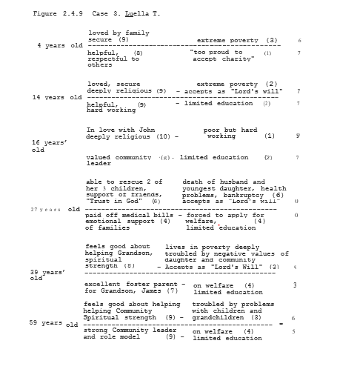

2.4.3.5 Case 5. Betty B. (42yo WF)

While Betty B. was born into a middle-class home, she spent her childhood in emotional poverty. Betty's father, a salesman, was often gone from home. When he was there, however, with his heavy drinking and physical brutality there was terror throughout the home. Betty would dread Thursdays when her father would return from his business trips. She and her two older brothers would hide in their rooms and listen to the yelling between her parents. She knew the physical beatings would come soon thereafter.

When she was seven, Betty remembered her older brother, Tom, being hospitalized with a fractured collarbone after being beaten by her father. Because she was afraid of what would happen to herself and her children, Betty's mother had lied as to what happened, saying Tom had been injured falling down the stairs. Although they lived in a small town, to their neighbors in Elmwood there was a superficial sense of "normality" about the family. No one outside the family knew the secrets. Thus from the beginning, Betty lived with a sense of terror and of being trapped (-4/-1).
As with her daughter years later, Betty was a quiet and withdrawn child with mediocre grades (Cs) and few friends. The message she learned was "If I tell the 'family secrets,' things will only get worse for everyone." Therefore she simply withdrew into herself and her own private fantasy World. In a very real sense, she felt she was helping her mother and brothers by keeping silent. Thus when her father started sexually abusing her at age 10, Betty was in many ways, the perfect victim. When her father carne to her bedroom she did what he wanted. When he left, she seemed to forget it had ever happened. He did not really have to threated her not to talk. She had already learned that throughout her life (-6/-3).
At 18, a month after graduating from high school, Betty eloped with her “childhood sweetheart," Peter. Pete was the only person that Betty had ever told about her father's sexual abuse. Pete tried to help and protect her and she loved him for it. Although Pete had planned on going to college, when he had found out that Betty was pregnant he had instead gotten a job as a mechanic at a local garage. Tammy was born the following January. While Pete tried to be a good father and “provider" for Tammy and Betty, in many ways, he too felt trapped in this marriage. Both she and Pete used to frequently attend “beer parties" when they were in high school together. Now Pete started to drink more heavily. A year and a half after Tammy was born, Pete lost his job for telling his boss off at work when he was drunk. Tammy helped out by getting a job as a waitress. But tension was growing between them (4/4).

Just when things looked like they would be over for Betty and Peter, Betty's father suddenly died of a heart attack. To her surprise, her father had left her a small inheritance. The money was enough to support them while Pete went full-time to a local Junior College. Peter also agreed to go to counseling with Betty which, for a while, helped them both to make much progress in their relation. Betty continued working part-time as a waitress. Her mother helped out with babysitting.

Towards the end of Pete's second year in college, Betty found out that she was pregnant again. Peter felt strongly that they couldn’t afford a second baby at that time and wanted Betty to have an abortion. Betty refused. They fought, but Betty was adamant. Peter started drinking heavily again. Two months after the birth of their second daughter, Cecilia (Sissy), with the help of his parents, Peter, moved to another State to finish his last two years of college. Although Peter invited her to come ultimately, Betty decided to stay in Elmwood. Betty worked as a secretary while her mother watched Tammy and Sissy. A year later, she and Peter were legally divorced. The following year, Betty met and married her second husband, Frank.
At first, the marriage with Frank appeared to go well. Although Frank was a relatively heavy drinker, he had a steady job as a computer programmer and a good work history. Frank treated Betty well and was particularly fond of taking Tammy and Sissy on trips to the park, zoo and other places that they might enjoy. Several months later, however, Frank lost his job when the company that he worked for went out of business. Although he got another job after about five months, this event seemed to change Frank in many ways. While he was off of work, Frank began spending more and more time with Tammy and drinking more and more heavily. One day while "wrestling" on her bed, Frank who was drunk at the time began to fondle Tammy, then went on to sexually abuse her. Although frightened, Frank warned Tammy not to tell or he would leave them and never come back. As Frank "visited" with more and more often, he drank more heavily and became even more brooding. He would find "reasons" to be physically abusive to Betty, Tammy and Sissy. Secretly then, he would make "deals" with Tammy to "let up" on the beatings in return for sexual favors.
The message of "family secrets" is often one passed on, often unintentionally, to future generations. Thus, years later, when Betty's daughter Tammy was being abused she felt that by keeping the secret of abuse, she was keeping the family together. Although later Betty said she sometimes "suspected” something was going on," there was the part of her who had also been abused who found it easier to block out these thoughts rather than confront him head on. Indeed, even when Tammy and the police finally told her about the abuse years later, there was still the part of her that desperately wanted to deny it ever happened. Such is the power of inner fears. Such are the cycles of abuse.

For all of the reasons there were for exposing and dealing with Frank's abuse of Tammy and Sissy, the immediate result of his arrest and conviction was to throw the family into financial chaos. Ironically, Frank was able to mortgage their house in order to hire a ''good" defense attorney. When Frank was sentenced to five years in prison, Betty had to declare bankruptcy and move with the children from their home. It was thus that Betty and the children found themselves on Public Aid and moving into Talbot Park.

Because of Tammy's friendship with James, Betty and Sissy were, in fact, relatively safe at Talbot Park. Betty, however, worried greatly about the sort of influence that James was truly having on Tammy. Within four months, her fears were confirmed. It was not just that Tammy was pregnant, but it was her use of drugs and eventual dropping out of school that equally troubled Betty. Betty also feared that Sissy would soon follow in her older sister's footsteps. Within two months of Tammy's announcement of her pregnancy, therefore, Betty had enrolled in a training program offered by Public Aid. Within -a year, Betty had gotten an entry-level job as a Medical Technician. She was off of welfare and moved with Sissy from Talbott Park vowing' never to return.

As was also the case with Luella T., because of her values and earlier "cultural" experiences, Betty did not allow welfare to become a trap for at least herself and Sissy. Clearly Betty spent her early life in a lose-lose position (-4/-1) that only got worse with the onset of sexual abuse by her father (-6/-3). But Betty was in part protected by being brought up in a small semi-rural town whose residents displayed strong family and personal values. Most of her friend lived in stable, two-parent families, went to the same church and served as positive role models for the values of Elmwood. Thus, despite the abuse by her father and her own relatively poor grades in school, for instance, Betty would not even have thought of dropping out and not finishing high school. Although she and Peter drank heavily at beer parties, they would never have considered using heroin or other hard drugs. Although there were the "bad kids" in school, there were not formal gangs as such. People even left their doors open and cars unlocked as a simple matter of habit.
As bad as her abuse was, Betty therefore had options never available to Mary or James T. When Betty got pregnant in her senior year at Elmwood High, it was not at all surprising for Peter to "do the right thing" and marry her. Indeed, there is even some question if this was precisely Betty’s intention all along. Either way, however, by marrying Peter, Betty went from a relatively negative position (-6/-3) to a relatively positive, if modest, lower middle-class life (4/4) in one "easy" step. Early on, therefore, since she and Peter were both hard workers, this move was a relative benefit to both herself and her community.
Although Betty's divorce from Peter was a ''step down" for her (2/2), her small inheritance from her father and her mother's help with the girls helped to keep this retrenchment from being any worse than it actually was. Marrying Frank moved her and the girls once again into a decidedly middle-class existence (6/4). As noted previously, although the reporting of the sexual abuse by Frank was absolutely necessary, its net effect was to plunge the family not only onto welfare, but ultimately into Talbott Park as well. As "positive" as Betty’s perception of their World had been (6/4), just so negative did it become (-6/-5). Thus, at least one of Frank's threats as to what would happen to the family if the "secrets" were told actually turned out to have some credibility to it.

While it is true that this “change ln status” was a perceived major loss for Betty (-6/-5), it is important to note that when Tammy reported this abuse, her own perceived quality of life was actually already quite low (-6/-1, Figure 2.4.3). Moreover, while Tammy had been willing to endure this lose-lose status for herself, when she found out that. Sissy was also being abused the rationale for her silence was also gone. As "bad" as welfare and Talbott Artwork, therefore, they were not worse than the continuing abuse by Frank of both Tammy and Sissy. Reporting Frank thus became a “rational” decision.
While Tammy's adaption of a negative win-lose lifestyle was a short-term "positive" for her (from. -6/-1 to 0/-2), Betty with her Elmwood born and bred value system looked upon these changes with true horror. It was thus not "poverty" nearly as much as the negative value systems Betty saw around her that were all the motivation that she needed to enter into the Medical Technician training program. Again, her finishing high school and previously positive, work history were major factors in allowing Betty to have “the system" work to her benefit in a win-win manner. Betty's leaving welfare and moving out of Talbot Park thus became “successes" as much for Society as they were for her (6/5). Trying to consciously design our systems to achieve such positive results will be the focus of Section 3 of this book.

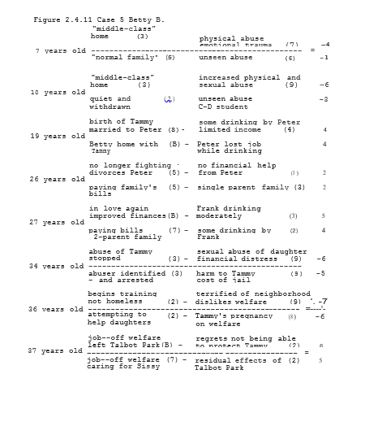
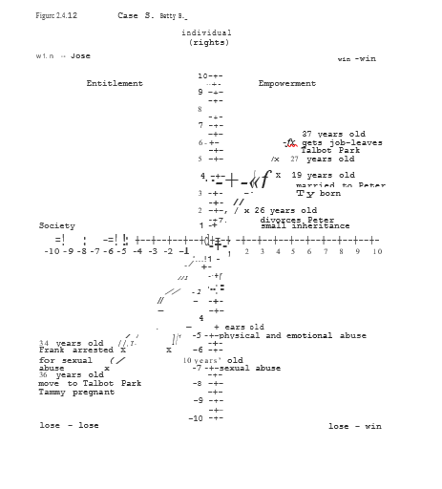

Table 2.4.1 Chronology of Events: Luella , Mary and James T.

1933 Luella T. born

1947 marries local war hero, John T., buy small farm

1949 Mary T. born

1951 Rachael born

1953 Rebecca born

1960 Father active in local Civil Rights movement; farmhouse firebombed; father and Rebecca killed;
Luella, Mary and Rachael badly burned; moved to Chicago

1964 Luella, Mary and Rachael moved to Talbot Park

1965 Mary pregnant with first child, heavy drug abuse

1966 Anita born two months prematurely; died two weeks later

1967 Mary solicitation-robberies; Shoots White Southern businessman

1968 James born; hospitalized first 9 months of life; lives with his grandmother for first five years of life

9/73 Mary released from jail

10/73 Mary moved in with boyfriend, takes James with her

1975 James beaten, sets fire, two children killed, first psychiatric hospitalization

1983 James dropped out, gang member, drug dealer, teen father

1984 Thomas born (Mary 35 years old)

1985 James murders rival gang member while high on Angel misdiagnosed as "schizophrenic," serves 5 years "easy time” in psychiatric hospital

9/90 James released from hospital, resumes gang and drug activities, commits several robberies and rapes in neighborhood

3/91 James meets Tammy, start "dating"

12/91 Charity born

3/92 James rapes and beats Tammy; on the run from the mafia

Table 2.4.2 Chronology of Events: Betty and Tammy B.

1955 Betty B. born
middle--class family, small town, rural Illinois (Elmwood)

1960 Betty's early memories of father being drunk and physical brutality towards mother and children

1965 Betty's father tries to fondle her

1970 Betty marries first husband Peter to complete high school

1971 Tammy born

1977 Peter, working as garage mechanic, gets financial stresses lead to Peter's increased drinking. Peter fired by multiple episodes of drinking on the job.
Betty helping out by getting a job as a result

1980 Cecilia (Sissy) born; Betty quits job, increasing financial stress on family; Peter's drinking increases

1981 Betty divorces Peter; Betty works as secretary; Betty's mother helps as babysitter for children

1982 Betty marries second husband, Frank; Returns to middle-class lifestyle; Quits job to stay home with her children

1983 Sexual abuse of Tammy by Frank begins

1989 Tammy tells a teacher about abuse when she finds out about abuse of Sissy; Frank arrested, convicted and jailed; Living in Chicago, mother not available for babysitting; Tammy forced to go onto welfare

1/91 Family moves to Talbot Park

3/91 Tammy meets James, gets pregnant

5/91 Betty enrolls in medical Technician training program

12/91 Charity born

3/92 Tammy beaten, raped and robbed by James; Tammy's suicide attempt (heroin overdose)

4/92 Betty gets job as Medical Technician moves out of Talbot Park with Sissy

Figure 2.4.13 Barnes Family Tree

Figure 2.4.14 Taylor Family Tree

III. Safe Haven— Breaking the Cycles

3.1 Multi-Systems Analysis (MSA)--Taking the Overview

3.1.1 Introduction

Having now presented 5 Case Studies as well as a brief analytic description of the problems of gangs, drugs and welfare, it is time to move to a discussion of how to break these all too vicious cycles ONCE AND FOR ALL. In order to accomplish such a goal, we need to be able to both clearly define our objectives and use steps that will be necessary to accomplish them. For this purpose, I will first discuss the principles of a Multi-Systems Analysis (MSA) approach to creative problem solving as they relate to these issues. Following this I will briefly outline some of the components of a Safe Haven program in major areas such as Work, Education, Social Services, Criminal Justice and Health Care. These programs can then be individualized to the particular needs of diverse communities and the people within them. After this review, I return to the Case Examples previously discussed to suggest various specific win-win options at critical points throughout the life cycle.

Finally, I will describe the present status of Safe Haven-related programs both at Lathrop Homes in Chicago and elsewhere in Illinois. It is again worth noting that, while I will be discussing Chicago and Illinois in particular, ultimately the Safe Haven principles described here can be applied in any setting with positive results. The key message is that, by working together, we can design integrated systems in which everybody is literally "part of the solution." Thus, by “taking the overview" we can not only understand the general principles of Safe Haven, but learn to apply these principles and programs for the benefit of all.

3.1.2 Multi-Systems Analysis (MSA)--The Win-Win Solution

3.1.2.1 MSA--Background

The primary goal of a Multi-Systems Analysis (MSA) approach to creative problem solving is to find ways to design the various levels of systems individuals may find themselves in (sell -­ internal systems; families; work; communities; State; National; Global) so as to achieve win-win outcomes for all parties involved. While often this is a stated goal and intent in the design of programs, all too often the outcomes are something much less positive.
One major problem often is clearly making the distinction between Entitlements (Rights without Responsibilities) and true Empowerment (Rights. AND Responsibilities). Whether it is as individuals or as a Society, it's generally hard to get somewhere when you really don't know where you're going. MSA helps to clarify this distinction. Another major reason for failing to reach win-win goals even when they are clearly articulated is the failure of the system to account for all relevant parameters that can impact upon the system. All too often, looking at a multi-dimensional problem through a unidimensional mindset is, at best, like the seven blind men trying to describe an elephant. Each has their own bit of the truth, but is unwilling or unable to look beyond it. If we can't look at problems from all perspectives, it will be hard if not impossible to even see the win-win overview.
An MSA approach as outlined below helps us to systematize the search for and attainment of win-win solutions for the benefit of all. While there is nothing at all sacred about this particular outline of win-win problem-solving steps, it helps to illustrate the process of identifying problems, setting goals, designing creative win-win solutions and measuring progress towards goals. As obvious as. such basic goal setting may be to many, if not most readers, it is surprising to find how often such goals are not even articulated let alone achieved. Again, if you don't know where you're going, it is going to be very difficult to get there. Conversely, most if not all people already have all of the basic ingredients that they need to feel "successful" in life, even if they do not yet have all the material possessions they might want. By stopping long enough to figure out what is truly important in life (love, family, health, meaning, faith, etc), many would come to appreciate how much they already have. Often in life, like Odysseus, we must travel long and far before we can come to appreciate the gifts that we had all along.
Whether it is individuals or Communities or entire Nations, losing touch with our basic values can often lead to many painful and ultimately tragic Chapters in the story of life. If we are lucky, we can learn from such stories and avoid some of the same mistakes in the future. I will use Betty B's (Case 5) first husband, Peter, as an example of an alcoholic man who just lost his job and whose marriage is a jeopardy to illustrate these steps (Case 6). The MSA--Individualized Goals Profile (IGP) illustrated in Figure 3.1.1 helps to summarize this example.

3.1.2.1 Case 6. Peter B. (43 yr WM)

Growing up in an alcoholic family, Peter B vowed that his own life was going to be different. Although financially well off, both of Peter's parents often fought after drinking leaving Peter, an only child, to fend for himself. Peter had always done well at school. When he was young, Peter wanted to be an astronaut. As he grew older he dreamed of being an astronautical designer who built the equipment to explore the galaxy. In its own way, perhaps, this was an escape from the constant tensions at home. But it was a dream that Peter was determined to see become a reality.
When Peter was a freshman in high school he and Betty shared several classes. together and became close friends. Peter could identify strongly with the chaos in Betty's home life and he tried to protect her from it as best he could. By the time they were senior’s ln high school they had agreed that they would be married after Peter had finished his first two years of college. When Betty got pregnant, however, late in their senior year it significantly altered both of their plans.

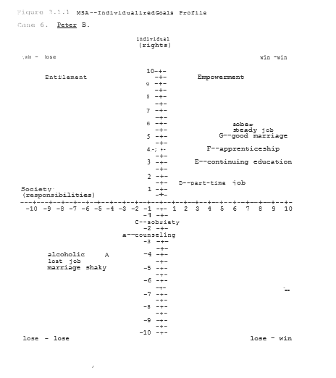

Because Betty would not consider an abortion, Peter "did the right thing" in his own mind by marrying her. Both Peter and Betty used to drink at "beer parties" in high school. (In fact, their first daughter, Tammy, was conceived at one such party.) Following their marriage, however, Peter began to drink more heavily. It was after losing his job, and almost his marriage, from drinking that Peter and Betty finally sought counseling.
When Peter first came alone to counseling, it was because he was afraid that Betty was going to leave with their daughter, Tammy. Over the year and a half since their marriage, Peter had become increasingly depressed, feeling trapped in his job and hopeless about the future. The more depressed he became, the more he withdrew into his drinking and away from Betty. While not overtly suicidal, Peter admitted to "not knowing what I would do" if Betty left.
During the initial interview, Peter also discussed his drinking and his original hopes for the future which now seemed so far away. While Peter wasn't completely sure if anything would save his marriage or even if Betty would be willing to come with him for counseling, he firmly understood that, particularly with his family history, there would be no chance of success without his giving up drinking completely. Peter therefore agreed to maintain sobriety and to begin using medication (Antabuse) and an antidepressant and attending AA meetings to help him in this process. (Antabuse makes individuals feel faint and nauseous if they drink.) In addition, Peter agreed to write out a list of his short- and long-term goals for himself and the marriage. Finally, Peter agreed to ask Betty to write out similar goals. He still remained skeptical, however, as to Betty's willingness to participate in these sessions. ·
To Peter's surprise, Betty not only showed up the following week, but had an extensive list of "goals" for them both. Peter and Betty were quickly able over the next few weeks to not only set up a series of obtainable step-wise goals, but actually implement several of them as well.

Peter found a part-time job and was able to enroll at a local Junior College as a first step towards returning to school. Not only did Peter maintained his sobriety, but he and Betty grew closer together than they had been in years. Literally, they felt like they were working together towards common goals. And they were.

As will be discussed below in describing MSA techniques and again in Section 3.7, it is important to periodically reassess progress towards stated goals and take appropriate corrective actions where necessary. After a few weeks of significant improvements, Peter and Betty felt that they had made sufficient progress to try "going it alone," for a while. While this is generally a desirable goal, such early termination of therapy can also be a way of avoiding issues sensitive to the individuals involved. In addition to suggesting that Peter and Betty consider returning later to continue their therapy, an agreement was made that they would "call if there are any problems." Unfortunately, a year and half later, when Peter was finishing Junior College and preparing to leave with Betty and Tammy to finish an engineering degree in another State and Betty again became pregnant, no such call was forthcoming.

Peter was bitter at Betty for what he saw as her efforts to "sabotage” his dreams of leaving Elmwood a second time. In college, Peter began having an affair with another engineering student: When he "admitted" this to Betty, she filed for divorce and forbade Peter from seeing the children whom "he never wanted anyway." While in college, Peter could not afford child support. Later on, Betty was remarried to Frank and didn't need or want assistance if it meant having to deal with Frank. Betty, with the help of her mother was able to support herself and the children by working and with the help of the remainder of her inheritance from her father. By the time Betty would have wanted child support some ten years later, Peter was nowhere to be found. Events moved too quickly to prevent the move of Betty, Tammy and Sissy to Talbot Park.

3.1.2.3 MSA-Steps in the Process

The above Cases involving Peter and Betty B illustrate on an individual level some of the potential pitfalls of creative win­win problem solving. In addition to issues of follow-through, there are many issues as to " levels" of therapy and support that contributed to the failure to attain all of the goals initially proposed by Betty and Peter. Clearly there are many things that they could have done differently to achieve more positive results.: Ultimately, however, the "systems" of which Betty and Peter were a part and the "values" reflected in these systems also contributed significantly to the final outcome in this situation.
It is fundamentally impossible to understand individual actions without understanding the context of the families and communities in which they live. It is even more impossible to design successful "treatment strategies" without a full understanding of these contexts. It is to better understand the "steps in the process" of a comprehensive and successful Multi-Systems Analysis that the following summary is offered.

MSA--Win-Win Problem Solving Summary

1. Assess present status (Where are you now?).

Whether assessing the status of an individual, a program, or a community, it is useful to try and estimate the “costs” and “benefits” of the present situation (Figure 3.1.1, Point A—alcoholic, lost job, marriage shaky).

2. Set specific measurable win-win target goals (Where do you want to get to? When do you want to get there?).

Define both the goal you are seeking and some of the criteria by which you will know when you have achieved it (Point G--sober, steady job, good marriage).

3. Assess relevant systems involved in achieving goals.

a. Assess the number of systems involved.

Include all of the various areas that can be contributing to the problem (eg, Peter was depressed because of a lack of education, with a genetic vulnerability to alcoholism, now unemployed, fighting with his wife).

b. Assess the number of systems involved.

Within a system, multiple levels may be involved. Often it is the oversimplification and discounting of certain levels of a system that may cause the most problems. For example, counseling for Peter might include individual, couple and group (Alcohols Anonymous) modalities as well as the use of an antidepressant and/or other medications (eg, Antabuse). In addition, a reality-based cognitive therapy might suggest that Peter would need additional education to get the type of job that might help him to keep from feeling “trapped" and depressed.

4. Design an integrated multi-level system to accomplish goals.

Once what are believed to be the appropriate systems and levels of systems necessary to accomplish an objective are identified, it is necessary to integrate them in such a way as to either simultaneously (parallel) or sequentially (series) move individuals or communities towards desired goals. For example, in order to maximize the chances for success, it would have been best for Peter and Betty to continue in some form of ongoing therapy throughout the period at least that Peter was completing his college education in getting a job in his chosen field.

5. Implement programs to accomplish goals.

Once the integrated multi-level system is designed it is important to actually implement it and work towards accomplishing the specified goals. Simply put, ACTIONS SPEAK LOUDER THAN WORDS.

6. Assess progress towards goals.

Periodic assessment of progress towards stated goals is essential not only for maintaining momentum but also for evaluating potential "trouble areas" in the original design. Often, the failure of a particular MSA design suggests the need to expand the system and/or the levels included to make progress. For instance, when Peter left Elmwood to continue his schooling, the fact that he and Betty had long since discontinued therapy along with his finding another girlfriend both contributed to the failure of the original goal of marital reconciliation. Later, Peter's not paying child support contributed to Betty's troubles both before her marriage to and after her divorce from Frank. To deal with this problem as well as the drugs and gang violence at Talbot Park would take adding several additional systems and levels to the original solution design. We will come back to these issues in Section 3.7.

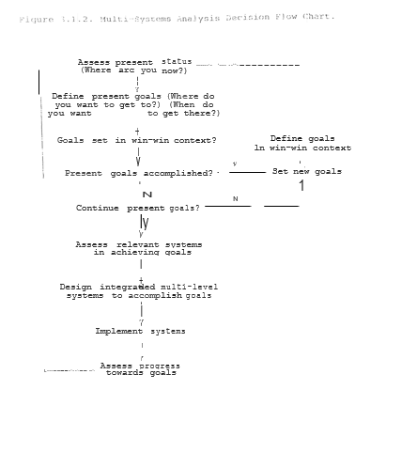

7. Set new goals.

Either after present goals are accomplished or a decision is made to change goals, it is necessary to select new goals and/or expand upon past ones. As noted above, while Peter went on to finish college and obtain a good job out-of-State, Betty, Tammy and Sissy spent years struggling to get their lives back in order. Similarly, the other Cases described also suggest major problems with the present "System" in helping individuals to move forward in positive directions. Thus, in addition to individuals setting new goals based upon past experiences, so too Society as a whole can collectively decide to learn from such experiences and improve upon the overall system. In part, this is a purpose of this book. I shall come back to this point in Section 3.8 in discussing the Politics of Change. ·

The relation of these steps is summarized in Figure 3.1.2. This Figure is meant more to be illustrative than definitive of an MSA approach to problem solving. Its relevance here is that there are multiple ways and points at which effective problem solving can fail. When it does, individuals, families, communities or nations can become stuck in perseverative loops in which inordinate amounts of energy and resources can be expended with no meaningful goals being accomplished. It is precisely in order to break such “loops" or cycles that the MSA system has been developed.
Figure 3.1.2 also illustrates that there is nothing inevitable about defining goals in terms of win-win scenarios. We learn values from our experiences as we grow. While we can reexamine and change our values at any point if we so chose most often we act on these values without necessarily truly understanding their implications. Win-win outcomes, therefore, represent a conscious choice as to the type of lives we wish to live and the type of society we wish to create. Therefore, by specifically seeking out win-win solutions, we apply these positive values every time we set goals for ourselves and our institutions. Again, it is precisely by knowing where we want to go that we are most likely the get there.
I will come back to Figure 3.1.2 as it relates to our attempt to actually implement parts of the Safe Haven program in Chicago and elsewhere in Illinois. A much broader discussion of the range of applications of MSA techniques can be found in my book MSA: Breaking Cycles-Winning Solutions. For the present, however, I will limit this discussion to the actual designing and individualizing of Safe Haven programs.

3.1.3 Safe Haven: One-Stop Case Management (OSCM)

The focus of all Safe Haven programs is on a multi-level, multi-agency long-term intervention, prevention and treatment strategy to identify and correct individual, family and community-related factors that maintain dependency behaviors including drug usage, chronic welfare, teen pregnancy, unemployment, abusive relations, school dropouts and gang-related activities.

Safe Haven is different from other intervention strategies in the extent to which it involves local community and public housing residents in becoming “part of the solution” to their own problems.

Rather than looking primarily at bringing additional off-site services and unity, Safe Haven would vastly expand the use of Public Aid recipients in a program called Community Service Corps (CSC) to develop these services locally to the greatest extent possible especially in conjunction with developing Resident Management Corporations (RMCs). The bottom-line message of CSC is that all recipients would participate in some form of traditional private-sector or CSC-type work. But, to the greatest extent possible, it will be up to the CSC participants to choose which programs they would most like to be involved with and which would best suit their long-term job/career interests.
Figure 3.1.3 outlines a “One-Stop Case Management” (OSCM) approach to Safe Haven which incorporates the general principles of the MSA techniques as discussed in Section 3.1.2. In order to clarify the use of these MSA principles, I will summarize this Figure as outlined below.

Safe Haven One-Stop Case Management (OSCM) Summary

1. Assess present status--Points of Entry.

As illustrated in Figure 3.1.3, any risk factor for an individual or family can become a "point of entry" into the Safe Haven program. By having a single (one-stop) intake procedure, however, we can ensure that the individual and their family are receiving a thorough assessment as to service needs with appropriate referrals being made where possible. This initial assessment would be done through an integrated network of Local Level Community Organizations (LLCOs).

2. Set specific measurable win-win target goals--IGPs and CGPs.

As part of the initial intake assessment we wish to know not only where people are now, but where they want to go over various periods of time (immediately, 1 month, 6 months, 1 year, 5 years, 10 years, lifetime, etc). While the initial assessment generally focuses on the immediate needs of individuals and their families, instructions are given to start thinking about and writing down more long-term goals.

These more long-term goals, become part of the Individualized Goals Profile (IGP--Figure 3.1.4) more fully developed in Step 3. Just as individuals can articulate their goals, so too Communities through LLCOs, Resident Management Corporationsn(RMCs) and directly through town-meetings can develop Community Goal Profiles (CGPs) of both short- and long-term objectives. Once specific goals are set, then they too can apply these MSA steps towards the accomplishment of these objectives.

Figure 3.1.4 CSC Participants I GP Assessment Worksheet

Name:
Address:
Phone #:
DOB:

Family Members:

Ages:

Current Status

Work:

Education:

Supportive Services: Criminal Justice:

Individualized Goals Profile

Immediate:

l month:

6 months:

l year:

2 years:

5 years:

10 years:

lifetime:

3. Assess relevant systems involved ln achieving goals—CSC Orientation

Once the initial intake assessment has been done and the individual and their family's immediate situation has been stabilized, an appointment is scheduled in the near future for participation in a CSC Orientation Seminar. During this 3-day long seminar, individuals are introduced to some of the various CSC Public- and Private-sector work options available to them. Workshops and group discussions are also held on drawing out IGPs. In evaluating their short- and long-term goals, individuals with assistance can start to identify the number and level of systems that will be necessary for them to accomplish their desired goals. As illustrated in Case 6 above, such systems will often include Jobs, Education, Supportive Services, Health Care and possibly Criminal Justice to name but a few.

4. Design an integrated, multi-level system to accomplish goals.

Once, with assistance, the systems relevant to a particular individual and their family are identified, an integrated, multi­level system to accomplish these desired goals is developed. While individuals are ultimately making their own choices to the greatest extent possible, they are assisted in this process in groups by trained case managers. These case managers in generally will work with groups of CSC participants throughout the entire process of achieving their goals.

5. Implement programs to be accomplished.

In a One-Stop Case Management approach, these community-based CSC programs are run by consortiums of Local Level Community Organizations (LLCOs). Under contract with the various State, Federal and Private agencies involved in the Community, the LLCOs coordinate and, where possible, actually provide the services previously performed by these outside agencies. Because, to the greatest extent possible, LLCOs are owned and run by Community members themselves, in essence this long-term process of individual and Community goal identification and attainment becomes an example of neighbors helping neighbors. As such, the Community-base for local Empowerment and control is strengthened.

6. Assess progress towards goals--CCD/ATS (Central Computerized Database/Automated Tracking System)

For both local CSC programs and referrals to agencies and/or programs outside of the community (eg, Education, jobs, etc), the LLCO maintains a computerized file on the individual participants and their families as part of a standardized Central Computerized Database (CCD). This database is updated with information from multiple sources such as school attendance, job performance, parole status, etc. from all of the various agencies working with the individual and their family. As such the CCD serves as an integral part of an Automated Tracking System (ATS) that continuously monitors and assesses progress towards IGPs and CGPs.

In addition to its direct role in tracking and assessing progress towards stated goals the CCD also serves as the centralized database for statistical comparisons between various individuals and communities on a local State and even National level. Just as the Federal Center for Disease Control (CDC) tracks various traditional "infectious" processes, the CCD allows us to expand this epidemiological tracking and research include social "infectious" processes such as child abuse, school dropouts and crime. By having such data available on a continuous basis, evolving epidemiological patterns and trends can be identified and appropriate responses can be implemented in a highly timely and cost-effective manner.

7. Set new goals.

Just as in the Cases of Peter and Betty B. setting goals does not necessarily mean that they will be met or at least accomplished in the way originally conceived. One of the major benefits of articulating goals is to be able to better assess how " realistic” they may actually be and how much work may be necessary to accomplish them. A gang-banging high school dropout may wish to become a millionaire. Short of winning the lottery, in the past he would have accepted the win-lose Entitlement alternative of drug-dealing and crime. By reframing objectives within a win-win context, however, more positive alternates may be sought. There are countless examples of businessmen, professionals, sports and entertainment figures and many others who worked hard over many years to see their dreams become realities. When dreams are dreamt in a win-win context, everybody benefits.
Just as with individuals, so too on a Community and Societal level as well, we can all "have a dream" and work to see it happen. But while we can formulate positive goals, it is essential that we track the progress or lack thereof towards their actual attainment. As we strengthen Communities and see them evolve, we can come more and more to learn that true Community Empowerment comes from collective action. In a Participatory Democracy this means letting the People set the social agenda and then holding politicians and bureaucrats alike ACCOUNTABLE for their implementation. I will come back to this discussion in Section 3.7 when I talk of the Politics of Change and what is yet to be done.
The goal that has been set for Safe Haven is the achievement of "A Gang-Free, Drug-Free, Full-Employment Economy in America by the Year 2000" (now, 2020). In the next several Sections I will outline some of the broad features of such a comprehensive, achievable Safe Haven programs in the areas cdxc however, are far less important than keeping the dream alive and working together to see it happen. If we want the goal enough, we will find a way to make it happen.

3.2 Work--The Full-Employment Option
"If anyone will not work, let them not eat." --Apostle Paul, 2 Thessalonians 3:10

3.2.1 Background

An important long-term goal of Safe Haven is to design an integrated series of systems so that children· grow up learning the necessary skills, behaviors and attitudes to help both themselves and America compete in an increasingly global marketplace of products and ideas. As such, Safe Haven emphasizes a collaborative partnership between business and the education system for all individuals whether defined as ''at-risk" or not. In order to achieve a truly cost-effective, win-win system, however, we must also start with the assumption that the system is designed to work for everyone. As such, the objective of a full -employment economy becomes a relevant criterion in the system design.
A full-employment economy in America can be most readily achieved by starting with the assumption that, to the greatest extent possible, everybody but the elderly and most severely disabled will be expected to contribute in some positive way to their communities. If we make the assumption that no one in America needs to starve, then we are only talking about people working versus not working for the benefits that they receive.
As the above quote by Apostle Paul suggests, the value of work is not a new concept to the World. But, as a Country, we have lost our way and forgotten the importance of these basic values. We can accomplish wonderful things if we all literally Work Together. By everyone becoming "part of the solution," our communities can start to restore these basic values in our Society. Safe Haven is designed not simply to change behaviors, but to change attitudes and values as well.
Far more important than the obvious economic benefits of a full-employment economy, therefore, are the cultural benefits that would come by moving from an ethic of Entitlement to one of true Empowerment. By everyone accepting the notion. that along with Rights come Responsibilities, the importance of work becomes obvious. Once the assumption is made that everyone will work, then individuals have a strong incentive to move towards the jobs and careers that will give them the most satisfaction. Safe Haven’s One-Stop Case Management is designed to assist in this process.
As an early step in a One-Stop Case Management program, individuals would be assessed as to both their present abilities and longer-term goals. From this assessment, an Individualized Goals Profile (IGP) would be developed. By designing a series of levels of work involvement, ranging from community service to public- and private-sector jobs as illustrated in Figure 3.2.1 individuals can then be placed at a point in keeping with their present abilities, but work over time towards their long-term goals. Thus a continuum of positive win-win goals can be set startling from wherever an individual may presently be.

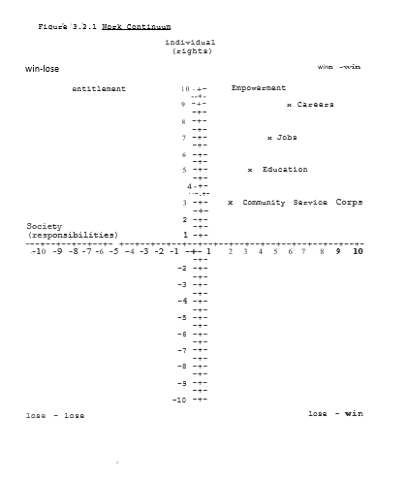

It is important to again note about this continuum that the more “Rights" an individual wish (eg, education, good paying job, family, etc), the more Responsibilities that they also require (studying hard, working hard, being a good spouse and parent, etc). Since it is precisely such issues that have often been barriers to success in the past, a Multi-Systems Analysis (MSA)-generated IGP would also identify the types of educational/ training opportunities and supportive services that will be necessary for individuals to achieve their stated goals. The range of such supportive services that will be necessary for individuals to achieve their stated goals, from educational and training seminars to goal-oriented support groups to participation in work-based Enhanced Employee Assistance Programs (EEAPs), are discussed in further detail in Sections 3.4 and 3.6.
In order to better understand the application of these MSA techniques, we will come back to this continuum and IGPs when in Section 3.7 we apply these principles to our five Case Histories previously described. As was seen in our original discussion of Learned Helplessness, negative self-defeating behaviors can be maintained indefinitely unless alternative more rewarding positive options are available. Even then, however, it takes good structure, repetition and multiple perceived ”successes" for positive habits and values to be developed and maintained. It is follow-through that most often determines outcome. Thus, again, by combining the “Right" of assistance (salaries, tuition, training, etc) with the “Responsibilities" to oneself, one's family and community (including working and being a good parent and citizen), that individuals are increasingly Empowered moving along Freedom's Road.

3.2.2 Community Service Corps (CSC)

Community Service Corps (CSC) would serve as the general program in which all Public Aid recipients are provided with at least some hours of work with or without additional schooling each week as part of a therapeutic regimen designed both to improve self-esteem and to foster the habits and skills of work while contributing useful services to their local communities.
Depending upon the particular track chosen (eg, work experience versus academic), CSC service would be done in conjunction with other more traditional Public Aid requirements such as job search on days when clients are not actively participating in other programs. While continuing education would be emphasized as a CSC activity, individuals pursuing these activities would also participate at least some hours in other CSC projects such as tutoring, support group counseling or other options of their choosing. A partial list of potential programs include the following: '

--continuing education (high school, GED, job training, higher education, etc) ··
--school, study-hall, park and playground monitors
--neighborhood Resident Patrol teams--eg, monitoring elevators and entrances in public housing and throughout neighborhoods teams patrolling with walkie-talkies, etc.
--community clean-up crews--eg, cleaning vacant lots, parks, alleys, wire-brushing off or painting over graffiti, shoveling sidewalks in winter, etc.
--ecology recycling teams and garbage collection
--day care aides
--teachers’ aides and tutors
--library aides--eg, reading hours for children
--nursing home aides
--hospital aides
--meals on wheels for elderly and disabled
--janitorial services in public buildings, churches, mosques, synagous, etc.
--Big Brothers and Big Sisters
---organized activities counsellors (eg, Scouts, 4-H 1 local sports teams, etc.)
--local school board and/or PTA participation
--Vista-type projects

Because some programs can be implemented more rapidly than others, it is proposed to gradually phase in these programs over several years starting out now with Public Aid recipients identified as priority groups under the Federal JOBS bill including younger recipients, especially those first coming on to Public Aid, with or without a high school diploma or GED. Other additional specific early target groups would include fathers not paying child support and convicts released on probation or parole. Later stages could involve, for example, working with businesses to develop extended apprenticeship programs, sheltered workshops and work-release programs for other particular identified populations. Some programs, however, eg, After-School programs, Community Clean Up, Resident Patrols, and Parole/Work Release/CSC could be set up very rapidly with minimal start-up costs and could be begun as at least demonstration programs in a community quite rapidly. Rapid set up could be facilitated particularly by drawing on the expertise of personnel presently working as Public Aid caseworkers and in other community-based programs. A brief summary of these early Safe Haven initiatives is given in Table 3.2.1.

Table 3.2.1 Partial Summary of Proposed Safe Haven Programs

1. Safe Haven Community Policing/Resident Patrols

Community Service Corps participants walking in groups of two or three and linked to local security by walkie talkies (now, smart phones) "secure the perimeter" of various areas of the Community as "Safe Havens."

2. Before- and After-School Programs

Safe, positive after-school programs run with use of PC/CSC
workers as study hall and playground monitors, tutors, etc.

3. Pre-Head Start/Advance--High Quality, Affordable Day Care

Proposal for Infant/Toddler day care programs in the schools to provide quality Pre-Head Start environments for children while teen parents complete high school and participate in parenting classes with their children. Later stages in this program would make such affordable day care available for all American citizens wishing to use it.

4. At-Risk Support Groups

Voluntary and mandated after-school programs for students and their families identified as at risk for gang crime, alcohol and drug abuse, dropping out and teen pregnancy.

5. Chronic Recidivist/Homeless/Developmental Disabilities Program

Five-level program of interventions to provide work experiences in progressively structured environments based on the needs and abilities of individual patients as part of a therapeutic regimen to foster maximum patient autonomy and responsibility.

6. Probation/Parole/Work Release/Community Service Corps

Five-level intervention program to provide remedial educational and long-term work experiences in progressively structured environments for individuals involved in antisocial behaviors.

A simple example of the organizational structure of a CSC program, in this case Community Policing/Resident Patrols (CPs/RPs) can be seen in Figure 3.2.2. Groups of 2-3 RPs would monitor a designated area, eg, parks, schoolyards, buildings, etc., keeping in contact via walkie-talkie (now smart phones) with a local CHA security dispatcher and the regular CHA security personnel for that designated area. RPs are NOT to intervene in potential problems, but simply report them immediately to CHA security who are then. available as "rapid deployment" forces. As such, CP/RPs would empower local residents to create literal Safe Havens within their neighborhood. CP/RP would thus help to truly bring the Community into Community Policing.
After-school programs would complement the work of CP/RPs by providing neighb0rhood youth positive educational, recreational and sports alternatives to gang activities within the established Safe Havens. Again, CSC workers would be acting a$ assistants to personnel (eg, at CHA, the Park District, schools, etc) who may presently feel overloaded in the task they have. Thus, a sports coach, for instance, might now have ten assistants so that more children can be served, but with less overall effort.
In Illinois, a “new” program called Earnfare (1972) allows individuals recently cut off from General Assistance (GA) to work for up to 6 months without cost to private and/or public employees willing to give these individuals work experiences: As such, we therefore have the beginnings of an CSC-type program in which individuals can provide valuable services to their Community while simultaneously getting the experiences that will help to break these cycles once and for all. A partial list of possible CSC jobs and those Chicago Departments proposed to provide supervision and potential entry-level positions resulting from these jobs are given below (Table 3.2.2)
It is argued that each project described will not only improve conditions and provide services but will actually save money by its implementation. Table 3.2.3 lists approximately $40M in savings and/or additional services that Chicago could achieve by using even 3,500 CSC participants in the various listed City Departments and Agencies. 3,500 participants represent less than 5% of the approximately 80,000 Public Aid recipients presently unemployed in Chicago alone.
But direct savings from increased services is only the beginning of the story. If by the use of such Safe Haven programs we were able to reduce gangs, drugs and teen pregnancy rates by even 10%, we would be saving over $400M annually in Illinois alone (Figure 3.2.3). By reinvesting even, a portion of these savings into prevention--oriented programs such as high-quality affordable Day Care and After-School programs, we would get a multiplier effect with even greater savings, both financial and otherwise, in future years.

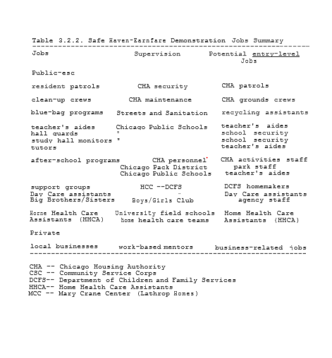
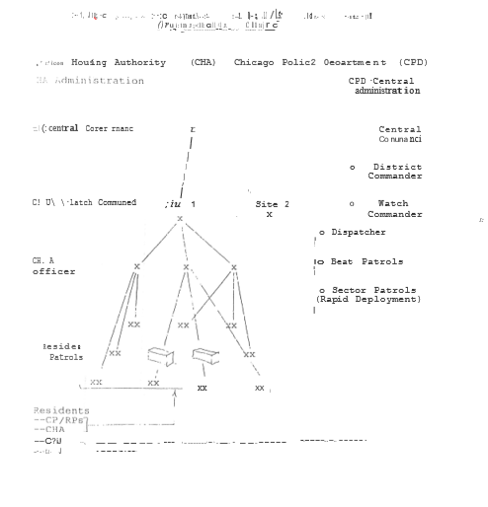

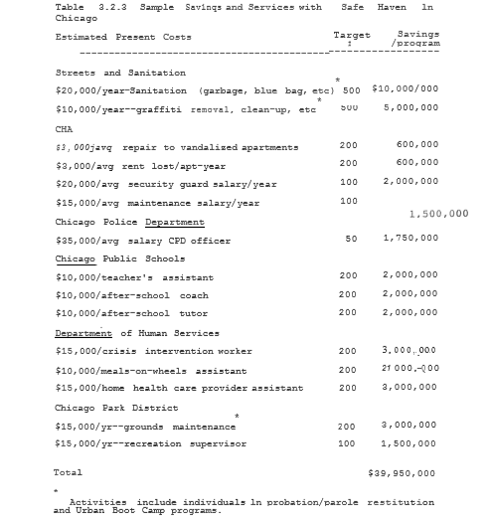
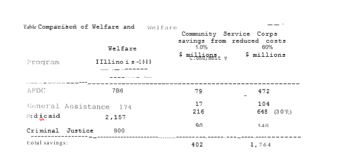

The results from our initial program sites will be used in improving upon and expanding the services available to increasingly large numbers of Illinois citizens in future years. Thus, for example, important initiatives in quality day care and after-school programs as noted above and discussed in more detail in Section 3.3.1 can potentially be funded not by raising taxes, but by improving prevention efforts from which everybody benefits. In addition, depending on the cost-effectiveness of our initial programs, it may even be possible to offer college students partial or full scholarships for CSC VISTA-type participation thus broadening its base and aiding middle-income as well as low-income families. By creating a new ethos of community involvement, we could again reach out to the idealism of our youth and young adults to participate as active members and leaders in the process of change and community renaissance.

3.2.4 Work—Public-Sector

The ultimate goal of the CSC programs is to not only to break the Welfare cycle, but also act as a first step towards the goal of a full-employment economy in America by the year 2000 (now 2020). As such the CSC program serve as a transition mechanism from the present' welfare systems to permanent jobs in the public and private sectors. By their very nature many, if not most, of the CSC jobs could be seen as training for entry-level positions in the public sector including the social services and community-based organizations (CBOs). Particularly at a time of significant budgetary cutbacks, CSC offers a means of significantly expanding community-based social services while simultaneously reducing overall costs.
Table 3.2.2 above illustrates a variety of CSC jobs which could be used as transitions to entry-level positions in various Chicago Agencies and Departments. In this example, using even 3,500 Public Aid recipients in CSC positions could potentially save Chicago nearly $40 Million annually. While initially CSC volunteers could work under the supervision of individuals in each of the listed Departments, over time as their skills increased, the City and other local and State agencies could make a commitment to hire a certain percentage of their new workers from among the ranks of these volunteers.
Similar to City Departments, many State as well as local CBOs could also serve as more long-term employers of local residents once their skills had been improved. Details of some such positions in Illinois' Department of Children and Family Services (DCFS), Mental Health (DMH) and Public Health (DPH) are further discussed in Sections 3.4 and 3.6. Even if, in a worst-case scenario, individuals did not develop skills above minimum wage or near-minimum wage value, simply being “part of the solution" rather than part of the problem would in and of itself be of value to the Community.
Whether it is Resident Patrols/Community Policing, teachers’ aides, Crisis Intervention, After-School or Day Care programs, the fact that these programs would involve local residents helping out their own neighborhoods often working with their own children would help to strengthen the sense of community involvement and Empowerment. Who better to work in these programs than the individuals who know their own community the best and have the most to gain from the program's success? Thus, by conscious design, these programs would create a win-win scenario for individuals, their communities, local government and taxpayers alike.

3.2.4 Work--Private-Sector

As important as public-sector jobs are, particularly in the short-run, the long-term ideal of Safe Haven is to move people increasingly into private-sector jobs whenever and wherever possible. In order to achieve this goal, various levels of intervention can be implemented based upon the particular needs of the businesses and communities involved in such programs. A summary of some of the programs to be discussed is given below.

Table 3.2.4 Levels of Private-Sector Work Interventions

--tax credits
--Free Enterprise Zones
--Adopt-a-Community
--Work Apprenticeships
--Continuing Education
--Full-Employment Economy

3.2.4.1 Tax Credits

One of the simplest and most rapid ways to encourage the hiring of individuals on public assistance into private-sector jobs is through the use of tax credits. While such tax credits can be useful in some settings, often the amount of paperwork involved in applying for, reporting and collecting any benefits is enough to discourage many, especially small businesses, from taking advantage of these programs.
Safe Haven proposes to move towards a "paperless" terminal­ based system that would link potential employers directly with job applicants. Some components of such a program are presently being tested by Illinois' Department of Employment Security (DES). In this fully developed system, employers would register available jobs with DES. If jobs are approved for tax credits, they would be entered into part of the Centralized Computer Database (CCD) network. A list of available jobs and necessary qualifications can then be accessed from any terminal within the community-based programs. As part of the intake assessment process, an individual’s educational and work history would be also entered into the CCD. A match is then automatically done as to which jobs would potentially be suitable for a particular application. Appropriate interviews would also be arranged electronically.
An applicant who is accepted for a position would be so indicated by the employer within the CCD system. The new trainee’s attendance and work performance would be entered into the same system. Based upon this information the appropriate tax credit would be automatically calculated and registered within the employers CCD records. Automating the tax-credit system should greatly simplify the process for all involved. By eliminating paperwork and simplifying the entire system, it is hoped that a greater number and variety of employers would find the Safe Haven-CCD system both cost-effective and suitable to their needs.Thus, rather than necessarily raising the amounts of the tax credits, simply improving the system could do much to attract employers to at least give it a try.

3.2.4.2 Free-Enterprise Zones

In Free-Enterprise Zones entire areas are designated as eligible for various tax credits. Similar to the procedure with individual companies the automated CCD approach could help to encourage entire communities to consider participation in these programs. Equally important, however, Safe Haven would also emphasize such areas safe and positive environment for employers and employees alike.
If we wish to stop the flow of American companies to other communities, let alone other countries, then we must understand the issues underlying this problem. While many inner-city areas may be taking on the demographic characteristics of third-World countries, some of the factors underlying this trend, in addition to cost, actually are crime, poor work habits and even literacy rates are often by no means competitive. An employer "who feels that his or her business may be robbed, vandalized or even burned down is hardly likely to want to invest in an area regardless of the amount of tax credits. Thus, improving the human factors of a community such as safety as well as worker skills and motivation will ultimately be as important as overall costs in attracting and keeping employers in Free-Enterprise Zones. ·
In addition to improving the physical safety of communities, therefore, Safe Haven will also focus on improving the educational and motivational factors that would make such communities attractive to employers. While these subjects will be discussed at greater length in Section 3.6. 6, one issue is the creative use of Enhanced Employee Assistance Programs (EEAPs).

Traditionally, EAPs have been set up by employers to "assist”' and often refer employees who are having personal and, particularly when these affect their work· performance., While EAPs are thus often "reactive," Safe Haven would focus on an increasingly proactive, prevention-oriented approach of overall mental and physical wellness. Working with others, we are developing work-based programs that assist in improving not only worker productivity, but overall job and personal satisfaction in life. Thus, as noted previously, the overall goal of Safe Haven is to assist all individuals towards the realization of their full potential. By incorporating such EEAP-type programs into our overall Safe Haven design, we thus help in the realization of these potentials for individuals and communities alike.

3.2.4.3 Adopt-a-Community

For some companies who cannot physically move, the option of "adopting" a community may have some mutual win-win benefits. In addition to being a "good corporate citizen," developing an ongoing partnership with a particularly community may have some other benefits as well. For a small or medium-size manufacturing plant in a suburb, for instance, transportation may be a serious barrier to hiring inner-city residents to entry-level positions. By adopting a particular housing development, however, it might in fact become cost effective to have a van or bus pick up workers/trainees en mass in the morning and return them home at night. The company can thus take advantage of tax credits and (or lower salaries while assisting individuals in gaining new skills and opportunities.
For all of the work options discussed, mentoring programs can both complement and enhance traditional training and work practices. By encouraging more experienced employees to act as mentors, trainees would get both valuable assistance and positive role models to assist in the transition to the work environment. Because trainees would be working either free of charge or at a reduced rate, companies could afford to give mentors either additional time off and/or bonuses for their efforts. Mentors could also avail themselves of continuing educational opportunities during their additional time off." Thus, again, a win-win scenario is created from what could otherwise be a divisive, adversarial situation.

3.2.4.4 Work Apprenticeships

As Safe Haven program are further developed, a significant step towards an increasing focus on prevention would be the establishment of strong work apprenticeship programs. Just as companies could H adopt a community," so too they could “adopt. schools as well. While many companies already assist schools either financially and/or by the volunteer work of some of their employees, apprenticeship programs could, again, be a win-win option for students, schools and companies alike.
Through the development of apprenticeship programs, particularly students in vocational programs could get valuable experience in actual work settings. Where the value of a student's work may not totally offset the time spent in training and supervision, it may prove cost-effective to school districts to pay companies a certain fee rather than trying to buy the necessary modern equipment to run such training programs themselves. In addition, companies would have better quality control in ensuring that students would learn those particular skills. and. Jobs that are important to the company. Thus, companies would be ensuring themselves of a supply of new workers already familiar with their particular needs and operations.
Students, too, would have a greater incentive to take such training seriously if they felt that good performance might eventually lead to a job after graduation as done by some corporations already. Part-time and summer­time jobs might also be offered as "rewards" to particularly promising students. Thus positive behaviors would be encouraged and positive values would be taught in deeds as well as words.

3.2.4.5 Continuing Education

Because the nature of work and the workplace will continuously evolve through our and our children's lives, the need for continuing education will become increasingly important. By integrating many components of our educational system within the workplace itself, we could make such life-long learning something to be appreciated rather than feared. As noted previously, such personal and professional development could become a primary focus of future Enhanced Employee Assistance Programs (EEAPs). Further, to the extent that such learning would ultimately tend to improve both overall job security and worker productivity, it is again a win-win option for employees and employers alike.
The two basic options for continuing education would be on-site and off-site locations. Off-site programs, including on-line courses, part-time community college curriculums, night school, leaves of absence, worker retraining programs, etc are already fairly well understood although they can certainly be further expanded. The advantages of such programs are that they are already established and have on staff personnel who can connect some of the traditional educational needs of workers in a relatively expeditious fashion. Creative partnerships between such traditional academic institutions and businesses may be particularly cost-effective and should be encouraged.
In addition to off-site classes, however, there is much to be said for significantly expanding on-site training with continuing education programs. Just as was discussed above with tax credits and apprenticeships programs, there are many advantages to on-the-job training for employees, employers and tax-payers alike. Again, by having much of a worker’s on-going training occurs at the workplace, they are getting hands-on experience that most closely meets their and their employer’s particular needs. Rather than simply discussing "theory” and/or working on often out-of-date equipment in “shop classes," workers can thus apply what they are learning to their day-to-day work experience. Thus, programs can be evaluated for cost-effectiveness not just by traditional " grades," but by bottom-line dollars and cents worker productivity.
Having some education and scholarship dollars spent in the workplace rather than traditional classrooms would also mean that companies would have a greater incentive to invest in new technologies and equipment to keep their companies competitive in national and international markets. Similarly, by awarding worker retraining contracts on a competitive bidding basis, those business who could most use the workers would require the least public funding to train and hire them. Thus, instead of paying extended Unemployment Compensation, worker retraining program dollars would also be able to be targeted to "real jobs" in "real businesses."
As important as the potential cost-savings of on-site continuing education programs may be, their value in terms of employee morale and job satisfaction may be even greater. For many years a somewhat artificial distinction has existed between experiences learned in “the school of hard knocks” and those coming from informal education. By giving workers formal credit for their various expertise we would also help to give additional recognition and value to the efforts they make and the accomplishments they achieve. Equally important, workers themselves would start to perceive greater value to their accomplishments and help in the setting of new and even greater personal goals.
By seeing education in the workplace as a lifelong process, workers and managers in some situations may be students and in others, teachers. Taking on both roles can also help to demystify the process of learning and encourage individuals to continue to grow at whatever pace is right for them. By everyone having something of value to contribute, we are also reaffirming the value and worth of all. "Quality circles" that enhance the cooperative win-win benefits of linking the joint goals of education and overall productivity in many ways embody the potential win-win benefits to be found in linking the goals of education and support with overall productivity.
Similarly, encouraging workers to develop in their personal lives as individuals, spouses, parents and community members also helps to improve overall life satisfaction. Thus continuing education becomes a value and way of life which helps individuals and society alike to grow and prosper.

3.2.4.6 Full-Employment Economy

If we commit ourselves to a full-employment economy in a single region or the entire Country, the principles would be the same. By making the basic assumptions that nobody starves, but everybody works, we are ultimately strengthening not only the American economy, but our values as well. For years, foreign migrant farmworkers have picked our crops because many on welfare no longer had the "incentive" to do such "menial" and difficult work.
There is no such thing as a "menial" job--only “menial" attitudes. Fifty years ago, many were too proud to accept welfare. Today many are “too proud" to accept a low paying and/or difficult job. Our values must change if our Country is to remain competitive in a Global economy. '. .
Fifty years ago, people in America knew and believed what families in Japan or elsewhere around the World know today--that the future belongs to those with a good education and who are willing to work both in school and on the job. The difference between a full-employment economy of hamburger flippers (which will someday be automated anyway) and one of good paying jobs will be the educational level of its citizens. Thus continuing education offers workers a positive win-win alternative to lower paying jobs.
Without getting into a detailed economics discussion of Net National Products, Consumption Schedules and Phillips Tradeoff Curves, it would still be useful to consider some of the practical and human aspects of implementing a full-employment economy. Table 3.2.5 below illustrates a hypothetical sliding scale of reimbursements of Government to Employers for hiring various groups of individuals into training and/or entry-level positions.
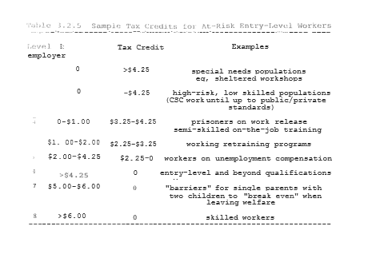

Keep in mind that the tax credits illustrated here represent not more, but generally significantly less, than we are already paying the same individual to do nothing. Unfortunately, it is precisely this "nothing" that all too often leads to the cycles of gangs, drugs and welfare that we wish to break.
By integrating the long-term unemployed into the work economy we, by definition, break the welfare cycle ONCE AND FOR ALL. We also automatically change the incentives and value system from one of chronic dependency and Entitlements to one of increasing autonomy and true Empowerment. Now, rather than the artificial dilemma of having to make over $5.00-$6.00/hr., before it is “worth it" for a single mother with children to leave welfare, the economic realities of the marketplace would be ln force. Now having a child at 16 or 17 would result in more work not less. Now fathers as well as mothers would be held economically accountable for their actions. Now "dropping out" of school would mean going to work instead of onto welfare. Now criminals instead of victims and society would end up paying the costs of their own crimes. By reincorporating economic accountability into the system, we reestablish the vital link between Rights and Responsibilities, between positive values and positive behaviors.
As positive as all of the effects of a full-employment economy may be, however, they must also be seen to benefit present workers and employers as well in order to achieve a true win-win solution. As noted above, it has been suggested that particularly productive workers could volunteer as mentors for new trainees. In this role senior workers could train and act as positive role models for the new workers. In return for these added Responsibilities, mentor/trainers could be offered a reduced number of hours of work per week for the same amount of such employees could also be offered the opportunity to participate in additional training and/or other educational programs themselves during this "time off."
Since the employer would be getting "two workers for the price of one," they would win. Since the trainee would be getting valuable work experience, they too would win. The mentor/trainers also would win in the form of reduced work and/or additional bonuses. Other workers would benefit to the extent that the business would be overall more profitable and competitive than before. Taxpayers would win from both the elimination of welfare and reduced drugs and crime in society. Thus both the intent and effect of. these programs would be a highly positive win-win outcome for all involved.
To help present employees who may still feel threatened by low-wage "replacements," clear written agreements between employers and workers on hiring and firing policies would be a precondition to any tax credits being awarded to a particular business. Such agreements would stipulate "good cause" conditions for disciplinary and/or termination procedures against current employees. Specified due process procedures would be required so that workers are both warned about particular areas of deficiency (eg, absences, drugs, low productivity, etc) and given the opportunity to correct them if possible. Similarly, in layoffs, current workers would have to be first rehired before subsidized workers could be added on as well.
Stipulation of the specific criteria for evaluation, promotion and/or disciplinary of employees could actually ultimately have a positive effect on both productivity and employee morale alike. By knowing specifically what the expectations of a particular job may be, workers can better plan what efforts they will need to make to reach these goals. Thus increasing individual and plant productivity could become goals which both employees and employers alike could literally work together to achieve. It would be precisely such positive win-win collaboration that would help to maintain American competitiveness in; the increasingly global business economy.

3.2.5 Global Competition and World Economies

In order for American businesses to remain competitive in our increasingly Global economy, unfortunately, competent, motivated, highly skilled workers are not enough. If we are to succeed in maintaining, let alone improving upon our present standard of living, we will need to be economically competitive with lower-salaried workers from around the World. Again, the only long-term answers will be to either lower average worker salaries or to move towards more high-tech, good paying jobs that will remain competitive in the global marketplace.
A recent report about the closing of an undergarment factory in a small Southern city illustrates the long-term nature of foreign competition well. The plant workers were overwhelmingly white, middle-class older women with a strong work ethic and good community values. The plant manager and employees all agreed that no one could make undergarments of higher quality than they. Yet where the average workers at the plant earned over $6.00/hour, the new workers at the plant opened in Mexico were making well under $2.00/hour. As badly as the plant manager felt about it, economically there was no way to support the operations at the American plant. This story is being repeated in broad areas of our manufacturing economy. While these particular workers may need to accept retraining or lower wages, it is not necessarily inevitable that these jobs need to leave the Country.
Factories getting tax credits in conjunction with Free Enterprise Zones or other areas of high unemployment would at least guarantee that all American adults would be engaged in some form of productive work. Rather than extended unemployment compensation or welfare, individuals would now be productively contributing to the well-being of themselves, their families and communities. As much of worker retraining would be done on-the­ job in those companies needing new workers the most (ie, bidding the highest salary), America would be helping to keep jobs from going out of the Country in an economically cost-effective manner.

3.2.6 Towards a Global Safe Haven

Clearly, there are at least some significant short-term dislocations caused by the increasing trend towards a global economy. But, if done right, in the long-run there may be many benefits to outweigh these costs. As the global standard of living rises, so too do the markets for American products. The more integrated the markets become, the greater becomes our interdependency. Thus, more and more, people have the clear incentive to cooperate in achieving win-win solutions, harnessing competition towards positive ends.
In addition to an abstract support for issues. such as World Peace, the environment or “Worker's Rights," for instance, American workers, businesses and Government officials now have a clear economic incentive to push for social improvements overseas. The more “level the playing field” in terms of standards of living and basic protections of human Rights, the easier it will be to support American standards of living as well. Thus, over time, we help ourselves by helping the World become a better place. Such is the nature of win-win options.

On the road towards such a potential global Safe Haven, however, it is more than appropriate that we start with ourselves. America is uniquely qualified to serve as a model for the World of such ultimate international cooperation. With our cultural diversity, there is literally not a part of the World that is not represented within these United States. Thus, as a Nation of nations, a Community of communities and a People of Peoples, if we can make Safe Haven work here, then we can truly stand as a beacon of hope to others of the Democratic dream of Liberty and Justice for ALL. Our first step in this journey towards true human freedom and global is to break the cycles of gangs, drugs and welfare in America ONCE AND FOR ALL. This quest will start in and with lifelong learning and education.

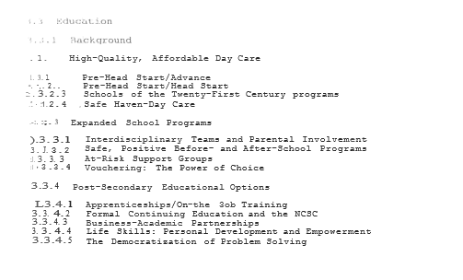

3.3 Education

3.3.1 Background

Given how we are going about it, it should come as no surprise that our present education system does not work. While America pays the most in the "World for its educational system, it gets some of the poorest results. America consistently scores at the lowest end of all the major industrialized countries in academic performance. This deficiency is particularly disturbing for results in Mathematics and Science. Even our top 5% of students rank low when compared to the top 5% of other countries. These are our future scientists, businessmen and leaders. Clearly our present school system is failing. If we are to help our children and our Country, then we must understand some of the basic underlying problems and quickly act to correct them.
Far more important than money, the number one predictor of academic performance is parental involvement. More than anything else it is attitude towards education and a commitment to excellence that can literally make the difference between success and failure. A few often-cite cross-cultural examples of these issues illustrate the point. For instance, Japanese mothers are much more likely than their American counterparts to list studying hard and getting a good education of high importance in their children's lives. On a societal level, these values are reflected in Japan’s 240-plus days a year of school compared to an average of 180 days in the United States. Equally appallingly indicative of the problem is that American children still spend more time watching television than going to school. You can hardly be expected to learn when you're not even studying. These are parental and societal values that must change if we are to see an improvement in educational achievement.
While lengthening the school day and/or school year could involve some additional expenditures many of the most expensive assets, for example, in buildings and equipment are, in fact, already available and generally under-utilized at present. In addition, however, there are other factors that not only don't cost anything, but actually save a substantial amount of money over the present system. ·
During World War II in America, it was not uncommon for there to be 40 or even 50 students in a class. At present, the average is 17 students per class. Again, times have "changed," but not necessarily for the better. The point of this illustration is not so much to argue for an immediate "doubling" of class size as it is to examine why such an option would be so difficult in the America of today. A lack of discipline in the classroom reflects more on a decline in parental and societal authority than it does on budgets and bottom lines. If we teach our children an Entitlement Ethic of Rights without Responsibilities, why should we be surprised by the anarchy in our schools? We Empower parents, teachers and students by again returning to a system that requires Rights and Responsibilities from all individuals.

In America, as recently as 25 years ago Nationally and in many smaller communities even today, you can walk into a classroom during a study period and literally hear a pin drop. You could look at the outside and inside of schools and find them neat and clean. You could look in the schoolyard and see children playing, not living in fear of guns and drugs. Until we can make not only our schools but entire neighborhoods Safe Havens, it will be very difficult for children to focus on their studies even when they and their families would wish to do so. Clearly, physical and emotional safety and well-being are essential preconditions to effective learning let alone positive social development.

A few weeks before the final draft of this book was finished (1993), a seven-year-old boy, Dantrell Davis, was shot in the head while on his way to school with his mother a block from his home in the Cabrini-Green housing project in Chicago. What made this event even more tragic was that it was the third murder of a child at that one Elementary School alone in the past year. And it was yet one more murder of a child in a year with the highest per capital murder rate in Chicago's history. Not even in the worst days of Al Capone was Chicago anywhere near as dangerous for anyone, let alone children, as it is today. And Chicago is by no means the worst American city in crime and violence.
When you multiply the effects of this chronic fear of death, by the pervasive effects of gangs and drugs, should it be any wonder that educational standards are down and dropout rates are up in our inner-cities? When families are so often fragmented, when physical and sexual abuse are so often the sequels of addiction and dysfunctional families, why should we be surprised to find more young, black males going to prison than to college? If we are to improve our education system for all children these are the issues that must be addressed. We owe this much to Dantrell and the countless other victims of our morally and economically bankrupt welfare system. The time for. change is NOW.
If American education is to play the essential role that is needed in the revitalization of our Country, then we must rethink both its scope and mission to accomplish these goals. If education is truly a lifetime process, then we must design systems to ensure that this becomes a reality and not just a convenient slogan. If we truly wish a system that brings people together rather than driving them apart, that teaches people Responsibilities to themselves, their families and communities as well as Rights to a better life for all, then we must work together to see this happen.
This Chapter represents an attempt to outline the broad features of such a Safe Haven approach to American education. By integrating education-related programs from day-care and schools to businesses and Universities, we can design a Win-Win Multi­Systems Analysis approach to not only breaking the cycles of gangs, drugs and welfare in America, but preparing ourselves as a Nation for the economic and social challenges of the Twenty-First Century.

3. 3. 2 High-Quality, Affordable Day Care

In order to ensure that children are getting a high-quality early learning environment, it is important that parents have the adequate skills and resources to meet these needs. Even in two working-parent middle-class families, meeting these needs can be difficult. With even more latchkey children for a multitude of social and economic reasons, there is even a greater need to ensure that safe, positive, learning environments are available to all children in America. Our goal, therefore, is to make available high-quality affordable day care to all families wishing this option. To break the welfare cycle, however, our first priority will be to focus on this at-risk group of parents and their children.
Presently, if a teenager gets pregnant and has no other means of support, she immediately becomes eligible for welfare's Aid to Families with Dependent Children (AFDC). Just as with Tammy B, where a student may be doing poorly in school, involved in drugs and/or undergoing other stressful life events, the present system gives an incentive for "dropping out" in all senses of the term. Thus, having a child can often become an attractive alternative to an otherwise bleak future. Again, as with James T, even when fathers remain in the picture, they are often neither financially nor emotionally supportive of the family. Neither parent's nor children's educational needs can be well met in such a stressful environment. Thus, parents, children and society alike all suffer from this present system.
There are several existing programs that give partial models of a solution to the problems of breaking cycles while providing high-quality, affordable day care in America. I will briefly review three programs already showing promise in these areas. Following this, I will present their synthesis within a broader Safe Haven context.

3.3.2.1 Pre-Head Start/Advance

Project Advance, originally developed and tested on Chicago's southeast side, mandates new teen mothers to stay in school as part of the conditions for receiving AFDC. In addition, it provides funding for day care services while the mothers attend school. Of the 1610 participants during the first year of this program, there were only 10 drop-outs and 5 repeat pregnancies. Pre-Head Start/Advance would expand Project Advance to other designated areas with incorporation of day care in the schools where possible. Advantages of such a program, in addition to spending day care money within the schools, is to provide a quality Pre-Head Start enriched environment for infant/toddlers (six weeks and up) and valuable parenting and job skills for the participating parents while they finish high school. Those parents wishing to work additional hours in the day care centers could gain credits towards certification as Day Care Assistants (DCA). Such certification could be even further upgraded by continuing their educations while their children remain in day care.

The Illinois Department of Public Aid (IDPA), DCFS and the Chicago Public Schools (CPS) are presently co-sponsoring a demonstration infant/toddler program in the Chicago Public Schools. Such school-based programs offer the ideal opportunity for these parents and their children. In addition to parenting classes for mothers and, hopefully, fathers as well, such day care programs can provide enriched pre-Head Start environments that also can monitor children for signs of abuse and neglect.
Ongoing support groups would encourage discussion concerning a wide range of topics including parenting, home life, career goals and relations. The objective of such groups would be to help parents in understanding and meeting the needs of their children as well as in completing high school, setting career goals and avoiding 2nd pregnancies. Thus, ultimately, children would be getting a high-quality, positive environment at home as well as at school. It is precisely such a positive, nurturing environment which would be most conducive to the long-term achievements and well-being of children.

3.3.2.2 Pre-Head Start/ Head Start

Numerous studies have now documented the beneficial effects of early learning programs such as Head Start for long-term intellectual and emotional development (Holden, 1990). For at­ risk youth the use of Zero-to-Three programs which work with both children and their families have also shown promise in reducing long-term problems. A 19-year follow-up study of Head Start participants has shown the following results (Table 3.3.1).

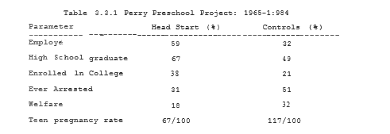

It is conservatively estimated that every dollar spent on Head Start saves $7 in later services not needed, including jails. Being able to merge both Pre-Head Start and Head Start programs into Safe Haven will allow for a long-term, cost-effective continuum of educational opportunities for children within the Safe Haven context.

3.3.2.3 Schools of the Twenty-First Century Program

Yale University psychologist Edward Zigler, a founder of Head Start, has encouraged school-based day care as a cost­ effective approach to providing quality environments for children at affordable prices. Examples around the Country have been able to provide services from 6 A.M to midnight, seven days a week and on holidays for children 6 weeks and up. Because these programs generally at least partially utilize already existing facilities, they can charge parents substantially less than otherwise for day care and after-school programs. In addition to these programs being safe and affordable, however, some of the most important aspects of school-based programs are their potential for providing enriched emotionally and intellectually stimulating environments for children during their crucial early years of development. Thus, while our initial focus will be on child care for present welfare parents, ultimately, by expanding the number of skilled day care personnel available, these programs will become increasingly available as high-quality, affordable day care for all who wish to use it.

3.3.2.4 Safe Haven-Day Care

Combining the above models within a Safe Haven context offers substantial benefits for both children and parents alike. By having welfare mothers and, where possible, fathers as well participate in the Day Care needs of their own children, they would be learning both valuable parenting and jobs skills necessary to break the welfare cycle. In addition to the service provided to both their children and the program, having parents get educational credit for these programs while remaining in school allows us to break the welfare cycle often before it even begins.
By reestablishing the middle-class value that having children requires additional Responsibilities as well as Rights, we are going far towards moving from Entitlements to True Empowerment. If having a child now results in more work, not less, even while parents are still required to continue their education, there is now a strong incentive to defer having children until parents are both financially and emotionally able to resume such Responsibilities. In short, rather than having and “Underclass” and a “working class,” we would have a system that empowers ALL to move forward rather than stay behind. And, in the process, our children are given the tools they will need for success in the 21st century.

3.3.3 Expanding Primary and Secondary School Programs

Just as with preschool experiences, the school years themselves are critical times in the intellectual and social development of America’s future--our children. As such, it is essential that we reframe the concept of “education” to be both a day-long and a life-long process. We can offer our children an opportunity to explore the wonders of the universe and its unlimited possibilities. We can challenge them to understand the past and to move towards a better tomorrow. Or we can abandon them to the despair of drug-infested, crime-written neighborhoods. The choice is ours. But, again, win-win solutions are available that help to reaffirm traditional American values.

3.3.3.1 Interdisciplinary Teams and Parental Involvement

Dr. James Comer, a child psychiatrist at Yale, has for years pioneered the use of interdisciplinary teams and strong parental involvement to achieve impressive results in achievement and social skills. Working with 2 inter-city elementary schools in New Haven, Connecticut, Dr. Comer slowly developed programs pooling the talents and expertise of educators, parents, mental health professionals and social workers into a team approach which looked at the needs and abilities of individual students on and on-going, interactive basis. From being ranked the lowest in achievement among the 33 elementary schools in New Haven in 1969, “by 1984, pupils in the fourth-grade of the 2 schools ranked 3rd and 4th highest on the Iowa Test of Basic Skills. By the early 1980s attendance rates at these schools were either the 1st or 2nd highest in the city. There have been no serious behavioral problems at either school in over a decade” (Comer, 1988).
In addition to the impressive results of Dr. Comer, Anne Henderson of the National Committee for Citizens in Education has reviewed the results of over 50 studies looking at the effects of parental involvement in school performance. In each and every study, participation by parents in their children's education, both in the schools and at home, significantly improved academic achievement (Henderson, 1987). Clearly for any program to work and be accepted by the Community, there must be both strong parental involvement as well as a strong team approach to the solving of these multi-faceted problems. This commitment to excellence may be one of the most important lessons that both schools and parents can teach our children.

3.3.3.2 Safe Positive Before- and After-School Programs

As noted above, a significant impediment to work for many parents is the issue of finding safe, affordable care for both young and school-age children. In addition, whether or not their parents are working, children growing up in crime-infested areas are at substantially increased risk for gang recruitment, poor scholastic performance, drug and alcohol abuse, teen pregnancy and high school dropout. Schools can be made into literal "Safe Havens " within their communities by expanding the hours that they are open and providing much needed services (eg, child care, continuing education, recreation, support groups etc.) on­ site or nearby whenever possible.
Also, particularly for specific at-risk student populations, after-school programs could provide deterrence from negative influences while providing support and positive incentives for growth in more productive directions. In addition to enhancing the physical safety of children and providing constructive alternative to gang activities, the availability of after-school programs should provide important educational opportunities to many students. Generally, the difference between a "C" or "D" in a class and an "A" or "B" has less to do with ability per se than it does with EFFORT and COMMITMENT. Some may be able to learn faster than others, but most children can master well a core curriculum by simply devoting adequate time and effort to the process. Indeed, quite likely such factors are the most important variable accounting for the relative success of Japanese or German students vis-a-vis their American counterparts. Such additional motivation supplied through parents and the community could also underlie the success of Dr. Comer in New Haven and elsewhere.
By utilizing Community Service Corps participants as supple­ mental staff (eg, hall-guards, study hall and playground monitors, teacher’s aides, tutors, recreation facilitators, etc.), it is anticipated that such a program could be started up at minimal costs. Further, by providing alternatives to gang activities, dropping out and teen pregnancy, such programs could potentially provide significant savings while simultaneously improving safety and cohesiveness within the community. Ultimately, who better than parents to provide such educational, recreational and support services for their own and other neighborhood children?
In addition to Resident Patrols and supervised recreational programs Safe Haven would also increase the availability of educational programs (eg, tutored study halls, interest groups, etc) and support group services in addition to supervised recreational components. In particular, specific programs would be proposed for "at risk" populations such as those with academic and/or conduct problems in school. While recreational programs would continue to be available for all students, "at risk" populations might also be mandated to Extended Study Hall (ESH) at which they would be required to stay until they had completed all assigned homework and/or other remedial projects before also participating in recreational activities.
Particularly difficult at-risk populations (eg, identified gang members and chronically truant and/or disruptive students), might be mandated either by the school and/or the courts to stay in the school programs until, eg, 8 pm, when they could be picked up and taken· directly home by a parent for the night. Gang members with arrests might be mandated to a combination of ESH, after-school support groups (for themselves and their parents) and CSC participation for their activities. Again, such a program could be a highly effective, credible, low-cost deterrent to gang activities and could be particularly useful at a time of over­crowded courts and jails. It is also a highly desirable alternative to suspended sentences and/or traditional probation.

3.3.3.3 At-Risk Support Groups

In addition to support groups for CSC participants, as noted above, Safe Haven would make such groups available for specifically identified at-risk populations of high school and elementary school students as well. In both cases “at-risk" groups could be defined as students with academic, emotional and/or behavioral problems leading to difficulties performing up to their potential in and out of school. Some of the potential risk factors hypothesized to be leading to these difficulties include disruptive home environments (including instances of emotional, physical and/or sexual abuse and neglect), poor role models both at home and in the community, early involvement with alcohol, drugs and/or gang activities and poor academic performance.
All of these factors and many others can have as a final common pathway a poor sense of self-esteem and increased hopelessness as to the future. Particularly when feeling trapped in an environment where "things never change" and "everybody does it," it can hardly be surprising that at least a certain percentage of at­ risk youths will "give up" and "give in" to the multitude of negative pressures bombarding them daily.
The first priority of such support groups would be students at both the elementary and high school levels who are performing poorly academically, involved in gang or "pre-gang" activities, alcohol substance abuse and/or other specific behavioral problems (eg, attention-deficit hyperactivity disorder, etc). Again, as with adult support groups, in addition to focusing on the here and now issues related to these student's identified problems, serious attempts would be made to help them identify issues in their pasts leading them (individually and collectively towards their dysfunctional behaviors. It is hoped that as these at-risk students begin to understand themselves and each other better they could come to form particularly strong mutual support groups for positive changes in their lives.
In addition to working with at-risk students similar (eg, tough love) support groups could also be set up for the parents of such students on a weekly to monthly basis as needed so as to facilitate change while also assessing critical elements of the home environments. Mandatory parental participation in educated cases may not only help their children to change but will also give parents the training and support to intervene effectively in the future and to know that they are not alone in facing these difficult problems. Such groups could also help parents to look at themselves as role models for their children so as to motivate positive changes in their own lives as well. Periodically throughout the year both at-risk students and parent support groups could meet jointly to dialog and problem-solve on mutually important issues.
In order to "destigmatize" the notion of such support groups', efforts would be made to promote such groups as educational in nature (eg, Psychology 101, etc). Ideally, credit could be given for skills learning in such areas as communication, stress reduction and effective problem-solving. To emphasize this educational component, a set of semi-structured exercises and assignments would help to give a focus to these on- going meetings. By developing such workbooks, semi-structured assignments, exercises and aides, teachers, nurses, school counsellors, parents and/or other mental health professionals could effectively run such groups with regular on-going supervision, interdisciplinary back-up support and follow-up as needed.
In addition to these traditional support group components, however, it is strongly suggested that mandatory participation in specific after-school remedial programs may be the major factor that can potentially lead to long-term behavior and attitudinal changes in at-risk youth--especially when parents are also involved. Particularly when begun at the elementary school level, there can be a highly cost-effective and humane emphasis placed on primary- and secondary-prevention prior to the development of ingrained resistant patterns of antisocial behaviors.
If consistently done, from elementary school on, there are very clear and credible consequences for inappropriate behaviors (eg, ESH and CSC) and equally credible rewards for good academic and social performance (eg, recreational groups, special. interest clubs and, ultimately, good paying apprenticeships, scholarships and jobs), then a set of incentives and a corresponding set of values and work ethics can be fostered in these students. Equally important, the "middle group" of students who could go either way in a system would find negative role models (eg, gang members and teen mothers) no longer holding positions of esteem, fear and envy in the community.
Restoring credibility to the system could help to reestablish respect for the rules and each other while fostering an increased sense of discipline and self-pride within the schools. Also, when mandatory high school and CSC programs reinforce the message that having children and/or dropping out of school no longer means leaving the workforce, young men and women will have an increased incentive to not only stay within the system and utilize it to its fullest potential, but also to defer having children while pursuing more long-term career goals. Thus, it is anticipated that the more widely disseminated these programs become, the greater the reduction in teen pregnancy, drug use and gang crime and the higher scholastic achievements will be.

3.3.3.4 Vouchering: The Power of Choice

While this Chapter would not be the place to resolve all of the issues related to a universal vouchering system for financing our children's educations, vouchering could in many ways help to bring the beneficial effects of competition to the present problems of American education. As part of Free Enterprise Zones, for instance, businesses might well choose to offer Apprenticeship programs with both academic and on-the-job·- training combined. Allowing students and their families the choice to select such program might ultimately both improve the quality of education and facilitate the transition into the job market.
Similarly, one reason traditional nonpublic schools have been successful in the past is that they could set standards o£ expectations for both academic and behavioral performance. By allowing parents the same ability to set expectations for academic institutions by “voting with their feet” to get the best value for their academic voucher dollar, there would be more incentive for schools to be responsive to the needs of the community. By periodically evaluating students in all school settings, private and public, and making the results widely available, parents could become better informed “consumers” on behalf of the needs of their children.
If education vouchers could be written in such a way as to ultimately allow for their application in other post-secondary settings as well, they might also be useful in settings such as apprenticeship, worker-retraining and continuing education programs, as well. Thus rather than seeing the vouchering question. as limited to K-12 programs, we might actually be able to apply the same principles to the entire continuum of educational opportunities. As such, we might be able to maximize diversity and choice at all levels while keeping down overall' costs.

3.3.4 Post-Secondary Educational Options

Perhaps one of the most important lessons to learn during the first twelve years of formal education. is that this is just the beginning of a lifetime of learning. Rather than just thinking that such "learning" is confined to formal "coursework," if done right there will be a continuing expansion of horizons in an individual’s personal, family and community life as well as at work. Thus, rather than an end, whatever the path taken, these first twelve years, more and more, should be just a beginning.

3.3.4.1 Apprenticeships: On-the-Job Training

Apprenticeships and on-the-job training options for individuals not going onto college have been discussed in Section 3.2 dealing with work-related issues. Linking such training to continuing education programs again allows an important association to be made with life-long education. Particularly as job requirements change and evolve, along with the "right" to secure employment come the "responsibility" to develop those skills that will be needed and competitive in an increasingly global market.
As noted above, given enough time, motivation and options (e.g., self-paste on line learning, etc.), most individuals would surprise even themselves by how much they could actually learn. Often the difference between those going on to college and those not has much less to do with innate ability and much more to do with environment-influenced factors such as financial resources as well as familial and cultural expectations, self-esteem and self-confidence. Having individuals experience successes on the job may help many to consider both work-based and more traditional educational opportunities later on in their lives.
To encourage success and reduce overall costs, new approaches to education may also be considered. As the technology evolves, it should become increasingly possible for individuals to participate in highly interactive, self-paced, computer-based learning programs. Rather than being bound by the walls of a University or even a job-site, much future learning may become increasingly decentralized and individualized. Once the software for a core curriculum on a particular subject is developed, it will be just as easy and much more cost-effective to make it available to an entire industry rather than a classroom or two o£ traditional students.
Access to such a "University of the World" could either be via the internet or other such technologies in an even more decentralized manner. Many traditional aspects of classroom learning such as lectures and tests could thus be repeated at a student's own pace as often as necessary until an appropriate level of mastery was achieved. Rather than repeating the same lectures year after year, instructors could be freed up to focus on more personalized discussion groups and hands-on experience. By putting the focus of learning on understanding and mastery rather than on competition and grades, per se, the importance of self-discipline and perseverance would be reaffirmed. Learning could thus be seen as the result of "time and effort" rather than as matters of "success or failure." The greater the effort made, the greater the level of understanding and benefits for all. Again, a win-win option would thus be achieved.

3.3.4.2 Formal Continuing Education and the NCSC

Ultimately, the health and well-being of our Country will depend upon having the best educated, most technologically advanced workforce in the World. In order to achieve and maintain such a goal, whether it is directly following high school or after a period of time in the job setting, more and more individuals are likely at some point in their lives to participate in some type of formal continuing education. Even doctors have yearly Continuing Medical Education (CME” requirements-- as well we should.
In order to optimize both the benefits and availability of this option it is important to design the system with these goals in mind. By again, however, linking the "right" to a high-quality education with the "responsibility" to contribute in a productive way to society both during schooling and afterwards creates an empowering win-win scenario for all involved. -
One of the most equitable ways of combining the Rights and Responsibilities of a college education is by making available a National Community Service Corps (NCSC) Scholarship program along with other options. Just as has been discussed by many National leaders, a NCSC program would allow college students the option of receiving full or partial scholarships in return for a certain period of Community Service either before, during and/or after graduation. Such NCSC programs could range from participation in on-going community-based field school out-reach programs, to tutoring and counseling at-risk youth to assuming various leadership positions in community-based organizations for those willing to make a long-term commitment to finally solving the problems of our inner-cities.

The National Community Service Corps (NCSC) can certainly be an option for financing college for over-burdened middle-class families. Equally important, however, it can make the dream of a college education a reality for ALL Americans regardless of their financial background. Rather than spending $25,000-$35,000/year to send a Gang-Banger to prison, we can now offer those youths clear and credible positive alternatives that benefit themselves, their families and communities as well. By combining the Right to a better life with the Responsibility to work in positive ways to make it happen, the important cultural value of the work ethic and true EMPOWERMENT are being reborn.
Whether the involvement in NCSC was a little or a lot, such participation in the solutions to these long-standing problems would go a long way towards increasing the multi-cultural sensitivity of our youth. By bringing people closer together we would do much' to foster the depth of understanding to bring about a true Renaissance in America. By awakening the idealism and sense of hope, not just among college students, but inner-city youth as well, we can move away from gangs and drugs and towards a better tomorrow for all. Such would be a true education in every sense of the term.

3.3.4.3 Business-Academic Partnerships

Just as the NCSC can underwrite college in return for a certain number of years of work at a prearranged salary, businesses could also set up similar such programs in a highly win-win fashion. By negotiating multi-year intermediate-salaried contracts with their employees, businesses could actually lower their long-term costs, while providing employees with the security of a higher-paying job at the end of their efforts. By offering bonuses for superior academic performance, companies would be giving employees additional incentives to do their best. Often it will be in the best interests of all involved for employees to continue to work while attending college part-time in person or online. In such setting, the maximum benefits can be achieved with the minimum risks. And the knowledge gained is being applied in practice as well as in theory.
In addition to undergraduate degrees, however, businesses could also benefit perhaps even more by extending their partnerships with academia even further. Just as in the future much post-secondary education can occur at the workplace, so too some private and national business objectives could be best obtained through a strong, working relationship with academia. For a long time now, research laboratories at companies such as AT&T and IBM have· been important contributors to America's global competitiveness as well as their own. The link between business and academia in such settings has long been a fact of life. By expanding such cooperative business-academic partnerships, however, both institutions and the American people would be well served.
By providing full or partial scholarships to their research and development personnel, business could utilize the expertise of academia towards the improving of their own productivity. Focusing business-sponsored Masters and Doctoral-level research on specific business-related problems would not only help to speed the process of technological breakthroughs but would prepare such graduates as highly-trained experts on the particular problems and needs of their sponsoring company. As the benefits to both academia and business of such focused research would be obvious and often quite tangible, industries would have an increased incentive to financially support such research and academic institutions.
While distinctions are often made between "applied" and "theoretical" research, the fact is that integrating the two often makes for the best results. Far more than once, engineers from industry have had a thing or two to teach their “academic" counterparts. In the process of such increased dialog, everybody benefits.
Since “theoretical” research has often been the domain of direct and indirect Governmental funding, having additional business support for even "applied" projects ultimately helps to increase the overall funding available for all research. It may well be that the major effect of business funding, particularly of their own personnel, would be to decrease the lag time from "academic" discoveries to "practical" applications. But it is precisely such business-academic cooperation that would translate into increased global competitiveness for American industries.

3.3.4.4 Life Skills: Personal Development and Empowerment

Of all the lessons of life, perhaps that of love and respect for each other and ourselves is the greatest of all. Many of our forbearers who emigrated to this Country were poor of possessions but rich of spirit. Many Communities during the Depression, White and Black, were poor yet safe and decent places in which to live and raise a family. Ultimately, it is not money that brings happiness and gives life meaning, but the values we live and the love we share. If we wish to be a model for the World, then we must learn to live our values every day, at home and at work, with families and friends, colleagues and strangers, in all ways--great and small.
In the past, religions were the strong anchors of shared values within our Communities. For many, such religious beliefs remain their guides. Faith lights their path through life and death. Some have come to question old values, but have not found a suitable replacement. Still others, cynical and hurt by life's misfortunes, adopt negative values that often hurt themselves as well as others. It is only by resolving such inner conflicts and finding a positive value system that use happiness and satisfaction can be achieved. It is by finding ways to foster such personal exploration and development that we can grow as individuals, families, Communities and Nations.
If we are to prosper not just financially, but emotionally and spiritually, we will need to find ways to integrate such personal development into the fabric of our everyday culture. Hany of the basic life skills such as communication, negotiation and positive win-win mutual problem-solving can not only be Learned but applied to a wide variety of human interactions. In addition to learning the problem--solving skills in classes and/or enhanced Employee Resistance Program (EEAP)-type settings, applying these techniques in formal and informal support groups could help greatly in the promotion of personal development. By teaching such skills to couples and families in crisis much could be done to deal with underlying problems rather than simply the most. obvious of symptoms.
By not only teaching such skills, but applying them in the context of homework and school, we could do much to improve people's overall life satisfaction. In the process, we would also tend to make our systems higher functioning and more productive. Such is the technology of win-win solutions.

3.2.4.5 The Democratization of Problem Solving

As people come to apply the techniques of effective win-win problem solving more and more in their everyday lives, over time these techniques can come to take on the characteristics of a cultural norm. Whether it is support groups at school or "quality circles" at work or family meetings at home, there is a sense of democratization and general Empowerment that comes from people coming together in search of answers for the benefit of all.
More than anything else, what such groups can teach us is that working together we can all grow stronger. Whether it is a couple, a family a Community or a planet, such is an important lesson for us all to learn. Whether it is crime in our streets, a massacre in Bosnia or "simply" a divorce or child abuse in the home, the failure to understand and find positive win-win solutions is ultimately a price we all pay. Our education as individuals and citizens cannot be complete until we feel empowered to act. Alone we are limited. Together we can change the World and ourselves as well.

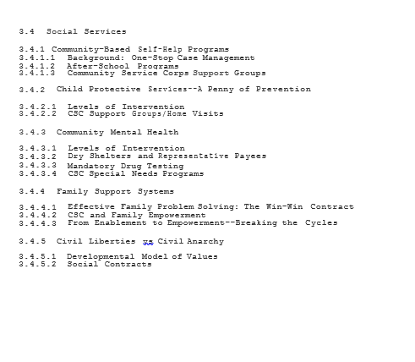
3.4 Social Services

3.4.1 Community-Based Self -Help Programs
3.4.1.1 Background: One-Stop Case Management (OSCM)

Supportive Social Services can be defined and implemented at many levels. Here we will use the term broadly to include all activities that help individuals and families to grow as healthy and productive members of Society. As was discussed in Section 3.1 a "One--Stop Case Management” approach to supportive social services allows us a more comprehensive overview of the particular needs of individuals and the interconnectedness of the Agencies that work with them. By integrating these services in a Multi-Systems Analysis (MSA) approach with other areas such as v1ork and education, we can assure that people are moving forward rather than being left behind. Thus, as in other areas, while these Safe Haven programs are initially designed to deal with the immediate needs of "high-risk" groups, over time more and more the focus moves from crisis intervention to primary prevention and enhancing personal development.

3.4.1.2 After-School Programs

As discussed in Section 3.3.3, After-School programs allow us to meet many of the needs of at-risk youth and their families early on in positive win-win ways. Programs focused on the academic, recreational and psychological needs of children and adolescents can do much to help all youth not only to survive but flourish. Through the use of Comer-type teams of teachers, parents and mental health workers (Section 3.3.3.1) a much clearer picture can emerge of the needs of individual students. A One-Step Case Management approach to Social Services would allow for the designing, implementing and tracking of Individualized Goals Profiles (IGPs) for both students and their families. Thus, rather than getting lost in the bureaucratic cracks, by having family members as part of the team, progress could be assessed on literally a daily basis.,
In those Safe Haven communities where Community Service Corps. programs would be running, there would be an even greater opportunity to involve parents in the well-being of their children and communities. Again, who better than the parents themselves to be actively involved in roles such as teacher's aides, tutors, study hall monitors and after-school program assistants? Just as in the Day Care Assistants programs, working in such roles would not only directly help the children but, equally important, help the adults to develop important parenting skills while becoming productive members of the community.
Thus, within Safe Haven communities, children would be surrounded by positive role models of people helping people. After-School programs would help to reward efforts while working to understand and correct negative behaviors. Such empowering values of Rights and Responsibilities could help to give children credible, positive alternatives to the gangs and drugs of the past. In such consistently safe and positive environments, all children could be helped to develop to the maximum of their potential. And in the process, all would benefit.

3.4.1.3 CSC Support Groups

Just as children would have their support groups through the schools, so too CSC participants would have their own groups as well. In addition to groups on traditional job skills, other sessions would be held on issues such as parenting, communicating, problem solving, alcohol and substance abuse to name but a few. Just as Individual Goal Profiles (IGPs) for children might include grades and handing in homework assignments on time, adult IGPs would include work attendance and performance as relevant factors for tracking. By being able to discuss a week’s successes and frustrations in a supportive environment, positive feedback would be available in a timely manner.
As was seen in several of the Case Studies previously presented, drugs and alcohol are often complicating factors in long-term welfare dependency. Similarly, lack of education and chronic depression are not uncommon in these populations. For those SC participants with special needs support groups would be designed to both identify and meet these needs. The overall goal of such groups, therefore, would be not to perpetuate the status quo, but to assist participants and their families to move forward in positive directions. In this way, CSC support groups would be similar to those that might be designed for Enhanced Employee Assistance Programs (EEAPs) in the private sector as discussed in Section 3.6.6.
The longer that CSC participants remained in such support groups, the greater their overall knowledge base and confidence level should become. As CSC positions would generally be seen as transition stages to entry-level positions in the public and private sector, over time early participants could very likely act as mentors for those who follow. By learning more and more to feel good about helping others, the spirit of community would come to grow ever stronger.
Because of the positive nature of Safe Haven groups and jobs, it is anticipated that at least some of these participants will express an interest in continuing to work in supportive roles within their communities. In addition to the possibility of working towards entry-level positions in the various State and private human service agencies, there is also the option of using participation in a National Community Service Corps as a means of financing further educational goals. Thus, whether individuals ultimately move towards jobs in the public or private sector, CSC support groups will help to bring together not just individuals, but entire communities, to work together towards common goals.

3.4.2 Child Protective Services--A Penny of Prevention

Primarily because of budgetary restraints, traditional Child Protective Services such as Illinois' Department of Children and Family Services (DCFS) are reactive rather than proactive in nature. In addition to the countless number of tragedies that such a system inevitably permits, it is extremely costly in financial terms as well. Physical, sexual and emotional abuse, by definition, places children at high risk for a myriad of dysfunctional behaviors from low self-esteem, depression and low achievement to the acceptance of abusive relations (including prostitution) to substance abuse and other antisocial activities to florid psychotic and dissociative states.

A pioneering study of adult female patients in State Mental Health facilities by Dr. Leigh Steiner found that over fifty percent had been sexually abused as children or adolescences. Even worse, however, in the majority of these cases this abuse had never even been identified, let alone adequately treated. Even in the hospital setting, years after the fact, psychiatrists and other staff generally did not know enough to identify this history of abuse within the myriad of secondary symptoms.
A common axiom among those familiar with the sequelae of abuse is that the females often end up in psychiatric facilities while the males often end up in prison. Either way, we are generally dealing with the same issues of anger and rage either directed inwards, outwards or both directions. And in the process, everybody losses. Clearly if we are to prevent such abuses and their sequelae in the future, we will need to significantly improve both our understanding and detection of such problems in the future.

3.4.2.1 Levels of Intervention

As discussed at length above, Safe Haven is inherently preventive and proactive in its focus and design. By establishing community-based parenting classes, Pre-Head Start and Head Start Day Care and After-School programs, we provide safe, high-quality environments in which children can learn and grow. By providing incentives for students to finish school and strong disincentives for dropping out, Safe Haven encourages deferring having children until parents are both emotionally and financially ready to assume such major life Responsibilities. By working with parents through CSC and other at-risk support groups, Safe Haven works in such issues as alcohol and substance abuse, low self-esteem, anger, depression and histories of abuse in parent's own backgrounds that often underlie and predisposed adults to abuse. Yet, in addition to such proactive measures, we must design our systems to identify and treat the problems of today if we are to truly break these cycles once and for all.
Figure 3.4.1 again draws the Cycle of Poverty first presented in Section 2.1. It should come as no surprise, as noted before, that the risk factors for poverty are also many of the same risk factors for abuse and neglect, drug usage, crime or the myriad of other social problems that we have previously discussed. This is by no means to suggest that child abuse is in any way limited to those in poverty although it is over­represented in these populations. But a major predictor of abuse in any socioeconomic class is coming from a dysfunctional family, particularly where abuse was experienced as a child. Thus, again, the major way to break these cycles is to address these risk factors as early and aggressively as possible.
In Figure 3.4. 1, therefore, I also list several of the potential interventions that I have already discussed. Again, A PENNY OF PREVENTION IS WORTH A DOLLAR OF CURE.

Table 3.4.1 outlines several levels of intervention where child abuse may be suspected. In considering this Table, it is important to start with the knowledge that most child abuse is never reported and often goes on for years before it is even suspected. Therefore, rather than assuming that all cases of abuse are clearly identifiable, particularly early on, most cases are prompted by various "levels of suspicion."
Because the risks of missing abuse far outweigh the benefits of ignoring it, we wish to design our programs to be sensitive to even very low levels of suspicion. Just as a lump in a woman's breast should prompt further investigation, so too it is with even very low levels of suspicion of abuse.
By designing our system based upon prevention and/or early treatment, rapid interventions can focus on supportive positive growth rather than on "punishment" per se. Thus, classes for all age groups in abuse awareness, for example, can help all people be aware of and sensitive to these issues while simultaneously helping potential victims to come forward and seek help for both themselves and others involved.
Where there is some "index of suspicion" for abuse or other at-risk behavior, it would be beneficial for all involved to participate in some form of at least short-term support group activities. Such a setting would allow both further assessment of the presenting problems and further training in positive coping skills whether abuse turns out to be present or not. At low levels of suspicion such participation could be focused on the child. At higher levels of suspicion, or where group participation leads to further disclosures, parents and/or perpetrators would also participate in separate support groups. It would only be at the highest level of suspicion ("founded") cases and/or where the safety of a child was at direct risk that children would need to be removed from the home either temporarily or permanently, depending upon the circumstances of the case.
By focusing on treatment rather than punishment, a much more rapid, positive, comprehensive and even cost-effective outcome can be achieved. Rather than waiting for a lengthy, costly and often ineffective court system to decide upon someone's "guilt" or "innocence," levels of suspicion can allow for a much less adversarial outcome to be achieved. Since the focus of all support group work could be to assist people to learn and grow, ultimately, they could be beneficial to victims and perpetrators alike.

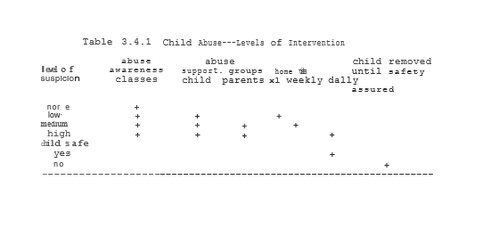

3.4.2.2 CSC Support Groups/Home Visits

In keeping with the community-based philosophy of Safe Haven, CSC participants could be used as co-facilitators for support groups whenever and wherever possible. Depending upon the particular nature of the support group, a trained professional group leader might or might not also be necessary. Either way, however, the participation of local community residents in such support groups could help to bring neighbors and neighborhoods even closer together.
As with other CSC activities listed in Table 3.2.1, support group co-facilitators would work under the supervision of someone with expertise in their particular area. Thus, for example, co-facilitators might work under a mental health worker or DCFS caseworker for issues involving abuse. In addition to their work in support groups, these CSC participants would also function in a " Big Brother/Big Sister"-type capacity making home visits throughout the week in between group meetings.
As indicated in Table 3.4.1, home visits could be based upon the severity and acuteness of the case. Assignments and caseloads could also be flexible enough so as to allow these community residents to deal with crisis situations as they arise. It is precisely the ability to identify and respond in such crisis situations that can mean not only the difference between abuse or no abuse, but even whether or not a family may be able to stay together as a family.
Thus CSC support group co-facilitators could often be saving much more than simply money. Depending upon their level of interest and proficiency, it is anticipated that at least some CSC co-facilitators will express an interest in continuing on with both education and work in the social services. Thus participation in such groups could often lead to at least entry-level positions in a wide range of social service-type positions from crisis-intervention home visitors to caseworkers to mental health assistants whenever and wherever possible at least part of such jobs would remain working within an individual's own community. Thus, over time, jobs are created, people are helped and communities are strengthened. Again, a win­win outcome is achieved.
It is also worth noting that, while such CSC co-facilitators are discussed in a secular context, individuals can equally be encouraged into apprentice programs within churches, mosques and synagogues as well. Simply put, God is ALWAYS welcome in our communities. Lord knows, we can use the help….

3.4.3 Community Mental Health

Among psychiatric patients there are multiple reasons leading to repeated frequent hospitalizations and/or poor outpatient outcomes (chronic recidivism). Previously identified variables include: poor compliance with medications and outpatient follow-up; unstable family and community support systems; acute stressors including financial mismanagement; lack of structure ln environments and alcohol and/or substance abuse.
One not infrequent pattern that is seen in State Psychiatric and Veterans (VA) settings is patients repeatedly coming into the hospital one to three weeks after having received their monthly assistance check. The main identifiable precipitant in these cases is the patient's having unwisely allocated their funding often by the purchase of alcohol and/or drugs which further weakens their already precarious stability and outpatient setting.

For many kinds of patients, including those seen by psychiatrists there is often presently a diagnostic and therapeutic dilemma posed in certifying patients for disability subsidies. On the one hand, patients may be sufficiently impaired so as to not presently be competitive in the open labor market place. Such patients are de facto "unemployable" in the eyes of many even though they can potentially still be perfectly capable of some forms of limited work. On the other hand, stating that such patients are "too disabled to work" often sets up a Learned Helplessness pattern of chronic dependency behavior on the future. In fact, a significant percentage of disability patients express depression over the loss of productive activities but also are concerned over losing benefits if they work and/or lack the self-confidence to even try.

3.4.3.1 Levels of Intervention

It is proposed that for chronic recidivists and long-term psychiatric patients Safe Haven programs be set up (in both State and VA institutions) whereby patients on various forms of assistance who demonstrate repeated failures in the outpatient setting are mandated to programs of graduated degrees of structure depending on the individual needs of the patients. For all but the most severely disabled of patients, some form of work will be recommended as part of the therapeutic regimen to enhance self-esteem and autonomy and minimize counterproductive patterns of over-dependence on the system. Below a five-level system of structured interventions will be described. While this model can and should be easily extended to other types of medical conditions, cases here discussed will be limited to psychiatric patients, the homeless, developmental disabilities and alcohol and substance abusers.

Level I
Impairment--mild

Description--mild DSH III-R Axis I and/or Axis II, including mild developmental disabilities, alcohol and substance abusers and some homeless patients in need of support but maintaining financial and social stability in the community.

Intervention--mainstreaming clients in full CSC program with weekly or monthly support groups where patients are assessed and assistance checks are distributed.

Level II

Impairment--moderate/outpatient

Description--Patients with repeated failures in financial and social stability but still appropriate for outpatient treatment.

Intervention--specialized CSC programs designed with the specific limitations and needs of these patients in mind. Safe Haven programs would mandate representative payees to manage patient's finances. Level II patients would have rent checks directly sent to landlords but would still be given the remained of their checks in weekly installments. Sizes of the weekly checks would in part be a function of maintaining sobriety with good attendance and conduct at work which would be reviewed in weekly support groups.

Level III

Impairment--moderate/inpatient

Description--patients in need of short-term hospitalization but still appropriate for a part-time work as part of their therapeutic regimen and to prepare them on a progressive basis for outpatient follow-up. Intervention--patients assessed for appropriateness of types of CSC programs (eg on- or off-grounds) and numbers of·hours/week to be assigned on a progressive basis as therapy progresses. Progress in therapy and work to be assessed in daily to weekly individual and support group settings. Financial assistance checks during time in the hospital would go to offset costs of inpatient care. That subsidies do not accumulate while the patient is in the hospital is especially important for patients with histories of alcohol and/or substance abuse being treated for dual diagnoses problems or on rehabilitation units. The reasons include not only cost containment and removing temptations following discharge, but also to avoid abusing the inpatient setting as a convenient "shelter" when alternative settings are available.

Level IV

Impairment--severe

Description--patients having failed outpatient care in need of long-term residential placement but still capable of simple work in a structured environment. Intervention--assistance checks to go towards the payment for structured residential programs with on- or off-site sheltered " workshops. Again, work is to be geared to the needs and abilities of individual patients, but should generally be expected at most points during treatment as part of the therapeutic regimen. Other types of work in the structured environments (e.g., setting in cleaning dishes, sweeping floors, etc.) can also help to involve patients in their environments and help to give them a sense of self-worth and community. Such activities can again be reinforced through feedback in daily to weekly support groups as appropriate.

Level V

Impairment--profound

Description--patients in need of long-term inpatient hospitalization, or incapable of work even in structured settings.

Intervention--supportive custodial care with therapeutic groups as tolerated.

3.4.3.2 Dry Shelters and Representative Payees

As discussed above, the Community Mental Health levels system allows a significantly greater degree of flexibility in addressing many of the problems of our present welfare/social service system. Numerous studies have shown that structured, monitored, supportive environments can be a highly cost-effective and powerful intervention in the curbing of alcohol and substance abuse problems. Where clients can stay for extended periods, often coupled with work programs and support groups, impressive decrease in usage have been achieved. Representative payeeship allows programs to collect directly an individual's subsidy check to pay for services, food and shelter while simultaneously keeping clients from spending this money on alcohol and drugs. It has been found that Representative Payeeship can be a powerful motivation for improving individual financial management. Direct management of subsidies or salaries is gradually reintroduced as individuals demonstrate improved responsible behavior both through continuing sobriety and on the job performance.

3.4. 3.3 Mandatory Drug Testing

In 1980, over 25% of enlistees in the Armed Forces admitted to being occasional to heavy drug users during their time in the service. Following the introduction of strong anti-drug education and random mandatory drug testing, positive drug test results plummeted from 10.2% in 1983 to only 1.4% in 1989 or an 86.3% decline in drug usage. Even better results have been obtained in professional sports where the consequences of usage (potential loss of large contracts) are even more certain and greater. The use of mandatory drug testing, especially for populations seriously at risk for recidivism (eg drug users, convicted criminals both in jail or out on probation or parole, pregnant mothers with drug histories, etc.) could do much to curb this growing problem and its tragic sequelae including AIDS and babies born addicted and/or with the disabilities arising from drugs and fetal alcohol syndrome. If ever there was a place to show the distinction between the philosophy of Entitlement and that of Empowerment, it is in the role of mandatory drug testing to stop these raging epidemics.

3.4.3.4 CSC Special Needs Programs

Just as with CSC programs for Department of Children and Family Services (DCFS) populations, so too specialized programs for Mental Health populations are also anticipated as described above. In addition to the participation of patients in such modified CSC programs, however, there will also be the availability for more high functioning participants as well. For some types of programs, there may well be a graduation of former support group participants into more of the role of group co-facilitators as time goes on. In the case of substance abusers, for instance, it would be a natural progression to see individuals not only remain drug-free, but become sponsors for others as well.
In some cases, individuals could also progress on to become Mental Health Assistants (MHAs), Certified Addictions Counsellors (CACs) or other mental health-type workers. For patients who have been hospitalized, whether in the public or private sector, there are often problems associated with the transition from inpatient to outpatient settings. Often a patient develops a relation with a certain treatment team as an inpatient only to lose contact with this team upon discharge. Even where the patient does follow up in outpatient treatment (by no means a given), "starting all over" with a new team is at best both inefficient and time-consuming.
By having some CSC participants act as Mental Health Assistants (CSC/MHAs) in both inpatient and outpatient settings, we would improve the continuity of care for patients and thus help to improve the success of outpatient treatment. Similarly, if a patient has been followed on an outpatient basis and acutely needs hospitalization, their length of stay can be reduced significantly when at least some members of the treatment team are the same in both settings.
Again, as with child abuse cases, CSC participants could be involved in different levels- of outpatient intervention depending upon the severity of symptoms an individual patient may be displaying at a particular time. Table 3.4.2 summarizes both levels of impairment and corresponding levels and types of intervention available.

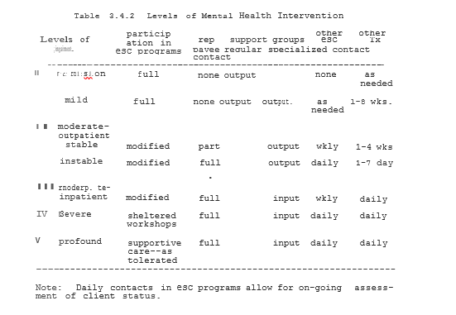

3.4.4 Family Support Systems

No chapter on Community Mental Health and Social Services would be complete without at least a brief review of the potential roles of the family, both positive and negative, in patient treatment. When it is a child or adolescent patient, understanding and working with the family is critical to a successful and stable long-term outcome. In working with adults, the effects of a patient's behavior on their spouse, children and other family members are also critical factors that need to be understood. Very often the failure of treatment may result from an inadequate understanding of these family dynamics. Conversely, when therapy is successful, it is in no small part because the family is working together instead of against one another. In microcosm, therefore, the family offers the same opportunities to design win-win solutions as does Society at large.

3.4.4.1 Effective Family Problem Solving: The Win-Win Contract

In working with patients and their families, just as with any system, it is important to help people become effective win­win problem solvers. By helping families to first articulate and then actually list problems, they can then alone and together learn to seek mutually beneficial win-win answers. While this process often takes some time and practice to learn, it is precisely the previous absence of such effective communication, negotiation and problem-solving skills that often has block therapeutic progress in the past. And, as with any other skills, the more that they are used, the more effective and successful families tend to become.
One particular advantage of family contracting is that it sees the entire family as an inherently interconnected and interactive system. As such, everybody can play a positive role in the therapeutic process. By being able to explore what it is that individual members need and want from the family over time ways can be found to bring expectations and reality more in tune with one another. By everybody in the family having both Rights and Responsibilities, we can again work towards achieving true Empowerment.

3.4.4.2 CSC, and Family Empowerment

One of the most important functions of the CSC in addition to providing individuals the opportunity to contribute positively to their community, is to help people develop more effective problem-solving and coping skills in their personal and family lives as well. Through the participation in parenting classes and other self-help programs as part of CSC support groups, it is hoped that the general level of parenting skills in the community will be raised significantly. In addition, however, where there are indications of "at-risk" behaviors on the part of either children or adults, the OSCM approach would ensure that additional interventions and follow-up would occur.

As noted above, in addition to support groups were both at-risk youth and their families were necessary, CSC-Mental Health Assistants (MHAs) and other mental health professionals would also be available on an as-needed basis. Rather than just focusing on outside help, however, to the greatest extent possible family members participating with CSC would work in programs that would be of direct benefit to themselves and their families. Thus, a CSC mother of a child having difficulty in school might work as a teacher’s aide or study hall monitor. The CSC father of her child with a misdemeanor might work as an after-school coach or playground Resident Patrol where appropriate. Again, who better than the parents themselves to be working with their own children and their neighbors in their own neighborhood?

3.4.4.3 From Enablement to Empowerment--Breaking the Cycles

In the study of addictions, alcoholism and abuse of spouses and children there has been much research into what types of factors maintain such destructive behaviors within the family system. Perhaps not surprisingly, it is not at all uncommon to see multiple generations of a family as both the victims and perpetrators of such problems. In many cases we are finding various, “genetic markers" for alcoholism, depression and schizophrenia., for example, that suggest a possible familial "vulnerability" in the neurobiological "hardware" underlying some negative behaviors.
Perhaps even more important, however, are the learned behaviors (software, tapes, scripts, etc) that can often get passed down generation to generation through all-too­painfu1 exvperience. As the noted psychiatrist, Richard Kluft, has observed, for example, "Abuse is the gift that keeps on giving." If we are to break these cycles, then family members will have to change behaviors and learn new roles.
In Family Systems Theory, when a wife, for instance, makes excuse for a husband's drinking or beating of her, she is said to be "enabling" this behavior. Similarly, children not reporting abuse for fear of a breaking up the family, end up "enabling" the abuser and his or her behavior. While the victims of such abusive situations clearly would prefer them to stop, generally they fear losing something or making matters worse if they try to resist. Over time, the resignation of Learned Helplessness sets in. And in the process, the abuse not only continues, but often worsens.
Just as in families, entire Societies can end up "enabling" dysfunctional behaviors sometimes with the most noble of intentions. It is argued that the Liberal Entitlement Ethic emphasizing individual Rights, but ignoring social Responsibilities is a classic example of societal enablement of the worst kind. All too often in the Liberal Entitlement Ethic of present day ''Political Correctness," the Rights of the individual are sanctified, but the Rights of Society are ridiculed or ignored.
Thus, for example, searches for guns and drugs in Chicago’s Public Housing have to date been opposed by the ACLU in spite of strong community support during the midst of the highest murder rate in Chicago's history. Instead of Empowering, such Entitlement-based attitudes Enable our present Civil Anarchy and has allowed it to grow to its present literally epidemic proportions.

From a Multi-Systems Analysis perspective at least, part of the reason that such dysfunctional Enabling policies have continued for so long is the lack of effective feedback in the system and the "covert rewards" for the present behaviors. The elites who are most responsible for the promulgation of Entitlement-based programs are rarely directly affected by their consequences. Members of the ACLU and similarly-minded elites and, most particularly, their children, rarely live in Public Housing. As such, they can speak in the abstract about what they can generally avoid in reality.
Simultaneously, those addicted to the present system have tended to vote in large numbers for those promising to maintain or even expand the present welfare system. The road to hell may be paved with good intentions, but the underlying foundation is often built on self-deceit if not outright hypocrisy. It is time as a Society to rethink these literally self-destructive policies and stop the Enabling once and for all. If we are to truly break the cycles of gangs, drugs and welfare, then we must move beyond Enablement to true Empowerment.

3.4.5 Civil Liberties vs Civil Anarchy

While some who first read of mandating various forms of therapy or other work activities may find this questionable, it is important to once again make the distinction between true Empowerment and simple "Entitlements" or, as framed above, Civil Liberties vs Civil Anarchy." In order to better understand this distinction, it may be useful to put it within a developmental context of the vital interrelationship between Rights and Responsibilities.

3.4.5.1 Developmental Model of Values

The role of parents in a healthy family is not to stifle a child's growth but to foster it in a loving and nurturing environment. When a child is first allowed to play alone outside, he or she may initially be confined to a front or back yard. Later, parents may permit them to go down the block and only later to cross a street alone to a nearby park. Even years later when the question is borrowing the car or dating, the issue is the same. At each point in a child's development a parent's Judgment of "allowable" activities is based upon finding the appropriate balance between a child's desires (Rights) and abilities (Responsibilities). When a parent denies a five-year-old child's "right" to play ln the park alone, it is out of love and concern, not capriciousness.
Similarly, a conscientious parent would not tell a child they did not need to go to school, make their bed or even eat their vegetables. Parents help their children most precisely by helping them to develop an internal sense of responsibility and positive moral values. When such values and expectations are first learned ln the family, it is much easier to later extend and include other community members in the future.
The Freedom Quotient (FQ), rewritten below, makes the freedom quotient decision- making process clearer while a child may perceive the benefits of a· particular action (eg going to the park alone, borrowing the car, etc), they may quite less readily perceive the potential dangers and costs inherent in a situation. Youth marvels at opportunity. Wisdom and maturity are precisely what can come from learning from our individual and collective mistakes. It is precisely their lack of experience that leave youth eager to try what later they may come to regret.
Good parents do not try to shelter their children from all of the dangers inherent in the World. But they do try to teach them the wisdom to understand such dangers and to proceed with appropriate intelligence. Parents can do no better than to prepare their children as best they can. Wisdom, opportunities and love can be the greatest gifs we pass on to generations as yet unborn.

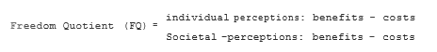

Fig re 3.4.2 represents the natural parallel expansion of Rights and Responsibilities within the context of the FQ previously discussed in Chapter 2. As was clear from the Case Examples previously discussed, and to which we will return in Section 3.7, such a natural developmental progression is by no means guaranteed in life. Yet the closer we are able to maintain the balance between Rights and Responsibilities, the more we are able to maximize an individual's true freedom, be they a child or an adult. Such natural balances in value systems apply equally well to individuals and Society at large. Thus, the ACLU notwithstanding, we have a clear means of distinguishing between true Civil Liberties and the Civil Anarchy with which it has all too often in recent years been confused.

3.4.5.2 Social Contracts

Just as with the family, we all live with implicit and explicit social contracts that effect what is acceptable and unacceptable behavior when these rules are explicit we call them lying when implicit, these rules are called values or the morals of Society. Whether implicit or explicit however, ultimately how we deal with such rules are a reflection of our own personal values. Our values, in turn, are in large part learned by early experiences and in particular the rules we 1earned within our families. Thus, if we are to develop a more perfect society and World, then we must start with the values taught within the family.
When, for whatever reason, an individual shows behavior that may be a danger to themselves or especially others, Society has not only the right but the responsibility to intervene in a positive manner. Just as in the family, while such corrections are ultimately beneficial for the individuals involved, they are also beneficial for Society at large. We may thus hope and even expect that individuals entering our Mental Health and/or Criminal Justice systems may ultimately benefit from the experience. But in an epidemic, Society has the right to quarantine those who would otherwise do more harm to others.
Because Society, composed of human beings, is a living and evolving system, its laws and values must also evolve over time to meet the changing realities of its members. Such an evolution is a dynamic process and must lead us all to "Question Authority" as a fundamental part of being a responsible citizen and even family member.
Regardless of the letter of the laws, however, the spirit of trying to help all individuals develop to the maximum of their potential can and should be both preserved and expanded through it all. In the process, however, it is essential that the Rights of individuals always be balanced by their Responsibilities to themselves and Society at large. This is the distinction between true Civil Liberties and mere Civil Anarchy.
In the context of Community Mental Health, the levels system discussed above emphasizes the continuum between "sickness" and varying degrees of "wellness." There are some situations where Society may consider an individual a potential “danger” to themselves or others" requiring a more restricted environment for a certain period of time. In a psychiatric setting, such- a determination may lead to either voluntary or involuntary a civil mission to a mental health facility for appropriate treatment. In a Criminal Justice setting, such a determination may lead to incarceration or similar such action. In all such cases, the level of individual "Rights" ideally should remain balanced by the level of responsibility or self-control shown or not shown at that particular time.

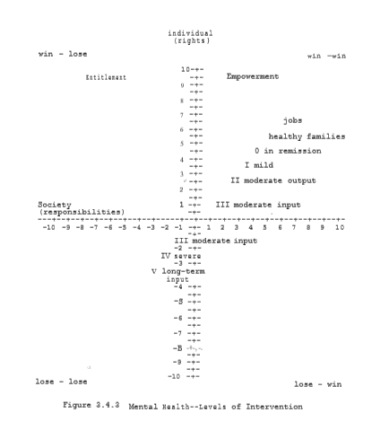

Figure 3.4.2 Community Rights of Individuals; one of the levels of intervention eventually discussed for the Community Mental Health model. A similar figure will be used in Section 3.5 to illustrate a Multi-System Analysis approach to the Criminal Justice system. The fact that there is a significant amount of overlap in these figures is consistent with the significant overlap in these populations themselves as previously discussed. Again, the distinction between our mental health and criminal justice system is more illusionary than real. The earlier we intervene in both settings, the greater the savings, both financial and human. When we thus talk about "Civil Liberties”, we must always understand that the dependency created by drugs, child abuse, illiteracy, or chronic welfare are all just forms of slavery by another name. It is only by breaking such bondage, that individual families and Communities can achieve genuine Empowerment by putting the needs of Society as well as individuals back into the equation of the Freedom Quotient, we can at last achieve a fair and humane balance between Rights and Responsibilities. It is only thus that the health of our Nation as well as our people can finally be restored ONCE AND FOR ALL.

3.5 Criminal Justice
3.5.1 Background

"'If you ever go to Houston, you better walk right. You better not stagger, you better not fight. Sherriff Benson will arrest you and he’ll take you down. And you can bet your bottom dollar, you're penitentiary bound." Midnight Special—Leadbelly

Major factors in the perpetuation of violent crime in America include the failure of families and schools to effectively curb antisocial tendencies early on and the failure of the reluctant criminal justice system to deter criminals from repeat offenses. When looking at the demographics of repeat offenders, it should come as no surprise to find by-it-large poorly educated, poorly skilled, inner-city, young males often with long histories of drug/alcohol abuse, gang involvement and trouble with the law and schools from a very early age. Also, not surprising, are the findings of large numbers of inmates coming from chaotic and often highly abusive home and community environments.
From a community mental health perspective, preventive interventions are needed to stop this growing epidemic in our society of which increasing drug use and violent crime are only some of the more obvious symptoms. In the preceding sections, several primary and secondary preventive programs were discussed. It is argued that these programs can have both short- and long­ term significant impacts on crime rates in the United States. In fact, these and the tertiary programs discussed below, far from being revolutionary new concepts, are the common-sense approaches to these problems found in many societies around the World, and even our own not that many years ago (see Leadbelly above), which greatly account for their significantly lower rates of crime and violence.
It is clear if we are to stop criminals from returning to our streets simply as more hardened, experienced and professional, then we need to look more closely at not only what has occurred in jails and ln the past, but also where these individuals are going and how we can help assure that they develop positive, permanent changes in the future 63% of Federal and State convicts are rearrested for a serious rime within 3 years. 25% are rearrested within six months. 40% of convicts are rearrested in this first year alone. For individuals younger than 25 with eleven or more prior arrests, there is a recidivism rate of 94% (Hodgkinson, 1989). Clearly the present system is failing at both retention and rehabilitation. To simply release such criminals with no thought to follow-up is a guaranteed recipe for failure.

3.5.2 Probation/Parole/Work-Release/Community Service Corps

Probation/Parole/Work-Release/CSC (P/P/WR/CSC) programs are designed, as with the general psychiatric population, to assess what strengths and weakness individual criminals have and to develop a long-term program of in-prison and after-prison activities to address these deficits and monitor progress towards agreed upon goals.
Again, as with psychiatric patients, a series of levels of intervention are proposed to provide the necessary levels of structure to facilitate positive changes in behaviors and attitudes while simultaneously protecting the Rights and safety of the community at large. Also, as with CSC in general, a fundamental principle of all levels of intervention is to require participation in work programs is an essential part of both rehabilitation and restitution to society and to break the cycle of released inmates simply return to a poorly supervised life of crime. By providing for graduated levels of intervention, the criminal justice system would be providing credible, cost­ effective alternatives to either indefinite sentences or probation and parole with minimal follow-up.

Level I--Referrals

Description--Youth involved in first time minor offenses and misdemeanors (eg, truancy, curfew violation, fighting where no injuries are involved, minor drug and/or alcohol abuse) where formal criminal charges are not sought but intervention is sorely needed. Interventions--Youth mandated to Extended Study Hall (ESH) and other after-school programs. Hours/day and duration of assigned programs would be dependent on the nature and chronicity of offenses and response to interventions. Support groups for both youths and their parents would also be mandated to explore underlying problems and facilitate their correction. Incentives (eg, decreased hours of ESH, increased recreation time, etc) can be offered for good behavior and improvements in grades. Where indicated, mandatory drug screening can be implemented. It is hypothesized that where positive tests immediately result in combinations of additional ESH and possibly CSC time, a dramatic decrease in drug use will be seen.

Level II--Probation; Nonviolent Parole

Description--Youths or adults in repeated minor offenses or more serious first offenses (eg, drug selling, vandalism, break-ins, robberies, battery, etc.) and adults with repeated disorderly conduct (including alcohol/drug intoxications), vagrancy and loitering charges where probation is deemed a viable alternative to incarceration. Also, cases of nonviolent criminals having finished Level III or IV sentences but still in need of structured follow-up. Intervention in addition to ESH for youths, some CSC or work-release time will be required as part of the conditions of release where work is to be assigned as deemed most appropriate.
Vandals, for example, might specifically be assigned to cleanup crews wire-brushing graffiti off of walls. Homeless individuals convicted on vagrancy or Loitering charges could be mandated to psychiatric assessment with assignment to Level I-III psychiatric programs with application to appropriate funding sources. Again, mandatory drug and alcohol testing would be done as needed. Failures in performance, attendance, and/or sobriety would be reviewed in weekly support groups. here problems keep repeating, options would include extending the duration and/or number of hours a week served or remanding individuals to higher levels of intervention for violation of parole conditions.

Level III—Half-Way Programs

Description--Individuals in need of more structured environments than home or the streets, but not presently in need of jail. Examples include individuals failing Level II or graduating from Level IV and those sentenced directly to Level II by the courts (eg, drug and alcohol repeat offenders, domestic violence cases, etc.).

Intervention--24 hour/day supervised, structured half-way houses with AA, NA and other support groups in addition to CSC/WR programs. The focus of programs includes maintaining sobriety and other appropriate behavior while simultaneously practicing the habits and skills of steady work. For school­ age youths, school and/or GED classes may be additional components of daytime programs provided that sufficient motivation in classwork is demonstrated.
Where possible and appropriate, work-release programs offering the hope for more long-term employment will be favored, but CSC programs will still provide needed structure and incentives for later full-time employment. As individuals progress through the program and demonstrate appropriate behavior, daytime passes for jobs and occasional weekend home passes could be given. As· above, failures in drug testing or other behaviors would be reviewed in weekly groups and be grounds for extending sentences or returning to jail if necessary.
As previously discussed total duration of CSC/WR programs at all levels should reflect not simply punishment, but also restitution to victims of crimes and at least partial payment for these remedial programs themselves. Also, to have other community members now see criminals atoning for their actions by work in their own neighborhoods may have additional positive deterrent effects on others who might have previously seen such individuals as negative role models.

Level IV--Boot Camps

Description --Young offenders with moderate-serious offenses but not yet hardened criminals.

Intervention--Particularly for young offenders, boot camps should be seriously considered as alternatives to traditional prison settings. By teaching discipline and mutual respect to young offenders, this option can be an alternative to teach self-control in a semi-structured setting. Intense efforts could be made to break old patterns while working on improving skills and self-respect. In addition, urban boot camps maybe a cost-effective positive form of halfway houses for chronic but nonviolent offenders. Particularly where personnel from the down-sizing military could be involved, ROTC-type programs could offer a long­ term alternative to traditional gang activities.
Such a structure could also introduce additional positive male role models for children of single-parent households to emulate. Strenuous exercises, extended school days and Community service would help in changing old behavior patterns. Mandatory support groups for offenders and their families would further assist in the development of more positive value systems. Transitions to Level II programs would allow such progress to be not only maintained but strengthened over time.

Level IVb--Jails/Parole

Description—Individuals sentenced to jail not appropriate for boot camps but eligible for future parole.

Intervention--The fundamental principle in all cases where parole is an option is, first, to provide the basics for improvement in attitudes, behaviors and skills so as to make future success possible and second, to mandate that all releases from jail are paroles and that no one is paroled without an individualized CSC/WR program as a condition of release. At or before sentencing, all inmates would be assessed for educational level, skills, aptitudes and deficits and assigned to jobs and remedial classes as appropriate. Just as in out-of-prison settings, weekly support groups could be used to monitor behaviors and any progress in skills and attitudes and provide corrective feedback as needed. Failures in performance at work, fighting, intimidation, positive drug tests, etc. could delay the time of parole and/or add to a sentence's duration. In this sense, incarceration would not be dissimilar to psychiatric hospitalizations for "acting out" adolescents with an added component of restitution for past crimes.
In most cases parole would mean graduation to Level II programs with Level III programs possibly available directly to some nonviolent offenders. Again. the duration of Level I, II and III programs are not simply for punishment and long-term out-of-jail monitoring of work performance, but also for restitution from salaried work for the victims of crimes and the costs of these programs. Finally, projects in the investigation of prison/work programs should be examined in additional means of deferring costs of the criminal justice system away from the taxpayers. Contracts should be particularly encouraged where there is agreement to train inmates for marketable job skills with bonuses given for increased employment and decreased recidivism.

Level IV—Jail Without Parole

Description--Conviction with life sentences for which there is no parole.
Intervention--The focus in these programs is on restitution with in-jail work programs and support groups available to help inmates cope with prison life as appropriate. Consideration could be given to "lifers" participating in other groups as examples with other prisoners as to help others avoid their own fate.

3.5.4 Windows of Change

As described above for the Mental Health System, the Criminal Justice level systems provides a natural continuum of levels of structure meant to protect Society, yet allow for rehabilitation where possible. Figure 3.5.1 illustrates this continuum and a "window” range of socially acceptable behaviors. While some variation within this "window" of appropriate behaviors would be expected, the Freedom Quotient would argue that the greater the variance from this "window," the more justified Society would be to intervene. For comparisons sake, some of the problems discussed in the Case Examples (and to which we will return in Chapter 3.7) are also illustrated in this Figure. Important to note about these other behaviors is that in general they were "allowed" over a prolonged period of time by the present system. As noted earlier, social policies that "enable," these behaviors, over time, only reinforce them and make them more difficult to change.
If we wish to design Criminal Justice systems that reliably change behavior for the better, then it is essential that the balance between the individual's Rights and Responsibilities be restored. What an effective rehabilitation program does is to continuously practice responsible behavior until they are successfully internalized. As this can often be a gradual and potentially erratic process, it is important that adequate structure be maintained until a high degree of confidence can be achieved that old behaviors will not return. The intense work training and parole-monitoring program can be a highly preferable alternative to either suspended sentences or early releases with very few restrictions.
In order to significantly reduce recidivism therefore, a fundamental condition of all probations and paroles should be a clear long-term "contract" as to what expectations will be placed upon the individual. As in writing other forms of "contracts," when other ground rules for and consequences behaviors are clearly articulated and upheld, individuals tend to behave accordingly while being very clear on both the expectations on work and sobriety. For instance, this behavior is more likely to be demonstrated. Particularly if it is clear; that failure to work or having positive drug screens would be considered parole violations, compliance would be more likely· to occur. Since a person going on to get a steady job and contribute to society could obviously be considered “freer " than a person repeatedly returning to jail, the benefits, both financial and otherwise, of a person going on to get a steady job and contribute to society could obviously be considered “freer " than a person repeatedly returning to jail, the benefits, both financial and otherwise, of such a program could further outweigh any "costs" for both convicts and society alike. Such a program could further outweigh any "costs" for both convicts and society alike.

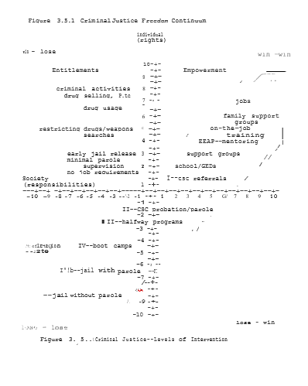While having "consequences” for negative behavior can help in changing behaviors, ultimately it is best when individual act in positive win -win ways because they believe that this is best for both themselves and everyone else as wel1. Thus, when programs are designed right, over time people come to act in positive ways, not simply to avoid punishment and gain rewards, but because they actually believe that it is the right thing to do. Such an ideal can only occur when positive values are truly internalized. At such a point, the goal of treatment has been achieved. The window of change has opened at last.

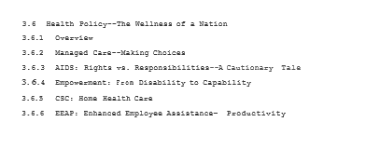

3.6 Health Policy—The Wellness of a Nation

3.6.1 Overview

This Section would not be complete without at least briefly touching upon the theme of a National Health Policy. My purpose here is not so much to endorse a particular approach as to emphasize the need for some type of comprehensive policy that renders all Americans while promoting wellness, prevention and cost-effectiveness by its very design. All too often, our present system rewards inefficiencies and abuses of secondary and primary health care programs is not uncommon example from psychiatry can illustrate this point. Recently an adolescent whom I had seen for over a year and who was making significant improvements as an outpatient was hospitalized for several months by another psychiatrist during the middle of a custody dispute between the parents. Not surprisingly the child was finally discharged when 1nsurance benefits were about to change. While some "benefits" undoubtedly may have come from this extended hospitalization, it is not at all clear that the beneficiaries were the family, let alone the patient. What is clear is that the entire hospitalization could have been avoided or at least dramatically shortened with more aggressive outpatient treatment of not just the child but the parents as well.
The point of this vignette is not to say that physicians or hospital administrators are necessarily intentionally unethical or "corrupt." Rather, the present system or its design rewards ''inefficiencies" and punishes good conservative medicine. At present both physicians and hospitals generally have clear built-in incentives for long-term hospitalizations and many medicolegal risks if they do not. If we are to improve both our overall health care systems and its cost-effectiveness, then we must design "managed care" approaches that reward physicians and patients alike not only for wellness but cost-effectiveness and productivity as well.

3.6.2 Managed Care--Making Choices

In most areas, health care can be both improved and made less expensive by giving all involved strong incentives for practicing good preventive medicine. In addition, as a Society we must make hard choices as to what our medical priorities are · to be. As noted previously, it would be very easy to spend $500,000 or more on the first six months alone of Neonatal Intensive Care Unit (ICU) care of a premature baby with profound brain damage and a life expectancy of a few years at best. Similarly, the average cost for the treatment of an adult AIDS patient is conservatively some $60,000/year. It has often been noted that approximately two-thirds of all health care dollars are spent within the last year of life. And currently approximately 20% of US families faced with catastrophic illnesses end up bankrupt.
Clearly there are many tests, procedures and medications that we can (and presently do) use that have very little impact on extending the quality or time of life. These are "choices" we make at present more by default than by design. A managed care approach, whether in private or public sector, allows us to make such decisions as to what priorities we wish to make in spending an infinite number of health care dollars.
In a comprehensive Managed Care system, it is possible to merge the roles traditionally provided separately by insurance companies and health care providers. In programs such as Health Maintenance Organizations (HMOs), for example, businesses can contract for a total health care package at a prearranged set price that covers both inpatient and outpatient services. In such a program, health care providers now have a clear financial incentive to keep people healthy and out of hospitals whenever possible. By combining such programs with patient deductibles, over usage of costly inpatient facilities can be avoided. By having businesses give employees bonuses, discounts or other incentives for healthy activities (eg, weight reduction, smoking cessation, sobriety, etc), a strong win-win focus on prevention and wellness can be achieved.

In the Public sector, making choices in health care has been equally critical to cost containment. Defining what procedures will and will not be included 1in a standard Medicare or Medicaid benefits package can help to clearly bring the Public back into this important decision-making package. While recent efforts to "rank" the cost-effectiveness of health care procedures in Oregon have been at least temporarily blocked, such rankings are the inevitable result of a finite number of available resources. Making additional "extended coverage" benefits packages available for all those who wish them again helps to combine the "right" to such additional coverage with the responsibility to pay for it.
If, overtime, the present welfare system can be replaced with simply a guaranteed jobs program, then health care benefits packages for this population would be the same as for any other employees in the Public or Private sector. Efforts can be made to transition in reforms over a period of several years so that those presently on Social Security could avoid present benefits from being adversely affected. Simply containing present expenses and reevaluating our future priorities, however, could lead to substantial savings and improvements in health care over time. A cautionary tale involving AIDS will help to illustrate many'. of the problems with the current Entitlement health care system.

3.6.3 AIDS: Rights vs. Responsibilities--A Cautionary Tale

Over the past 15 years AIDS has gone from being an unknown disease to a major epidemic destroying countless lives and costing billions of dollars a year in America alone. World-wide, especially in Africa, the effects of the growing epidemic are even worse: From the time of being diagnosed as HIV positive, the average time to develop full-blown AIDS is 5-7 years (in 1992). The average life expectancy once AIDS is diagnosed is 2 ½ years. Therefore the “Rights" of each and every person contracting AIDS by whatever means are absolutely violated. There is nothing inherently. "liberating" about dying of AIDS. But this is one tragic epidemic that we have, by and large, brought upon. Surely we could easily eliminate AIDS as a major healthcare system in the United States over a period of' years or less at a fraction of what we are presently spending were it not for the damaging Liberal Entitlement Ethic that continues to emphasize "Rights" ·without Responsibilities.

Because AIDS is not highly contagious, there are only a relatively few ways of contracting this disease. Incidence rates for new cases among homosexual populations is thankfully, declining. But new cases among HIV drugs abusers and their sexual partners continues to rise. As this happens, more and more, AIDS becomes a disease disproportionately affecting already disadvantaged inner-city populations. Yet those such as the ACLU who so often portray themselves as the II champions" of these groups are yet once again in the vanguard of those who would reflexively block those actions which could help them the most and end this literal plague upon the land once and for all. (Again, the chi1dren of ACLU members tend not to live in these neighborhoods nor, as a group, are they at high risk for iv drug abuse.)

If we were truly serious about stopping AIDS and stopping it now, then we would have to stop treating AIDS as a political "exception" to the basic medical laws of epidemiology. When "consumption” or tuberculosis (TB) was a leading killer of America at the turn of the Century, public sanitoriums were set up in which to quarantine its victims. The commonly accepted social standard was that, along with the right to medical treatment came the social responsibility to protect others from getting the disease, Ironically, TB, once a well-controlled disease, is now experiencing a resurgence in a small part because of its prevalence among AIDS victims. But where once physical quarantines were considered thoroughly socially justified, now, even the insistence on taking appropriate medications and other socially responsible behavior, is considered a violation of an individual's “Civil Liberties." And in the process, thousands upon thousands of people are condemned to a sad and lingering death.
As noted in all of the examples previously cited and with AIDS as well, we as a Society have lost perspective on the essential balance between Rights and Responsibilities. Because AIDs is not readily transmitted we do not need traditional quarantine in most cases to control its spread. But we can and need to identify, people infected with HIV and ensure that it is not passed on to others. To do this, just as in the past, we need to balance the right to treatment with the responsibility to avoid further transmission of the disease. The most effective first step in stopping the present AIDS epidemic would be the mandatory testing of members of high risk population and their sexual and/or drug partners. A slower, but perhaps more "politically acceptable "compromise approach” would be the mandatory testing of all high-risk populations either showing medical symptoms and/or entering the criminal justice system. Again, to be most effective, potentially infected partners need to be identified and also tested.
Finally treating the AIDS epidemic like any other epidemic, where we balance individual "Rights" and social Responsibilities, would start to break this deadly cycle once and for all. When HIV-positive cases are identified, the second step in stopping this epidemic would be to ensure that the virus is not passed on to any new victims. If solely relying on the good will of present AIDS victims to act responsibly both, for instance, in always practicing safe sex and not sharing needles was adequate, then we would not be facing the present AIDS epidemic. By definition, therefore, stronger measures than what are presently being used are essential in controlling this raging epidemic. Again, if we are truly to be concerned about "civil liberties," then the more people that we can protect from the death sentence of AIDS, the better it will be for us all.

In order to make even being with AIDS victim a "win-win" situation, we must try to maximize the Rights of victims within the context of protecting Society from the further spread of the disease. Since stopping the AIDs epidemic with its present victims would, in fact, save Society a considerable amount in both financial and human terms, we could literally afford to offer a high level of care to these patients. In return, however, by requiring all individuals identified as HIV positive to wear a small indelible ink stamp in a private area (eg, below a bikini line), they could continue living as full and normal a life as possible.
Because the ink stamp would have to be reapplied every few months, if there ever is a cure for AIDS, then these restrictions could also be lifted. In the meantime, however, any potential sexual or drug partner would have a clear way o£ being warned of any potential dangers. Since the responsibility of wearing of the stamp would allow the patient the right to quality health care and other supportive services, everybody would be benefiting to the maximum extent possible.
Often in dealing with victims of abuse, it helps them ultimately to feel that, by sharing their experiences and identifying perpetrators, they are helping to end the cycle of abuse. Similarly, if we were able to stop the AIDS epidemic with its current victims, they could take a great satisfaction in having stopped this terrible plague from being passed on to others. Ultimately, if we cannot always eliminate the pains of life, then at least we as individuals and as a Society can learn and grow from them. If we cannot ultimately save the lives of current AIDs victims, at least they can know that they were contributing positively to Society and did not die in vain.

3.6.4 Empowerment: From Disability to Capability
Part of Empowering all members of Society is to move from a mindset of what people can't do ("disabilities") to a focus on what they can do (capabilities) both now and in the future. If the case of an AIDS patient perhaps working in a hospice, perhaps talking to young drug abusers, may seem to be at the "extreme" of examples. It should help to illustrate that almost everyone in Society can perform some useful and socially redeeming role if we are only creative and resourceful enough to design the system to accommodate their special needs.
By designing the system to the best extent possible could be a "win-win" for everybody, over time we would think less of "handicaps" and more of " potentials." Such a society would help us all to strive to develop to the maximum of our potentials--for the benefit of all. Now that the Americans with Disabilities Act of 1992 (ADA) is the law, it is even more reasonable and necessary to find useful work for those who have previously been set aside by Society.
As has been previously noted, presently in Illinois since the passage of Earnfare-I, if you are considered to be "abled-bodied," then you are told that you must work for your benefits. But if you are a drug addict, an alcoholic, have less than a 6th grade: education or even have diabetes or high blood pressure, you are considered "unemployable" and not required to work. Again, the present system is inherently designed to enable dysfunctional behavior and discourage moving forward. If we were to move from "disabilities" to capabilities, then we must design. our systems to reflect these new values. Just as in Sections 3.4 and 3.5 I discussed a levels-system approach to rehabilitation in the Mental Health and Criminal Justice systems, so too in the Health Care System in general an emphasis should be placed on matching people to abilities­ appropriate jobs. Table 3.6.1 lists an example of a three-level system of physical and (or behavioral impairments.)
Rather than considering disabilities as absolute, it is much preferable to talk of "areas · of ability." By so doing, individuals can be matched to appropriate types of work. This process would be particularly facilitated by use of the Central Computerized Database (CCD) as part of a One-Stop Case Management (OSCM) approach as described in Sections 3.2.2 and 3.4.1. Allowing business tax credits for hiring the disable can again potentially result in a win-win solution if the needs of both employers and employees alike are understood and, appropriately addressed.

3.6.5 CSC: Home Health Care (HHC)

In the Public sector many CSC-type programs have already been described. In this Section I will focus on those types of CSC options, such as Home-Health care, Meals-on-Wheels and the like that can often gain offer a win-win solution to all involved. From the standpoint of the disabled and their families, home­ health care often is a highly desirable alternative to much less personal institutional settings. From the standpoint of taxpayers, home-health care is generally much less expensive. And from the Standpoint of CSC participants, they can again be learning valuable skills while helping their neighbors and community in the process.

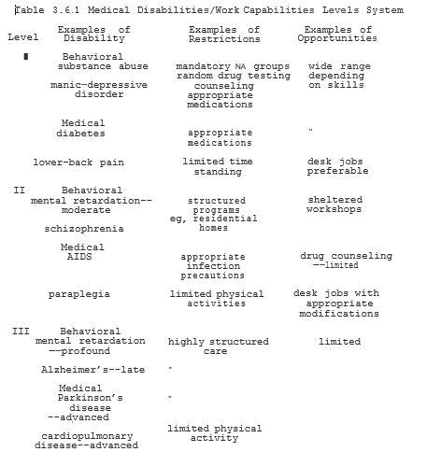

Just as in other CSC programming, putting up with health care teams composed of professional, paraprofessionals, and CSC alliances, a high quality of service can be achieved in a highly cost-effective manner. Because Home-Health Care (HHC) assistants positions can potentially lead to both jobs and careers, those CSC participants following this particular track are again providing valuable services while helping to break the welfare cycle in the process.
Finally, just as in the Mental Health area, some CSC-HHC participants can spend time in both the inpatient and outpatient settings. As such CSC-HHS participants can help to provide an additional element of continuity of care not only for the patient but often for their families as well. Thus, once again, the total worth of CSC participation goes Well beyond its ii1rnple monetary value. Whether CSC-HHC jobs are in the Public or private sector they one more time illustrate ways to bring communities closer together rather than drawing people apart. Living in safe, positive. and healthy environments is the epitome of the philosophy embodied in Safe Haven. That communities can reflect the full range of the life cycle from young to old makes them all the stronger. To the extent that CSC Home-Health Care can support such a goal, it too can contribute to the wellness of America.

3.6.6 EEAP: Enhanced Employee Assistance Productivity

If one long-term goal of a full-employment economy is to see individuals productively employed and developing up to the maximum of their potential, then Enhanced Employee Assistance Programs (EEAPs) can play a vital role in obtaining such a goal. Rather than focusing on crisis interventions or medical emergencies per se, EEAPs would help employees develop Individualized Goals Profiles (IGPs) covering both professional and personal objectives (work, education, personal, family and health) that individuals wish to achieve.
A basic outline of the areas covered in an IGP is illustrated in Figure 3.6.2. If our expanded definitions of health and wellness include success in all five areas of the IGP, then the goal of the EEAP is, in part, to facilitate the defining and attaining of such goals. Not only can work and educational goals be pursued as described in Sections 3.2 and 3.3, respectively, but personal, family and general health goals can also be set as well. The employers in the past might not have formally adapted a hol1st1c approach to worker productivity, many have always at least intuitively understood the interrelation of personal lives with on-the-job performance. Formalizing this relationship in terms of specific goal setting may help both workers and employers to see movement in positive directions.
To the extent that some issues such as drinking or substance abuse affect worker productivity many companies have already set up traditional EAPs to deal with such problems. EEAPs are different to the extent that they try to evaluate and integrate the goals within all five areas of an individual's life in assisting them to develop to their full potential. As such, ultimately EEAPS perform much of the role that will initially be performed. ln community--based One-Stop Case Management (OSCM) programs for individuals presently in various high-risk groups, including being on welfare.

Obviously not everyone’s personal idea. of "success" is going to be the same as everyone else's. But each of us in our own way can ultimately be. just as "successful" in life as we wish--if not in material possessions, then certainly in the inner peace and satisfaction that comes from loving and doing one's best in all at we do. If by reaching out, we all come closer together, then we have done more for the health of ourselves, our families, our unities and our World than all of the pills ever invented. In the end, " health" is as much a state of mind as it is a physical condition.

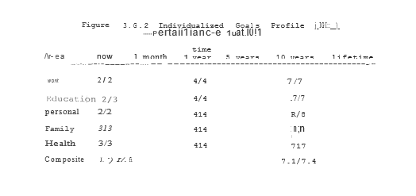

3.7 Case Analyses--Profiles of Success

3.7.1 MSA--Profiles of Success

"To George Bailey, the richest man ln town."--It's a Wonderful Life.

"Success" ln life can be measured in many ways. When all is said and done, however, it is much less possessions accumulated than values lived that determines content of character and satisfaction with life. Just as in Frank Capra's It's Wonderful Life, George Bailey learns how different Bedford Falls would have been without him, so too each of us in our own way can chose to make a difference in the World around us. The choices we make reflect our values. No matter where we start, no matter what has happened in the past, we can all live our values in the here and now and help to build a better World for generations as yet unborn. We can set as goals win-win "Profiles of Success" for the benefit of all.
Having now reviewed the application of Safe Haven principles ln 6 broad areas of social concern (Work; Education; Social Services; Personal/Family; Criminal Justice; and Health), we are now ready to apply these broad principles to the Cases we have previously discussed. Using Multi-Systems Analysis (MSA) techniques we can now design Individualized Goals Profiles (IGPs) to reflect the particular needs and interests of the individuals involved. While any number of win-win scenarios ("scripts") could be imagined, writing out specific goals has many positive benefits.
In addition to helping individuals seriously consider what they would like to accomplish, it also helps to define some of the basic steps necessary to reach these goals. IGPs may change frequently based upon various successes and failures in reaching interim goals. At each point, however, by defining goals in win­win terms, we can help to break old negative cycles once and for all. In the following six Case Studies, I will apply the MSA techniques previously discussed to illustrate the benefits of an integrated approach to the resolution of these complex problem. Because a full Case analysis and IGP can in fact, be quite long and detailed for the sake of brevity I will omit or shorten certain steps ln some of these Cases. For those interested; a more detailed stepwise application of these MSA techniques can be studied elsewhere (Ladien, 1993). For our present purposes, however, I believe the following reviews shall suffice.

3.7.2 Case 1: (Tammy B. 18 yo SWF)

In the Case of Tammy B, her first "point of entry" into a Safe Haven One-Stop Case Management (OSCM) system would be at the State Psychiatric facility here she was taken following her suicide attempt with an overdose of heroin. Because of the involvement of both drugs and the "neglect" of her daughter, Charity, during her suicide attempt, however, criminal charges were pending for Tammy upon her discharge from the hospital. Where in the past such Criminal Justice involvement could be seen as only adding to Tammy's "problems" in a win-win Safe Haven model, such charges could actually be used to Tammy and Charity's long-term benefit.
When Tammy was first interviewed at length the morning after her late-night admission to the hospital, she was scared, hostile and at first highly uncooperative in revealing any details of her story. Her initial response upon being greeted was “I want to get out of here and see my baby. I'm alright and I don't want to talk to anyone.” From this very first point of contact, therefore critical issues of Entitlement vs. true Empowerment were raised. How we see a Society deal with these issues will determine if we are truly to break these cycles or simply see them get even worse over time.
Underlying Tammy's initial response to being in the hospital was her tremendous fear that if she was in anyway found to be "crazy" and/or sentenced to jail, Charity might be taken away front her permanently. Indeed, such fears would not be completely unfounded based upon cases from years gone by. While Charity could potentially benefit in such a situation (remember, eg, when James T lived with Luella T), such an outcome could be emotionally devastating to Tammy (Figure 3.7.1-A; -9; -3). Thus, conceivably in the present Mental Health system, Tammy could have some understandable reasons for not wanting to talk with a psychiatric.
Partially in response to what could legitimately be seen as abuses in the past, groups such as the ACLU have more recently swung the legal pendulum far to the left in protecting patient “Rights” but neglecting their Responsibilities. Thus, in the present system, Tammy could with relative ease obtain free legal counsel' that would in all probability be successful in obtaining both her release from the hospital and the return of Charity. Because Tammy could well be advised by legal counsel that she would run a risk by talking with mental health workers, she could easily be deterred from seeking follow-up outpatient counseling even if she might think that she could benefit from this service. Thus, particularly because of the generally poor quality of counseling and care in present Public Mental Health institutions, it could be argued that Tammy would personally be better off being released, even if Society in general and Charity in particular were hurt by this action (B; 6/-7).
Instead of having to make the artificial and counter-productive choice between "Rights" or "Responsibilities," all parties (most certainly including Tammy and Charity) would be best off where these', two factors worked in unison instead of opposition. Thus, a system that combined Rights AND Responsibilities would lead to true Empowerment while maximizing the benefits to all involved. Option "C" illustrates the type of step-wise continuum of progress that could decisively break old negative cycles while helping both Tammy and Charity to progress towards greater and greater true freedom.

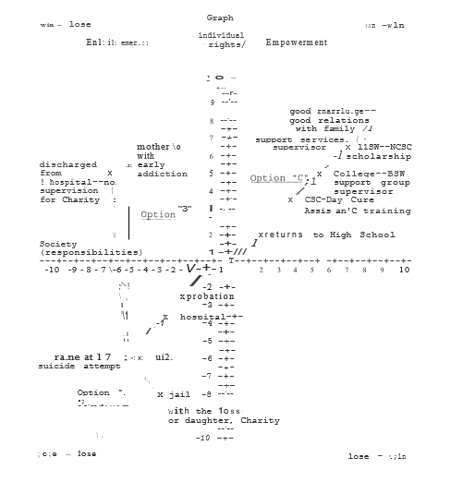

Figure 3.7. 2 represents a partial IGP work-up sheet as might be developed by Tammy and various OSCM members during the first few days of a brief Safe Haven-style hospitalization. As illustrated in the Present Status section, an assessment of 6 general areas of interest (Work; Education; Supportive Services; Personal/Family Criminal Justice; and Health) helps to more fully define the starting point for all future work. Much of Tammy's present status has already been described. It would be important, however, to update this information to include other immediate issues. For instance, if Tammy were pregnant again from the rape, a whole new series of questions would have to be asked and answered in order to know what issues would be needed to be addressed.
Once these issues are resolved and Tammy's present status is understood, the next priority of this evaluation. is to begin an IGP starting with the immediate goals desired by this particular individual. The immediate goal of an MSA approach to creative problem solving in this particular case would be to help Tammy to "get out of this place" and "see my baby" in a way that will benefit all parties involved. By the use of "creative sentencing," the Criminal Justice system can however be used to achieve positive "leverage" (motivation) in helping Tammy move forward (Figure 3.7.1-C) rather than reverting to old negative behaviors (B) or losing her daughter forever (A). Thus, "plea bargaining" a comprehensive plan can become a win-win condition for both discharge from the hospital and avoiding more serious criminal prosecution. Providing a long-term, monitored, semi-structured plan for progress, Tammy can start to truly consider what sort of positive goals she might like to set for herself over a period of the next several years.

In this particular example, Tammy sees herself as continuing on in school while ultimately going on to get a degree in Social Work. She sees herself as helping others in the Community who, like her, had been abused as children. By also expressing a future interest in both marrying and improving relations with her family, Tammy is establishing positive personal goals that will help to give additional meaning to her other accomplishments. Most importantly, by taking the time. to look forward and dream positive dreams, Tammy is learning again the value of hope and hard work. While goals can and, most likely, will change with time and experience, helping Tammy to at least start considering stretch options is the first step in breaking through the bondage of Learned Helplessness.
While any number of goals might be possible, having to specifically think of goals in test of Rights and Responsibilities also helps to clarify: the distinction in her own mind between Entitlements and true Empowerment. Thus, rather than being some dry academic theory, Tammy's newly reaffirmed positive values are now clearly reflected in her behaviors over an extended period of time in a way that, ultimately, benefits everybody. In the practical attainment of positive goals, simply put, ACTIONS SPEAK LOUDER 'THAN WORDS.

Figure 3.7.2 Case 1. Betty B. Partial IGP Work-Up Sheet

Present Status

Work—Unemployed. On AFDC

Education—Dropped out in Sophomore year

Supportive Services—Inpatient at DMH Psychiatric facility, following suicide attempt. 4-month-old daughter, Charity, temporary ward of the State (DCFS)—placed with grandmother, Betty B.

Personal/Family—Depressed, scared, anxious as to what will happen to her daughter.

Criminal Justice--Arrest warrant pending for possession of heroin and neglect of daughter pending on discharge from hospital.

Health--Early drug dependence. Depression. Attending individual, group and family therapy sessions on inpatient unit. Being interviewed and evaluated by CSC Mental Health Assistant for outpatient Community-based follow-up in individual, family and group settings. Defer use of medications at present time.

Individualized Goals Profile (IGP) Immediate

Work--Arrange attendance at Safe Haven CSC orientation for early post-discharge period.

Education--Interviewed for return to high school and assessed for abilities and appropriate classes.

Supportive Services--DCFS assessment of Tammy and other family members (Betty B. and Sissy) as to ability of Tammy to care for Charity upon discharge Charity temporarily placed with Betty B pending final placement decision and discharge. Interview Tammy for possible participation in Day Care Assistant training program where Charity is to attend Pre-Head Start Infant/Toddlers program while Tammy is in school.
Personal/Family--"Get me out of this place." "I want to see my baby." ·

Criminal Justice--Review of case with State Attorney's Office for approval of IGP as part of plea bargain settlement of charges pending.

Health--Contract with Tammy for safety, sobriety, outpatient follow-up and random drug testing as preconditions for discharge.

Work—Tammy working part-time as Day Care Assistant at Center when Charity stays while Tammy is at school.

Education—Tammy resumes classes as Sophomore in High School. Receiving additional credits for time spent working at Day Care Center.

Supportive Services—Charity attends Infant/Toddler Pre-Head Start program at local Day Care Center while Tammy attends classes.

Personal/Family—Tammy stable at home with Charity. Feeling good about working towards positive goals.

Criminal Justice—On probation x3 years as long as complying with IGP. Primary monitoring of compliance to be done through CSC job participation and weekly support groups as part of overall One-Stop Case Management (OSCM). Individual review 1x/month or as needed.

Health—Weekly support group sessions. Daily contact by CSC Mental Health Assistant group co-facilitator until stability of Tammy and adequate parenting for Charity is assured. Frequency of psychiatric follow-up and family sessions to be determined by progress as outpatient. Random drug testing available on an as-needed basis.

6 months

Work—Continuing work as Day Care Assistant as CSC activity.

Education—Maintaining B average in High School with aid of CSC Study Hall tutors.

Supportive Services—Charity doing well in Infant/Toddler program. Home visits down to 1x/month to maintain progress.

Personal/Family—Tammy enjoys her own and Charity’s progress. Family session with mother, Betty, and Sissy have helped to improve dialog among them all.

Criminal Justice—Continues with 3-year probation dependent on compliance with IGP. Supervision in weekly support groups. Individual reviews every 2 months or as needed.

Health—Continues in support groups. Maintaining sobriety. Random drug testing and additional counseling available on an as-needed basis.

1 year

Work—Working at Day Care site as support group co-facilitator as CSC activity.

Education—Finished Junior year with B average. Continues to get credit for CSC activities.

Supportive Services—Charity doing well in Infant/Toddler program. Home visits only on an as-needed basis.

Personal/Family—Tammy improving in self-confidence with B average at school and being promoted at Day Care Center to support group co-facilitator. Feels comfortable with parenting skills. Is glad for improved relations with mother and sister. First contact in years with father, Peter B.

Criminal Justice—Continues probation without incidents. Supervision in support groups. Individual reviews every three months or as needed.

Health—Continues with weekly support groups. Maintaining sobriety. Mandatory drug testing and counseling on an as-needed basis.

2 years

Work—Tammy working as CSC group co-facilitator and homemaker, including “Big Sister” contacts with younger at-risk adolescent group members.

Education—Finished High School with B+ average.
Supportive Services—Charity doing well in Pre-Head Start Infant/Toddler programs.

Personal/Family—Tammy making final decisions on career goals after High School. Regular family contacts with mother and sister. Meets with father.

Criminal Justice—Last year of probation. Supervision in support groups. Individual reviews every six months or as-needed.

Health—Continues in support groups. Maintaining sobriety. Mandatory drug testing remains available during final year of probation along with counseling on an as-needed basis.

3 years

Work—Working part-time still as group leader supervising other CSC group co-facilitators and homemakers as part of National Community Service Corps (NCSC) pay-back Scholarship program.

Education---Tammy completing undergraduate classes for degree in Social Work--financed in part through NCSC Scholarship program.

Supportive Services—Charity doing well in 1st grade an in after-school programs while Tammy is at work and at classes.

Personal/Family--Tammy dating. Charity doing well. Good relations with family.

Criminal Justice--No further probation or problems with the law.

Health---Maintaining sobriety. Strong positive self-image. Regular physical fitness program.

Lifetime

Work—Work in Community Service helping others, especially incest survivors and victims of domestic violence.

Education—Completes Master in “Social Work.” Considers going on for Doctorate.

Supportive Services—Charity involved in various After-School programs throughout her school years.

Personal/Family—Wants to marry and perhaps have additional children. Wishes to continue to strengthen family relations.

Criminal Justice—No further negative criminal justice contacts. Runs support groups for at-risk youth and young offenders.

Health—Easily maintains sobriety and positive self-image. Regular exercise routine.

3.7.2 Case 2. James T.

James’ case is both complicated and sad. But it illustrates well both the' absolute need for early intervention and the ability of the human spirit to transcend the moment and find meaning of life in the face of adversity. James’ first point-of entry into the Safe Haven program was upon his arrest in downstate Illinois where he was picked up following the robbery of an all-night convenience store during which a clerk had been shot and seriously wounded. At the time of his. arrest he was homeless. He was caught during a raid on a crack house where he was found accidentally, strung out on drugs. Because of. James' jumping bail in Chicago and high school history of violence, he was appropriately denied bail while awaiting trial. Given that this was reportedly a contract out for his life for a Mafia drug deal: that had gone bad, it could be argued that James was as safe in· jail as he would be anywhere else. At least in jail James was getting meals and shelter and was no longer a danger to the Community at large.

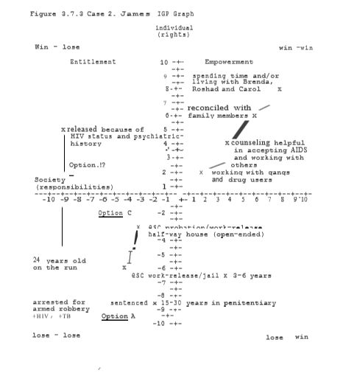

As part of the medical work-up upon his arrest,James was found to have active tuberculosis (TB). Because of this risk action, he was also screened for his HIV status which came back positive. Thus, in addition to his legal and other problems, James was now found to be in the early stages of a full-blown AIDS infection. With his arrest and identification as an AIDS victim, the perceived quality of James' life which' was already out the door while he was "on the run" (Figure 3.7.3, -7/-8) to even more (-8/-9).

Because of James' medical and past psychiatric status, the exact course of his criminal case could be significantly altered. [n years gone by, James might have been convicted of armed robbery and attempted murder and sentenced on 15-30 years in the State penitentiary regardless of his health status (Option A). In more recent years however, again the pendulum has swung far in the opposite direction. Under the present Entitlement Ethic, it might well be the case that James would not even be mandated to the treatment of his active tuberculosis, let alone be tested for the HIV virus.
Since James ended up spending only five years in a State Mental Hospital following the murder of a rival gang member, the chances of him spending any time in jail for armed robbery might be slim to none. If his HIV status is determined, it would probably be an additional reason for him not spending time in jail or perhaps even in a psychiatric institution. In fact, the major outcome might well be to simply increase the amount of his Supplemental Security Income (SSI).
If James is released at this time, however, given his all of past history, there is every reason in the World to believe that he will continue to use drugs and spread both his TB and the HIV virus to others as well, leaving aside the issue of further rapes or armed violence. Thus, far from either effectively treating James or even protecting Society, the present Entitlement Ethic would only tend to perpetuate these problems and add even further victims to this growing National travesty and tragedy (Option B).

As difficult as James' situation is, not only can a positive Win-win outcome can still be written, but it is essential to us all that this: be done. For a true win-win outc6me to happen, however, we must be able to employ the full range of options available using an HSA One-Stop Case Management approach. Figure 3.7. 4 outlines some potential steps in achieving such a result as also mapped out in "Option C" of Figure 3.7.3. By both denying bail and keeping James in relative isolation until his tuberculosis is under control we also help to ensure that he is spreading neither the tuberculosis bacilli nor the HIV virus.
During this initial period, not only is a baseline skills/ needs assessment being conducted, but an evaluation of James ' potential appropriateness for a modified work-release program is being ascertained. In addition to individual counseling/assessment time, James would also participate in a modified CSC orientation within the prison complex. It is during his orientation that the tentative IGP outlined in Figure 3.7.4 would be developed with: appropriate assistance. In terms of immediate goals, James' cooperation with the orientation groups and overall evaluation process will be a good indicator of his appropriateness for a work-release program.
In such a program, James would be bussed to a nearby factory or other CSC activity where he could work under supervision during the day while returning to the jail to spend the evenings. As James would be thus obtaining a certain limited amount of freedom as well as skills and positive habits in this process it would have overall benefits for himself as well as society (-6/-4) compared to a traditional long-term jail sentence (-8/-6). Just as importantly, however, rather than being an endpoint, this CSC work-release program would be seen as a new beginning.
Depending upon how James did in jail-based work-release and other components of his IGP (education, counseling, health, etc) he could be reevaluated in a relatively short period (eg, 3 years) to a less restricted half-way house version of these programs. Not only would this be a benefit to James, but to taxpayers as well (-2/-2). With James' health also an issue, he would have strong incentives for doing as well in all aspects of these programs as possible. Again, by maintaining the level of structure appropriate to balance Rights AND Responsibilities James too can move forward along Freedoms Road.
By starting to work with gang members and drug users, James is beginning to transform the hurt and anger of his own life into a source of healing for himself and others. As James shares his own experiences with others both in support groups in talking with teens, he is coming to understand himself more and more. In helping others, he is helping himself as well--the ultimate empowering win-win outcomes. As he lets go of past angers, he moves further along Freedom's Road.
While particularly at the beginning, there is no guarantee that James will achieve his goals, by beginning to think in such terms, to dream, to hope, to work for a better tomorrow, James can always feel that he has given life his best effort and lived it to the fullest. In the end, James fondest hopes would be to be reconciled not only with his mother and grandmother, but with his younger brother, Thomas, his children and the mothers of his children as well. If he cannot ultimately "save" himself, then at least he wants to help others including his children and Thomas. Particularly for his oldest children, Roshad and Carol, James wishes to have them learn from his example of overcoming the odds against him. These are goals that give special meaning to James' life as he fights to see them happen. In the end, James' may die, but his struggle and message would live on in the lives he had touched. James has been a fighter all of his life.

Figure 3.7.4 Case 2. James T. Partial IGP Work-Up Sheet

Present Status

Work—Only work experience is selling drugs.

Education—Dropped out of High School as Sophomore; 6th grade reading and math levels.

Supportive Services—Homeless; no visible means of support.

Personal/Family—Alienated from all family including mother and grandmother and four children; no child support.

Criminal Justice—Arrested for armed robbery and rapes, including of Tammy B.

Health—HIV positive; elevated liver enzymes; tuberculosis

Individualized Goals Profile (NP)

Immediate

Work—Somewhat complicated by HIV status, but evaluated for work-release apprenticeship training programs.

Education—Enroll in GED program.

Supportive Services—Modify SSI payments to a) mandate compliance with IGP and b) payment of benefits directly to the state during the period of incarceration.

Personal/Family—Contact mother and grandmother to inform of incarceration; start reviewing life goals (IGP) particularly in light of HIV status.

Criminal Justice—Deny bail based upon history of violent behavior and fleeing prosecution.

Health—Quarantine from other inmates until infectious period of TB is controlled. Complete list of sexual and iv drug partners; indelible “AIDs” stamp below the “bikini line” renewed each 2 months; counseling to deal with issue of HIV status and incarceration; cooperation with notification of drug and sex partners as well as overall behavior during incarceration would give elements in determining appropriateness of work release; weekly support group with other convicts.

1 year

Work—work release factory apprenticeship program; some time spent on anti-g rig, anti-drug counseling.

Education—obtain GED

Supportive Services—SST continues to go to State to defer costs of incarceration and child support.

Personal/Family—attempts to reconcile with family members including the three mothers of his four children.

Criminal Justice—continues work release programs for at least three years with possible transfer to half-way house with good behavior.

Health—complete treatment of TB; periodic reevaluation of HIV and general medical status; renewal of ink “AIDS” stamp every two months; continue with weekly support groups with other work-release convicts.

Lifetime

Work—would like to work with gang members and drug users using his own example to encourage youth towards more positive lifestyles. Particularly as James’ health deteriorates, he could match his work to reflect his health needs.

Education—might consider some part-time junior college classes depending upon availability and interest.

Supportive Services—continue with SSI payments to State at half-way house and, possibly, hospice if later needed.

Personal/Family—be able to spend time with family members; ideally James would want to reconcile and, perhaps, even live “with his childhood sweetheart,” Brenda, the mother of his first two children, Roshad (8) and Carol (7)

Criminal Justice—obtain early (eg, 3 year) parole; be a “model prisoner” and help to “pay back” Society by his work with young gang members and drug users.

Health—focus on life, instead of dying; try to develop and maintain healthy habits, including those necessary to avoid passing on HIV Virus to others (eg, safe sex, no drugs, etc); continuing with weekly support group; coming to terms with life; being at peace with himself and others

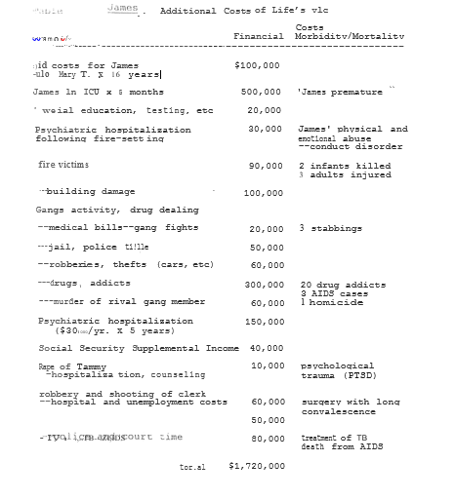

3.7.3 Case 3. Luella T.

If James T. up to the present has been a major "cost" to the Community (Table 3.7. l), his grandmother, Luella T., has been a major benefit. In addition to her years of tireless work for her local church, Luella's values were also reflected much closer to home as well. As the caretaker of Rachael, Luella T has sacrificed much of her own life and possibilities to the care of her younger daughter. At first because of the severity of Rachael's lung problems remaining from the fire, a visiting nurse would come to their home once a week. Over time, however, Luella became expert at the techniques and procedures needed to care for Rachael. Thus, rather than years of costly and relatively impersonal nursing home care (Figure 3.7.5, Option A), by her actions Luella was able to have a significant positive effect on the quality of life for Rachael and many other Community members as well. Luella's faith has helped her to find an inner peace even ln the midst of tragedies of Talbot Park.
As "accepting" as Luella is of her own life, she still worries greatly for her family and community. As Luella grows older she wonders what will happen to Rachael when she is no longer able to care her alone. Because of their lifestyles, Luella has refused to talk with Mary and James until they "stop hurting themselves and everyone else." Even if someone could help with Rachael at home, however, Luella has seen Talbot Part get significantly worse even over the nearly two decades that she had been there. Thus resolving problems in her family and community would have high priority in Luella's own IGP (Figures 3.7.5, 3.7.6).
Traditional "liberal" responses to the problems of welfare, eg, raising subsidies, in Luella's case might marginally improve the quality of her life but would do very little to address her own more pressing priority issues (Option B). In fact, to the extent that such liberal Entitlement-based policies would tend to worsen rather than break the welfare cycle, they could ultimately be counterproductive and damaging to the best interests of Luella and her family and community.
As the primary caretaker of Rachael, Luella has in fact been acting in a CSC-Health Care Assistant (HCA)-type capacity already for years. Given her overall expertise in this area, her proven leadership abilities and the presence of many other disabled and elderly individuals in the Talbot Park area, Luella would be an ideal candidate to act as the local resident coordinator of CSC­HCA programs. In addition to home-based care, however, there may also be the possibility for developing various half-way houses and sheltered workshop-type settings.
Thus, by one more time acting in her role or a natural community leader, Luella would be helping to guarantee the availability of cost-effective, community-based care for Rachael and many others as well. In order for Luella co be reconciled with Mary and James, they would have to give up their old destructive behaviors and show by deeds as well as words that they "had seen the light" as it were and changed their values. In many ways, therefore, Luella and Safe Haven once more natural allies. By helping both Mary and James to identify and pursue positive values in their community,

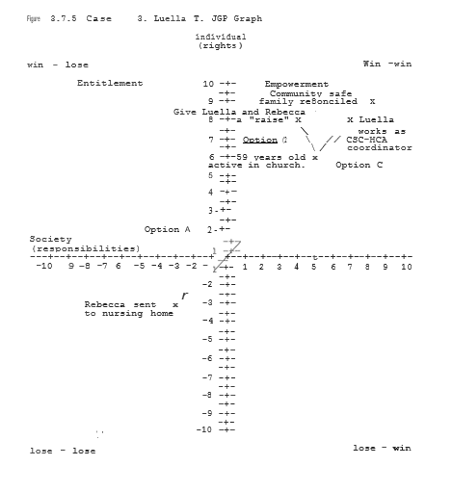

Safe Haven is doing precisely what Luella has for so long been advocating. Conversely, if there is one factor above all others that would motivate James and Mary to change, it is the example of Luella who has lived h2r values in all that she has done. Thus, in their reconciliation, not. only do James, Mary and Luella benefit, but so does the community at large (9/9). An essential win-win outcome is thus achieved.

Figure 3.7.6 Case 3 Luella T. Partial IGP Work Sheet

Present Status

Work—Technically unemployed on SSI, but full-time caretaker of her granddaughter Rachael.

Education—9th grade level education, but reads the Bible daily and can quote long passages.

Supportive Services—Receives SSI for herself and her daughter Rachael, originally received weekly visits until Luella learned the techniques necessary to clear Rachel’s lungs.

Personal/Family—Close relation with Rachel, with many friends, is alienated from daughter Mary, and grandson James, which bothers her greatly.

Criminal Justice—one arrest with deceased husband John, at Civil Rights rally in 1952. She and John were convicted of “civil disturbance.” Suspended sentence with one-year probation. (Sentences handed down one month prior to the firebombing).

Health—2nd and 3rd degree burns over 75% of her body now healed but with extensive scarring. Lung damage limits amount of physical exertion possible at any one time.

Individualized Goals Profile (IGP)

Lifetime

Work—establish and mark as first CSC Coordinator of Community-based residential home and sheltered workshop.

Education—study for and complete GED.

Supportive Services—be able to make transition of Rachael to cure at Community-based sheltered worship. Get assistance with shopping, transportation, meals-on-wheels, etc as needed.

Personal/Family—See family members all doing well and reconciled.
Criminal Justice—See her community safe and healthy.
Health—Maintain health as well as possible. Get supportive services to remain at home if possible. Otherwise, retire to Talbot park. Nursing Home needed.

3.7.5 Case 4. Mary T.

As previously noted, Mary T. presently lives alone with her younger son, Thomas (9), in Talbot Park. Ever since James was arrested and hospitalized following the murder of a rival gang member, Mary significantly cut back and eventually stopped dealing drugs "for the sake of Thomas." Unfortunately, because of the gang activities at Talbot Park as well as James' reputation, it was essentially impossible for Thomas not to be affected by these influences. Thus, in addition to the general academic problems at school, there have been several "minor” episodes of vandalism and drug-related activities that have already brought Thomas to the attention of the police.
Given the multiple problem areas readily identifiable (Figure 3.7.7, 4/-6; Figure 3.7.8), there are several potential entry points for Mary into the Safe Haven program. First, as a recipient of AFDC at Talbot Park, Mary would have different options to choose from for CSC participation in the Public and/or Private sectors. Second, because of. the behavioral and academic troubles that Thomas has been having in school. Mary would have been contacted for family sessions around these issues as well. Since Mary at present has given up drug dealing she would not be likely by herself to trigger criminal justice involvement" Because of Thomas' own early gang activities, however, Mary could again be mandated by the courts into some type of parental involvement as previously discussed in Section 3.5.3.

Regardless of the particular entry point, there are a least three quite distinctive options available for attempting to address the issues raised by the present status of Mary and Thomas. If, as a rigid "conservative" approach might suggest, Mary were simply cut off of welfare and told to fend for herself, it is quite likely that she would simply return to drug dealing and other criminal activities (Option A, 3/-8). When "abled bodied" recipients of General Assistance in Illinois were “'cut off of the dole," we had the highest per capita murder rate in history. Clearly, simply cutting benefits without providing appropriate opportunities can at least potentially make the situation even worse for the individuals and society at large.
If instead of cutting subsidies we actually increased benefits to Mary and Thomas as many traditional "liberals" might advocate (Option B), we might marginally improve circumstances for Mary in the short run while adding to the tax burden on average citizens (6/-7). Even worse, however, by making welfare relatively more "attractive," it not only deepens the rut for Mary to climb out of, but actually increases the likelihood that others will become entrapped as well. Therefore, rather than breaking the cycle, Option B, runs the great risk of making the problem even worse as I have discussed at length earlier.
By having Mary participate in various Safe Haven programs, she would be greatly helping back herself and Thomas as well as other community members as well. Chasing, for instance, to participate as an CSC teacher's aide as previously discussed in Section 3.5.3, she’d be able to directly have a positive impact on both Thomas' behavior and academic performance (4/4). Continuing on to get her GED would allow Mary even more options to reach her goal. Following that, by working as a part time teacher while taking courses at the local junior College, Mary would be eligible for a National CSC Scholarship program that would help to support her and Thomas during this time, Mary is able to talk more in support groups and she is able to sort out many of the sources of her anger and despair from the time of her father's murder when she was eleven to the present. She also comes to better understand the many sacrifices made by her mother for herself and Rachael and why she did this.
By understanding the nature of the struggle. By understanding not just the struggle of her parents, but of leaders such as Martin Luther King and so many others as well, Mary comes to better appreciate the choices, the freedom, that others have literally laid down their lives to give to her. For Mary, the raising of political consciousness is the beginning of true Empowerment.
As Mary rediscovers the value of both of her patients, her outlook on life moves strongly from being the victim of society’s wrongs, to being a soldier in the struggle for a better tomorrow. Instead of feeling alone and alienated, she feels strengthened by the challenge before her. By reconciling with her family and running for the President of the local Resident Management Corporation (RMC) at Talbot Park, she is putting into action these rediscovered values. Considering further political activities in the future might help to even further empower both Mary and her community. Thus, again, continuing the Rights to assistance with the responsibility to contribute in positive ways to the community, ultimately helps to empower everyone.

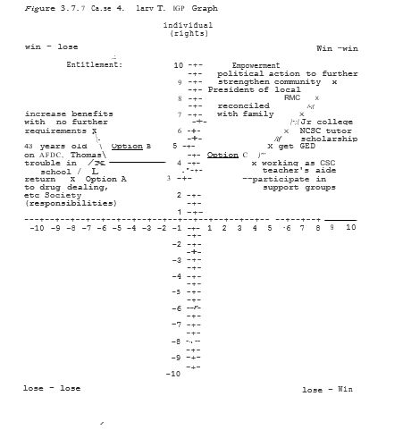

Figure 3.7.8 Case 4. Mary T. Partial IGP Work-Up Sheet

Present Status
Work—Limited “legitimate” work experience; presently unemployed/

Education—Dropped out of sophomore year of High School.

Supportive Services—Presently on FDC with younger son, Thomas. Thomas gets into fights at school, counseling recommended.

Personal/Family—Alienated from son, James, and mother Luella; worried about James’ safety and health; worried that Thomas will follow in his older brother’s footsteps.

Criminal Justice—Multiple past arrests, drugs, prostitution, armed robbery, served 5 years of ten-year sentence for homicide; no current charges pending.

Health—Aggression; occasional binge drinking; mildly elevated liver enzymes; 2nd and 3rd degree burns over 20% of body; now healed, but with scarring; mild lung impairments; asthma with exertion.

Individualized Goals Profile (IGP)

Lifetime

Work—See Talbot Park Residential Management Corporation (RMC); become a thriving, self-sustaining, community-owned and run enterprise; develop long-term relations with local businesses and corporations to make available apprenticeships and other on-the job training positions or Talbot Park residents; possible future political organizing.

Education—Finish college and possibly advanced degree, eg in communications.

Supportive Services—Continue to push for the expansion at presentation-oriented programs at Talbot Park and elsewhere.

Personal/Family—Reconciliation with family; working together to see both family, community, and Country break the old cycles of despair.

Criminal Justice—Work at the Community Policing/Resident Patrols and other prevention-oriented programs to make Talbot Park and other communities safe and healthier places for all to live.

Health—Maintain own health; no alcohol or drugs; work to ensure that health-care programs are readily available within the Community for her own or other families benefit.

3.7.6 Case 5. Betty B.

At the time of Tammy's suicide attempt, Betty B had just completed her year-long medical technologist training course. As she had not yet gotten a job, she was available to care for her granddaughter, Charity, while Tammy was in the hospital. Thus, her immediate point of entry into Safe Haven auld be as it relates to the temporary care needs of Charity.
As part of a comprehensive One-Stop Case Management approach a full needs-assessment would be made of not just Betty, but her entire family including Tammy, Charity and Sissy as well. As is often the case, there are several factors that relate to other family members in Betty's Individualized Goals Profile as will be summarized below.
As noted previously, because of her· own middle-class background, Betty had found poverty, let along Talbot Park, to be highly environments from the beginning. Tammy's pregnancy, dropping out and now suicide attempt convinced Betty all the more of the need to leave. Had Betty simply been cut off of welfare without first having gone through the training program available (Option A), Society might have saved some money in the short run (-8/-3 vs -7/-7). But obtaining even an entry-level medical technician position which would also allow Betty to leave Talbot Park would be even a greater benefit for her and Society (Option C; 6/5).
Conversely, Option B of simply increasing welfare benefits would, again, actually work to discourage Betty from getting a job. Thus designing an IGP that starts helping Betty obtain a job will ultimately be the greatest benefit to everyone.
Based upon the family sessions held while Tammy was still in the hospital, Betty and she agreed that if they pooled their resources, they would be able to find a place where they could all live together at least while Tammy was finishing High School. By that time, Betty would have hoped to have advanced far enough as a medical technician so as to be able to afford an apartment in a "decent” neighborhood whether or not Tammy continued to love with her and Sissy.
Thus, at least in the short-run, by everyone working together, they all would benefit. An additional part of the One-Stop Case l1anagement approach in Betty's case would be to help her obtain assistance as to both child support from Peter (Section 3.7.7) and financial restitution from Frank (Section 3.5.3) for both Tammy and Sissy". This assistance would not only help to support the family's move out or Talbot Park, but also help with counseling and a college fund for the girls. As the alternative to this assistance from Peter and rank would be that taxpayer’s money would go to pay for these services, from a fairness standpoint, the Societal choice should be obvious. In addition, by holding both Peter and Frank responsible for the actions and inactions, ultimately everyone saves us along Freedom's Road.

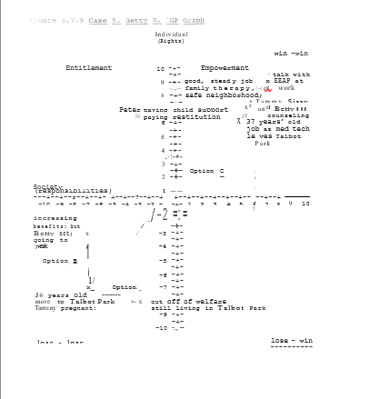

While Betty's present "lifetime" goals are relatively limited (good steady job; seeing the family happy and living in a safe neighborhood), as she advances in her medical technician work, her needs and wants really well evolve. By participating in individual, family and group counseling sessions, Betty would have the opportunity to work through a great many unresolved issues not just from the past several years but going back to her child and adolescence years as well. Just as with James' abuse in growing up in the inner city, the physical, sexual and emotional abuse of Betty's childhood have left many wounds that, were not successfully identified and addressed, can see her not getting all of the joy and satisfaction out of life that is there to be had.
By talking with her Enhanced Employee Assistance Program (EEAP) counsellor at work, Betty could help to assure that she is not only meeting her short-term goals, but is also leaving the door open for future growth and opportunities as well. Although the last several years have left particularly prominent emotional. scars on Betty and her family, continuing to plan for the future can be a major benefit to them all as well as to Society at large. By working with Betty to help her plan for and meet these future goals, her company gets a better employee, her community a better neighbor and her Country a better citizen.

Figure 3.7.10 Case 5. Betty B. Partial IGP Work-Up Sheet

Present Status

Work—Working in entry-level medical technician position.

Education—Graduated High School; some college credit or medical technician classes.

Supportive Services—No child support; sporadic counseling for family; temporarily watching Charity while Tammy is in hospital.

Personal/Family—Tammy alienated from family; Betty worried about Tammy being in hospital post-suicide attempt.

Criminal Justice—Being assisted in applying for child support from Peter and restitution from Frank for Sissy and Tammy.

Health—Good health in general.

Individualized Goals Profile (IGP)

Lifetime

Work—Advance in job far enough to have a decent income and to be able to retire comfortable at a reasonable age.

Education—Continue education for long enough so as to meet work objectives; may take additional specialized classes as new medical equipment becomes available.

Supportive Services—Peter paying child support and later helping with college payments until Sissy is at least 21 years old.

Personal/Family—See family reunited with everyone happy and doing well.

Criminal Justice—Live in a safe community where neighbors help neighbors; financial restitution for Sissy from Frank.

Health—Good health; gets regular exercise and maintains good diet, routine physicals and testing (eg, mammograms etc) as indicated.

3.7.7 Case 6. Peter B.

When Peter had first gone off to college, he had wanted Betty and Tammy to come with. With the small inheritance Betty had gotten from her father, things would have been tight but, by working part-time jobs, they would have been able to have made it through the two years needed for him to least complete his undergraduate degree in Computer Engineering. When Betty got pregnant with Sissy, however, all of Peter's financial planning went for naught.
The first time that Peter started drinking heavily after the birth of Tammy. It had almost cost him his marriage. The second time this happened, when Betty announced that she was pregnant with Sissy, the marriage was over.
It was never really that Peter and Betty stopped loving each other so much as, at the time, both felt that they were not getting what they needed from their marriage. The values of their parents had said to stay together at least for the sake of the children. But. is was precisely their own experiences in dysfunctional families that lead Betty and Peter to reject this option. Given what. Happened to all involved in the ensuing years, a third option would have been desirable. Peter's life since his divorce from Betty in 1981 has had a series of "highs” and "lows.”
After finishing a Master's degree with honors in Computer Engineering, Peter was able to fulfill a lifelong dream when he was hired by a major defense contractor to work on the team designing the computer controls for the NASA space shuttle. Peter would dream of how the space shuttle and the Apollo moon landings as the first tentative steps of humanity into the infinite domains of the universe to be explored. In a very real sense, Peter felt a tremendous pride and excitement that he was in his own way at least a small part of an important milestone in human history.
After the launch of Voyager, because of his low seniority and budget cutbacks, Peter was laid off at work. During this time Peter began drinking heavily again. He was called back briefly to work on a program involving guidance systems for cruise missiles. Because of his continued drinking and a DUI arrest, however, Peter lost his security clearance and was fired from the company.
During this time, Peter's second wife divorced him. They had no children. Since Peter's second divorce he has withdrawn more into himself and drinking and has seen his dreams for the future grow more and more remote. Although a superior Computer Engineer, Peter's drinking and lack of "focus" in his work have to date kept him from achieving the sort of goals and personal satisfaction that he would want and has led to his being fired from his past three jobs.
Presently Peter is working as a Chief Productions Engineer in charge of automating plants to improve his company's productivity. Peter's company is in direct competition with manufacturers in other Countries, especially Germany and Japan. In order for them to survive, let alone flourish, Peter has as one of his Responsibilities to look at sites in Third World Countries, particularly Mexico, to relocate at least some of the company's basic manufacturing and assembly operations. While Peter s ambivalent about his work, if he does achieve it, he can ultimately be transferred to the developmental division of his company to work on projects of which he has always dreamed of.
Although, as is generally the case, there could be multiple points of entry for Peter into an overall Safe Haven program, Tammy’s hospitalization following her suicide attempt will illustrate the process well. As previously noted, when Illinois' document of Children and Family Services (DCFS) placed Tammy’s daughter Charity, with Tammy's mother, a full needs assessment of Betty and her family was conducted. Although Betty and Peter had informally agreed at the time of their divorce; that, per Betty’s wishes, he would give up custody and visitation and, in return, would not be required to pay child support, this was no longer necessarily in the best interests of either Tammy or Sissy. Since at the time that Peter went to school he had no money to pay, and Betty had her small inheritance, this financial arrangement seemed air and equitable to them both. Peter got his “freedom" and Betty got the children. Although Peter regretted not being able to see his children, he convinced himself that, because of Betty's hostility towards him, ultimately his absence could be the best interest of them all.
Originally Peter felt that what he was giving up in family life, he would make up for by literally "reaching for the stars” in his work. More recently Peter had come to feel a failure in both areas. At first, when Peter was contacted by Illinois Child Support Enforcement Division he was angry. Peter had felt, perhaps with some justifications, that Betty had tried to "trap” him into staying in Elmwood both times that she got pregnant. His initial response to hearing of Betty's petition for child support payments; was "Here we go again." Peter was confused, hurt and angry and he did what he had learned long before to do in such situations. He began drinking again more heavily.
Peter got the news about the child support payments in the morning at work. He was so shaken by the situation that he took an early "lunch" and went to a local bar to "calm his nerves." When Peter finally got back to the office late in the afternoon, he had missed an important meeting and was thoroughly drunk. Early the next day, Peter received notice to report to the Corporate Vice President in charge of his division. Again, as usual, depending upon the decisions made and programs in place, significantly different outcomes could be expected for all involved.
In a traditional company, as had. happened in his three previous jobs, Peter could be fired by his boss for chronic alcoholism (Figure 3.7.11, Option A). In this case, Peter might not have money available for child support and could, potentially, even be jailed for non-payments. Alternatively, if Peter had assets such as a house, it might have to be sold to cover back payments and future child support. (Option B). This option could conceivably benefit Society in general and Tammy and Sissy in particular even while being highly aversive to Peter. (Option B) could potentially be even more aversive if; while Peter is ordered to pay child support, he still has no contact with Betty or his children.

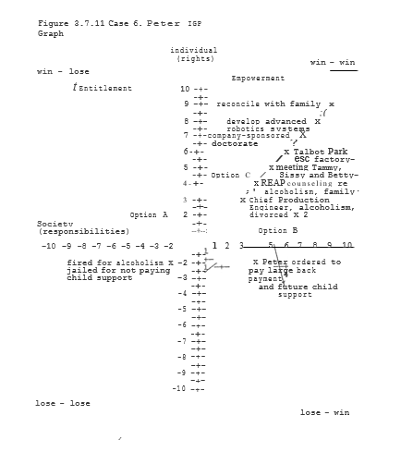

In previous cases, so too here, a win-win option provides changes in attitude as much as in behaviors. By the company offering him the choice of counseling as an alternative of being unwarily fired, they have the opportunity to not only be a valuable employee, but to strengthen and develop him even more into absolute sobriety (perhaps again enforced with Antabuse) could be an essential prerequisite to keeping his job. But, by expanding the scope of counseling to include issues such as not seeing the children and his own troubled childhood, Peter would have the opportunity to gain valuable insights allowing him to get out of his destructive cycles once and for all.
By keeping his job Peter has the money to send to Betty and the girls to help them out. As he continued in counseling, Peter is now able to admit to the void left in his life by the separation from his family. The more that he talked, the more that Peter realized how genuinely interested he was in getting to meet his children and Betty again after so many years. Since his parents had long ago moved from Elmwood, he had heard nothing about Betty and the girls since she had married Frank more than ten years earlier.
Although the official contacting Peter did not get into any details, Peter assumed, that Betty was divorced and in some way in trouble. Despite all of the years of separation and silence, Peter came to realize how much he still cared and wanted to help. Counseling helped Peter to find ways to reach out to Betty and his children without alienating them in the process.
Over a period of time as Peter was able to help Betty, Sissy, Tammy and Charity financially, they were willing to share more of their experiences and feelings with him. Tammy and Sissy both needed and wanted a "father figure” in their lives and Peter was finally getting to a point where he could fulfill this role in positive way. By remaining both sober and productively employed, Peter was not only helping his family, but himself and his company as well.
In this particular win-win scenario, as Tammy became more involved with other community members in developing Safe Haven programs at Talbot Park, there came a point at which the local President Management Corporation (RMC) was actively developing working relations with nearby companies for Apprenticeship and on-the-job training programs. In particular, the RMC as successful in getting Talbot Park incorporated into a local Free Enterprise Zone where businesses would be able to train and, ultimately employed at local CSC participants as part of an automated ax voucher system.
Because of the improvements in educational standards and reductions in crime in the Talbot Park area since the Safe Haven programs are implemented, Tammy was able to convince her father to consider Talbot Park for one of the assembly plants his company had previously been planning to set in a Third World Country. By keeping these jobs in America many levels of “community" we are ultimately drawing closer and closer together. Once the assembly plant at Talbot Park as operational, Peter would be in a position to move on to a position in Research and Development to work on some of his advanced computer designs as he had always wanted to do. For financial reasons, Peter had to go to work directly after getting his Master's degree.
Although he had taken many specialized courses since that time, he had never gotten the do oral degree that he had always wanted. As part of a collaborative effort with a local University, Peter's company now sponsored his doctoral work on advanced robotics. As this work ultimately would have several patentable elements to it, this doctoral work was again a win-win proposition for all involved.
Finally, as Peter was able to begin achieving many of the professional goals he had set for himself so long ago, he also began to find more satisfaction in his personal life as well as having long since given up completely both his drinking and smoking, Peter was physically in much better health, and he and Betty had the opportunity to work out many of their differences, they too grew closer together. Seeing both Sissy and Tammy their granddaughter, Charity, doing well. also gave them both great joy. Thus, by making a conscious choice to seek positive solutions to their long-standing problems, in the long-run, everyone benefited and grew closer together in the process. Again, such is the nature of win-win solutions.

Figure 3.7.11 Case 6. Peter B. Partial IGP Work-Up Sheet

Present Status

Work—Computer engineer; previous jobs have included work on both space shuttle and cruise missile avoidance systems; fired from last two jobs and security clearance revoked for chronic alcoholism.

Education—Master’s degree in Computer Engineering; multiple physics seminars and training programs for specialized development.

Supportive Services—Two brief alcohol detox programs in the past; one past 21-day rehabilitation program which Peter left within 10 days; briefly in AA in the past, but did not follow up; he is not presently paying child support.

Personal/Family—Living alone in South Western state; has not seen children (Tammy and Sissy) nor his first wife, Betty, and has not paid child support since divorce in 1981; one other brief marriage ending in divorce secondary to alcoholism.

Criminal Justice—Several past DUIs; civil lawsuit pending for company and present child support.

Health—Elevated liver enzymes from chronic alcohol abuse; smokes two packs/day; 25 pounds overweight; elevated cholesterol; family history of heart disease.

Individualized Goals Profile (IGP)

Lifetime

Work—Advanced robotics for further exploration of Mars and other planetary studies.

Education—Possibly obtain doctorate in company-sponsored, community-based accrual program.
Supportive Services—Paying back child support for Sissy and Tammy; continuing child support payments for Sissy; regular assistance to begin counseling through work-place EEAP for both drinking and feelings related to child support and the family.

Personal/Family—Although still having much anger at Betty for deciding to "divorce " him in the past: and now again; he would like to get together to ultimately reconcile with Betty and be a father to his children.

Criminal Justice—Intends to settle child support petition out of court; will finish probationary period allowing DUI conviction and avoid all further abuse problems in the future.

4.1 MSA—Levels of Change

" If we stand united, our voices will be heard. " - Ross Perot

So, if we wish to see true change that moves this Country forward and benefits all, what can we as individuals do? First, as the Multi-Systems Analysis (MSA) model and common sense suggests, there are multiple levels of change to be considered. As Figure 4.1.1 illustrates, change can and must occur at all levels from the personal to the g1obal if as individuals and as a Society we truly wish to build a better World. But in a very real sense, whether we are parents or Presidents, administrators or advocates or just concerned citizens, in a Democracy we all have a role to play. It all starts and ends with ourselves.
Until and unless we can all truly say "We're mad as hell and we're not going to take it anymore," and then act to make change happen, we are not yet truly free. The true key to political Empowerment is not isolation, but cooperation. Ultimately, we can design as bright a future as we can ream. Vision, perseverance and collective action are the ingredients that can help turn these dreams into realities. Indeed, as Ross Perot says, "If we stand united, our voices will be heard."
The MSA techniques described in Section 3.1 offer a way to partially systematize both the analysis and design of systems so as to ensure that they are working for us and not against us. A summary of these steps s given in Table 4.1.1. Assuming that the present status (for instance, of a community) and program goals have been tentatively established, it remains crucial that the appropriate number and level of systems be identified and incorporated into the overall program design. The case of the Beethoven program on Chicago's South Side illustrates these issues well.

Figure 4.1.1 Levels of Change

Global
Multi-National Groups
Nation State County
City/Town; community
Neighborhood
Family
Individual

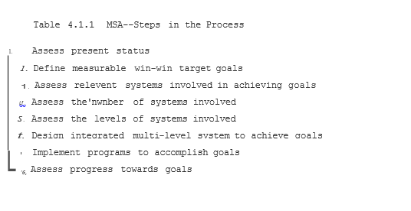
4.1.1 Case 9 Rolling Over Beethoven—Broken Dreams

For years Irving Harris has been acknowledged as a Chicago philanthropist with a strong commitment to the welfare of children and their families. In addition to founding the Ounce of Prevention program and the Erikson Institute, he has supported many projects aimed at the prevention of child abuse and the encouragement of early childhood education.
In 1987, Irving Harris began what has been called the Beethoven Project at six buildings in the notorious Robert Taylor Homes on Chicago's South Side. The Beethoven Project, based upon a Liberal model of increasing Entitlements, illustrates well the problems of an inadequate system design, however well-meaning it may be. Before children were ever born, home visits were paid to welfare mothers to encourage them and their children to participate in the Center for Successful Child Development, as the Beethoven Project is officially named.
In addition to Zero to Three educational opportunities, Beethoven offered medical care, advice on child development and nutrition, a supportive play environment and even a week1y parents support group. All the mothers in the six participating high-rise buildings had to do to participate in these programs for the benefit of themselves and their children was little more than to just show up.
The initial goal of the Beethoven Project as envisioned by Irving Harris was to produce a class of 120 kindergartners entering the local Beethoven Elementary School by the Fall of 1992. Each year thereafter at least as many children were to follow until, in time, the overall quality of life in the Robert Taylor Homes was to be transformed. Unfortunately, however, instead of 120 highly motivated, well-prepared children entering one school, only twenty Beethoven Project graduates ended up entering several different schools. While some argue that at least some children showed increased self-confidence and school preparedness, others felt that the children they saw "seem no better prepared for school than other students." Thus, for all of its promise, to date Beethoven has been more a matter of broken dreams.

So why has Beethoven to date been so unsuccessful? Edward Zigler, one of the original founders of the Head Start program; calls Harris' efforts "courageous." But Zigler also notes "that programs like Beethoven cannot have a substantial effect unless Society attacks these ills with the equivalent of another War on Poverty.”
As important as the issues of health, job training and drug addiction that Ed Zigler notes are, however, voluntary programs that emphasize "Rights" but not Responsibilities will inevitably continue to fail and cost American tax payers millions of dollars in the process. Irving Harris states that his "greatest disappointment has been the program's inability to reach the most depressed and desperate of mothers in Robert Taylor Homes who did not have the motivation to enroll." Thus, as was true in our Case Histories as well, the highest "at risk" populations are precisely the least likely to enter into a voluntary program. Such is the literally fatal flaw of the Entitlement Ethic.
In addition to "poverty" and poor motivation, crime also remained a critical problem for the Beethoven Project. As Irving Harris himself noted in explaining why the Child Center would periodically have to close, "The gangs say, 'Don't be here this afternoon.' We close and get out." As long as we allow gangs and other criminals to rule the streets, things will only get worse instead of better. We need literal Safe Havens to begin to make a difference.
As noted at the beginning of this book, therefore, for all of its fine intentions programs like Beethoven are like giving antibiotics to children with pneumonia, but then sending them back out naked into a blizzard. Unless and until we deal with these issues in a comprehensive manner that combines Rights AND Responsibilities leading to true Empowerment, such Entitlement­ based programs will inevitably continue to fail and cost the America tax payers millions of dollars in the process. Well-intentioned or not, the people of Robert Taylor Homes and the American public at large deserve something better than a snow job. If we are not very careful, however, the travesty of Beethoven could soon be replicated on a National level. The choice, ultimately, is up to us.

4.1.2 Feedback and Accountability

Irving Harris is a private citizen and whether he spends his money wisely or foolishly is ultimately up to him alone. Mr. Harris has put more than $2M of his own money into the Beethoven Project. Unfortunately, you, the American taxpayers, have put in substantially more into this and similarly designed programs.
If you could individually sit Jane and John Q. Public down and explain to them the problems with programs as fundamentally flawed as Beethoven, they would be quickly fixed or ended. But there are a myriad of such poorly conceived programs and the American public has a finite "channel capacity" for attending to, understanding and responding to the details of them all.
The question therefore becomes one of "How can we design our systems so as to both provide the public with adequate information and then allow for appropriate feedback and accountability to take place?" To illustrate a rather dramatic example of this 'very common problem, let me first describe the case of John La Plante and the Great Chicago Flood.

4.1.2.1 Case 10: Tunnel Vision: The Great Chicago Flood

Some may remember that in April of 1992, Chicago workup to find that the tunnel system underlying Chicago's downtown had "sprung a leak" and that millions of gallons of the Chicago River were rapidly filling up the basements and lower levels of Chicago's major shopping and business district. By the time that the leak was finally plugged several days later and clean up and reconstruction finished several months after that, the total cost to not just the local economy but the American taxpayers as well was well in excess of half a billion dollars.
What some of you might not know 6r may have by now forgotten is that the clearly damaged and dangerous tunnel wall that ultimately collapsed was known and warned about repeatedly for several months prior to the disaster on April 5, 1992. Employees of a local cable company had actually even videotaped the damaged section of the tunnel some three months prior to the disaster.
While this information was passed on to City officials within days 'of the discovery, it was several weeks before the tunnel site 6 even investigated. At the time of the disaster, the City officia1 primarily involved, John La Plante, was waiting to get competitive bids for the $50,000 worth of bulkheads that would have prevented the half a billion-dollar fiasco. Once again, A Penny of Prevention....

4.1.2.2 Bureaucracies and Democracies: Series and Parallel Systems

What the above short parable of the Great Chicago Flood may suggest more than anything else is the true danger of "tunnel vision" in every sense of the term. All too often bureaucracies are designed in a hierarchical fashion so that crucial information available at one level of the system is blocked or "filtered out" in the final decision-making process. As with old­ fashion Christmas tree lights, "If one goes out, they all go out." Such are the inherent dangers of any exclusively "series" design.
In order to avoid problems related to "blocked" or missing information it is generally useful to design redundant parallel systems as illustrated in Figure 4.1. 2. In such a system, individuals at any level of the organization are able to bypass some or at intervening levels to assure that critical information is passed along in a timely fashion. Such parallel pathways often will have their own "gatekeepers" such as an ombudsperson in a company or governmental agencies. While by no means foolproof, having multiple redundant pathways helps to increase the probability of the message getting through and the job getting done.
Democracies themselves can be seen to be macro examples of a series-parallel design in action. Whether on the local, State or National levels while bureaucracies may run day-to-day operations of government, ultimately it is we the people as "owners of the company" as Ross Perot would put it, who decide who the "CEOs of these organizations will be.” How we make these decisions depend on large part of the quality and quantity of information available to us and our ability to use it wisely. Democracies afford us in theory at least the ability to influence the system. But if we cannot reach one another, we can still be blocked from collective action.

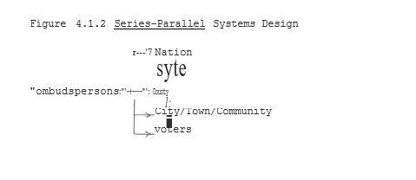

4.1.2.3 Vox Populi—The Dynamics of Dialog
"The Price of Freedom is Eternal Vigilance."
Traditionally one thinks of the media as the means of "dialog" among people. Yet whether it is on the local, state, national or even international level, we are always dealing with a multitude of interacting and often competing "systems" of which the media in its various forms is only one player. Whether it is in the form of daily news items or popular culture, what we see and what we hear is influenced and filtered at many levels. There was a time, for instance, not that long ago when the level of gratuitous sex and violence seen on TV any day would not have been tolerated by the American public. Today we have let our cultural values of Rights without Responsibilities deteriorate to the point that we have come to accept an "anything goes" attitude that only further worsens our social problems over time. If collectively we told advertisers that we would not purchase their products if they continued to pollute our airways, these behaviors would change and change quickly. United we have power. Yet truly "The price of freedom is eternal vigilance."
Figure 4.1.3 illustrates in a highly simplified fashion some of the basic types of interaction between levels of government, power groups and the voters of America. While any and/or all of these groups attempt to directly influence the outcomes of legislative bodies, they also work in part by the messages they pass on or don't pass on to the American electorate. If the price of freedom is eternal vigilance, then we must make sure that we can not only be aware of the choices we have, but have the means to ensure that these changes are implemented. To the greatest extent possible we must attempt to establish secure parallel pathways that allow for both genuine dialog among the American people and effective action. We will come back to this theme in Section 4.3 on National Agendas. Again, "If we stand united, our voices will be heard."

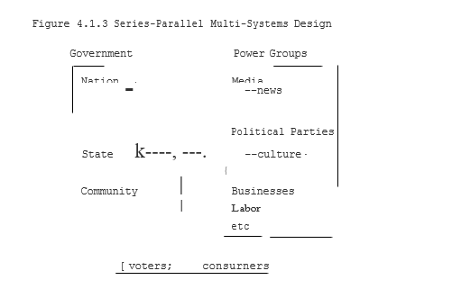

4.1.2.4 Of Ensembles and Assemblies, Catalysts and Revolutions

In order to understand the process of change in a democracy it may be useful to briefly discuss some of the basic principles of nonlinear systems first studied in the physical sciences in areas as diverse as electronics, chemistry and neurophysiology. We can use the cycles of a brain EEG, for instance, as a partial example of some of the cycles of politics and change. In the brain there are many neurons in the cerebral cortex that are interconnected and can weakly excite one another when they fire. Usually, however, these cells are kept from firing by strong local inhibitory forces from cells called interneuron. It is only when a large number of weak excitatory cells fire simultaneously as part of a unified ensemble that they can together overcome the local inhibitory forces. In large part it is the cyclical interactions of the excitatory and inhibitory processes that causes the cycles that we are on an EEG.
The state change that can occur for this unified, coherent interaction of brain cells is called hysteresis and is illustrated in Figure 4.1.4. Transitions between two different points can be smooth (A) or sudden (B) depending on the particular pathway taken and the circumstances (eg, "attractors") involved. Some transitions that might not happen at all spontaneously will happen readily with the appropriate catalyst present. A student may be struggling with a problem for hours, for instance, and yet have a sudden "aha" phenomenon after a minute spent with a teacher. Ideas, therefore, can be some of the most important and powerful catalysts for change in existence.
The same types of figures that can be used' to depict "aha" phenomena can also be used to describe other events from stock market crashes to World Wars. Thus, whether we are talking of brain cells or revolutions, the mathematics of such state changes are by and large the same. Ultimately, we can use such knowledge to help design systems that are of maximum benefit to all. Again, ideas and a vision of the future we desire can be the very catalysts for change that we need.

4.1.3 Win-Win Systems

If we wish to apply the techniques of a Multi-Systems Analysis (MSA) approach to the study of social interactions we now have the techniques to design our systems to clearly be of benefit to all. In this Section I will briefly discuss several different levels of "systems" designs that can be used to illustrate such win-win principles in action.

4.1.3.1 Individuals and Families

While we have already discussed at some length the various case examples of the Baker and Taylor families, it will be useful here to briefly summarize the principles underlying both the Individual Goals Profile (IGP) and more broadly defined family "contracts," In each instance, the IGPs are meant to "start where the individual is “at" but then chart in detail both specific

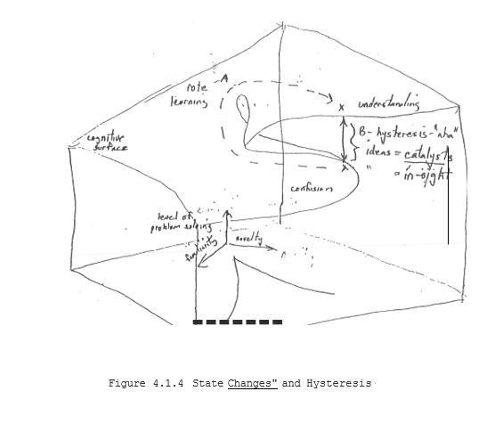

Goals and the various strategies that might be applicable in achieving them. An example of this goals/strategies list shown in Figure 4.1.5 for Tammy B. By specifically thinking in terms of win-win outcomes we can also clarify the type of goals being sought and have benchmarks in place for the monitoring of progress towards these goals. On a family level the same principles can be applied in the development of a Family Goals Profile (F'GP). Such FGPs are not only a composite of IGPs but a specific working document on the individual family members can help one another in achieving these goals. In order to achieve such goals, a detailed family contract can be developed in specific steps. A first step in this process is the writing of detailed problem/solutions lists as illustrated in Figure 4.1.6.
Most individuals in a family, or any other context for that matter can be relative experts at talking about the "problems" in a relationship. It becomes, therefore, a very good starting point in establishing a dialog to write down as many of the problems that an individual can think of related to this relation. By keeping an ongoing list, individuals can keep on compiling more and more extensive inventories of "problems" that need addressing. The trick, however, of good win-win problem solving is to commit yourself to moving from the "problem" side of the paper to coming up with effective SOLUTIONS that benefit everyone.
Once individuals write down problems, therefore, both they and other family members should write out at least several potential win-win solutions that they feel might be acceptable to all parties involved on at least a temporary basis. Once an agreement is reached, these solutions are written down as illustrated in Figure 4.1. 7. This document is then signed and dated by all parties involved. Then for at least a minimum specified amount of time (eg, one month) all parties agree to abide by the terms of this contract to see how well it works.
By periodically (eg, weekly) reviewing both compliance and any problems related to the contract family members can have the opportunity to "fine tune" their agreements and continue their dialog on perfecting win-win solutions to shared family problems. If particular solutions are not achieving their desired goals after an agreed upon period of time, other solutions may be tried by mutual consent. As important, therefore, as any particular agreement may be, the process of dialog and commitment to finding win-win solutions is at least equally important.
If from very early on children as well as adults are feeling included in this process of problem-solving and dialog, then they are learning the basic values of democracy that will help not just their family but their communities as well. If parents and children in support groups can share not only their experience but even their contracts with each other, a core cohesiveness of values can begin to be reestablished. Parents, for instance, who know not only their children's friends but their parents as well begin to build the foundations of a community. It is upon such a core foundation of win-win values that communities and countries can be reborn.

Figure 4.1.5 Problems/Solutions List: Baker Family
Problems Solutions

Figure 4.1.6 Goals/Strategies List: Tammy B.
Goals Strategies

Short-Term

Long-Term

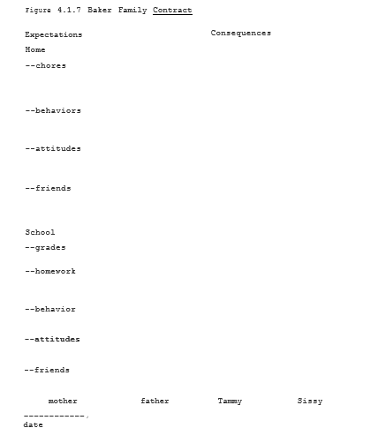

Figure 4.1.3.2 Safe Haven Resident Management Corporations

An exciting and important trend in community Empowerment is the concept of Resident Management Corporations (RMCs) where Public Housing residents gradually take over the management and, ultimately, even the ownership of public housing. It was found, for instance, at the Kenilworth-Parkside Development in Washington, DC, that after the implementation of resident management and related supportive programs there were decreases in teen pregnancy, welfare dependency and crime of 50%, 60% and 70%, respectively. It is estimated that implementation of resident management may save taxpayers over $5.7 million at this one site over a ten-year period (Figure 4.1.8; Figure 4.1.9 in Capara and Alexander, 1989).
Again, however, any monetary savings have to pale by comparison to the positive effects on individual and community pride and Empowerment. When government and the people all work together impressive results can be achieved from which everybody benefits. The basic limitation of the above RMC design is that it in essence works with only the "motivated few in any Public Housing Development. As was discussed earlier with the Beethoven Project, for instance, the very people who most need assistance in changing their behaviors are precisely the least likely to participate in these programs on a voluntary basis. Thus, in an Entitlement-based system, RMCs are fighting at best an uphill battle always at risk of being overwhelmed by the violence and despair surrounding them.
In a Safe Haven-based RHC, the Community Service Corps guarantees that all Public Housing residents are, by definition, "part of the solution." As noted in the previous discussion and Case Examples by everyone participating in these programs, communities can literally become Safe Havens in which everyone benefits. By allowing RHCs to keep at least a percentage of any savings that come from such prevention-oriented approaches (see below) Safe Haven would be giving communities and community leaders not only the means, but the concrete incentives to participate in such programs. Thus, by consciously designing win­win solutions Safe Haven allows us to replace Entitlements with true Empowerment.

4.1.3.3 Prevention-Oriented Incentive Plans (Pre-OPs) "Before major surgery, it is important to have a Pre-OP." Pre-OPs--County; Community.
Just as Safe Haven can be designed to offer concrete incentives for participation on the local level, so too these benefits can be realized on other levels of government as well. The Prevention-Oriented Incentive Plan (Pre-OPs) is one specific means of making the Safe Haven program a clear win-win proposition for whatever level of government wishes to adopt it. As was discussed above for RMCs it makes political as well as psychological sense to reward communities and government bodies that can actually save money while expanding social services. Pre-OPs offer a means to do just this. As Pre-OPs is one of several Safe Haven-related initiatives that are being introduced in Illinois State legislature, I will discuss it in this context. Before we do major surgery to remove the cancer of welfare from the Country, it is important that we have a Pre-OP in place.

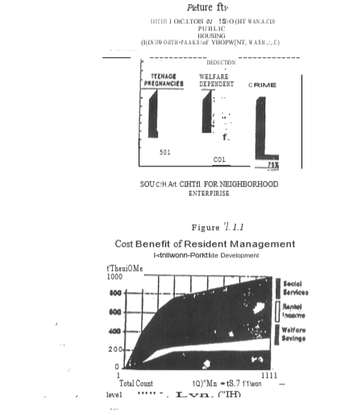

As with many other States, Illinois is presently facing serious budget deficits, traditional ways of dealing with these problems are raising taxes (favored by many Democrats) or reducing services (favored by many Republicans). As Social Service dollars are presently allocated on a "greatest needs basis, those counties in Illinois that make efforts to combat problems locally are actually penalized by reduced dollars being allocated in future years.
The present system thus in essence rewards incompetence and inefficiencies and punishes innovation and initiative. Not surprisingly, under this system problems in Illinois have continued to get worse instead of better. Under the Pre-OPs program, individual counties in Illinois would get a block grant of all Social Service-related monies spent within their boundaries.
These block grants would include funds for welfare, SSI, Child Services, drug and alcohol programs as well as criminal justice. The percentage of total funding currently spent in each county would be frozen at their current levels. Counties would get no more, and perhaps less, money each year than in the past. But any money that they saved by the introduction of intense prevention-oriented Safe Haven-type programs would actually remain to be spent within that county. By reinvesting at least some of the savings into even further expanding prevention-oriented programs such as day-care and after-school programs a multiplier effect could be achieved with even greater savings (both financial and human) in future years.
As all counties would get block grants, they and their various communities would be empowered to make discussions based on local needs and circumstances. If an individual county did not want to include a strong CSC program in their communities, then they would need to make up for the obvious inefficiencies in their system by increasing local taxes. Conversely, counties could even further empower local communities even down to the level of Public Housing Developments, for instance, by setting up block grant Programs for RMCs and/or other organizations as discussed above.

Pre-OPs--National
Just as counties and communities within an individual State could be allowed to adopt Pre-OPs, so too these plans are important on a national level as well. Some of your federal tax dollar is sent to' Washington are already sent back to your State on a block grant basis. But, again, just as on the State level, the majority of both block grants and other tax dollars are allocated on a priority “needs” basis. Again, therefore, under the present system the better your State does in reducing overall welfare and Social Service costs, the more you as a citizen and taxpayer of that State are penalized. Pre-OPs gets us ready for surgery on a national basis to solve these problems ONCE AND FOR ALL.
By allowing States to get block grants for all Social Service spending on their State we could begin the process of local Empowerment in a truly meaningful manner. By locking in the government's percentages of Federal dollars sent to States with any savings remaining to be spent as local taxpayers see fit, now local States would have the clear inventive to adopt strong prevention-oriented Safe Haven-type approaches to welfare reform.
Taxpayers and citizens could now hold their State and local officials exquisitely ACCOUNTABLE for the bottom line in terms of both savings and RESULTS. Conversely, those States or local municipalities not adopting Pre-OPs would need to pay the difference in terms of increased State and local taxes. When voters are faced with such clear options and incentives, the choices would be obvious. Thus again, win-win scenarios are designed to benefit all.

4.1.3.4 Science--Universal Win-Win Problem Solving

It has often been said that "liberals" look to make the slices of the social pie more equal while "conservatives" try to make a larger pie. Many, if not most, disagreements in life are not so much a matter of "right" or "wrong" as they are matters of perspective. Different people have different pieces of the elephant of "truth" and then overgeneralize to think theirs is the only “true" reality.
Science in many ways is like a large game of "connect the dots" (Figure 4.1.10). Usually we move along adding piece after piece to our collective knowledge. Occasionally ''critical mass" is achieved and a new vista is opened up. What once may have seemed contradictory or disconnected now makes sense precisely by seeing things from new perspectives--by expanding the dimensionality of our conceptual universe.
This is the process of science, the process of universal win-win problem solving. The more we seek inclusion instead of exclusion, the more we seek understanding instead of dogma, the more we grow as individuals and as societies.
Over the centuries, little by little, the standard of living and the range of options open to us all have continued to expand. Kings and potentates suffered with gout and gallstones along with the rest of-us. Neither Alexander the Great nor the mighty Czars of Russia could ever see a simple picture of the planet Earth or the moons of Jupiter. We take such progress for granted, but it shapes in many ways the very fabric of culture.
When it was written, Puccini's opera La Boehme about a poor young woman dying of "consumption" was a tragedy. But for someone today to die of tuberculosis borders more on malpractice. The fact that we are again seeing a resurgence of TB among special "at risk" populations such as AIDS victims and the homeless says volumes more about the limitations of our present Entitlement­ based programs than it does as to the limitations of science. Similarly, the plagues of gangs, drugs, child abuse and violence in our society are all treatable conditions if we simply dealt with them more as matters of science and medicine and less as matters of politics and ideology.

As illustrated in Figure 4.1.10, even once having obtained that Individual data point (here represented as numbers), it is not always easy to discern that pattern until the higher order processing goes on when we "connect the dots.”
Different strategies can be applied, for instance, as to the order in which we connect the dots or even which dot to connect with which we recognize the truth right even when it is right before them, and even then, insight comes on many levels. It is only by perseverance, hard work and determination that in the end we come to see the overview that in reality was there all along waiting to be seen.
Whether it is computers and the Information Revolution now upon us or the mysteries of the universe as yet unexplored, science offers us the means to work together for the Common Good. In their own way, artists observing and commenting upon the World around them may also be acting in part as scientists.
Science is as much a matter of synthesizing new visions and understanding the World as it is a matter of the simple compilation of facts. Above all, however, it is a matter of testing hypotheses to determine their validity. When such knowledge and understanding can be used to benefit us all, we have reached a true win-win outcome. We can use the example of medicine to illustrate these principles well.

4.1.3.5 Medical Models and Clinical Trials
When trying to evaluate the effectiveness of a particular medication or treatment strategy, the accepted standard practice is to run clinical trials. Depending upon the specific questions to be answered (safety, cost-effectiveness, reliability, relapse rates, etc), clinical trials can be designed in many ways. The unifying principle of all such trials, however, is that medications and treatment strategies must prove themselves relative to available alternatives in order to become part of accepted clinical practice. Thalidomide, for instance, may have been useful in helping mother's deal with the symptoms of morning sickness early in pregnancy. But the risk of malformed fetuses made this an absolutely unacceptable treatment option. If we were to evaluate welfare in terms of the excess morbidity and mortality it has caused it would make Thalidomide look like cotton candy by comparison. And yet where Thalidomide was pulled off of the market within just a few years, welfare has been with us now for well over three generations.
If we applied even the most minimum of medical malpractice standards to the politicians and bureaucrats responsible for welfare, they would all be in jail and we would have long since thrown away the key. Clearly, Accountability in this instance has utterly failed. John La Plante and the folks who brought you the Chicago Flood look like rocket scientists by comparison.
Table 4.1.2 itemizes some of the strengths of the Safe Haven program to other options presently available in Illinois in order to most fully document the clinical effectiveness of Safe Haven, however, it remained essential that clinical trials of these programs be run.
As the process of getting approval for and implementing such Safe Haven demonstrations is in and of itself at least partially a political process, these "politics" as it were need to be considered as part of the overall clinical evaluation. Treatments that exist simply as talk without action are clinically useless. The Multi-Systems Analysis approach will allow us to track the "clinical trials" of Safe Haven to date as outlined below. Following this Section, I will come back to the discussion of the implications of these results for potential political action.

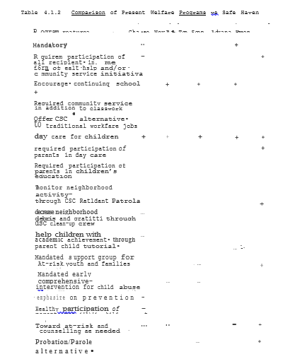

4.2 Safe Haven: Clinical Trials and Tribulations

In order to illustrate some of the MSA principles in action, I will use three case examples involving Safe Haven. While the story of Safe Haven goes back at least 20 years, and its origins much further still, the cases described here will be of much more recent vintage. The series of goals and levels of organization to be discussed in Cases 11-13 are outlined in Tab1e 4.2.1 and Figure 4.2.1, respectively. A much fuller account of the story of Safe Haven and the obstacles to genuine change in America is given in my book Drawing Fire: Living Values in a Troubled World.

4.2.1 Case 11. Safe Haven-Chicago Futures (Cycle l)

In order to begin to test the principles of Safe Haven described above my initial goal was to set up a small pilot program in Chicago. In spite of an overall positive response of both governmental officials and community leaders to the concepts of Safe Haven, it still took over three years of very hard work and considerable personal sacrifices to get approved from Chicago's Department of Human Services (DHS) for this pilot program under the heading of Safe Haven--Chicago Futures.
During the first two years, I had focused my efforts on explaining Safe Haven to various City and State officials and community leaders and developing a consensus for these demonstration programs. A particular early practical problem was dealing with entrenched bureaucratic ideological mindsets.
While Illinois has had relatively conservative Republican Governors for the past 16 years (1992), the bureaucracies of Social Service departments such as IDPA are overwhelmingly liberal in their thinking. They are also highly resistant to programs that might ultimately eliminate many of their jobs. Thus, while the people of Illinois and their chief elected officials might well have been sympathetic to the ideas of Safe Haven, actually "getting past" the lower level bureaucracies was in and of itself a major undertaking.
As would be predicted by the MSA model, it was not until I was able to bypass these bureaucratic "obstacles" (in this case through the intervention of State Representative Jerry Weller) that progress with Safe Haven was finally made. Then, with Representative Weller's assistance, I finally was able to go "to the next level up" in the system, meetings were finally arranged and with the IDPA Director, Phil Bradley, and Governor Edgar's Executive Assistant for Social Services, Felicia Norwood. It was with their assistance that I finally obtained a small grant· from DHS.
Thus, it was by a combination of perseverance (iterations of the loop)1, education (increasing the "gain," removing barriers) and expanding the system (including Director Bradley) that a positive outcome was finally achieved.
Having achieved the first goal of getting a grant, our second objective was to actually run the program. After considering different options, it was decided that we would train 15 local Public Aid recipients to work as "support group facilitators" for 36 at-risk youth and their families at Lathrop Homes during 1992.

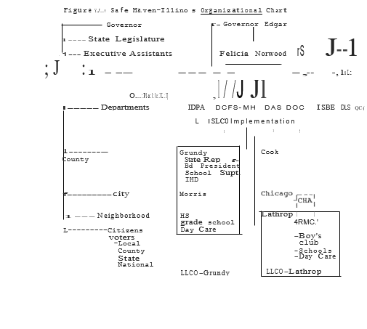

Before we even started running Safe Haven-Chicago Futures, as a sign of his own commitment to the success of these programs, IDPA's Director Bradley offered to fund a Day Care Assistants (DCA) training program at Lathrop Homes' Mary Crane Day Care Center (MCC). Thus, a joint venture agreement was entered into between "IDPA, Safe Haven and Mary Crane Center" to develop these programs.
Initially I had intended to offer the "support group training" as a voluntary alternative to other "work experience" programs in which Public Aid recipients could participate. However, because the prospect of obtaining a future job as a "group facilitator" was, at the time, fairly remote, despite the efforts of many individuals and community leaders, no volunteers were forthcoming. The lack of volunteers for just "support groups" alone made clear once again the need to integrate these programs into the broader spectrum of Safe Haven initiatives if success was to be achieved in serving the needs of the Community.
By entering into our Joint Venture agreement, however, many volunteers came forth for the Day Care training program. By designing the system in that way, not only would Public Aid recipients get training as Day Care Assistants but they could act as the support group facilitators during the first cycle of Safe Haven-Community Futures.
Having reported from January 1992 on to DHS on this collaborative undertaking where the children's support groups were being held at MCC, I devoted some 70-80 hours/week of my own time to trying to expand the Safe Haven programs at Lathrop Homes. Through these efforts, major opportunities would be created not just for 36 children but for all of the 900-plus families at Lathrop Homes and the surrounding community as well. Thus, by achieving a "critical mass" of collaborating individuals and agencies we were able to double DHS's money, see twice as many children as originally proposed and see them five times a week rather than once.
In addition, eight women who were previously on Public Aid (seven volunteers dropped out during the course of the first program cycle) now were ready for placement in long term, good paying jobs. Their new-found skills were of benefit to themselves, their families and the community at large.
Finally, long-term opportunities to expand the benefits of these programs were opened for the benefit of all--a true win-win scenario in every sense of the term. However, as Case 12 and l3 below will suggest, we can still trust bureaucracies to be the bane of us all. Such was to be the case with Safe Haven.
Initially we had proposed to also simultaneously run a Community Policing/Resident Patrols and a series of After-School programs as well but these were rejected by DHS. Thus, from the beginning, Safe Haven-Chicago Futures represented only one small fraction of a comprehensive Safe Haven program. This limitation, or lack of "critical mass" of programs, in and of itself created problems later on as will be described in Cases 12 and 13.

4.2.2 Case 12. Safe Haven-Illinois: Circuit Testing the System
“Welfare was never meant to be a lifestyle. It was never meant to be a habit. It was never supposed to be passed from generation to generation like a legacy. It's time to replace the assumptions of the welfare state and help reform the welfare system." -- President George Bush, State of the Union Address, January 28, 1992.
In order to overcome the initial limitations of Safe Haven­Chicago Futures and to develop a full-scale demonstration of the principles outlined in this book, Safe Haven-Illinois was specifically designed as a multi-year, multi-agency initiative that could be comprehensively implemented in two target communities, one semi-rural (Grundy County) and one urban (Lathrop Homes). This program could then be expanded year-by-year until the entire State was ultimately composed of Safe Haven communities.
The specific vehicle chosen for this demonstration was a Community Partnership Study Program in the Department of Health and Human Services (HHS). At the time the particular division the grant carne under was called the Office of Substance Abuse Prevention (OSAP). Applying the MSA principles discussed above, an integrated, comprehensive program structure was designed as illustrated in Figure 4.2.1 above. This organizational chart illustrates the concepts of multi-level coordination and integration of services that have been discussed in greater detail in Section 3.
The first major task of this grant application process was to get written agreements (Appendix A) from all participating parties from Governor Edgar's office and the State Social Service departments to the Grundy County Board Chairman and the President of Lathrop Home's Resident Management Corporation. As it had taken many years of persistent effort to reach the point where these individuals, agencies and groups were willing to consider joining into this multi-year, multi-level, multi-agency initiative, in and of itself, I considered this a major achievement. But the fight for Safe Haven-Illinois had only just begun.
Before grants are reviewed on their merits, they are first screened by OSAP's parent agency, at the time called the Alcohol, Drug and Mental Health Agency (ADAMHA). Because OSAP grants traditionally involved a single "target community" and a single "control group," the notion that we would expand Safe Haven from our initial two sites, to many others arid perhaps the entire State over a period of five years was one that did not sit well with bureaucrats at HHS's ADAMHA. Only a bureaucrat would find doing more for less to be a problem.
All too often, however, a problem for a bureaucrat ends up being a problem for us all. Making bureaucrats more ACCOUNTABLE for their actions (ie, increasing the appropriate feedback) is one of the clear lessons of this situation and many others. A second even more startling objection that was raised was that, because Safe Haven spoke of using fundamental welfare reform and the CSC as ways of breaking the cycles of gangs and drugs throughout Illinois, the folks at ADAMHA felt that Safe Haven was "beyond the scope" of OSAP and ADAMHA. Therefore, although Safe Haven met all of the criteria of the OSAP grant proposal, because we significantly exceeded these minimum requirements and were nontraditional in our approach to solving these long-standing problems, we quickly exceeded the channel capacity of these bureaucrats and their bureaucracy to deal with these different ideas. Being different, however, did not make us wrong--just more difficult to understand.
Another iteration was completed. The goal was still unachieved. The story continued. As can be seen in Figure 4.2.7 below the main problem with getting Safe Haven-Illinois even considered on its merits appeared to be primarily at the level of OSAP and ADAMHA, it seemed reasonable to "circuit test" this theory by bypassing ADAMHA and simply going to the "next level up" in the organization.
Since both President Bush and HHS's Secretary Sullivan had repeatedly stated their support for such welfare reform it seemed much more than reasonable to ask them for help in this matter. The purpose of this exercise was a simple test of VISION and LEADERSHIP. Either President Bush and Secretary Sullivan didn't mean what they said or the folks at ADAMHA and OSAP simply weren't getting the message. One way or another, something had to change. My first attempt to work on these issues through Secretary Sullivan's office and the White House met with sympathy but little success. Although I repeatedly emphasized that this was simply a matter of having Safe Haven evaluated "on its merits and on its merits alone," there was still reluctance to "interfere" with the decisions of ADAMHA and OSAP.
When I reminded White House and HHS officials that ensuring that lower-level management was implementing the policies they claimed to espouse was generally considered to be a sign of LEADERSHIP not interference, still nothing happened. Thus, if leadership was to come in advocating for Safe Haven, based on the evidence, it was unlikely to come from the White House or HHS.
Based upon the failure of my own direct efforts, it was clear that if Safe Haven-Illinois was to succeed, it would take a strong show of support from the "community" of Illinois. Since the two leaders most directly to be involved in Safe Haven were Governor Jim Edgar and Mayor Richard Daley, again to "circuit test" the system, I went to their offices for help. By now, however, time was quickly running out for Safe Haven-Illinois. Before discussing the outcome of this process to date, it will be useful to finish the story of Safe Haven-Chicago Futures.

4.2.3 Case 13. Safe Haven-Chicago Futures (SH-CF): Something Ventured. Something Lost.

"And for the support of this declaration with a firm reliance on the protection of Divine Providence, we mutually pledge to each other our lives, our fortunes, and our sacred honor."
--American Declaration of Independence

As noted previously, a major limitation of the initial SH-CF design was that it did not include all eligible adults at Lathrop Homes in its CSC programs nor was it comprehensive in its design. To address these issues, I had aggressively begun to pursue funding for the Safe Haven-Illinois (SH-I) program as described above. Because such funding would not be available any earlier than November of 1992, however, I spent a considerable amount of time pursuing other options as well.
With all of the time demands of pursuing Safe Haven (70-80 hours a week), I had already made the decision to severely limit my clinical practice during 1992 while I devoted myself to the goals of Safe Haven on a pro bono basis. Over the past several years there have been considerable personal as well as financial costs involved in my pursuit of Safe Haven. These sacrifices have been examples of my personal commitment to getting the job done. I have often likened these battles against bureaucracies to "walking point" or storming machinegun nests. Someone needs to act and take risks if the battle is to be won.
Throughout our history many have sacrificed far more in the fight down Freedom's Road. Sooner or later, in one way or another in this second American Revolution, we must all stand and be counted. When the opportunity to act was there, ethically I could do no less. If Safe Haven was to "fail," it would not be for lack of effort. In the face of adversity, I simply redoubled my efforts and worked even harder.
In spite of my major commitment of time and resources to Safe Haven, early in January 1992 it became clear that decisions would have to be made on how to pursue this work in the most cost-effective and efficient manner possible. Because of the joint venture agreement reached with the Mary Crane Day Care Center (MCC) at Lathrop Homes and IDPA, it became possible to assign the supervision and records-keeping aspects of the program to MCC staff.
As MCC staff would be doing the training of the volunteers in their role as Day Care Assistants anyway, my secondary supervision of them would have been both redundant and intrusive in the operations of the training program. Since the long-term goal of Safe Haven was to have the program run independently of myself, the superb qualifications of the MCC staff brought us that much closer to this goal. Indeed, the organizational and professional skills of the MCC staff were a major reason for pursuing a joint venture with them in the first place.
As part of the standard CDBG protocol, a monthly statistical report was sent to Chicago's Department of Human Services (DHS) explicitly discussing Safe Haven's joint venture agreement with MCC and IDPA. In addition to this formal reporting, I met on multiple occasions with DHS staff and discussed our program including our joint venture. From January through March of 19 a needs assessment and ethnographic study was being done of which, for instance, the selection of MCC and the negotiation of details of the joint venture were part.
During any of this time we could have easily modified the SH-CF program design had this been requested by DHS. Once cycle one of the program began (4/92-7/92), however, it would have been very difficult to make any changes until cycle two which was set to begin in September. With no objections being raised, we began cycle one with MCC staff supervising trainees and the at-risk children while I concentrated on expanding the program to include more residents of Lathrop Homes. I continued to put at least 70-80 hours/week on some of my other Responsibilities into this work.
While initially I needed to contact individuals and agencies in conjunction with the Safe Haven-Illinois as an extension of the SH-CF program, I also pursued the option of more immediate CSC options. Just after the Chicago Flood had occurred on 4/5/92, I recommended to Mayo Daley's office that CSC participants could be actively involved ln the clean-up efforts. Not only would such participation help to keep the costs of the clean-up down for the taxpayers of Chicago (and elsewhere), but it would help to "prime the pump" as it were as to providing jobs and integrating community services.
During this time, I met directly with DHS' Commissioner Alvarez. I explained in detail not only my Safe Haven Chicago Flood proposals but our joint venture at Lathrop Homes as well. As a concrete example of precisely the sort of win-win cleaning up for the approach to problem solving that could also be achieved in the full clean-up, I hoped that our joint venture might help Commissioner Alvarez to understand what it was that I was proposing.
While my proposals met with polite interest and promises to "consider the proposal," no action was taken. Weeks went by and the jobs went elsewhere. Such is the mentality of bureaucrats. Having discussed at length our joint venture with everyone from the receptionist to Commissioner Alvarez and· reported on it in each of 6ur monthly project reports, it could hardly be said that DHS was unaware of this arrangement.
And yet late in May, low-level bureaucrats at DHS claimed precisely this. The fact that DHS took over 5 1/2 months to even do a site visit, let alone raise objections to our basic program design seems fairly amazing. But from the city that brought you the Chicago Flood, nothing should be too surprising. The folks at DHS were bound and determined to make John La Plante- and friends look like rocket scientists by comparison.
The issue as it finally evolved was relatively simple. Because of our joint venture agreement, MCC had kept excellent records on all of the Day Care Assistants and the children involved in the program. Because I did not keep separate (ie, redundant) records on these individuals, DHS arbitrarily decided that I could not count them as clients for our program.
As the first cycle of the SH-CF program was more than half over at the time, there was no reasonable way to change this situation in the short run other than accepting the MCC records which DHS refused to do despite our joint venture agreement.
While many events involving SH-CF occurred over the next several months, suffice it to say that rather than working together to find a win-win resolution of these problems, relations with DHS deteriorated from bad to worse. Because of problems including the "advance" money for our program being some three months late in arriving, the accountant I had to help us with our books was no longer available to us.
As money was never the reason for pursuing this work, I held off billing DHS while our debts mounted in order to focus on resolving the issues related to our records. First I offered to personally run groups and keep records during the second cycle of SH-CF (9/92-1/93), but DHS was "not willing to wait that long." I offered to let DHS simply keep their money and rerun the entire program in 1993. DHS declined to do even this. The bureaucratic mind can be truly wondrous to behold.

Despite the intervention of several prominent Chicago aldermen and local Lathrop Homes community leaders, DHS simply refused to work in good faith to come up with a win-win resolution of this matter.
Instead, throughout the summer of 1992 which were critical months in attempting to get· support for Safe Haven Illinois· in Washington, Eileen Donnersberger, an assistant commissioner at DHS (whose husband just "happened" to be a powerful Chicago judge) and Commissioner Alvarez succeeded in blocking my repeated attempts to get in to see Mayor Daley.
Even though Chicago Housing Authority Chairman Vince Lane wrote on behalf of Safe Haven to then-HHS Secretary Louis Sullivan, the problems with our local Department of Human Services remained unresolved. Even the local media who could have made a difference at a critical juncture refused to get involved. Thus a program that clearly would have benefited the citizens and taxpayers of Chicago was not even allowed the opportunity to be considered by them. Such are issues that will need revisiting.
In 1992 Chicago had the highest per Capita murder rate in its, history. The Dantrell Davis story received national attention when this seven-year-old boy was shot and killed while walking with his mother from his home in the Cabrini Green Housing Project in Chicago a half block to his local elementary school. This had been the third murder of a child at that one school alone. Cases of crack babies were up. School performance was down. As always, the school system and city were in financial crisis.
Regardless of whether DHS liked the details or not, Safe Haven had brought additional services to the Lathrop Home co unity and saved money in the process. We could have just· as easily done the same for Cabrini-Green and/or the entire city. But to do so would have taken vision and leadership.
When politicians and bureaucrats fail to show vision and leadership, they fail us all. When we do not· hold them accountable, we also fail ourselves. Whether it is John La Plante and' the Chicago Flood or Rodney King and the Los Angeles riots, specific individuals can reflect much deeper overall system failures.
By their actions and inactions, two individuals at DHS, Commissioner Daniel Alvarez and Assistant Commissioner Eileen Donnersberger helped to block the implementation of full-scale Safe Haven demonstrations in Chicago to date. For this, they have been awarded the first annual "La Plant" Awards (Figure 4.2.2-). This award is dedicated to those bureaucrats and politicians wherever they may be who "do nothing, but just sit there looking pretty." While perhaps not pleasant to look at, these awards (arid/or their recipients) are suitable for hanging....
While several other politicians and bureaucrats have since also earned. themselves "La Plant" Awards, several others have by the.ir efforts won Safe Haven Good Citizenship Awards "for dedication and service to the Community" (Figure 4.2.3). Three early recipients of this honorable distinction have been State Representative Jerry Weller, Chicago Alderman Dick Mell and Chicago Mayoral Assistant Michelle Robinson. Each in their own way has tried riot simply to help Safe Haven, but more importantly to be a conscientious servant of the people and steward of their interests. Both the "La Plant" and Good Citizenship awards are reproduced in Appendix B. I would invite readers to copy and send the appropriate awards to those worthy of such distinctions.

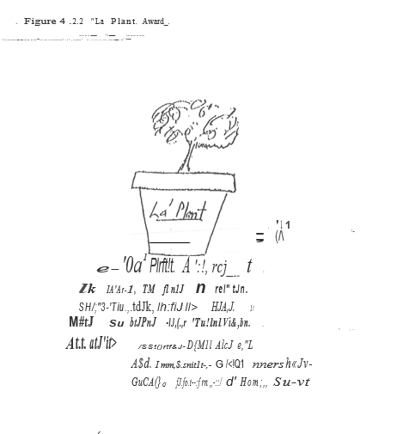

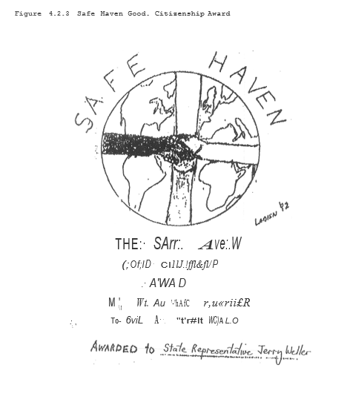

Once politicians, bureaucrats and/or other individuals are identified as "part of the problem," for accountability to work we must take clear and credible action. Living in a democracy we have no one to blame but ourselves if such action does not take place.
As I will discuss below, there are many clear ways that, by "working together, our voices will be heard." While grassroots local action is ag important starting point, gross incompetence and lack of vision are hardly limited to local politicians or the bureaucrats of any particular party. A post-mortem on Safe Haven­Illinois illustrates this point well.

4- .2. 4- Safe. Haven-Illinois: Post-Mortem Blues

"We must not deceive ourselves. No matter how well designed or reformed, government programs will have little lasting effect unless fundamental actions necessary to end the current cycle of Welfare dependency are taken by those trapped in Welfare. Any real hope for changing the pattern of current social problems such as teen-age pregnancy, school dropout and drug use requires individuals to take responsibility for themselves."
--Secretary Louis Sullivan, National Press Club, May 5, 1992

Because of the troubles of Safe Haven-Chicago Futures with local Democratic bureaucrats, it was clear that if Safe Haven­ Illinois was to succeed, help would need to come from the State and Federal levels. As was previously noted, just as in Chicago, lower-level bureaucrats in Washington's Department of Health and Human Services (HHS) had succeeded in blocking even the consideration of Safe Haven-Illinois on its merits. Just as in Illinois' State government, while the upper administrative levels of HHS were ostensibly "Republican," much of the lower echelons at HHS were run by liberal Democrats.
In a similar manner to my earlier efforts on the State level, therefore, I attempted to bypass these obstacles and move the project forward. Unlike on the State level, however, State Representative Weller, who had been so crucial to our earlier successes, had only limited influence on the Federal level.
The office of the local Congressman, Torn Ewing, tried to be helpful but also felt limited in what they could do. Even high-ranking officials at HUD who expressed significant interest in Safe Haven felt restricted by law from any direct influence or contact with HHS to have Safe Haven-Illinois simply reviewed on its merits. As noted previously, local CHA Chairman Vince Lane did write to Secretary- Sullivan for his assistance, but to no avail.
Between the time of the Chicago Flood and the murder of Dantrell Davis, on a national level another city’s ghetto had been set ablaze in the East LA riots of 1992. While jobs were going out of our borders, legal and illegal aliens were flocking into the Country for jobs that some Americans felt "too proud" to do. We spent more on health care and education and had less to show for it than almost any other industrialized nation in the World but, again, like giving heroin to heroin addicts, this is only made the situation worse. Simply put, despite my best efforts, I could not get Safe Haven-Illinois implemented in the absence of an “institutional Sponsor.”
The Bush administration (41) was able to put together an international coalition to "win" (somewhat) a war against Iraq but could not put together a domestic agenda that addressed our society's many problems both concretely and effectively. As the needs intensified, the vision dimmed. A time of. reckoning was at hand. As noted previously, because of legal restrictions on other agencies directly getting involved in HHS affairs, if the lower level obstacles at HHS were to be overcome ("bypassed") then vision and leadership in this matter would have to come from Secretary Sullivan's office and/or the White House.
Although I have had several conversations with individuals in Secretary Sullivan’s office, "reviews" were conducted, but no effective action was taken. Similarly, multiple conversations with officials in the White House's Office of Policy Development lead at best to words, not deeds. It's hard to know how much vision these folks really had when they kept on stumbling around in the dark.
During the Spring of 1992 as the Presidential primaries were concluding, a new force in American politics was emerging. In many ways Ross Perot's own frustrations with bureaucrats and "politics as usual" struck a sympathetic chord in many voters. With Bill Clinton's problems with the draft and possible past womanizing, even his opponents for the Democratic nomination felt that George Bush could "peel him like a boiled peanut...”
While at the time it seemed the Presidency was George Bush's to lose, it was also not at all clear that he was hearing the underlying message of discontent rumbling through the land. When I sent the White House Figure 4.2.4 along with a letter outlining my problems at HHS, they were in more ways than one demonstrating the same "tunnel vision" that had gotten John La Plante in trouble just a few months earlier. Those who do not learn from the past….
As the months went on George Bush missed opportunity after opportunity to show the type of leadership and vision that could have saved his presidency. While Safe Haven per se, was hardly alone as an issue, the failure to assist a plan· that could have benefited many while actually saving money in the process was at least an indicator of the problems in the White House at the time.
As the end was drawing near for both Safe Haven-Illinois and the Bush presidency, I sent the folks at the White House Figure 4 .2.5 of a plane flying into a mountain with the caption "staying the course." The only thing inevitable about the out outcome of the election was the American People's insistence on better results. Accountability comes in many forms.
The people in the White House who could have acted on Safe Haven and so many other things and didn't are now all gone. Many good people at HUD with many good ideas but little power are also gone. (One joked sardonically following the elections "Well, we finally hit the mountain.") Many, at best, mediocre people at HHS with few ideas but much power are apparently still there. Such is the nature of bureaucracies and tunnel vision. If this is to change, it is up to us all to make it so.

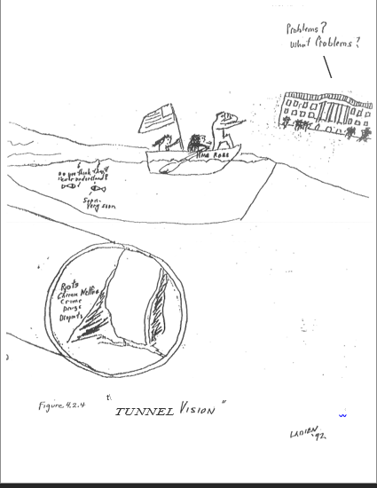

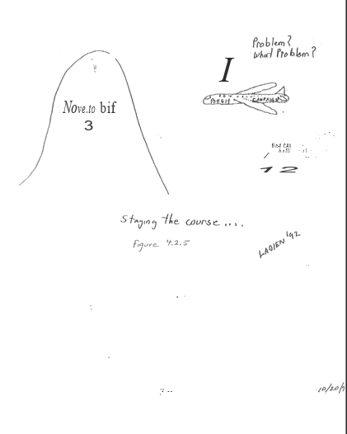

4.2.6 Earnfare-I: Glimmers of Vision

"This is a modest plan. It's not going to make anyone rich, but it could provide self-respect, some general skills and a chance to show a private employer that a worker can show up on time and put in a good day's work. It is the kind of program that government must try to wean people from welfare dependency and help them make the transition to private-sector jobs. Republicans and Democrats...should find room for· the Earnfare program, the kind of bipartisan effort that can make them all look good." Chicago Tribune editorial, June 28, 1992.
While bureaucracies on the City and National levels were busy conducting business as usual and flying into mountains, some actual progress was being made with the principles of Safe Haven at the State level. Because Illinois was facing a major budget deficit, in 1992 the Illinois State legislature looked at the issue of welfare reform as a way to save money.
Initial Republican initiatives were to cut off aid to recipients of General Assistance (GA). Democrats, on the other hand, were in fact advocating for increased subsidies and no cutoff of aid even to the "abled bodied" recipients of GA. Given this all too familiar impasse it was only pressure from the people and taxpayers of Illinois in an election year that brought change about.
In order to break the liberal/conservative gridlock in Illinois' legislature several factors had to come together. First, because 1992 was an election year, the issues of "no new taxes" and accountability were on people's minds. At the time that these issues were being considered George Bush still appeared very strong and likely to be reelected as president. Under these circumstances liberal Democrats were more motivated than usual to look for some new middle ground and "cut a deal."
In a search for middle ground, IDPA Director Phil Bradley convened a summit of public, private and legislative interests as part of a JOBS Opportunity Advisory Council (JOAC). Ostensibly the role of the JOAC was to advise on specific ways of implementing the Federal JOBS legislation as it applied to welfare recipients. Some council members, however, were willing to define their mission more broadly.
One legislative member of JOAC, Representative Earleen Collins, from an inner-city Chicago neighborhood worked with IDPA staff and Felicia Norwood to fashion Earnfare-I as an outcome of this process. Without perhaps deliberately meaning it as such, Earnfare-I was a first important legislative step towards a Safe Haven Community Service Corps program in Illinois.
In this Earnfare-I bill, "abled bodied individuals would be cut off of General Assistance. While no longer being eligible for welfare subsidies, these individuals could earn the same benefits by working up to 20 hours/week for as long as six months in any year. It was hoped that the work experience gained during this period would then enable these former welfare recipients. to then find more permanent long-term jobs on their own.
In many ways this JOAC conference and the dialog it engendered in its own way represented a major conceptual turning point in moving from an Entitlement Ethic to one of true Empowerment. I must confess that there was something personally gratifying in finally hearing dyed-in-the-wool knee-jerk liberals suddenly talking about what of jobs and community work individuals might be involved in instead of how much their welfare benefits should be increased. In certain ways, this epiphany of sanity and reason was, perhaps, too good to be expected to last.
By the time that Earnfare-I finally found its way into the legislature, liberal Democrats had "come to their senses" as it were and loaded it up with a litany of standard Entitlement concepts. Now, for instance, if you were absolutely abled­ bodied," then you would still be required to work for your benefits. But if you were "sick" or "disabled" in virtually any way including simply having diabetes or high blood pressure, then you would be maintained on welfare. Even worse, however, if you were an alcoholic, drug addict, had a history of criminal activities or mental illness or were even just reading below a 5th grade level, then you too were also kept on welfare and not required to work. Thus, the message to individuals was in essence "prove to us how little you can do" instead of "show yourself how much is possible." The Entitlement mindset was alive and well in Illinois.
In many ways, the story of Earnfare-I was a matter of the cup being "half-full or "half-empty." In the. Illinois Senate, Republicans objected strongly to "letting people do nothing" and the bill only narrowly passed on a straight party vote. In the Illinois House, however, Republicans were willing to see Earnfare-I as the first step in a much larger process. All of the major Illinois newspapers and many public interest groups were also willing to support Earnfare-I in this light. With the help of Representative Jerry Weller and other Republicans, Earnfare-I passed in the House on a vote of 114-0! Such was an example of the Bipartisan Unity to be achieved when a glimmer of vision points the way towards a better tomorrow. And yet, if Earnfare-I was a promise of better things to come, it is a promise still waiting to be fulfilled.

4.2.7 Earnfare-II: Promises Made, Promises (As Yet) Unkept.

"I remain very intrigued by the concepts represented in Safe Haven....We may know what the sensible thing to do is, but steering a battleship is time-consuming." –Michael Belletire, Executive, Assistant to Governor Edgar, August 19, 1991

In September 1989, I presented my first major talk on the principles of Safe Haven at a HUD conference on Drug-Free Public Housing. A copy of my talk found its way to Mike Belletire who was then acting as policy coordinator for candidate Jim Edgar's gubernatorial race. In a meeting with myself and several others present, Mike concluded a discussion of Safe Haven with the promise that "After the elections we will be looking to implement these programs." As the above quote might suggest, the excuse given to date for no further action as yet having been taken is that "steering a battleship is time-consuming." While some activities have gone on as discussed above, it is important to distinguish between actions and RESULTS. As Figure 4.2.6 suggests simply rearranging the deck cha1rs on the Titanic does not fundamentally solve our problems. We must keep note of the difference between promises made and promises (as yet) unkept.

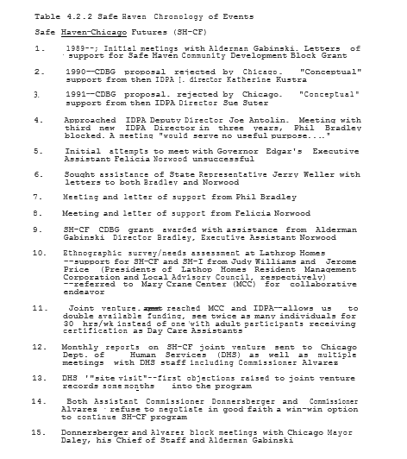

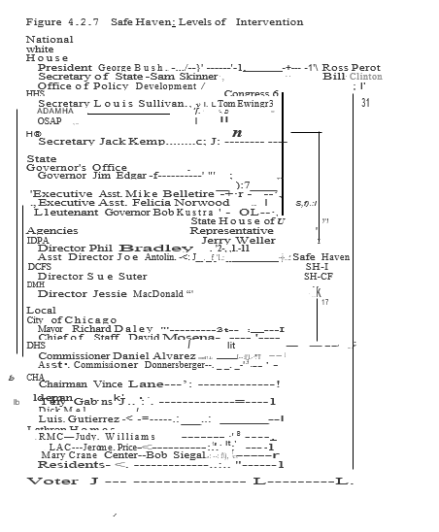
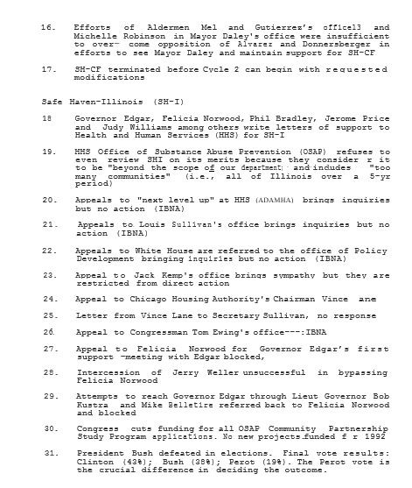

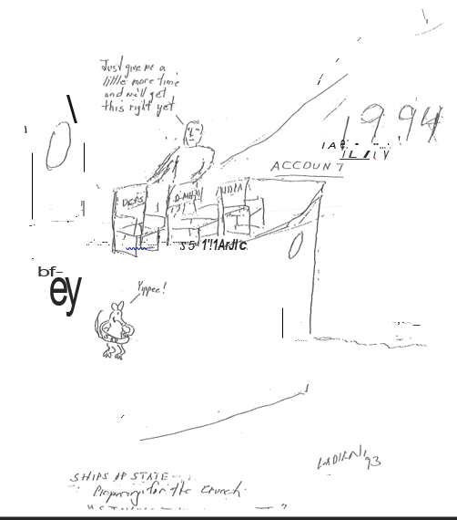

Having gone through the obstacles of Safe Haven-Chicago Futures and Safe Haven-Illinois, the distinction between what a politician or bureaucrat might agree to 'in principle and that they are committed to actually accomplishing was becoming abundantly clear. For this reason, it was also useful to note that those politicians who felt more conscientious and/or accountable to the voters were the ones most likely to be "motivated" in their actions.
Whether for the "right" or "wrong" reasons, positive changes can still be achieved, but only where there is the vision, leadership and adequate motivation to move things forward. When Earnfare-I was enacted, liberals complained that people would be "starving in the streets." Yet although General Assistance benefits were cut off to over 80,000 "abled-bodied" recipients, it took several months to fill the 51,000 Earnfare slots available around the State.
Rather than a stampede, it took major promotional efforts to fill even these slots. Even more revealing, however, was that a significant percentage of those individuals originally entering the Earnfare program actually dropped out before the completion of six months. Thus whether individuals went directly to the private sector or first took a part-time Earnfare job, it was clear that a major reduction in a welfare program had been achieved in a way that clearly was of benefit to recipients and taxpayers alike. With these initial successes in hand, it was now tome to move on to the next· logical step in this ongoing process, Earnfare-II. As it was initially introduced by State Representative Jerry Weller in the Spring 1993 legislative session, Earnfare-II had three main objectives as follows:

1. Expand Earnfare-I to include recipients on AFDC as well as other potentially employable individuals excluded from participation in the original bill.

2. Enact a Parental Responsibility Act (PRA) under which absent parents either financially contribute to covering the – costs of child support and/or participate in CSC activities to reimburse the State for the differences in expenditures.

3. Implement a Prevention-Oriented Incentive Plans (-Pre-OPs) proposal under which Illinois counties and local communities would get to keep any savings achieved locally through the implementation of Safe Haven-type programs.

Along with these three specific legislative initiatives, many other departmental and bureaucratic changes would also be required to fully maximize the impact of the Safe Haven program. Towards this end, Governor Edgar in January, 1993 appointed a task force under the leadership of Gary MacDougal, a prominent Illinois businessman to explore specific ways in which Illinois' social service departments can be restructured so as to improve services and outcomes in a cost-effective manner.
Although access to this task force has to date been restricted for the most part to the heads of Illinois' Social Service department (1993), it has the potential for making a significant difference in the pace of reform in Illinois. Both Felicia Norwood and Gary MacDougal have significant potential to excel or impede this process. How the votes of Illinois act in this situation to demand accountability from these individuals can yet have an impact on its outcome.
Figure 4.2.7 and Table 4.2.2 summarize some of the major events as they relate to the various Safe Haven and Earnfare initiatives. In each of these cases, some individual or individuals caused critical blockages in progress. Other individuals, successfully or unsuccessfully, tried to help in overcoming or working around these obstacles. Clearly in all of these cases some good was accomplished. Equally clearly, however, much work remains to be done.
The goal that has been set for Safe Haven is to move towards "A Gang-Free, Drug-Free, Full-Employment Economy in America by the Year 2000." While this goal is as important as it is achievable, it is by no means inevitable that it will be reached. If we let the politicians and bureaucrats of America set the agenda and the timetable, we will have no one to blame but ourselves for the results or lack thereof. If we are truly serious about such goals, then it is up to us all to make them happen. Figure 4.2.8 represents just one "tactical" solution to the growing problem a lack of accountability. It is up to politicians to listen and take heed.

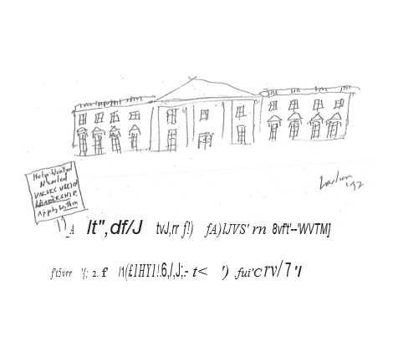

4.3.1 United We Stand
"If we stand united, our voices will be heard." --Ross Perot

In many ways, from a systems perspective, if Ross Perot and the United We Stand America (UWSA) didn't exist, we would need to invent them. In fact, it is precisely the frustration of great numbers of American people that has led to the formation of groups such as United We Stand America in the first place. If- we wish to end gridlock in Congress, if we wish to "fix the system," if we wish to achieve the goals set out in this book, then we must stop relying on politicians and start relying upon ourselves. People have continued to see their taxes go up and results go down. Rather than Government working for us, far too often it has worked against us. Rather than thinking in terms of Republican or Democrat, liberal or conservative, it is time for the American people to think in terms of short- and long-term goals and bottom-line RESULTS.
This section outlines a multi-year strategy for the American people to take back our Country from the politicians and bureaucrats (also known as "policrats"} and special interests and help make it work for everyone. Just as in the original American Revolution, the commitment of the many ultimately overcame the power of the few, so too now "If we stand united, our voices will be heard." And our message to the policrats of the World is very simple: "Talk is cheap. Deeds are precious. The time to act is NOW." It is time to set a National agenda and then work together to see it happen.

4.3.2 Setting Goals. Planning Strategies.·.

In order to get somewhere, especially in a reasonable amount of time, it is generally important to know not only where you want to go, but also how you want to get there. The distinction between goals and strategies is particularly important in that it is generally much easier to agree upon the former than the latter. By starting to have a general consensus of priorities for achieving different goals, we can then as a nation frame a much more rational discussion on specific means for achieving these agreed upon ends. While many goals can and over time should be set by the American people, I will use the goals outlined in this book of working towards "A Gang-Free, Drug-Free, Full-Employment Economy in America by the Year 2000" (ca. 1993—Now 2020 ca. 2018) as examples to illustrate the MSA techniques previously discussed.
Table 4.3.1 gives an example of a simple "timeline" of some of the possible steps that could be taken over the next seven years towards achieving the goals of Safe Haven. While, again there is nothing sacred about this-particular sequence of events at these particular times it does illustrate how specific goal setting can be used both to help define concrete objectives and then to measure progress towards their accomplishment.
Just as one can talk of eradicating smallpox, one can talk" about ending the diseases of drugs, gang violence and chronic unemployment. But the first important step is to understand that these are systemic diseases. If we. are to adequately treat them, then we must effectively treat and change the system. This is a goal that can and must involve us all.
Just as Freedom Quotients (FQs) previously discussed can be used to describe the progression of individuals towards increasingly positive goals, so too these principles can be applied to more broadly defined groups as well.
Figure 4.3.1 illustrates a National Freedom Quotient (NFQ) in which some of the steps in the implementation of a National Safe Haven program are shown as again progressively balancing out individual Rights and social Responsibilities on the road to true Empowerment. While any number of specific pathways could be drawn, all ultimately could lead to the stated goals within the stated time frame (by the year 2000—Now 2020) and still actually save money in the process.
Deciding on a particular pathway can be a combination of good science and the democratic process. Whenever a company engages with short- and long-term strategic planning, it is always a good idea to consider at least several different options, before finally deciding on any one particular strategy. Even once tentative decisions are made, however, a good company and good management remains flexible to adapt as necessary to both changing circumstances as well as the empirical results actually being achieved by a particular strategy. So too in government.
Where there is disagreement in a particular strategy to achieve agreed upon goals, it is reasonable where possible to conduct demonstrations of alternative approaches to the problems. While such an approach is the standard in science and clinical trials, it is still often considered a novel concept in politics that "When all else fails, examine the empirical evidence...."
If we were to apply the same basic cost-benefit analyses to social programs and policies that are used, for instance, in the evaluation of various treatment protocols and medicines, then some fundamental progress could be made in rationalizing the political process. Rather than opinions and ideologies we would have outcomes and analyses. What it lacks in "sound and fury," it makes up for in bottom-line results.

Table 4.1.1 Safe Haven Long-Term Goals: 1992-2000

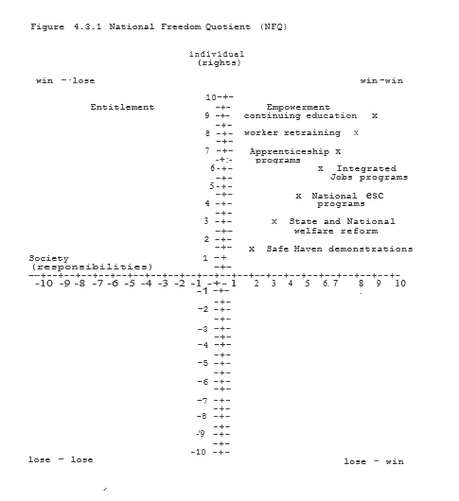

4.3.3 Tracking and Accountability: Writing the Wrongs

"The only thing needed for evil to triumph is for good men to do nothing" --Edmund Burke

If we are to hold politicians and bureaucrats (policrats) accountable for their actions and inactions, then we must have the proper tool to do the job. Perhaps now more than ever we are beginning to have the means available to closely track not only policrat's statements but their actions as well. Even more importantly, however, we are able to communicate more and more effectively in ways which either totally bypass traditional media channels or at least use them in ways that allow us more assistance that "our voice will be heard." In this context, it is perhaps not coincidental that Ross Perot's background at Electronic Data Systems (EDS) was in developing computerized information systems.
Clearly, the use of easy access computerized database networks to track policrats is an idea whose time has come. If we are to demand accountability from policrats, then it is up to us to be eternally vigilant and "write the wrongs" as a first step in saving the problems. In order to again illustrate the use and potential power of political tracking systems when combined with the power of the American people (United We Stand America), we will return to the example of Safe Haven.
Table 4.3.3 below summarizes some of the actions and inactions of individuals involved in this still unfolding and unfinished story. Rather than being exhaustive of the literally hundreds of people involving in the planning for and implementation of Safe Haven, this Table is meant to illustrate how, once specific goals are set, we can identify the particular individuals, agencies and institutions that will be necessary to get the job done (MSA Step 3).
Once goals are set and individuals are identified, we can use our tracking forms to allow individuals to develop their own "track record" of help and/or hindrance in the achieving of specified goals. Based upon the actions taken and the effectiveness of the outcomes to date, individuals can be rated and specific recommendations can be made. Actions can range from support of a candidate to specific "task forces" being set up to examine options when obstacles are encountered to working to remove from office those who will not change.
UWSA can thus help to improve the accountability of all policrats and place the focus on fault instead of promises. Just as tracking forms can increase accountability, we can also use the media to conduct electronic "town halls" and maintain computerized bulletin boards of the ideas and opinions of the American people. A simple early example of these techniques would be to maintain 900- call-in numbers for people to register responses to either specific questions and/or, for instance, the speeches or television appearances of particular policrats. Thus, for the price of a phone call, people can literally put their "two cents" in on a particular subject or individual. By reach1ng out and standing united, again, our voices finally can be heard. "Power to the people" can become more than just a phrase. It can become the reality of a true participatory democracy.

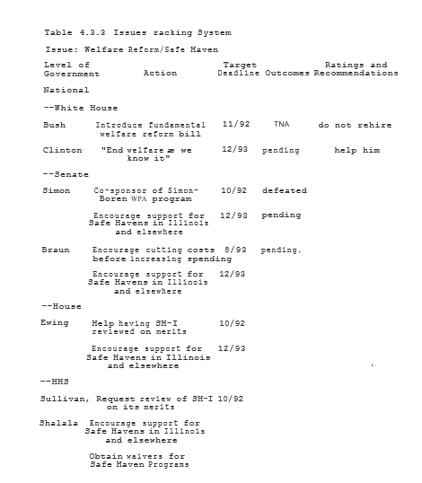

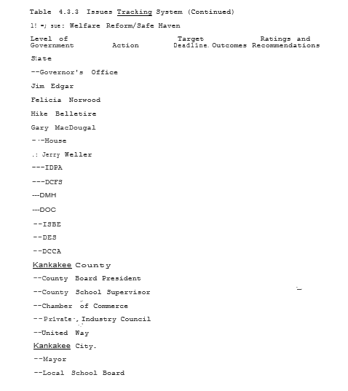

4.5 Global Imperatives—To the Mountaintop and Beyond
"I may not get there with you, but I've been to the mountaintop. I’ve seen the promised land; Martin Luther King, Jr.

Greatness comes in many forms. Individuals simply by living their lives with solid values and quiet dignity can be heroes to their families, their communities and the Country at large. So too times can come "that try men's souls" 'and demand that we rise to the occasion and act on our consciences. There are times when we must live our values by our actions in the here and now as well as in our words of hope for a better tomorrow.
We as individuals and people can and must be part of a greater historical movement if the thoughts and goals in this book are to be more than mere words to be read and forgotten. All around the World, from Moscow to South Africa, the forces of Democracy are on the rise. But as the tragedies of Tiananmen Square and Bosnia, Iraq and Somalia should remind us, the battle for a better, safer and more just World is far from over.
Technologies from television to telephones, computers to satellites all help to bring our global village closer and closer together. But if we are to truly help the World, we must first learn to help ourselves. We must as a nation "go to the mountain­ top" 'and see beyond.
America in many ways has and can continue to serve as a model for the World of the potential for a truly diverse and vibrant participatory Democracy. Yet to rise to this challenge we must solve the problems that have for far too long been plagues upon the land. Reaching the goals of. a "gang-free, drug-free, full-employment economy in America by the year 2000" would certainly not solve all of our problems as a Country or a planet. But they would certainly be steps in the right direction.
There could be little that would be a better gift to the World than to see America greet the Twenty-First Century fulfilling a two­ hundred plus year-old dream of a nation of Nations, of a people of Peoples working together, united in purpose, with liberty and justice for ALL.

5. Conclusions

One hundred years ago in Chicago there were thousands of deaths each year attributable to cholera, typhus, tuberculosis and other infectious processes. The majority of these cases were among children and the poor. The cities were more devastated than the Countryside. But no group of any age, race, status or geography escaped the ravages of these contagious diseases for which we were ignorant of a cure.
Over the following years, however, there was significant improvement in morbidity and mortality rates coming not from the discovery of antibiotics (which were still years in the future} but by concerted public action in the areas of public health, sanitation and education into the need for infection control. In our own day we have seen the rise of the new major epidemics of gang violence, drug abuse, AIDS and teen pregnancies. Just as a hundred years ago society, came together to overcome major diseases, so too in our time if these new problems are to be solved then we must first understand their origins and perpetuating factors and then, second, commit ourselves as a society to correcting the underlying problems, leading to these behaviors.
Looking at other cultures and even our own just a few decades ago, we can quickly come to see that there is nothing at all inevitable about these problems. In many ways it is perhaps our society's own version of "Learned Helplessness" that we have come to accept this alarming level of crime, drugs and violence as a given or, at the very least, as something that will take "billions of dollars" of new spending to correct.
Yet anyone in America over fifty years old can remember a time when, even in the cities, doors were often left unlocked, 'streets could be walked safely day or night, families on a summer night might sleep on the beach or in a park and you could go into a classroom and hear a pin drop. It is hard to imagine that such a society could have existed. Yet that was also a time when over 30% of the population lived in poverty and there was only a miniscule percentage of today's spending on social programs.
Clearly it was not money that was involved but a set of cultural values and intolerance for antisocial behaviors that made the difference. So, if we as a society decide that we do want to return to such a set of cultural values about work, families and individual Responsibilities how would we do it? Just as the Civilian Conservation Corps (CCC) in its day was the answer of the people to the Great Depression, so too today the Community Service Corps (CSC) could be our answer to the multitude of problems described herein.
Table 4.1.2 compares the costs and benefits of our present welfare system on a National level with those. of a Safe Haven Community Service Corps (SH/CSC) program that is progressively either 10% or 60% successful at reducing AFDC, Medicaid, law enforcement and crime costs and new cases of AIDS. Under the "10% improvement" conditions, $5.7 billion could be save from these programs even while significantly expanding the availability if there are affordable day care and after-school programs.
In addition, it would have provided valuable community services and begun to change the Entitlement Ethic through the involvement of all public aid recipients in Some type of work experience either in the community or in private industry. If, as more communities adopt a SH/CSC model, we can achieve decreases of 60% in such areas as AFDC, General Assistance and criminal justice expenditures and 30% in Medicaid, then savings of over $18 billion might be possible. Also, since the medical costs associated with teen pregnancy and premature delivery and drug and alcohol abuse including cases of AIDS and cocaine babies are disproportionately high, savings in these areas from increased prevention could be substantially higher than indicated.
And, again, far more important than simple monetary savings are the human benefits and reaffirmation of positive values inherent in the Safe Haven programs savings from reducing crime, drug and alcohol abuse and chronic welfare ultimately benefits everybody. It also allows us to use at least a portion of this money to significantly expand the availability of high quality, safe and affordable day care and after-school programs without needing to raise taxes. And such monetary figures do not even begin to reflect the increasing sense of safety, wellness and community throughout the land.
If we can achieve the goal of a drug free, gang-free, full­ employment economy by the year 2000, the improvements would be even better and the savings (both financial and human) would be even greater.
While these figures are only meant to be illustrative of the general principles of SH/CSC, they may help to answer the question of how to spend substantially more money on much needed ... Social Services" without increasing taxes. Again, simply put: A PENNY OF PREVENTION IS WORTH A DOLLAR OF CURE.
SH/CSC does not guarantee that all public housing residents would move into America's middle class. But it would make every effort possible to see this opportunity realized for their children. Yet, again, far beyond money, what SH/CSC offers is a renewed sense of hope, of community and of commitment by us all to expect the best of ourselves and each other in all of our endeavors.
Around the World as in America there are many who live in poverty yet have a richness of soul, dignity of character, closeness of family and pride in community that money could never buy. We cannot lose sight of such "intangibles" if we are to understand both what we have lost as a nation and what we have again to strive to have once again.
From a systems perspective of Preventive Community Mental Health, we know in theory what to do and how to do it to support loving families, healthy individuals and vibrant communities. A hundred years ago we applied science to sanitation and brought on a new era in public health. So too now, Preventive Community Mental Health can show us how to clean up the emotional toxic waste dumps we have made of our inner-cities and society. · It is time to put theory to practice and this is exactly what SH/CSC is designed to do.
If within the next decade we can again walk down any street anywhere in America at any time of the day or night and both feel and actually be safe, then we are starting to do our job. If we can go into any home and find love and caring; if we can go into any school and find learning and growing if we can go into any workplace and find. productive and drug-free employees; if we can reach .out into any. neighborhood and find a sense of pride and commitment to the Community, then indeed a new millennium will have been reached.
This is. our goal. This is our dream. It is one I hope to share with you all. Working alone we can. accomplish little. But working together we can change the World. As we read history and set the agenda, we have only seven years to go and not a second to lose. (Now, three years and still not a second to lose.)

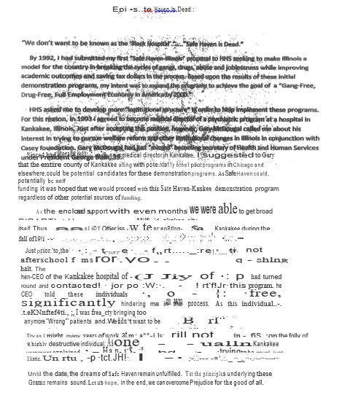

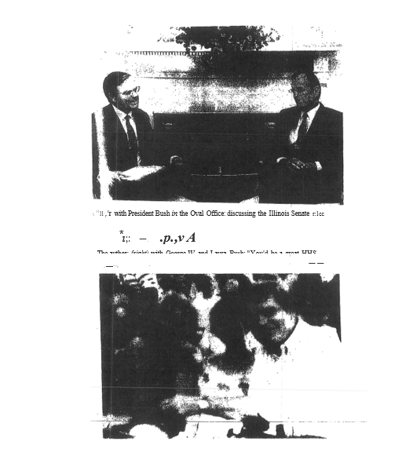

Kimball Ladien, MD — Biography
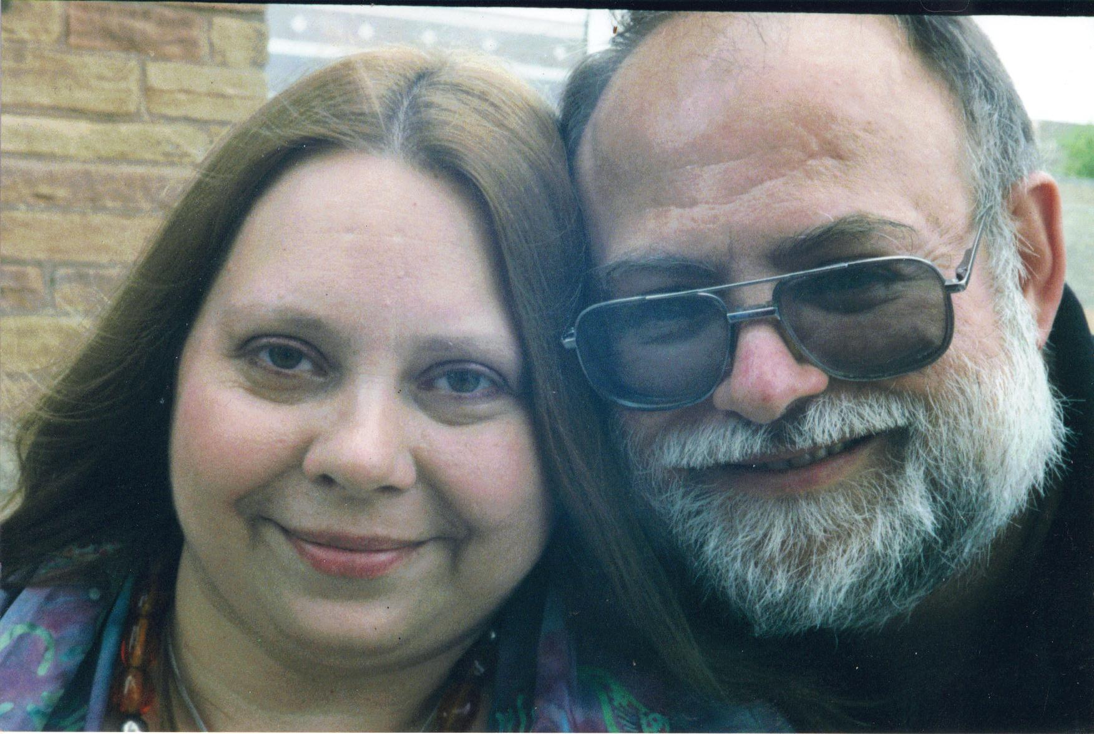

Between 1971 and 1981, Dr. Ladien was studying the hardware and software of Brain Information Processing as a means of understanding the not only the core foundations of human behavior but also the one “tool” that humanity has used to build all of its other tools over the millennia. The benefits and uses of Artificial Intelligence will be a subject for another day as part of Dr. Ladien’s Chicago Project.
As part of the next stage in this process, in his second year at Rush Medical College, Dr. Ladien was one of 10 semifinalists in an HHS competition for “Innovations in Healthcare” with his paper “Workfare Interventions in the Welfare cycle” which was his first formal presentation of Safe Haven.
Following his Residency in Psychiatry at the Loyola School of Medicine, during a Child Fellowship at the Institute of Juvenile Research, Dr. Ladien presented his paper “Safe Haven— Breaking the Cycles” at a HUD conference on Empowerment in Chicago.
After leaving IJR, Dr. Ladien’s first official act as a physician and Medical Director at Morris Hospital was to cut his salary in half so that he could continue his work on implementing Safe Haven while fulfilling his Responsibilities to the Hospital and his patients.
In 1993, Dr. Ladien accepted the role of Medical Director at St. Mary Hospital in Kankakee, Illinois with their explicit written promise to “support the implementation of Safe Haven in Kankakee” and surrounding Counties. Over the next several months, Dr. Ladien again worked 18-hour days to reach broad Bipartisan support for Safe Haven from the County Chair to the local chapter of the NAACP.
Just as Dr. Ladien was to present his proposals for final approval by the Kankakee School Board to implement Safe Haven Afterschool programs as the first step in this process, the then-CEO of SMH with a few calls to the Powers-that-Be in Kankakee was able to KILL Safe Haven dead in his tracks. The CEO’s “rationale” for his actions was “We don’t want to be known as the Black Hospital.”
As one well-meaning Kankakee County explained to Dr. Ladien, “Safe Haven is DEAD.” And so it remained for the next 20 years.
Details of the Wrongful Death of Safe Haven as well as the Wrongful Death of Dr. Ladien’s beloved wife and soulmate of over 50 years, Sylvia, are briefly discussed in the forward to this book.
Dr. Ladien tells all who will listen, and many who won’t, that Sylvia did Not die of Leukemia. Sylvia Died of Arrogance, Stupidity and Systematic Abuse of Power (ASSs). But over the millennia, from the Pharaohs of Egypt to Genghis Khan to Hitler and Stalin, literally millions have suffered and died at the hand of ASSs. It is time for this to end.
As noted in the forward to this book, following the Wrongful Death of Sylvia, Dr. Ladien has vowed to spend the rest of his life, however long or short it is, Fighting ASSs. Safe Haven is the first of four steps in Dr. Ladien’s Chicago Project which includes:
1. A Gang-Free, Drug-Free, Full-Employment Economy in America by 2020 (Safe Haven);
2. Building the “Cyber-City/State/Nation/World of the Future” (IF-PREVENT and Super-EPIC);
3. Building and implementing GEIP (Clean, renewable energy SAVING $2-3 TRILLION/year); and
4. PEACE on Earth by 2030 (starting with Peace Paradigm for ISIS, Iran and North Korea in 2017).
Just as landing a man on the moon was a noble goal for a previous generation, PEACE on Earth is not only Doable, it is ESSENTIAL if we as a Society are to Build a Better World for ALL of God’s Children.
Sylvia would never want the Taj Mahal as a “legacy.” But Sylvia would very much wish to share PEACE on Earth as a fitting tribute to ALL of those who have suffered under ASSs over the years.
As Dr. Ladien ended his original Safe Haven book over 20 years ago and believes now, more and more each day, “Alone, we can accomplish little. Working TOGETHER we can change the World. Let these be goals truly worthy of us all.

KLSHBiog9July16

