HOW TO THINK
LOGICALLY
by Bob Lichtenbert
The College of Complexes Dapper’s Restaurant November 26, 2022

Motivation: rather obvious, as thinking is the crowning glory of the human species that can best solve our problems, know truths and make complex decisions in our fast- changing world.

Etymology of “logic” comes from ancient Greek for “being rational” in general.

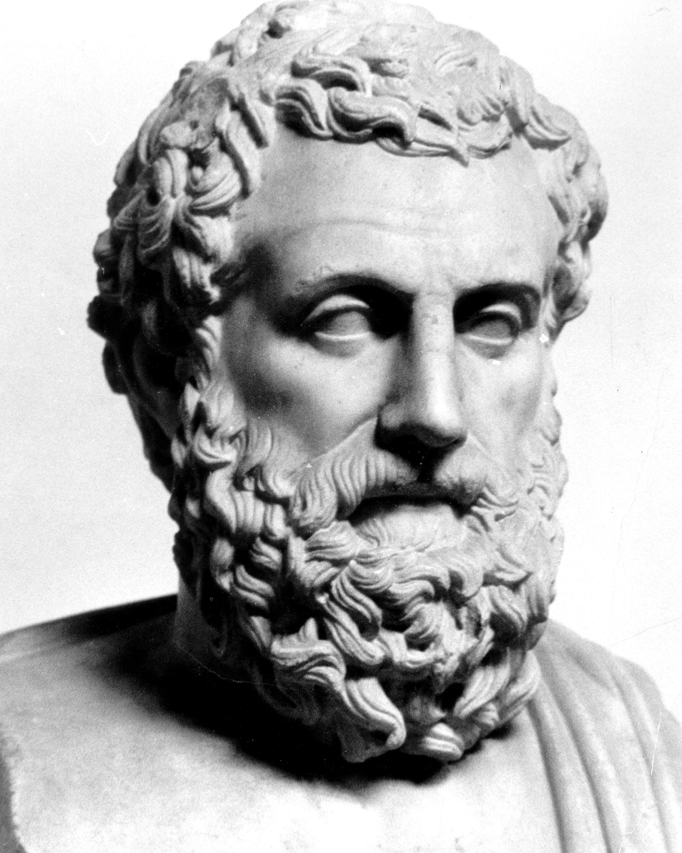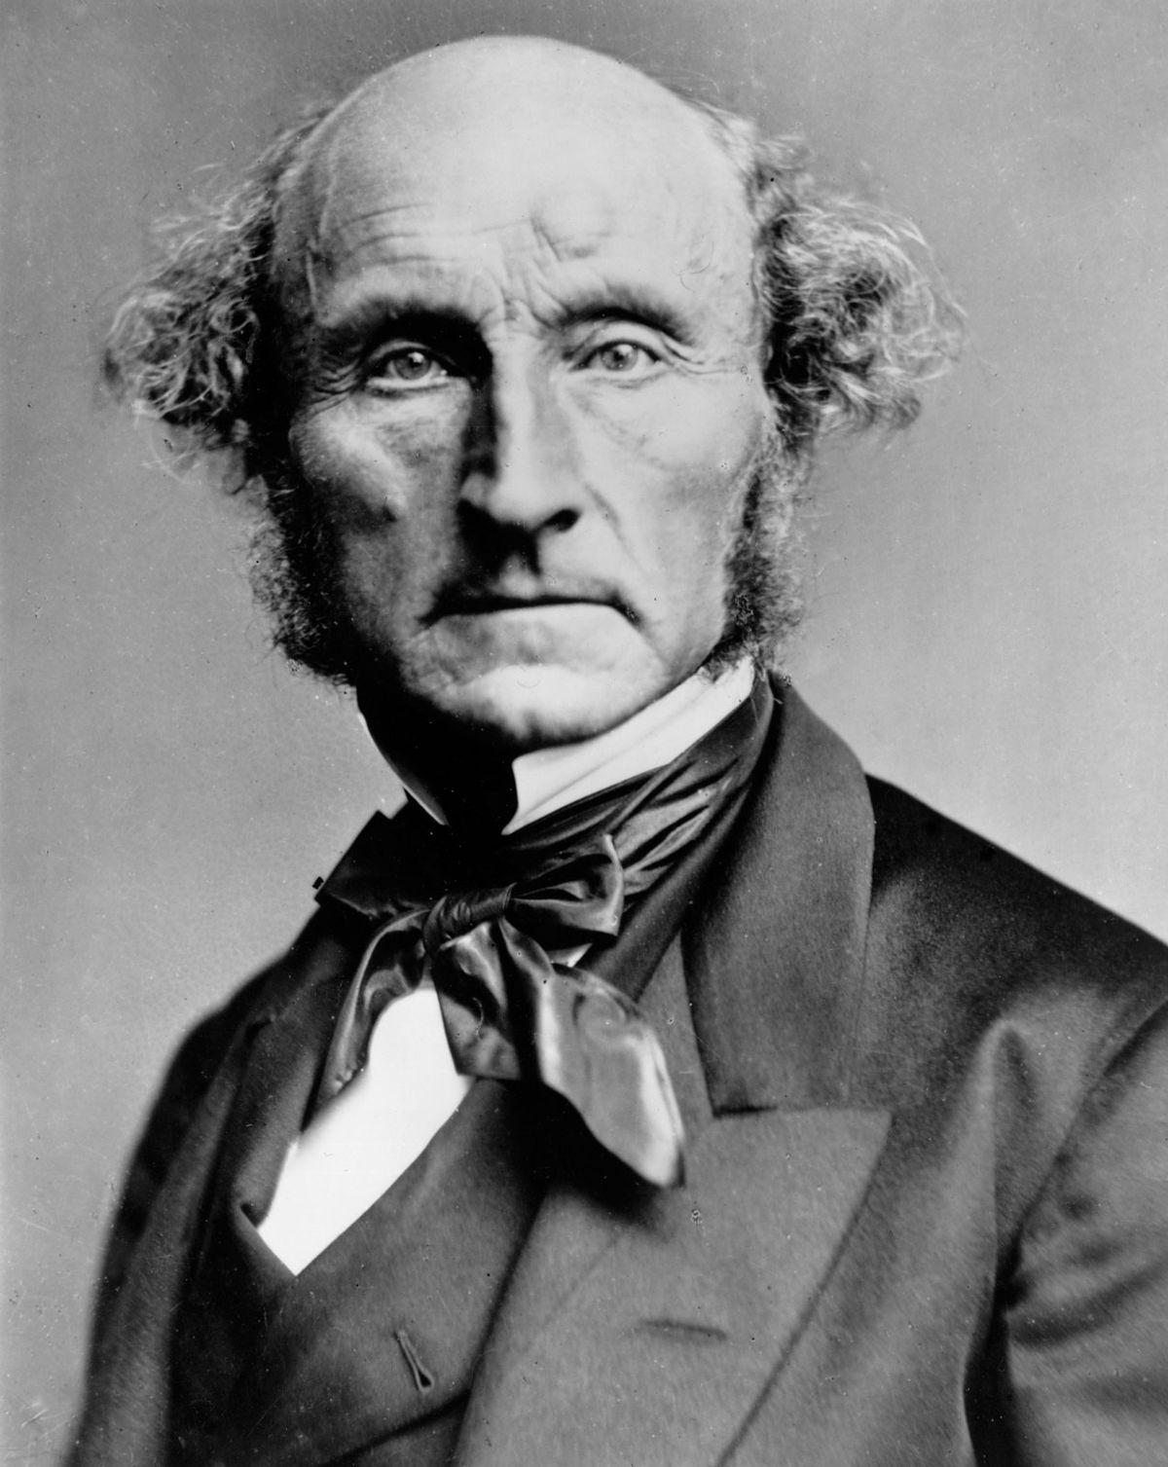

Aristotle J. S. Mill
Aristotle founded logic as well as many other fields of knowledge in the fourth century B. C. E. He wrote several treatises on logic. He completed this field until J. S. Mill made minor additions in the eighteenth century. (See the Scientific Method below.)

Definition of logic: the laws and methods used to distinguish good (correct) from bad (incorrect) thinking.

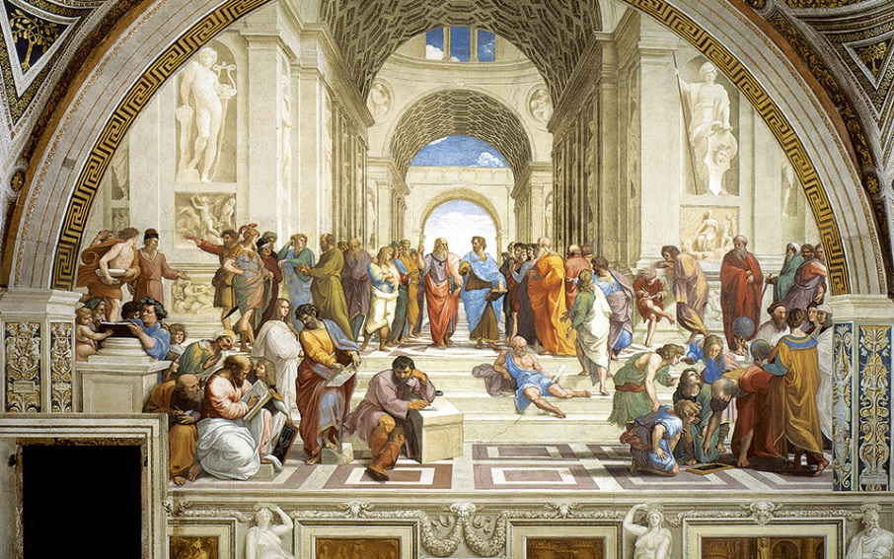
Raphael, “The School at Athens”
Logical thinking concerns how we ought to think. It justifies and establishes the soundness of all our thinking.

The laws of logic are absolute and universal or always apply to all individuals and all societies at all times. They destroy today’s widespread wishy-washy relativism at its core belief that the truth depends on each individual. No! It depends on the laws of logic which very few people know today.

The smallest unit of logical thinking is called an “argument.” A person begins her logical thinking with all of her knowledge. She begins to wonder about the truth of some belief. This becomes the point of her logical thinking. Aristotle called this a “conclusion.” He correctly maintained that a conclusion must be given evidence or supported by another truth from her background knowledge. Aristotle wrote that this can be used as a “premise.” A person needs to think of at least one of these to begin logical thinking about a conclusion. Thus, the form that an argument takes is the following:

premise (some evidence from a person’s background knowledge for a conclusion)
premise(s) (more evidence to add to proof or connection to the belief)
conclusion (belief demonstrated to be logical)

There are two types of arguments: induction and deduction. Induction is thinking from physical facts used as premises to a conclusion about them. This is a generalization from particular cases. Example: This swan is white, That swan is white, Therefore all swans are white. This type of logical thinking offers proof of a belief. However, all inductive beliefs are only probably true at most. Every one of them can be proven to be false by a physical fact that contradicts it. For example, black swans were discovered in Australia. (See much more on induction in scientific method below.)

Deduction reverses inductive thinking. It is purely thinking. In a deduction, a person thinks by combining inductive generalizations that she believes are true. She tries to know what these generalizations imply. If her thinking obeys the many implied rules of deduction, the conclusion must follow. Aristotle called this “valid.” Example: All people are mortal, Socrates is a person, therefore Socrates is mortal.

A fallacy is an illogical way of thinking (or correctly connecting premises to their con- clusion). A fallacy breaks one of the many implied rules of logical thinking. The following lists some of most common fallacies of the about 250 types: personal attack—yay College!, appeal to pity, misuse of authority, bandwagon argument and black-or-white thinking. Any others?

The newest branch of logic is how it effects the words or language that we use. This is very subtle and complex. Language has three main uses:
1) to communicate information—its only logical use—
2) to express emotions and
3) to give commands.

The words that a person uses often express or suggest her emotions toward it. Almost anything can be made to sound laudatory ( + ), neutral ( 0 ) or derogatory ( - ). Always think in neutral words to be logical. Example (from Bertrand Russell): I am firm ( + ), you are obstinate ( 0 ), and he is pig-headed ( - ). The meaning of a word is established by the common usage in one’s society.

Defining any unclear (ambiguous and vague) terms can much help logical thinking.
A definition specifies the precise meaning of a term. The most logical type of definition, given by Aristotle, categorize a term into its general class and then by its specific difference. Example: a human is a rational animal. A logical definition states the thing’s essential trait, is not be too broad or too narrow, is clear, is affirmative and stated in neutral language.

Finally, the scientific method is the most highly developed type of logical thinking.
Science seeks to describe, explain and control the world mostly by inductive thinking.
Scientific thinking does all this by analyzing causes. These prove that one thing is con- nected to something else. J. S. Mill developed four methods of doing this. For example,
If you find that one thing is always present when another, then the former probably causes the latter, for example, a certain germ is always present when a certain disease is. Mill’s methods brilliantly tell us how to test the causes of any thing.

The scientific method tells us how we can solve any practical problem. First, clarify the problem. Second, think of an hypothesis or educated guess that can solve the problem.

Third, refine the problem and the hypothesis. Fourth, confirm the hypothesis and solve the problem. Examples: curing of an illness, making money in business, getting good grades in a course, all scientific experiments, slowing down the COVID-19 pandemic and Sherlock Holmes solving murders and crimes. Any others?

To form an hypothesis, you need to think creatively, although this is far from logical. We all need to think creatively to improve, grow and solve our problems. We all need to make aa creative breakthrough. No rules cane be given for this. It is just happens “Eureka’ as Archimedes shouted! The key consists of combining all one’s ideas about problem in such a way that a new idea emerges. The thinker must prepare long and hard for this, as did inventor Thomas Edison. The subconscious takes a long time to work. Sleep helps this. Creative ideas need this to incubate. Don’t give up, above all! Be bold and adventurous in your thinking, but then be careful and thorough. Happy thinking!

